WOODY VOLUME, ABOVE-GROUND BIOMASS AND CARBON STOCKS IN THE CHITEMBO MIOMBO WOODLANDS – BIÉ PROVINCE, ANGOLA.
INTRODUCTION
The Miombo woodland is a dry forest that is characterized by the dominance of trees in the genera Brachystegia and Julbernardia. This woodland type covers an estimated area of approximately 2.7 million km² in southern, central and eastern Africa (White 1983; Frost 1996; Malmer, 2007; Ryan et al. 2010; Chidumayo, 2013). In Angola the typical miombo woodlands covers about 47 % of the total country surface (Huntley & Matos, 1994). The communities represent the most extensive vegetation unit in Angola and ranges in altitudes from 800 to 2000 m, with an annual rainfall of about 1300 mm/year. The soil is usually reddish clay, but often sandy (Shaw, 1947).
The miombo woodland plays an important role on the livelihood of rural areas, providing several products and services ranging from timber provision, honey, medicines, firewood, charcoal and construction materials to a large scale carbon and water managements services (Campbel, 1996; Chidumayo, 1997; Ryan et al. 2010). However, the miombo woodlands are understood to owe their structure partially due to human intervention through fire use and shifting cultivation.
Fire has played a central part of the miombo woodlands dynamics from at least 50.000 years ago. Intentional burning is practiced to prepare land for cultivation, clearing areas around settlements, to manage grazing, for charcoal production, honey collection and hunting (Chidumayo, 1997), with a direct impact on the woodland vegetation affecting the volume, above-ground biomass and carbon stocks. Other important human pressures on biomass is linked to the resources extraction, clearance for agriculture based on shifting cultivation, where woodland sites are cut over and the vegetation debris is burned. The site is later abandoned after 3-4 years of farming, because largely the decline in soil fertility under cultivation (Lumbwe, 2010; Houghton and Hackler, 2006 cited by Ryan et al. 2010).

Assessing volume, above-ground biomass and carbon stocks of the miombo woodlands due to the rapid increasing of deforestation and atmospheric CO₂ concentrations, and the development of payment systems to reduce emissions from deforestation and land degradation is crucial to preserve these tropical ecosystems and increasing global carbon stocks. Houghton (2005) cit. by Ryan et al. (2010) pointed that in Africa knowledge about the estimation of carbon density (t C/ha) of tropical land cover is the major uncertainty in the estimation of carbon emissions from land use change.
In this study developed under the frame of The Future Okavango Project SP05, we address to understanding the woody volume, above-ground biomass and carbon stocks information in the core site, in one of the country which is poorly studied and documented in terms of forests ecosystems services and functions. The project has funded by Germany Federal Ministry of Education and Research (BMBF) aiming to provide scientific support for sustainable land and resource management in the Okavango basin of Angola, Namibia and Botswana.
OBJECTIVES
- The main objective of this study is to assess the volume, biomass and carbon stocks in the miombo woodlands of Chitembo core site in Angola.
- Assessing how the volume, standing biomass and carbon stocks are affected by the shifting cultivation and charcoal production in the study area.
- Comparing data on volume, biomass and carbon stocks obtained in the study area with other miombo woodland of the region.
MATERIAL AND METHODS
Research area
The Kavango river basin occupies a wide area 149.700 km² of southeastern Angola. Most of its area is in Cuando-Cubango province, but it crosses five other Angolan provinces namely: Bié, Moxico, Huambo, Huíla and Cunene (Mendelsohn & El Obeid, 2005; Neto, 2011; Baptista, 2014). The Future Okavango (TFO) Project has two core sites in Angola that are located at Cusseque village in Chitembo, Bié province and in Mulemba village in Caiundo, Cuando-Cubango province. Two other core sites are designated in Manshare – Rundu in Namibia and Seronga - Maun in Botswana (Figure 1).
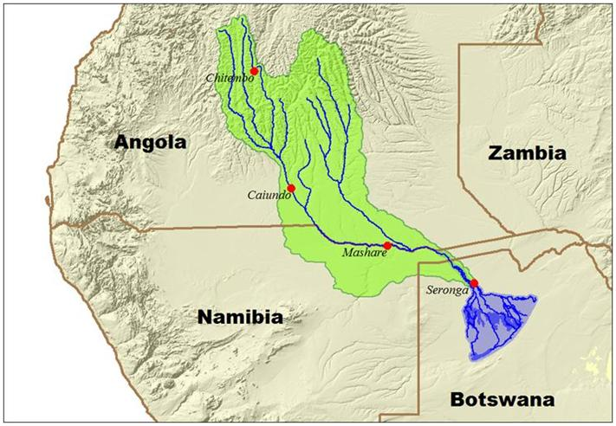
Figure 1 . : The Future Okavango project core sites in Angola, Namibia and Botswana.
For this study tree survey were done at Cusseque village, Chitembo core site. The study area is close to Cusseque River in Bié province, headwaters of Cubango/Okavango River. The landscape is dominated by the miombo woodland (Barbosa vegetation type 16). With dominant trees species composed by Julbernardia paniculata, Brachystegia spiciformis, Erythrophleum africanum and Cryptosepalum exfoliatum subsp. pseudotaxus.
The local population is mainly dominated by Kioko (Cokwe ethnic group) and some other important groups of Ganguela ethnic group. This people have in the subsistence agriculture (shifting cultivation), hunting, and honey production and more recently in charcoal production as the main source of income for their livelihood.
Tree survey assessment
Tree surveys in the woodlands were done within plots of 20 X 50 m according (Felfili et al. 2005), the major plot is subdivided in ten (10) subplots of 10 X 10 m for each selected area and disturbance stage. The tree diameter was measured at DBH (1.30 m). Measurement was made with a tape measure. Tree height measurement was done using a Haglöf Vertex Digital Clinometer (Chave, 2006). Inclusion criteria for trees measure were equal or greater than 5 cm. The number of stumps per plot were also counted and registered.
Assessment of volume, above-ground biomass and carbon stocks
Assessment of volume and above-ground biomass in re-growth and old-growth was done based on allometric relationships equations developed for the miombo woodlands in others countries of southern Africa. Different formulas developed for the miombo woodland of Mozambique, Malawi and Zambia was used in this study (Table 4). The carbon stock was assessed following the Guidelines of Intergovernmental Panel on Climate Changes, multiplying the total biomass by 0.5, considering that 50 % of individual is biomass (IPCC, 2000).
RESULTS
For this study we assessed woody volume, above-ground biomass and carbon stocks of a total of fifty plots of 1000 m² (20 X 50 m) within the core site. The plots were sampled according the fallow age: Ten plots corresponding to approximately 8 years of fallow, ten plots of 14 years of fallow, ten plots corresponding to 20 years of fallow and twenty old-growth plots. Also it was assessed ten other plots in the places with previous charcoal production in the last five to eight years of fallow. The results obtained on volume, biomass and carbon stocks are analyzed as follow.
Woody volume
Tree volume was assessed based in two different equations (Table 4). Equation one was adopted because showed low standard error. The volume varied significantly among the plots assessed. In the plots with ± 8 years of fallow the volume varied from 0,1 – 6,5 m³ ha⁻¹ with a mean of 2,9 ± 1,5. The volume in charcoal plots varied from 1,8 – 9,2 m³ ha⁻¹, with a mean of 5,0 ± 1,7.
The plots with ± 14 years the volume varied from 1,1 – 8,2 m³ ha⁻¹ with a mean of 5,5 ± 1,7. Plots with ± 20 years the volume was 3,2 – 12,4 m³ ha⁻¹ with a mean of 8,6 ± 2,3. While the old growth plots showed high volume varying from 5,4 – 19,2 m³ ha⁻¹ with a mean of 10,2 ± 1,7. The total volume and differences among the plots can be seen in table 1.
Above-ground biomass and carbon stocks
For the above-ground biomass we used five different equations developed for the miombo woodlands (Table 4). Two equations were used for the stems with DBH lower or equal to 0, 1 m and other three equations for stems greater or equal to 0,1 m. For this study we used two equations. Equation one (B = 2, 23 D-6, 44) for trees with lower DBH and equation two (B = 17, 43 D-188, 84) for trees with greater DBH. We choose this equation due to the lowest standard error showed in the calculations.
Based on this the biomass, plots with approximately 8 years varied from 1,2 – 37,1 ton/ha⁻¹, with a mean of 9,8 ± 4,9 ton/ha⁻¹ and a carbon stocks of 0,6 – 18,5 with a mean of 4,9 ± 2,5 ton C/ha⁻¹. The charcoal plots biomass varied from 1,1 – 46, 6 ton/ha⁻¹ with a mean of 15,4 ± 6,7 ton/ha⁻¹. The carbon stocks varied from 0,6 – 23, 3, with a mean of approximately 7,7 ± 3,4 ton C/ha⁻¹. The plots with approximately 14 years of fallow age, the biomass varied from 2,0 – 52,2 ton/ha⁻¹. The mean biomass was 19,4 ± 8,8 ton/ha⁻¹ and carbon stocks of 9,7 ± 4,4, varying from 1,0 – 26, 1 ton C/ha⁻¹.
Within the vegetation plots with 20 years of fallow age, the total above ground biomass varied from 3,4 – 77,9 ton/ha⁻¹, with a mean of 27,5 ± 12,2 ton/ha⁻¹. The carbon stocks varied from 1,7 – 38,9 with a mean of carbon stock corresponding to 13,7 ± 6,1 ton C/ha⁻¹. While the old growth plots the biomass varied from 0,9 – 113,9 ton/ha⁻¹, the mean biomass encountered was 34,2 ± 10,7 ton/ha⁻¹. The carbon stocks varied from 0,5 – 56,9 ton C/ha⁻¹ with a mean of 17,2 ± 5,4 ton C/ha⁻¹.
DISCUSSION
In general the average values of volume, above ground biomass and carbon stocks determined in the study area are within the range reported in various studies in southern Africa and other regions of the world (e.g. Chidumayo, 1993; 2002; 2013; Frost, 1996; Grace et al. 2005; William et al. 2008; Shirima et al. 2011). However Kusaga, M. (2010) reported that limited research has been done on estimating carbon stocks in the miombo woodland. Most studies focus on volume of woody biomass and often only commercially exploitable parts are considered.
The values on volume and biomass found in this study are closed with other studies developed in various ecosystems. Segura & Kanninen (2005) found in a study made in Costa Rica stem volume varying from 5 to 19 m³/tree. And total above ground biomass ranges from 3 to 13 mg/tree. William et al. (2008), found a value of 19,0 ± 8,0 ton C/ha⁻¹. The mean estimated stem C stock for the oldest abandoned machamba (> 20 years) was 15,7 ± 3,9 ton C/ha⁻¹. This values is relatively close to the results we found in the core site with an estimated carbon stock of 13,7 ± 6,1 ton C/ha⁻¹ in the plots with approximately 20 years of fallow. Kalaba et al. (2012) found 5,4 ± 1,1 Mg C/ha⁻¹ in re-growth plots of 5-6 years of fallow, this results can be compared with plots of approximately 8 years of fallow within the core site where we found 4,9 ± 2,5 ton C/ha⁻¹. Within the charcoal plots in the study area we found a mean of carbon stocks of about 7,7 ± 3,4 ton C/ha⁻¹, Kalaba et al. (2012) found 10,5 ± 2,7 Mg C/ha⁻¹ and 64,3 ± 10,1 Mg C/ha⁻¹ in the old growth plots where we found 17,2 ± 5,4 ton C/ha⁻¹.
Comparing and biomass in shifting cultivation plots and charcoal fallows in the study area showed that the volume, above ground biomass and carbon stocks is higher in charcoal plots than the shifting cultivation plots. This result is in accordance with the studies made by Kalaba et al. (2012) in Copperbelt province in Zambia, where they found significant differences in charcoal fallows and slash and burn agriculture after 5 years of fallow. The author also demonstrated that at 10 years of abandonment charcoal fallows had statically significant higher C storage than slash and burn re-growth. The author concludes that charcoal sites had higher carbon storage than slash and burn agriculture sites. This can be attributed to higher regeneration rates on charcoal sites as trees grows from coppices whish are new shoots emerging from stumps of cut trees. In our study area the higher contribution to the biomass and other parameters assessed it’s can be attributed also due to the trees charcoal producers never fell such as: Guibourtia coleosperma, Erythrophleum africanum and Lonchocarpus capassa due to its hard trunk or bad quality for charcoal. The ability of miombo species regeneration from coppices has been reported by various authors, demonstrating that high regeneration in charcoal re-growth increase C storage rapidly after abandonment.
CONCLUSIONS
Once Angola is part of Kyoto protocol of the United States Framework Convention on Climate Changes (UNFCCC), occupying the 172 position since May 2007. The country has now the responsibility to quantifying its forest resources and carbon stocks in order to reduce emissions from deforestation and land degradation under REDD⁺ Programme.
However, little past information is available regarding volume, biomass and carbon stocks of the Angolan miombo woodlands. Most of the existing information was only given to the species with commercial value, specially exploited woody species from Cabinda. Regarding the species occurring in the Okavango river basin, Baptista, N. (2014) found only information for two species – Guibourtia coleosperma and Pterocarpus angolensis, between the period of 1963 and 1967. The first specie (G. coleospema), was among the most exported species from the country, the most exploited specie, representing about 7,219 and 19,021 ton/year.
This paper aimed to determine volume, above-ground biomass and C stocks of the miombo woodlands in the Chitembo core site, and changes after charcoal production and shifting cultivation. We have shown in this study that the miombo woodlands of Angola are potential in terms of biomass and carbon stocks storage, such as other miombo ecosystems as demonstrated in various studies.
The study also demonstrated that once the miombo woodland is cleared for agriculture and charcoal production, biomass and C storage is also reduced and rapidly increasing after five years of abandonment. The miombo reaches high values in biomass and C stocks after 20 years, as demonstrated by Kalaba et al. (2012). It was also demonstrated that charcoal fallows has high values of volume, biomass and C stocks, compared with agriculture site with approximately the same period of fallow. This conclusion is in accordance with findings from Kalaba et al. (2012), demonstrating that the miombo woodlands are able to achieve mature vegetation structure (DBH and basal area) after at least 20 years of abandonment.
However, the natural succession and vegetation recovery of the miombo woodland can be affected by the human population growth in rural areas, with its negative impacts in the woodlands, and continuous growing demand of fuel in rural and main urban centers. The results presented in this study can be used as the first step toward sustainable management woodland in Angola, and support the decision makers with insights to understand C stocks changes in the miombo woodlands after disturbance, the study can also used as guide in the future negotiations in the emerging initiatives of C payments as mentioned by Kamelarczyk (2009). The author ensures that reducing emissions from deforestation and forest degradation may play an important role in climate change mitigation and adaptation. In this way there is an enormous potential to develop benefits and generate a new financing stream for a sustainable forest management in developing countries, following the recommendations from different sessions of the Conference of Parties (UNFCCC, 2011).

REFERENCES
- BAPTISTA N. (2014) Literature study of the woody Miombo vegetation and forest management in southeastern Angola with focus on data from the colonial era. A study conducted for the Polytechnic of Namibia in frame of The Future Okavango Project SP05 Task 6.
- CAMPBELL, B. (1996) The Miombo in Transition: Woodlands and welfare in Africa. CIFOR, Bogor.
- CHAVE, J. (2006) Medição da altura das árvores tropicais-Manual de Campo. Projecto PAN-AMAZONIA. Sixth. Framework Programme (2002-2006).
- CHIDUMAYO, E. N. (1997) Miombo Ecology and Management: An Introduction. IT Publications in association with the Stockholm Environmental Institute, London-UK. 166p.
- CHIDUMAYO, E. N. (2013) Estimating tree biomass and changes in root biomass following clear-cutting of Brachystegia-Julbernardia (miombo) woodland in central Zambia. Environmental Conservation 41 (1): 54–63. doi:10.1017/S0376892913000210
- FELFILI, J. M., CARVALHO, F. A. & HADAIR, R. F. (2005) Manual para Monitoramento de Parcelas Permanentes nos Biomas Cerrado e Pantanal, UnB, Brasília, DF-Brazil
- FROST, P. G. H. (1996) The ecology of miombo woodlands. In: Cmpbell, B. (ed.). The Miombo in Transition: Woodlands and Welfare in Africa. CIFOR. Bogor, Indonésia. p. 11–57.
- HENRY, M.; BOMBELLI, A.; TROTTA, C.; ALESSANDRINI, A.; BIRIGAZZI, L.; SOLA, G.; VIEILLEDENT, G.; SANTENOISE, P.; LONGUETAUD, F.; VALENTINI, R.; PICARD, N.; SAINT-ANDRÉ, L. (2013) GlobAllomeTree: International platform for tree allometric equations to support volume, biomass and carbon assessment. iForest (early view): e1-e5 [online 2013-07-18] URL: http://www.sisef.it/ iforest/contents/?id=ifor0901-006
- HUNTLEY, B. J. & MATOS, E. M. (1994) Botanical diversity and its conservation in Angola. Strelitzia 1 (1994).
- KALABA, F. K., QUINN, C. H., DOUGILL, A. J. (2012) Carbon storage, biodiversity and species composition of Miombo woodlands in recovery trajectory after charcoal production and slash and burn agriculture in Zambia’s Copperbelt. Sustainability Research Institute Paper No. 40. SRI Papers.
- IPCC (2000) IPCC Special Report: Emissions Scenarios. Published for The Intergovernmental Panel on Climate Changes.
- KAMELARCZYK, K. B. F. (2009) Carbon Stock Assessment and Modelling in Zambia a UN – REDD Programme Study. UN – REDD PROGRAMME. MRV Working Paper 4.
- KUSAGA, M. M. (2010) Participatory Forest Carbon Assessment in Angai Village Landa Forest Reserve in Liwale District, Lindi Region, Tanzania, A Dissertation submitted of the Requirements for the degree of Masters of Science in Management of Natural Resources for Sustainable Agriculture of Sokoine University of Agriculture, Morogoro, Tanzania.
- LUMBWE, F. C. (2010) Modelling Avifauna responses to Miombo woodlands degradation in Serenje District, Central Province, Zambia. A thesis submitted to the University of Zambia in fulfillment of the requirements for the degree of Doctor of Philosophy in Animal Ecology. (CHAPTER 3: woodland structure and degradation).
- MALIMBWI, R. E.; ZAHABU, E.; KAJEMBE, G. C.; LUONGA, E. J. (S. D.) Contribution of Charcoal Extraction: Experience from CHAPOSA Research Project. Department of Forest Mensuration and Management, Faculty of Forestry and nature Conservation, sokoine University of Agriculture. Morogoro, Tanzania
- MALMER, A. (2007) General ecological features of miombo woodlands and considerations for utilization and management. Working Papers of the Finnish Forest Research Institute 50: 34–42
- MENDELSOHN, J. & EL OBEID, S. (2005) Rio Okavango, a fonte de vida. Struik Publishers, Cape Town – South Africa.
- NETO, J. (2011) OKAVANGO. A importância da Gestão dos nossos Recursos Hídricos Transfronteiriços. 1.ª Edição. Rolo e Filhos II, S.A.
- RYAN, C. M.; WILLIAMS, M. and GRACE, J. (2010) above and below-ground Carbon Stocks in the Miombo Woodland Landscape of Mozambique. BIOTROPICA 1-10 10.1111/j.1744-7429.2010.00713.x
- SAMBANE, E. C. (2005) Above-ground biomass accumulation in fallow fields at the Nhambita community-Mozambique. A dissertation for the degree of Master of Science, University of Edimburgh
- SEGURA, M. & KANNINEN, M. (2005) Allometric Models for the Tree Volume and Total Aboveground Biomass in a Tropical Humid Forest in Costa Rica. BIOTROPICA 37 (1) 2-8.
- SHIRIMA, D. D.; MUNISHI, K. T., LEWIS, S. L.; BURGESS, D. N.; MARSHALL, A. R.; BALM, F. A.; SWETNAM, R. AND ZAHABU, E. M. (2011) Carbon storage, structure and composition of miombo woodlands in Tanzania’s Eastern Arc Mountains. African Journal of Ecology. Blackwell Publishing Ltd, Afr.J.Ecol. 49, 332-342.
- SHAW, H. K. A. (1947) The Vegetation of Angola. Journal of Ecology. British Ecological Society. Vol. 35: 23 – 48
- UNFCCC (2011) Report of the Conference of the Parties on its sixteenth Session, held in Cancun from 29 November to 10 December. GE. 11 – 60550.
- WHITE, F. (1983) The Vegetation of Africa. Natural resources Research 20. UNESCO, Paris.

ANNEXURE
Table 1.: Woody volume for the fifty plots assessed based on equation (1) for trees greater or equal to 5 cm of DBH.
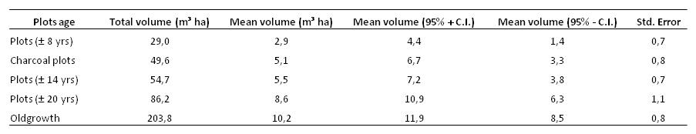
Table 2.: Woody biomass for the fifty plots assessed based on equations (5) for trees greater or equal to 0,1 m and (7) for trees lower or equal to 0,1 m.
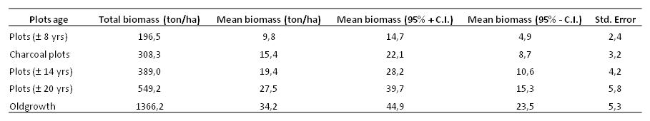
Table 3.: Carbon stocks based on the mean biomass calculations, for the fifty plots assessed within the core site.
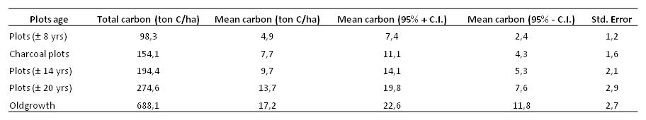
Table 4.: Woody volume and biomass allometric equations developed for the miombo woodland used in this study.
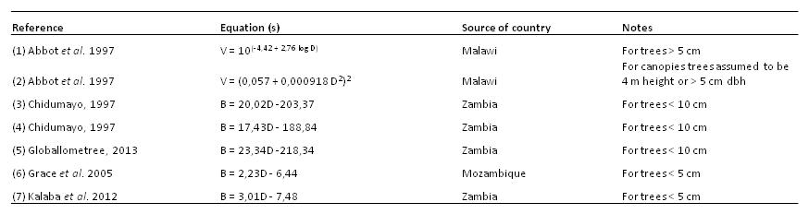
Where: V = tree volume, D = diameter at breast height, B = tree biomass, log D = is the natural logarithm or logarithm at base 10.

