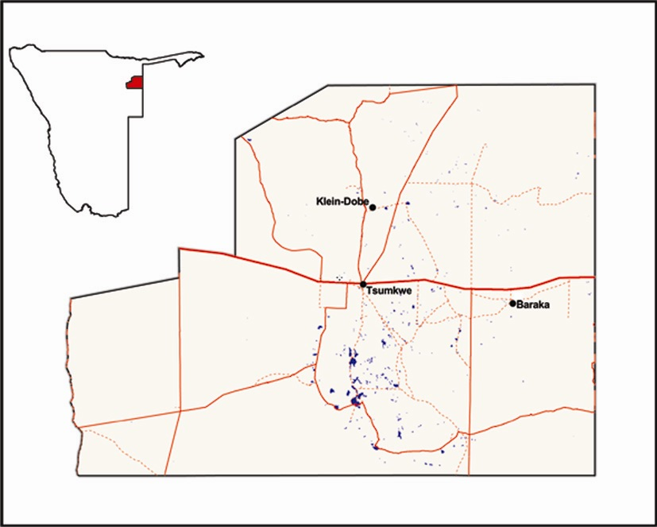

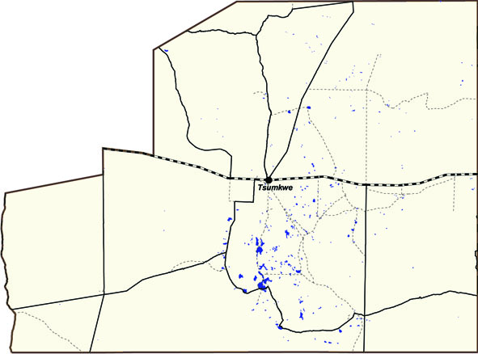







Population Estimates
Waterhole estimates
Distribution
Trends
Animals per day per waterhole
Animals seen during the count
FULL MOON WATERHOLE COUNTS IN NYAE NYAE CONSERVANCY
Elephant
Warthog
Roan
Kudu
Wildebeest
Hyaena
Leopard
Numbers seen
Low
High
DF = drinking frequency
2010

Species | //Achoach | //Xaece | /Ang!oah | Baraka | Boma | Buffalo 1 | Buffalo 2 | Buffalo 3 | Buffalo 4/Kiewiet | G/a!oan | G=aing=oqo | Grenspos | Gura | Klein Dobe | N#ama Pan | Nhoma pos 1 | Nhoma pos 2 | Nyae Khabi | Nyae Nyae | Xamsa | Xinni Xuri | Total
Buffalo |  |  |  |  |  | 3 | 92 | 348 | 17 |  |  |  |  |  |  |  |  |  |  |  |  | 460
Duiker |  |  | 1 | 1 |  |  | 1 |  | 2 |  | 1 | 4 |  |  | 1 | 1 | 3 |  | 2 | 2 |  | 19
Elephant | 2 | 20 | 124 | 26 | 50 |  |  |  |  | 37 | 197 | 29 | 47 | 147 | 33 | 65 | 6 |  | 2 | 23 | 10 | 818
Gemsbok |  |  |  |  | 1 |  |  |  |  |  |  | 2 |  | 1 | 3 | 2 | 6 | 1 | 8 |  |  | 24
Hartebeest |  |  |  | 6 |  |  |  |  |  |  |  |  |  |  | 9 |  |  | 1 | 10 |  |  | 26
Hyaena | 1 |  | 4 |  | 3 | 1 | 2 |  |  | 3 | 1 | 6 | 1 | 5 | 2 |  | 5 | 1 |  | 1 | 1 | 37
Jackal |  |  |  | 2 | 3 |  |  |  |  | 4 | 2 |  | 1 | 2 | 5 |  |  | 1 |  | 3 |  | 23
Kudu | 19 | 2 |  | 48 | 16 | 2 |  |  |  | 1 | 11 | 22 | 27 |  | 6 |  | 14 | 5 | 16 | 2 |  | 191
Leopard |  | 1 |  |  | 2 |  |  |  |  |  | 2 |  |  | 1 |  |  | 4 |  |  |  | 1 | 11
Rhino |  |  |  |  |  |  | 5 | 1 | 2 |  |  |  |  |  |  |  |  |  |  |  |  | 8
Roan | 3 |  |  | 1 |  |  |  |  |  |  |  |  |  |  | 2 |  |  |  | 7 |  |  | 13
Springbok |  | 24 |  |  |  |  |  |  |  | 1 |  |  | 1 |  |  |  |  |  | 83 |  |  | 109
Steenbok | 2 | 2 | 1 |  | 1 |  | 1 |  |  | 3 |  | 1 |  | 2 | 2 |  | 1 | 2 |  | 2 |  | 20
Warthog | 12 | 11 |  | 7 | 4 |  |  |  |  |  |  | 9 | 4 |  |  | 5 | 2 |  | 1 |  | 1 | 56
Wild dog |  |  |  |  |  |  |  |  |  |  | 1 |  |  |  |  |  | 12 |  |  |  |  | 13
Wildebeest | 1 |  |  | 3 |  |  |  |  |  | 14 | 9 |  |  |  |  |  | 6 | 1 | 5 |  |  | 39
 |  | //Achoach | //Xaece | /Ang!oah | Baraka | Boma | Buffalo 1 | Buffalo 2 | Buffalo 3 | Buffalo 4/Kiewiet | G/a!oan | G=aing=oqo | Grenspos | Gura | Klein Dobe | N#ama Pan | Nhoma pos 1 | Nhoma pos 2 | Nyae Khabi | Nyae Nyae | Xamsa | Xinni Xuri | Total
Count days |  | 2 | 3 | 2 | 2 | 2 | 2 | 2 | 2 | 2 | 2 | 2 | 2 | 2 | 0 | 2 | 2 | 2 | 2 | 2 | 2 | 2 | 41
Species | DF
Buffalo | 1 |  |  |  |  |  | 2 | 46 | 174 | 8 |  |  |  |  |  |  |  |  |  |  |  |  | 230
Duiker | 4 |  |  | 2 | 2 |  |  | 2 |  | 4 |  | 2 | 8 |  |  | 2 | 2 | 6 |  | 4 | 4 |  | 38
Elephant | 1.8 | 2 | 12 | 112 | 23 | 45 |  |  |  |  | 33 | 177 | 26 | 42 |  | 30 | 58 | 5 |  | 2 | 21 | 9 | 598
Gemsbok | 4 |  |  |  |  | 2 |  |  |  |  |  |  | 4 |  |  | 6 | 4 | 12 | 2 | 16 |  |  | 46
Hartebeest | 2 |  |  |  | 6 |  |  |  |  |  |  |  |  |  |  | 9 |  |  | 1 | 10 |  |  | 26
Hyaena | 2 | 1 |  | 4 |  | 3 | 1 | 2 |  |  | 3 | 1 | 6 | 1 |  | 2 |  | 5 | 1 |  | 1 | 1 | 32
Jackal | 2 |  |  |  | 2 | 3 |  |  |  |  | 4 | 2 |  | 1 |  | 5 |  |  | 1 |  | 3 |  | 21
Kudu | 2 | 19 | 1 |  | 48 | 16 | 2 |  |  |  | 1 | 11 | 22 | 27 |  | 6 |  | 14 | 5 | 16 | 2 |  | 190
Leopard | 2 |  | 1 |  |  | 2 |  |  |  |  |  | 2 |  |  |  |  |  | 4 |  |  |  | 1 | 10
Rhino | 4 |  |  |  |  |  |  | 10 | 2 | 4 |  |  |  |  |  |  |  |  |  |  |  |  | 16
Roan | 1.5 | 2 |  |  | 1 |  |  |  |  |  |  |  |  |  |  | 2 |  |  |  | 5 |  |  | 10
Springbok | 4 |  | 32 |  |  |  |  |  |  |  | 2 |  |  | 2 |  |  |  |  |  | 166 |  |  | 202
Steenbok | 4 | 4 | 3 | 2 |  | 2 |  | 2 |  |  | 6 |  | 2 |  |  | 4 |  | 2 | 4 |  | 4 |  | 35
Warthog | 2 | 12 | 7 |  | 7 | 4 |  |  |  |  |  |  | 9 | 4 |  |  | 5 | 2 |  | 1 |  | 1 | 52
Wild dog | 1 |  |  |  |  |  |  |  |  |  |  | 0 |  |  |  |  |  | 6 |  |  |  |  | 7
Wildebeest | 1.5 | 1 |  |  | 2 |  |  |  |  |  | 10 | 7 |  |  |  |  |  | 4 | 1 | 4 |  |  | 29
Species | Introduced | Breeding rate% |  | Breeding estimate | Waterhole estimate | Aerial census | Local estimate | Accepted estimate
Buffalo |  | 18 |  |  | 230 |  | 220 | 220
Duiker |  |  |  |  | 38
Elephant |  |  |  |  | 598 |  | 1000 | 800
Gemsbok | 274 | 10 |  | 668 | 46 |  | 800 | 900
Hartebeest | 541 | 10 |  | 1258 | 26 |  | 400 | 500
Hyaena |  |  |  |  | 32 |  | 180 | 200
Jackal |  |  |  |  | 21 |  | 450 | 500
Kudu | 303 | 10 |  | 747 | 190 |  | 1000 | 1000
Leopard |  |  |  |  | 10 |  | 150 | 200
Rhino |  |  |  |  | 16
Roan |  |  |  |  | 10 |  | 150 | 150
Springbok | 690 | 7 |  | 1209 | 202 |  | 600 | 600
Steenbok |  |  |  |  | 35 |  | 2000 | 2000
Warthog |  |  |  |  | 52 |  | 150 | 1500
Wild dog |  |  |  |  | 6 |  | 80 | 80
Wildebeest | 116 | 15 |  | 396 | 29 |  | 1000 | 800

