Gazania thermalis - a very special plant
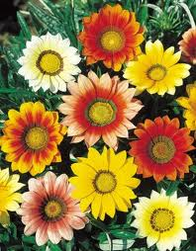
In southern Africa Gazania is known as a garden plant with particularly showy flowers that requires little watering. Gazania is a southern African genus with about 20 species. In 1921 the first official botanist of the then South West Africa, Kurt Dinter, described Gazania thermalis from a plant that he found at Gross Barmen and cultivated in Okahandja until it flowered. He called this species "thermalis" because he found it at the thermal springs. A specimen of this plant is lodged with the herbarium of the South African Museum (now part of the South African Biodiversity Institute, Kirstenbosch, South Africa). Unfortunately Dinter did not put a date onto this specimen and it is not clear when exactly he discovered this plant at Gross Barmen. It must have been before 1921. During following years this species was never re-collected at Gross Barmen and during a thorough search in 2013 it could not be found there again.
Showy flowers of Gazania bred for garden ornamentals

This species with its small, uniformly yellow flowers is distinguished from all other Gazania by the total lack of hairs on the leaves. Other Gazania species have white woolly hairs at least on the underside of their leaves.
In 1972 Mr and Mrs Wiss and the botanists Hermann Merxmüller (Botanische Staatssammlung München) and Willy Giess found Gazania thermalis at the thermal spring on Farm Sneyrivier. The curator of the National Herbarium in Windhoek at the time, Mike Müller, found this plant at thermal springs on Farm Lisbon/Grootfontein, south of Maltahöhe in 1980. This means that the only two places where this species grows are about 350 km apart. Comparing these localities shows that this Gazania seems to prefer the very saline, more or less continuously moist soils at thermal springs.
Upon closer inspection during 2014 it was found that more and larger plants occur in a larger area at Lisbon than at Sneyrivier. At Sneyrivier at least 100 plants were counted in April 2014. It is difficult to determine this precisely since this Gazania forms dense carpets and it is impossible to distinguish if these consist of one or several plants. Because of the small distribution area, the small number of plants and the continuous reduction of its habitat, Gazania thermalis was evaluated as critically endangered (CR) according to the criteria of the IUCN (International Union for Conservation of Nature).
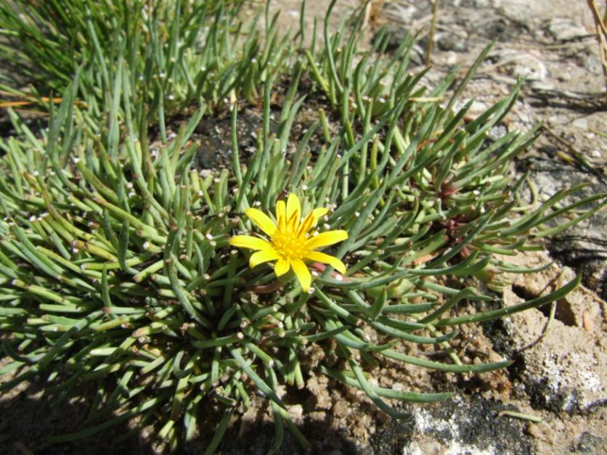
Gazania thermalis at Sneyrivier

With financial backing by the Ernest Kleinwort Charitable Trust from the United Kingdom, attempts are now made to re-establish this plant at Gross Barmen. For this, seeds are needed to either sow directly on site or raise seedlings that can be transplanted. Initially it was planned to use seed from the nearby Sneyrivier population, but because of the relatively small number of plants here, seeds were rather collected at Lisbon. First results show that it is extremely important to find exactly the right spot for re-introduction of these plants.
To ensure the survival of this species, every plant, and more importantly, its habitat, must be conserved. Possible development, extraction of spring water or excessive trampling of the surrounds by human or animal could mean the end of this unique plant.

Herta Kolberg, Millennium Seed Bank Partnership, Windhoek, Namibia

