- Results - Fire patterns in Namibia
The frequency at which Namibian rangelands burned for the 2000 to 2017 period was influenced by rainfall and land tenure (Figure 44). Higher rainfall areas tend to burn more frequently, while the dry western and southern parts of Namibia burn very seldom, if at all. When controlling for the effect of long-term rainfall on fire frequency, title deed areas burned far less frequently than either communal or protected areas (Figure 44 and Figure 45). In communal areas, however, fire regimes differ markedly. For example, the Cuvelai basin in north-central Namibia and the western and southern parts of eastern Namibia burn infrequently (Figure 44).
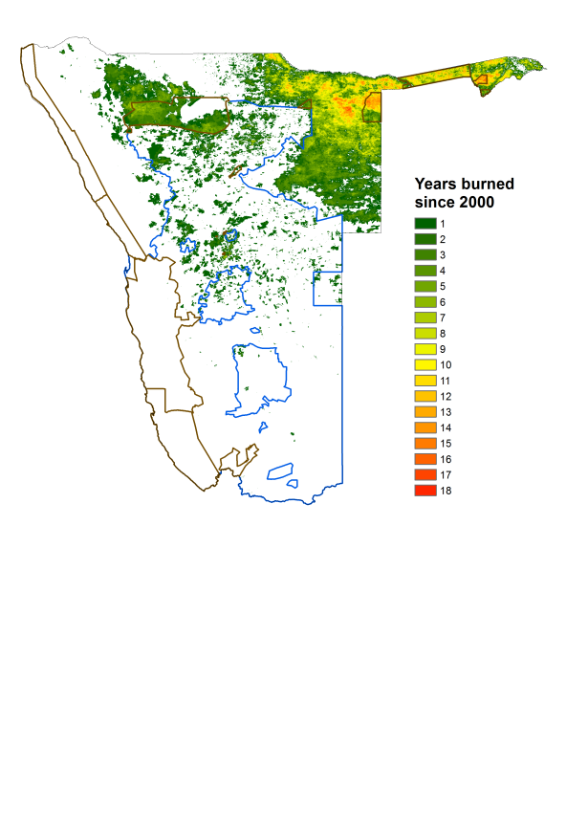

Figure 44 A map of Namibia showing spatial variability in annual fire frequency. No fires were recorded in the white areas for the 2000 to 2017 period. Green areas show low fire frequencies, yellow intermediate and red where it burned frequently since 2000. Blue outlines the commercial farming areas and brown national parks and state protected areas.

Figure 45 The average percentage of study units that burned annually from 2013 to 2017 in relation to different land tenure systems in Namibia in different aridity classes.

