List of Acronym

ASFR Age Specific Fertility Rate
CBS Central Bureau of Statistics
CEB Children Ever Born
EAs Enumeration Areas
ECD Early Childhood Development
HIV/AIDS Human Immunodeficieny Virus/ Acquired ImmunoDeficiency Syndrome
ILO International Labour Organization
MDG Millennium Development Goals
MTPIII Third Medium Term Plan
NDPII Second National Development Plan
NIDS Namibia Inter Censal Demographic Survey
PSUs Primary Sampling Units
SQL Sequential Query Language
TFR Total Fertility Rate
U5MR Under-five mortality rate
NPC National Planning Commission

Regions of Namibia

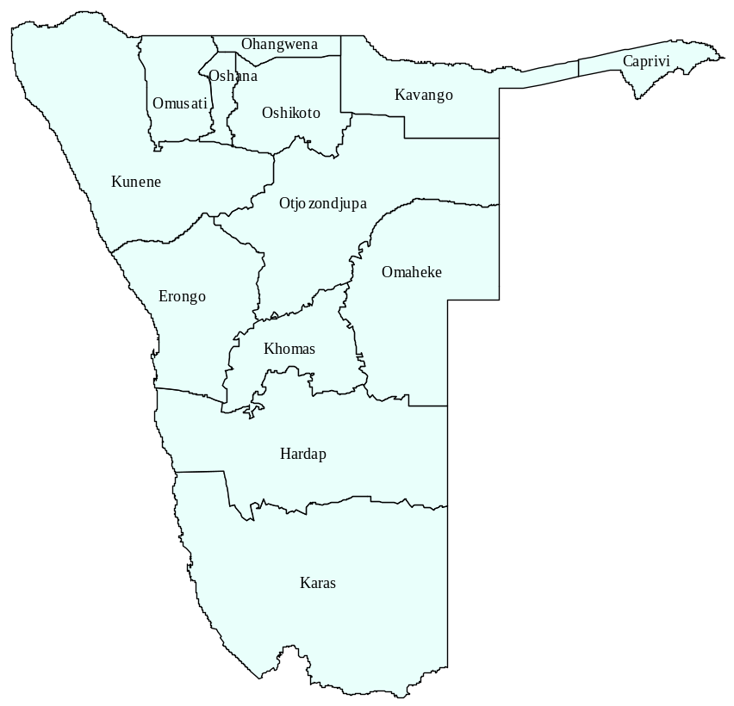
Total population:
Namibia | 1952454
Caprivi | 85224
Erongo | 134966
Hardap | 74495
Karas | 64872
Kavango | 237657
Khomas | 301050
Kunene | 76329
Ohangwena | 247103
Omaheke | 60773
Omusati | 224256
Oshana | 159827
Oshikoto | 161102
Otjozondjupa | 124800

National Summary Indicators 2001 Census and 2006 NIDS

 | 2001 | 2006
Population Size
Total | 1 830 330 | 1 952 454
Males | 887 721 | 924 804
Females | 942 572 | 1 023 511
Growth Rate | 2.6 | 2.0
Urban/rural, percent
Urban areas | 33 | 36
Rural areas | 67 | 64
Sex ratio: Males per 100 females | 94 | 90
Age composition, percent
Under 1 year | … | 5
Under 5 years | 13 | 13
5 – 14 years | 26 | 25
15 – 59 years | 52 | 54
60+ years | 7 | 7
Youth 15-35 years, percent | 37 | 37
Marital status: 15+ years, percent
Never married | 56 | 55
Married with certificate | 19 | 19
Married traditionally | 9 | 8.7
Married consensually | 7 | 7.8
Divorced/Separated | 3 | 2.8
Widowed | 4 | 5.6
Citizenship, percent
Namibian | 97 | 98
Non-Namibian | 3 | 2
Main language spoken at home,
Percent of households
Oshiwambo | 48 | 46
Nama/Damara | 11 | 12
Afrikaans | 11 | 12
Kavango | 10 | 10
Otjiherero | 8 | 9
Private households; Namibia
Number | 346 455 | 419 804
Average size | 5.1 | 4.7
Head of household, percent
Females | 45 | 43
Males | 55 | 57
Orphan-headed households | … | 0.5
Literacy rate, 15+ years, percent | 81 | 85
Education, 6-24 years: School enrollment rate
Namibia | … | 64
Urban | … | 60
Rural | … | 66
Early Childhood Development 3-6 years, percent attending
Namibia | 32 | 35
 | 2001 | 2006
Labour Force, 15+ years, percent
In labour force | 54 | 76
Employment rate | 69 | 73
Unemployment rate | 31 | 27
Outside labour force, percent
Students | 35 | 49
Pensioners | … | 25
Others | … | 26
Housing conditions, percent
Households with
Safe water during rain season | … | 75
Safe water during dry season | … | 84
No toilet facility | 54 | 49
Electricity for lighting | 32 | 39
Access to radio | 80 | 88
Wood/Charcoal for cooking | 62 | 57
Main source of income, percent
Household main income
Farming | 28 | 25
Wages and Salaries | 41 | 47
Business, non-farming | 9 | 8
Pension | 11 | 10
Fertility
Average number of children per woman | 4.1 | 4.5
Mortality
Infant deaths per 1000 live births
Both sexes | 52 | 50
Female | 49 | 49
Male | 55 | 54
Under five mortality rate
Both sexes | … | 63
Female | … | 64
Male | … | 61
Life expectancy at birth, years
Both sexes | … | 66
Orphanhood, children under 18 years, percent
Orphaned by
One parent | … | 33
Both parents | … | 8
Disability, percent
With disability | 5 | 5
Of whom, disability type
Deaf | 21 | 8
Blind | 35 | 13
Speech | 11 | 7
Hands | 13 | 35
Legs | 24 | 20
Mental | 5 | 11
Dependency ratio
Namibia | … | 78

Executive Summary

This report presents results of the 2006 Namibia Intercensal Demographic Survey (NIDS) that was carried out in November 2006. It is a nationally representative sample survey of 9 087 responded households taken between two censuses, the 2001 census and the proposed 2011 census, in order to update information on population size and growth, fertility, mortality, migration and other population characteristics as well as household facilities and amenities. The main objective of the 2006 NIDS was to provide demographic and socio-economic data necessary for policy making, planning, monitoring and evaluation at national and regional levels as well as to provides statistical information used to measure progress towards achieving national objectives and targets of the various plans and programmes. This survey was designed to produce estimates at the regional level for most indicators. The tables, figures and text are related to the most important indicators consistent with the objectives of the survey.

The survey estimated a household population of 1 952 454 as on the 19th November 2006 in 419 804 households. The average household size in Namibia is estimated to be about 5 people. In urban area households consist of 4 persons on average while in rural areas there are 5 persons on average per household. There are however, variations with respect to regions, with households in Kavango and Ohangwena regions having more than 6 persons average while households in Erongo region consis to 3 persons on average. The estimates presented in the report exclude institutional households (e.g. hostels, lodges, prisons etc). The estimated population in 2006 is not far away from the projected population. The average annual growth rate of the Namibian household population estimated between 19 November and the 2001 Census works out to 2.0 percent. Preliminary analysis of 2006 NIDS results reveal that urban regions are growing faster than rural regions. There is a strong movement of people from rural areas to urban areas. This is the case for Erongo and Khomas regions with a growth rate of 5.4 and 4.2 respectively, while Omaheke and Omusati regions have negative growth rates of -1.9 and -0.2, respectively. The growth rates were calculated based on the household population enumerated in the regions. The enumerated household population for a region in 2001 Census serves as the base population.

The results also reveal that the estimated total fertility rate (TFR) for Namibia is 4.5. This is slightly higher than the TFR of 4.1 reported in 2001. Kavango is the only region which shows a slightly decrease in fertility levels from 5.5 in 2001 to 5.2 in 2006.

More than 80 percent of households in Namibia have access to safe water during dry season. However, there is still unmet needs with regard to sanitation. About 50 percent of households in Namibia indicated that they have no toilet facility, instead they use bush. However, there is a slight improvement when compared to 2001 Census results.

For Namibia as a whole, about 3 percent of the population currently residing in Namibia were born outside the country, which is about 1 percent lower than the 2001 Census figure. Urban areas depict a significant rate of lifetime in-migration where about 20 percent of the population residing in these areas was not born there. Most people who usually reside in Khomas and Erongo regions were not actually born there, 38.1 and 35.1 percent, respectively.
Economically active persons are the employed and unemployed. The labour force participation rate defined as the percentage of the working age population (15 years and above) which is economically active is 75 percent. The participation rate has significantly increased if compared to 2001 census. About 73% are employed, while the rest are unemployed. A person is regarded as employed if he or she had worked at least for one hour for pay, profit or family gain during that period or she/he has job or business or other economic or farming activity that he/she will definitely return to. The analysis of 2006 Namibia Intercensal Demographic Survey follows the broad definition of unemployment and estimated unemployment rate of 27 percent.

CHAPTER ONE: Background and Overview

  - Introduction

The Namibia Inter-Censal Demographic Survey (NIDS) 2006 was conducted in November 2006 with midnight of 19th November as the reference time. It is a nationally representative sample survey taken between two censuses, the 2001 census and the proposed 2011 census, in order to update information on population size and growth, fertility, mortality, migration and other population characteristics as well as household facilities and amenities.

This report presents basic findings of the 2006 Namibia Inter-Censal Demographic Survey (NIDS). The 2006 NIDS is the second to be conducted Namibia, the first one was conducted in 1996. The data collected in the NIDS are very useful in planning and decision making more especially in the formulation, monitoring and evaluation of development plans, programs and projects. Indicators are mainly used in measuring the progress made in achieving national development objectives and in identifying areas, which need interventions to meet the targets as set in the development plans such as the National Development Plan II, Millennium Development Goals, Vision 2030 and others.

  - Objectives of the survey

The main objective of the 2006 NIDS is to provide demographic and socio-economic data necessary for policy making, planning, monitoring and evaluation at national and regional levels. Secondly, the survey provides statistical information used to measure progress towards achieving national objectives and targets of the various plans and programmes. The specific objectives include:

- To collect data for the evaluation of the performance of the NDP II and Medium Term Plan III for HIV/AIDS monitoring (MTPIII) in the improvement of social welfare of the Namibian people.
- To collect data for estimation of benchmark indicators for monitoring of development initiatives such as the Third National Development Plan.
- To serve as pilot survey for the 2011 Census.
- To provide data for up-dating the Namibia Master Sample

  - Survey design and Implementation

The target population of 2006 NIDS was the private household population of Namibia. The population living in institutions, such as hospitals, hostels, police barracks and prison were not covered in the survey. However, private households residing within institutional settings were covered.

    - Sample Design
The sample design for the survey was a stratified two-stage cluster sample, where the first stage units were geographical areas designed as the Primary Sampling Units (PSUs) and the second stage units were the households. The first stage units were selected from a current list of households within each selected PSU, which was compiled just before the interviews for the survey.

    - Sample frame and Stratification
The national sampling frame is based on the enumeration areas (EAs) of the 2001 Population and Housing Census and the number of households within the EAs. Depending on the number of households one PSU could be an EA, part of an EA or more than one EA. The frame was stratified first by regions and then by urban/rural areas within each region. The PSUs in urban areas were further stratified into high, middle or low levels of living according to the geographical location and the standard of housing. In rural areas, PSUs were further stratified into villages or settlements and communal or commercial farmer areas.

    - Sample size and Sample selection
Sample size was determined in order to make reliable estimates at the regional and urban/rural levels within each region. A representative probability sample of 10 000 was selected for the 2006 NIDS. The sample was selected in two stages. Firstly, PSUs selected with probability proportional to size, size being the number of households in 2001 Population and Housing census together with the systematic sampling procedure. Secondly, units were selected from the list of households within each selected PSU. The final sample consists of 10 000 households from 500 PSUs.

Table 1.1: Distribution of sample PSUs and households by region and urban/rural areas
 | Region |  | Sampled PSUs |  |  |  | Sampled Households |  | Total number of households (2001) |  | Sampling Fraction, %
 |  | Urban |  | Rural | Total
Caprivi |  | 13 |  | 20 | 33 | 660 |  | 16,839 |  | 3.9
Erongo |  | 28 |  | 14 | 42 | 820 |  | 27,496 |  | 3.0
Hardap |  | 15 |  | 17 | 32 | 640 |  | 15,039 |  | 4.3
Karas |  | 17 |  | 16 | 33 | 650 |  | 15,481 |  | 4.2
Kavango |  | 14 |  | 29 | 43 | 860 |  | 30,467 |  | 2.8
Khomas |  | 43 |  | 12 | 55 | 1100 |  | 58,580 |  | 1.9
Kunene |  | 11 |  | 17 | 28 | 580 |  | 12,489 |  | 4.6
Ohangwena |  | 5 |  | 34 | 39 | 770 |  | 35,958 |  | 2.1
Omaheke |  | 10 |  | 18 | 28 | 580 |  | 12,590 |  | 4.6
Omusati |  | 6 |  | 34 | 40 | 800 |  | 38,202 |  | 2.1
Oshana |  | 20 |  | 25 | 45 | 900 |  | 29,557 |  | 3.0
Oshikoto |  | 11 |  | 29 | 40 | 800 |  | 28,419 |  | 2.8
Otjozondjupa |  | 20 |  | 22 | 42 | 840 |  | 25,338 |  | 3.3
Namibia |  | 213 |  | 287 | 500 | 10,000 |  | 346,455 |  | 2.9

  - Estimation

In many situations the sample fraction may be varied by stratum and data will have to be weighted to correctly represent the population. More generally, data should usually be weighted if the sample design does not give each individual an equal chance of being selected. This can be accounted for using survey weights. Weights can also serve other purposes, such as helping to correct for non-response.
In this report population figures were estimated by raising sample figures using sample weights. Sample weights were calculated based on probabilities of selection at each stage. First stage weight was calculated using sample selection information from the sampling frame and second stage weight was based on sample selection information on the listing form. Some households out of the 20 selected households in a PSU did not participate in the survey due to refusal, non-contact or partially completion of the interview. Such non-responding households were few and there was no evidence to suggest that they were significantly different from responding ones. Hence, it was assumed that non-responding households were randomly distributed and the second stage weights were adjusted accordingly. Second stage weights were then calculated using responding households instead of the selected 20 households. The final sample weight was the product of the first and the second stage weights. Detailed estimation procedures are shown below.
Various types of population parameters can be estimated from the sample as follows:
- A total is estimated by the following estimator: 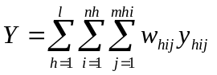 where 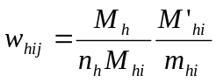
(Final weight = First stage weight x Second Stage weight)
M_{h} = number of households in h^{th} stratum according to census
M_{hi} = number of households in i^{th} PSU in h^{th} stratum according to census
n_{h} = number of PSUs sampled from the h^{th} stratum
M’_{hi} = number of households in i^{th} PSU in h^{th} stratum according to survey listing; and
m_{hi} = number of households in the sample from i^{th} PSU in h^{th} stratum
(b) A ratio is estimated by 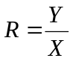 where X is estimated in the same way as Y.
(c) An average is in effect a ratio of two estimates, an estimate of the total and an estimate of the total number of units (households, individuals, etc..). An average can thus be estimated in the same way as a ratio, where the variable X takes the value of 1 for all units.
(d) A proportion can be estimated as a ratio. In this case the variable Y takes the value of 1 if the unit belongs to the specified group and 0 otherwise. The variable X takes the value of 1 for all units.

  - Data Processing

Scanning methodology was used to enter data into a database. This was done immediately after field work. Readsoft software called eyes and hands was used for scanning and verification of the data. Data cleaning was also carried out to ensure that the data from questionnaires were correctly interpreted by the scanner. Various variables from different parts of questionnaires were compared and checked for consistency. To facilitate the data cleaning process, a number of scripts were developed for retrieval of scanning errors and inconsistencies. Error lists were produced for verification and corrections. The corrections and/or data updates were done using the SQL applications. In parallel with scripts for manual update, other scripts for automatic updates were developed to update data directly in the databases. The main part of the data cleaning was carried out from 2008 to the third quarter of 2009. During the work with the preliminary report and the tabulations for the main report, some more errors and inconsistencies were found and corrected. The final database for retrieval of results was established.

After the data were verified and cleaned in the production database, a database for tabulation and analysis was designed. It was adapted to retrieve data to various statistical software packages. A large number of SQL scripts were developed to transfer data from NIDS to NIDS output database. Value codes and labels were unified and adapted for tabulation. Finally, the sample weights were calculated based on responding households and applied to the database. The output database covers all data recorded and captured.

For easy tabulation and presentation of data, SPSS database was created from the output database in SQL. All tables were produced in SPSS. The sample weights were included in SPSS and applied automatically. From SPSS, the tables were saved in Excel and customised. From Excel they were compiled to the report. All tables in the main report are stored as Excel tables and as a word document together with other parts of the main report. In addition, Mortpak 4.0 was used to compute the estimates of fertility and mortality rates.

  - Definitions

Definitions of some basic concepts and/or indicators used in the report are given below: Other definitions are given in each respective chapter.

A private household is defined as one or more persons, related or unrelated who live together in one (or part of one) or more than one dwelling unit and have common catering arrangements. A person who lives alone and caters for himself/herself forms a one-person household.
Child mortality: The indicator used for child mortality is the under five mortality rate which is the number of under five deaths per 1000 live births. This was estimated from children ever born and those surviving.
Dependency ratio is interpreted as the ratio of children (0-14) and elderly persons (65 years and above) per 100 persons in the working age population (15-64 years).
Educational attainment refers to the highest standard, grade or years completed by respondent at the highest level of school, college or university attended.
Head of household is a person of either sex who was looked upon by other members of the households as their leader or main decision maker.
Infant mortality rate is defined as the probability of a newborn not surviving to its first birthday. It is usually expressed as the number of infant deaths per 1000 live births. This was estimated from children ever born and those surviving.
Literacy refers to the ability to write and read with understanding in any language. Persons who could read and not write were classified as non-literate. Similarly, persons who were able to write and not read were classified as non-literate.
Live birth: A child born alive is one who cries after being born. Thus, a live birth is a birth, which results in a child that shows any sign of life irrespective of the time or period within which these signs are manifested. Miscarriages or abortions and stillbirths are not live births.
Orphanhood: An orphan is defined as a child aged between 0-17 years with one parent or no parent alive. Households with orphans have at least one orphan living in the household. Households without orphans have no orphans living in the household.
School attendance refers to attendance at any regular public or private educational institution, for systematic instruction at any level of instruction.
School enrolment refers to replies to the interviewer's inquiry whether the person was enrolled in regular school or not.
The sex ratio is the number of males divided by the number of females, expressed as a percentage.
Primary Sampling Units are geographical areas in the sampling frame which are formed from enumeration areas.
Youth refers to respondent who are aged between 15 and 35 years old.

  - Coverage and response rate

All 500 sampled PSUs were covered. The total numbers of responding households are shown in Table 1.2 below. Although not all sampled households were completely interviewed during the survey, it is hoped that the characteristics of these households are broadly similar to those that were left out. Most of the non-responding households were due to non-contacts.

Table 1.2: Household response rates by region

Region | Selected HHs | Responding households | Response rate % | Non-responding households
 |  |  |  | Number refused | Number non-contact | Others | Total | Percent
Caprivi | 660 | 600 | 90.9 | 2 | 38 | 4 | 44 | 6.7
Erongo | 840 | 722 | 86.0 | 3 | 78 | 6 | 87 | 10.4
Hardap | 640 | 590 | 92.2 | 0 | 22 | 24 | 46 | 7.2
Karas | 660 | 618 | 93.6 | 1 | 31 | 7 | 39 | 5.9
Kavango | 860 | 784 | 91.2 | 0 | 32 | 1 | 33 | 3.8
Khomas | 1100 | 996 | 90.5 | 2 | 89 | 5 | 96 | 8.7
Kunene | 560 | 484 | 86.4 | 1 | 43 | 3 | 47 | 8.4
Ohangwena | 780 | 748 | 95.9 | 0 | 15 | 3 | 18 | 2.3
Omaheke | 560 | 509 | 90.9 | 0 | 41 | 9 | 50 | 8.9
Omusati | 800 | 771 | 96.4 | 0 | 24 | 2 | 26 | 3.3
Oshana | 900 | 794 | 88.2 | 1 | 65 | 4 | 70 | 7.8
Oshikoto | 800 | 706 | 88.3 | 2 | 52 | 1 | 55 | 6.9
Otjozondjupa | 840 | 765 | 91.1 | 3 | 64 | 4 | 71 | 8.5
Namibia | 10000 | 9087 | 90.9 | 15 | 594 | 73 | 682 | 7.5

  - Quality

Comparison between this survey and the 2001 Namibia Population and Housing Census shows some variations in population and household numbers owing to differences in applied methods of data collection. Most of the population statistics published from the Census comprise the whole population of Namibia that is both household and institutional populations whereas only private household population is included in the NIDS. Another reason for variations between the survey and census is that the NIDS is a sample survey subjected to sampling errors whereas the census is a total count. The age data collected in the survey was tested for digit preference and heaping in terminal digits. The Whipple’s and Myer’s Blended indices calculated are 103.8 and 2.0 respectively. Theoretically Whipple’s index varies between 100 denoting no preference for 0 or 5 and 500 indicating that only ages 0 and 5 were reported. The theoretical range for Myer’s index is 0 representing no heaping and 90 which would be the result if all ages were reported at a single digit. Whipple’s index of 103.8 for Namibia shows that there was almost no preference for 0 or 5 in the survey and the data are fairly accurate in this regard. Myer’s index of 2.0 for Namibia show that age heaping was within reasonable limits (in fact closer to 0) indicating the good quality of age reporting.

  - Limitations of Data

The various estimates presented in this report are derived from a sample of the surveyed population. As in any survey, these estimates are subjected to both sampling and non-sampling errors. Sampling errors could be related to sample size. Non sampling errors are errors in survey estimates occurring for reasons other than the fact that estimates were obtained from only a selected portion of population. The main types of non-sampling errors are coverage errors, response and content errors and processing (coding, data entry).

  - The structure of the report

This report prepared immediately after completion of tabulation contains a brief analysis of some of the main results of the survey. It is by no means exhaustive and there is a need for an in-depth study of such topics like age structure, marital status, fertility, educational characteristics, labour force, mortality and migration. The report is structured in chapters and thematic sections. Chapter one provides the rationale for the study and specific objectives to be achieved, a description of the survey design and implementation. Chapter two considers the main characteristics of the Namibia population i.e. its spatial distribution and demographic characteristics. Chapter three gives the overview of disability, chapter four presents information relating to early childhood development, chapter five deals with education and literacy while chapter six focuses on economic activity of the population examining the notions of employment and unemployment. Chapter seven presents information on household compositions and characteristics, chapter eight presents information on housing conditions while chapter nine deals with the analysis of fertility. Chapter ten presents the analysis of mortality and orphanhood and information on migration is presented in chapter eleven. Appendices are included at the end. Some basic demographic and economic indicators are used throughout the report to illustrate living conditions for groups of households in Namibia. Indicators for a specific theme are described in the chapter where they occur. Variables which are grouped are specified in Appendix I.

CHAPTER TWO: Population Structure and Composition

Population Size

The total population in Namibia in 2006 was estimated to be 1 952 454, of which 1 023 511 (52 percent) were females and 924 804 were males. This gives a sex ratio of 90 males per 100 females. It should be noted that these were the persons who were physically present in households on the reference night, irrespective of their citizenship, nationality or place of usual residence. The survey also included persons who were visitors in the household during the reference night, hence members of the household who were not present during the reference night were not eligible for interview.

Population growth

The population growth rate between 2001 and 2006 was estimated to be 2.0 percent. The distribution of the population and the estimated growth rate between 2001 Census and 2006 NIDS by urban and rural areas as well as by regions are shown in Table 2.1. The growth rate was calculated based on the exponential growth method. This growth method takes into accounts that population growth is a continuous process. The household population enumerated in 2001 census serves as the base population. It is evident from the table that urban areas have a high growth rate (3.7 percent) as compared to rural areas (1.0 percent). At regional level Erongo and Khomas regions have recorded the highest growth rate of 5.4 percent and 4.2 percent respectively while Oshikoto and Karas (0.3 percent each) as well as Oshana (0.2 percent) regions exhibit the lowest growth rate. On the other hand, regions such as Omaheke and Omusati have recorded a negative growth rate.

Table 2.1: Percentage population growth rate by area from 2001 to 2006

Area | Household population, 2001 | Household Population, 2006 | Average annual growth rate
Namibia | 1,773,235 | 1, 952 454 | 2.0
Urban area | 578,812 | 695, 268 | 3.7
Rural area | 1,194,423 | 1, 257, 186 | 1.0
Caprivi | 78,785 | 85, 224 | 1.6
Erongo | 103,180 | 134, 966 | 5.4
Hardap | 66,028 | 74, 495 | 2.4
Karas | 64,039 | 64, 872 | 0.3
Kavango | 198,963 | 237, 657 | 3.6
Khomas | 243,585 | 301, 050 | 4.2
Kunene | 66,385 | 76, 329 | 2.8
Ohangwena | 226,416 | 247, 103 | 1.7
Omaheke | 66,779 | 60, 773 | -1.9
Omusati | 226,337 | 224, 256 | -0.2
Oshana | 158,181 | 159, 827 | 0.2
Oshikoto | 158,352 | 161, 102 | 0.3
Otjozondjupa | 116,205 | 124, 800 | 1.4

Population distribution

One of the most important aspects of populations is their heterogeneity. People are not all the same. Almost all populations contain people of different ages and most contain both males and females. Hence, age and sex are demographically, the most important ways in which people differ. The distribution of age and sex is a vital measure in understanding the past trends of the population structure. Table 2.2 presents the distribution of the population by sex and area as well as the sex ratio which is defined as the number of males per 100 females and is an index which compares the numerical balance between the population of both sexes. From the table, it is evident that more than half (64.4 percent) of the population in Namibia lives in rural areas. It is further observed that the overall sex ratio is 90 males per 100 females, and this pattern is also reflected in terms of urban and rural areas. It is however of interest to note that there are relatively more males in regions such as Erongo (109), Hardap and Otjozondjupa (104), as well as Kunene and Omaheke (103) respectively.

Table 2.2: Population distribution by sex and area, Namibia 2006 NIDS

Area | Total | Percent | Female | Male | Not Stated | Sex Ratio
Namibia | 1,952,454 | 100.0 | 52.4 | 47.4 | 0.2 | 90
Urban area | 695,268 | 35.6 | 50.6 | 49.0 | 0.4 | 97
Rural area | 1,257,186 | 64.4 | 53.4 | 46.5 | 0.1 | 87
Caprivi | 85,224 | 4.4 | 52.0 | 47.9 | 0.1 | 92
Erongo | 134,966 | 6.9 | 47.8 | 51.9 | 0.3 | 109
Hardap | 74,495 | 3.8 | 49.1 | 50.8 | 0.1 | 104
Karas | 64,872 | 3.3 | 50.5 | 49.4 | 0.1 | 98
Kavango | 237,657 | 12.2 | 52.6 | 47.4 |  | 90
Khomas | 301,050 | 15.4 | 50.2 | 49.2 | 0.6 | 98
Kunene | 76,329 | 3.9 | 48.9 | 50.6 | 0.5 | 103
Ohangwena | 247,103 | 12.7 | 56.0 | 44.0 | 0.1 | 79
Omaheke | 60,773 | 3.1 | 49.2 | 50.8 |  | 103
Omusati | 224,256 | 11.5 | 56.8 | 43.0 | 0.1 | 76
Oshana | 159,827 | 8.2 | 56.1 | 43.8 | 0.1 | 78
Oshikoto | 161,102 | 8.3 | 53.0 | 46.8 | 0.2 | 88
Otjozondjupa | 124,800 | 6.4 | 49.0 | 50.8 | 0.2 | 104

Figure 2.1 below illustrates the relationship between the sex ratio and age. It can be observed from the figure that there is a declining trend in the sex ratio with the increase in age.

Figure 2.1: Sex ratio by age, Namibia 2006 NIDS

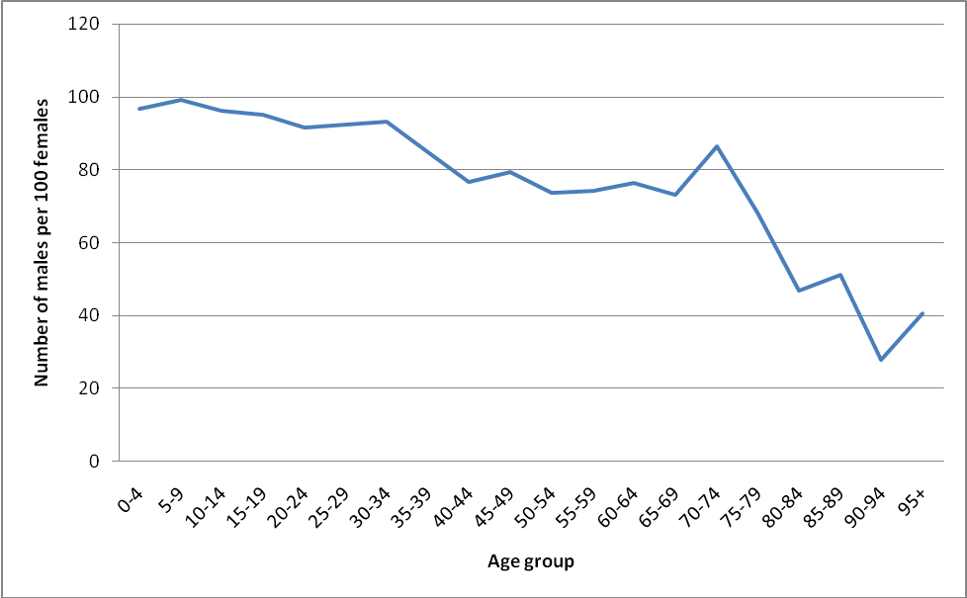

Age structure

The percentage distribution of the population by broad age groups is presented in Table 2.3. The result shows that over half of the population about 54.3 percent are in the age group of 15–59 and only 37.9 percent of the population falls in the age group of 0-14. This shows that Namibia has a relatively young population. Similarly the proportion of the population in urban area in the age group of 15–59 is higher than in the rural area, a pattern that is also reflected in the 2001 census results. In addition, the regional trends also follow the same pattern with a high proportion in the age group of 15–59. However, regions such as Ohangwena, Kavango, Oshikoto, Omusati and Kunene have recorded a relatively higher young population since the proportions of the population in the age group 0–14 are all above 40 percent.

Table 2.3: Percent distribution of population by area and broad age group, 2006 NIDS

Area | 0-4 | 5-14 | 15-59 | 60 +
Namibia | 12.7 | 25.2 | 54.3 | 7.0
Urban | 10.8 | 19.8 | 64.7 | 3.9
Rural | 13.7 | 28.3 | 48.5 | 8.7
Caprivi | 12.7 | 27.5 | 53.5 | 5.4
Erongo | 10.8 | 16.6 | 65.9 | 6.3
Hardap | 11.9 | 22.2 | 57.5 | 7.7
Karas | 10.9 | 21.7 | 59.1 | 8.0
Kavango | 13.7 | 29.4 | 49.9 | 6.3
Khomas | 10.2 | 18.0 | 67.5 | 3.0
Kunene | 17.8 | 23.6 | 48.5 | 6.0
Ohangwena | 13.9 | 32.9 | 43.1 | 9.5
Omaheke | 17.7 | 19.8 | 52.4 | 9.2
Omusati | 12.2 | 29.3 | 47.5 | 10.6
Oshana | 11.6 | 25.2 | 55.8 | 7.0
Oshikoto | 12.3 | 29.9 | 49.5 | 7.9
Otjozondjupa | 15.1 | 21.3 | 57.0 | 6.0

The youthfulness of the population is more pronounced by the population pyramid, Figure 2.2, which has a very broad base and a very narrow apex. Population pyramids of this shape are typical for countries with relatively high fertility and high mortality.

Figure 2.2 National population pyramid, Namibia, 2006 NIDS
150000
100000
50000
0
50000
100000
150000
0-4
10-14
20-24
30-34
40-44
50-54
60-64
70-74
80-84
90-94
Male Population Female
Male
Female
There are significant differences in the age structure between urban and rural areas as observed in the pyramids of Figures 2.3 and 2.4 respectively. The rural areas have relatively more young people as well as senior citizens. On the other hand, the urban areas have relatively more people in the economically active age groups i.e. 15-59 years. The pyramid for the urban areas is rather bulky in the middle and has a relatively narrow apex, implying a large proportion of the working population and a small proportion of the senior citizens. On the contrary, the pyramid for the rural areas has a relatively broader base and an apex, which is not as narrow as that of the urban pyramid. This is a demonstration of the relatively higher proportions of both the young and the old populations in the rural areas. These patterns are notable as well from the results of the 2001 census.

Figure 2.3 Urban population pyramid, Namibia, 2006 NIDS
60000
40000
20000
0
20000
40000
60000
0-4
10-14
20-24
30-34
40-44
50-54
60-64
70-74
80-84
90-94
Male Population Female
Male
Female

Figure 2.4. Rural population pyramid, Namibia, 2006 NIDS
100000
50000
0
50000
100000
0-4
10-14
20-24
30-34
40-44
50-54
60-64
70-74
80-84
90-94
Male Population Femaletaking into account those who looked or did not look for workis heavily male dominated. to 45% of their male counterparts. mat
Male
Female

Marital status

Marital status is a very important factor in population dynamics as it affects fertility and mortality as well as migration to a lesser extent. Table 2.4 below presents the distribution of persons, males and females aged 15 years and above by type of marital status. It can be observed that, about 27 percent of the population aged 15 years and above are legally married. About 19 percent are married with certificate. The never married population forms the highest proportion, which is slightly above 55 percent. On the other hand, 8 percent of the population is made up of couples in consensual unions, i.e. they consider themselves married but have not legalized their union. The proportion of the widowed and divorced/separated population is close to 8 percent. However, there are relatively more widowed and divorced/separated among females than males.

Table 2.4: Population aged 15 and above by marital status and sex, Namibia, 2006 NIDS

Marital status | Total | Female | Male | Not stated | Total | Female | Male
Never married | 671,618 | 334,817 | 335,900 | 901 | 55.4 | 51.6 | 59.9
Married with Certificate | 223,888 | 116,634 | 107,017 | 236 | 18.5 | 18.0 | 19.1
Married Traditionally | 104,963 | 55,428 | 49,487 | 48 | 8.7 | 8.5 | 8.8
Consensual union | 94,657 | 49,250 | 45,118 | 289 | 7.8 | 7.6 | 8.0
Divorced/ Separated | 33,823 | 26,096 | 7,714 | 13 | 2.8 | 4.0 | 1.4
Widowed | 67,542 | 59,991 | 7,488 | 64 | 5.6 | 9.2 | 1.3
Not stated | 15,409 | 7,139 | 8,167 | 103 | 1.3 | 1.1 | 1.5
Total | 1,211,899 | 649,354 | 560,891 | 1,655 | 100.0 | 100.0 | 100.0

Figure 2.5 shows that there are significant differences in the proportions of marital status between urban and rural areas. Traditional marriage is predominantly in rural areas (83.4 percent) than in urban areas. Furthermore, the result shows that there is no significant difference in the proportion of the population aged 15 and above who are in consensual unions in urban and rural areas. It is however very interesting to note that rural areas constitute a high proportion of divorced/separated (71.3 percent) and widowed (84.0 percent).

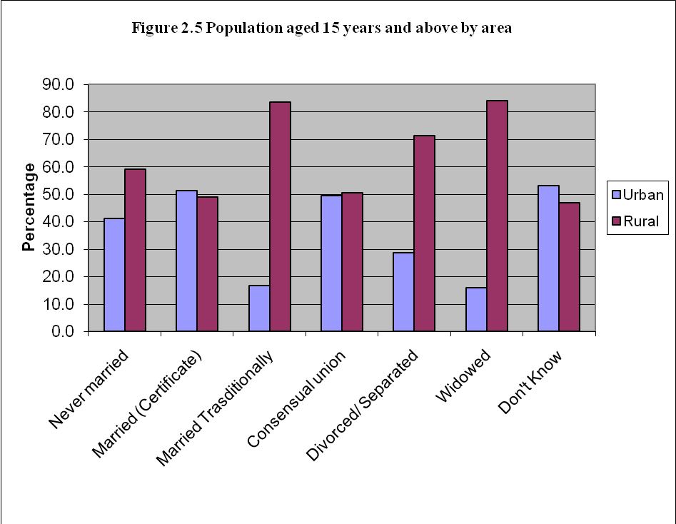

Citizenship

All persons in the selected households were asked to state their countries of citizenship. The information on citizenship are perceived to be a measure of the extent to which Namibia is interacting with the rest of the world. This information is presented in Table 2.5 as well as Figure 2.6. Overall, just over 98 percent of the population is Namibian. Similar to the pattern observed in the 2001 census, the non-Namibian citizens are made up mainly of Angolan citizens (34 percent), and the proportion of Zambians and South African citizens are the second highest with 15 and 14 percent respectively (Figure 2.6). It can be observed from Figure 2.6 that there are very few Botswana citizens who were enumerated in Namibia in 2006.

Table 2.5: Population by citizenship and sex, Namibia 2006 NIDS

Citizenship | Population |  |  |  |  | Percent
 | Total | Female | Male | Not Stated |  | Total | Female | Male
Namibia | 1,915,757 | 1,007,401 | 904,306 | 4,050 |  | 98.1 | 98.4 | 97.8
Non-Namibian | 31,337 | 13,377 | 17,887 | 73 |  | 1.6 | 1.3 | 1.9
Not stated | 5,360 | 2,733 | 2,611 | 15 |  | 0.3 | 0.3 | 0.3
Total | 1,952,454 | 1,023,511 | 924,804 | 4,139 |  | 100 | 100 | 100

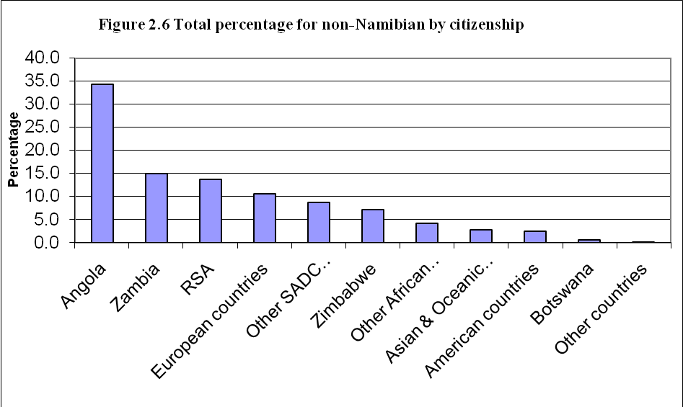

CHAPTER THREE: Disability

Disability is defined as a limitation in carrying out everyday activities at home, at work, or at school because of long-term physical or mental condition. Six various types of disability are identified: blind, deaf, impaired speech, impairment of hands, impairment of legs and mentally disabled/mentally ill. Disability information are important for policy and programme interventions targeting disabled persons. Table 3.1 below shows the disabled population by area and sex. It can be seen from the table that the proportion of the disabled population in Namibia is above 5 percent. There are no significant differences between females and males. The proportion of disabled persons is lower in urban than in rural areas. In the former it is 4 percent as against 6 percent in the latter. At regional level, there are significant differences. The proportion of disabled persons ranges from about 8 and 9 percent in Omusati and Oshikoto regions, respectively, while Erongo, Hardap and Karas have emerged as the regions with the lowest proportions of disabled population.

Table 3.1: Disabled Population by area and sex, 2006 NIDS

 | Population |  |  |  | Disabled population
Area | Total | Female | Male | Not stated | Total | Female | Male | Not stated | Total | Female | Male
Namibia | 1,952,454 | 1,023511 | 924,804 | 4,139 | 102,100 | 52,433 | 49,625 | 41 | 5.2 | 5.1 | 5.4
Urban | 695,268 | 351,911 | 340,806 | 2,551 | 27,263 | 12,368 | 14,854 | 41 | 3.9 | 3.5 | 4.4
Rural | 1,257,186 | 671,600 | 583,998 | 1,588 | 74,837 | 40,065 | 34,771 |  | 6.0 | 6.0 | 6.0
Caprivi | 85,224 | 44,322 | 40,859 | 43 | 2,445 | 1,268 | 1,177 |  | 2.9 | 2.9 | 2.9
Erongo | 134,966 | 64,526 | 70,013 | 427 | 3,119 | 1,467 | 1,652 |  | 2.3 | 2.3 | 2.4
Hardap | 74,495 | 36,581 | 37,871 | 43 | 1,676 | 580 | 1,096 |  | 2.2 | 1.6 | 2.9
Karas | 64,872 | 32,747 | 32,060 | 65 | 1,465 | 638 | 827 |  | 2.3 | 1.9 | 2.6
Kavango | 237,657 | 124,910 | 112,659 | 88 | 13,347 | 7,013 | 6,334 |  | 5.6 | 5.6 | 5.6
Khomas | 301,050 | 151,179 | 148,080 | 1,792 | 13,489 | 6,141 | 7,349 |  | 4.5 | 4.1 | 5.0
Kunene | 76,329 | 37,325 | 38,595 | 409 | 4,196 | 1,426 | 2,770 |  | 5.5 | 3.8 | 7.2
Ohangwena | 247,103 | 138,344 | 108,633 | 127 | 9,835 | 5,763 | 4,072 |  | 4.0 | 4.2 | 3.7
Omaheke | 60,773 | 29,915 | 30,843 | 15 | 2,784 | 1,081 | 1,702 |  | 4.6 | 3.6 | 5.5
Omusati | 224,256 | 127,479 | 96,489 | 287 | 21,029 | 12,057 | 8,972 |  | 9.4 | 9.5 | 9.3
Oshana | 159,827 | 89,691 | 69,926 | 210 | 10,945 | 6,488 | 4,457 |  | 6.8 | 7.2 | 6.4
Oshikoto | 161,102 | 85,395 | 75,373 | 334 | 12,968 | 6,533 | 6,394 | 41 | 8.0 | 7.6 | 8.5
Otjozondjupa | 124,800 | 61,097 | 63,406 | 297 | 4,803 | 1,978 | 2,825 |  | 3.8 | 3.2 | 4.5

Table 3.2 presents the disabled population by type of disability and sex. The results indicate that impairment of hands is the most common type of disability in Namibia, as it affects 35 percent of the disabled population. Impairment of legs is the second most common disability in Namibia, accounting for about 20 percent of all disabilities. This pattern however differs from the 2001 census which reported blindness as the most common disability.

Table 3.2: Type of disability by sex, 2006 NIDS

 | Number |  |  |  | Percent
Type of Disability | Total | Female | Male | Not stated | Total | Female | Male
Blind | 13,471 | 7,131 | 6,341 |  | 13.2 | 13.6 | 12.8
Deaf | 8,297 | 4,224 | 4,073 |  | 8.1 | 8.1 | 8.2
Impaired Speech | 7,013 | 3,493 | 3,519 |  | 6.9 | 6.7 | 7.1
Impairment of Hands | 35,766 | 17,741 | 18,025 |  | 35.0 | 33.8 | 36.3
Impairments of Legs | 20,111 | 11,056 | 9,055 |  | 19.7 | 21.1 | 18.2
Mentally Disabled/ Mentally ill | 11,241 | 5,510 | 5,689 | 41 | 11.0 | 10.5 | 11.5
Other disability | 10,878 | 5,293 | 5,585 |  | 10.7 | 10.1 | 11.3
Not stated | 11,227 | 5,534 | 5,584 | 41 | 11.0 | 10.6 | 11.3
Total * | 102,100 | 52,433 | 49,625 | 41 | 100.0 | 100.0 | 100.0
*The total is the number of persons with a disability. This is not the total in the column as some persons have multiple disabilities

Table 3.3 below presents the percentage of the disabled population by type and area. The table shows that most of the disabled population with all types of disability lives in rural areas, with corresponding proportions ranging from 65 percent to 83 percent. A high proportion of disabled population is in Omusati region with a total proportion of 20.6 percent. This comprises mainly of impairment of hand (22.7 percent), speech (20.8 percent), impairment of leg (20.2 percent) as well as mental illness (19.8 percent). Similarly, Khomas region is the second with the highest total proportion of 13.2 percent (of which the impairment of hand 20.8 percent and deafness14.3 percent are the main disabilities). In addition, blindness and deaf are the most predominant types of disability in the Kavango region each with a proportion of more than 19 percent.

Table 3.3: Percent disabled population by type and area, 2006 NIDS

Area | Total disabled | Percent Disabled |  |  |  | Type of disability
Area | Total disabled |  | Blind | Deaf | Speech | Hands | Legs | Mental | Other
Namibia | 102,100 | 100 | 13.2 | 8.1 | 6.9 | 35.0 | 19.7 | 11.0 | 10.7
Urban | 27,263 | 26.7 | 20.2 | 28.1 | 21.2 | 34.9 | 24.3 | 17.1 | 28.8
Rural | 74,837 | 73.3 | 79.8 | 71.9 | 78.8 | 65.1 | 75.7 | 82.9 | 71.2
Caprivi | 2,445 | 2.4 | 2.1 | 3.6 | 1.5 | 1.1 | 4.1 | 3.0 | 2.1
Erongo | 3,119 | 3.1 | 5.7 | 4.3 | 2.6 | 2.7 | 4.5 | 1.4 | 3.5
Hardap | 1,676 | 1.6 | 3.9 | 3.6 | 0.5 | 0.3 | 2.0 | 1.1 | 2.7
Karas | 1,465 | 1.4 | 1.9 | 1.8 | 2.5 | 1.2 | 1.5 | 1.4 | 1.8
Kavango | 13,347 | 13.1 | 19.7 | 19.2 | 13.3 | 8.3 | 13.7 | 16.7 | 10.8
Khomas | 13,489 | 13.2 | 6.1 | 14.3 | 9.8 | 20.8 | 8.8 | 8.2 | 11.1
Kunene | 4,196 | 4.1 | 6.0 | 2.1 | 4.6 | 4.2 | 3.3 | 3.9 | 4.4
Ohangwena | 9,835 | 9.6 | 15.0 | 16.8 | 12.2 | 4.7 | 10.1 | 14.4 | 6.0
Omaheke | 2,784 | 2.7 | 2.1 | 3.9 | 4.0 | 2.0 | 2.7 | 5.5 | 2.7
Omusati | 21,029 | 20.6 | 15.0 | 13.9 | 20.8 | 22.7 | 20.2 | 19.8 | 23.2
Oshana | 10,945 | 10.7 | 6.6 | 6.9 | 11.6 | 14.1 | 11.4 | 6.9 | 9.3
Oshikoto | 12,968 | 12.7 | 13.4 | 8.0 | 14.4 | 13.0 | 12.4 | 11.0 | 16.5
Otjozondjupa | 4,803 | 4.7 | 2.7 | 1.7 | 2.3 | 5.0 | 5.2 | 6.7 | 5.8
Note: the columns add to 100% for urban and rural and for all regions respectively.

CHAPTER FOUR: Early Childhood Development

One of the Millennium Development Goals set is to achieve universal primary education. To achieve this, early childhood development programme is crucial as the programme prepares children aged 3 to 6 years for formal education. Early childhood development serves as an important entry point for community and social mobilisation, promoting participation, organisation and a better quality life.

The survey estimated about 198 143 children in this age group. Out of these more than 34 percent are attending ECD programmes. There are no significant differences between female and male children. However, there are differences between urban and rural areas with the former having higher proportions of children attending ECD programmes. Attendance of Early Childhood Development Programmes in the regions varies notably. Proportion of children attending ECD has increased in most regions if compared to 2001 census results except in Ohangwena, Omaheke, Omusati and Oshikoto regions. Relatively small proportions, less than 20 percent, of children in the regions of Caprivi, Kunene and Omaheke are involved in ECD programmes. The regions with highest proportions, over 50 percent, of children in ECD programmes are Erongo, Khomas and Oshana. Table 4.1 presents the percentage distribution of the 3-6 year old attending ECD programmes by sex and area.

Table 4.1 Population aged 3-6 years attending ECD programme by area and Sex. Namibia, 2006 NIDS
 | Population 3-6 Years |  |  |  | Attending ECD |  |  |  | Percent Attending
 | Total | Female | Male | Not stated | Total | Female | Male | Not stated | Total | Female | Male
Namibia | 198,143 | 99,275 | 98,394 | 473 | 68,398 | 34,833 | 33,282 | 283 | 34.5 | 35.1 | 33.8
Urban | 55,505 | 27,232 | 28,206 | 67 | 27,742 | 13,362 | 14,313 | 67 | 50.0 | 49.1 | 50.7
Rural | 142,638 | 72,044 | 70,188 | 406 | 40,655 | 21,471 | 18,968 | 216 | 28.5 | 29.8 | 27.0
Caprivi | 8,809 | 4,777 | 4,032 |  | 1,556 | 938 | 618 |  | 17.7 | 19.6 | 15.3
Erongo | 10,683 | 5,406 | 5,217 | 60 | 6,037 | 3,348 | 2,689 |  | 56.5 | 61.9 | 51.5
Hardap | 7,033 | 3,169 | 3,864 |  | 1,762 | 791 | 971 |  | 25.1 | 25.0 | 25.1
Karas | 5,531 | 2,992 | 2,539 |  | 2,224 | 1,257 | 967 |  | 40.2 | 42.0 | 38.1
Kavango | 26,173 | 12,733 | 13,440 |  | 5,687 | 2,972 | 2,715 |  | 21.7 | 23.3 | 20.2
Khomas | 22,241 | 10,635 | 11,606 |  | 11,708 | 5,023 | 6,685 |  | 52.6 | 47.2 | 57.6
Kunene | 10,623 | 4,688 | 5,783 | 152 | 1,701 | 786 | 763 | 152 | 16.0 | 16.8 | 13.2
Ohangwena | 28,193 | 14,622 | 13,517 | 55 | 9,724 | 5,318 | 4,406 |  | 34.5 | 36.4 | 32.6
Omaheke | 8,858 | 4,910 | 3,948 |  | 1,655 | 963 | 692 |  | 18.7 | 19.6 | 17.5
Omusati | 23,709 | 12,341 | 11,305 | 64 | 8,406 | 4,596 | 3,746 | 64 | 35.5 | 37.2 | 33.1
Oshana | 15,532 | 7,528 | 7,937 | 67 | 8,484 | 3,842 | 4,574 | 67 | 54.6 | 51.0 | 57.6
Oshikoto | 17,090 | 9,096 | 7,994 |  | 6,178 | 3,513 | 2,665 |  | 36.2 | 38.6 | 33.3
Otjozondjupa | 13,667 | 6,378 | 7,213 | 76 | 3,277 | 1,486 | 1,791 |  | 24.0 | 23.3 | 24.8

Table 4.2 reflects the percentage distribution of the children in ECD programmes by type and area. It can be observed that, at national level, almost three quarters (73.1 percent) of the children are attending crèche/kindergarten and 22 percent are in pre-primary programmes. Higher proportions of children are attending crèche/kindergarten programme in rural than in urban areas, which is the opposite case for pre-primary preparation. The table also reveals that all the regions follow the same pattern whereby a large proportion of the children in ECD programmes are attending Creche/Kindergarten, followed by Pre-Primary.

Table 4.2 Population 3–6 years of age attending by type of Early Childhood Development Programme, 2006 NIDS

Type of Early Childhood Development
Area Creche/ Day Care Pre-Primary
Kindergarten /Nursery
Namibia | 73.1 | 4.7 | 22.2
Urban | 66.5 | 7.6 | 25.9
Rural | 77.6 | 2.8 | 19.6
Caprivi | 57.6 | 14.4 | 28.1
Erongo | 68.2 | 6.4 | 25.3
Hardap | 84.5 | 4.9 | 10.6
Karas | 67.6 | 1.3 | 31.1
Kavango | 73.2 | 0.6 | 26.2
Khomas | 57.5 | 9.3 | 33.3
Kunene | 75.2 | 3.6 | 21.2
Ohangwena | 79.7 | 0.9 | 19.4
Omaheke | 91.8 | 1.2 | 7.0
Omusati | 88.2 | 5.4 | 6.5
Oshana | 74.1 | 8.0 | 17.9
Oshikoto | 67.2 |  | 32.8
Otjozondjupa | 82.2 | 3.3 | 14.5

CHAPTER FIVE: Education and Literacy

An educated population is a central priority in achieving the MDGs. Educated people are in better position to create work for themselves and others and also to obtain formal employment. Education is stated as crucial to development in Vision 2030, the National Development Plans and the Poverty Reduction Strategy. Policy frameworks are in place, contained in documents such as the Education for All National Plan of Action 2001-2015, the Early Childhood Education Policy and the national Policy on HIV/AIDS for the Education sector. To determine the level of education, the survey asked questions on education. In addition, there was a question on their ability to write and read in any language with understanding, so as to measure the level of literacy in the country. School attendance means attendance at any regular educational institution, public or private, for systematic instruction at any level of education. Examples of educational institutions are primary schools, secondary or high schools, technical schools, agricultural institutes, teacher training colleges and universities. The questions on school attendance are aimed at dividing the population into three categories. Those who have never attended school, those who are presently attending school, college or university and those who attended school in the past but have already left. The question on educational attainment was asked to people who are presently attending or have left school, college or university. Educational attainment means the highest standard, grade or years completed by a person at a formal educational institution.

The purpose of the question on literacy was to divide the population into two groups: Those who are able to read and write a message in any language with understanding and those who do not have this ability. People who can write but not read or who can read but not write are not literate. The question on literacy was straightforward: “Can you read and write a message in any language with understanding?” The respondent’s answer was recorded directly without any further probing.

School Attendance

Figure 5.1 Percentage distribution of the population 6 years and above by school attendance and sex, Namibia, 2006 NIDS

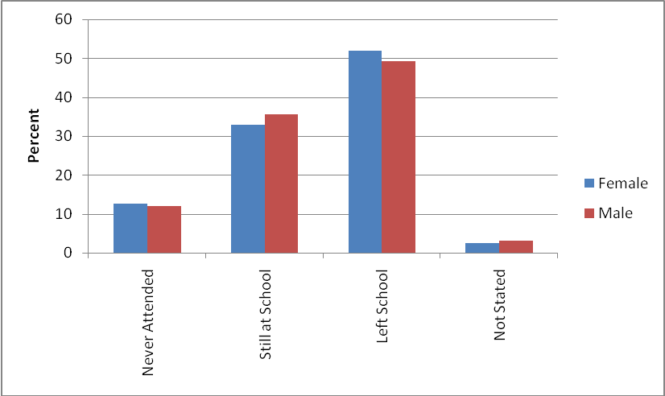

The survey enumerated over 1.6 million persons aged 6 years and above of whom 12% have never attended school. About 34% are currently attending and just over 50% have left school. The proportions are more or less the same in every category of school attendance for males and females (Figure 5.1).
Figure 5.2 Percentage Total Population 6 years and above by rural / urban and school attendance, Namibia, 2006 NIDS

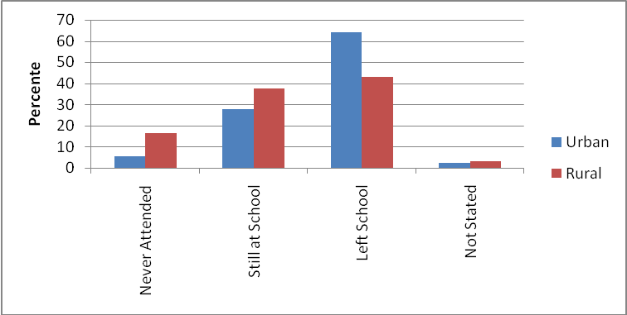

Figure 5.2 reveals significant differences in proportions of school attendance for those who never attended and those who have left school in urban and rural areas. Relatively higher proportions have never attended school in rural areas than in urban ones. At the same time, higher proportions have left school in urban areas. On the other hand, higher proportions are still at school in rural areas than in urban areas.

Figure 5.3 Percent Total Population 6 years and above by area and school attendance, Namibia, 2006 NIDS

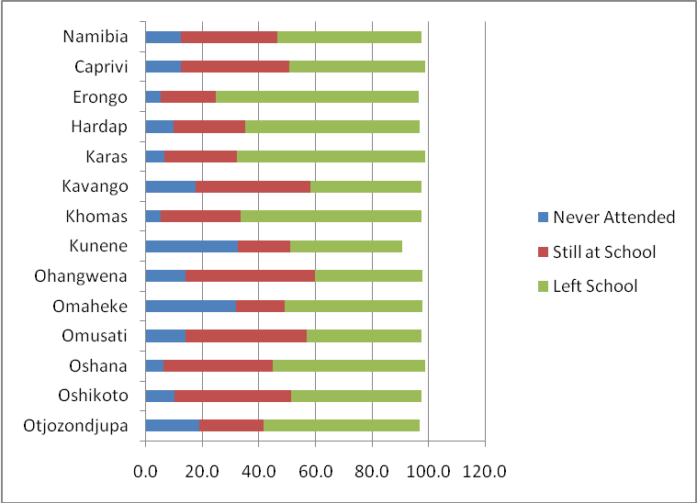

Figure 5.3 shows significant differences among regions for those aged 6 years and above who never attended school. In Kunene and Omaheke regions, higher proportions of the population, more than 30 percent, have never attended school. Nearly 20 percent of the persons in Kavango and Otjozondjupa regions have also never attended school. It is interesting to note that high proportions of the population in Khomas, Erongo, and Karas regions have left school and less than 10% of the same population in these regions has never attended school. In most regions more than 20% are still at school.
Table 5.1 displays school leaving rates in single years for the population aged 6-24 years. The rate of leaving school increases with age. The rate increases even further after the age of 19 as at this age most children are expected to finish with Grade 12. In the younger age males are leaving school more than females but after the age of 16, more females are leaving school than males.

Table 5.1 Population aged 6-24 those who left school by age and sex, Namibia, 2006 NIDS

Number |  |  |  |  |  |  |  | Percent
Age |  | Total |  | Female |  | Male |  | Not stated | Total Female Male
6 | 76 |  |  |  | 76
7 | 334 |  | 215 |  | 119 |  |  |  |  | 0.2 |  | 0.1 | 0.1
8 | 629 |  | 201 |  | 429 |  |  |  |  | 0.3 |  | 0.1 | 0.2
9 | 577 |  | 296 |  | 281 |  |  |  |  | 0.3 |  | 0.1 | 0.1
10 | 977 |  | 242 |  | 690 |  | 46 |  |  | 0.5 |  | 0.1 | 0.3
11 | 1,124 |  | 407 |  | 716 |  |  |  |  | 0.5 |  | 0.2 | 0.3
12 | 1,240 |  | 455 |  | 786 |  |  |  |  | 0.6 |  | 0.2 | 0.4
13 | 1,513 |  | 674 |  | 839 |  |  |  |  | 0.7 |  | 0.3 | 0.4
14 | 2,165 |  | 826 |  | 1,339 |  |  |  |  | 1.0 |  | 0.4 | 0.6
15 | 2,935 |  | 1,376 |  | 1,559 |  |  |  |  | 1.4 |  | 0.6 | 0.7
16 | 7,390 |  | 4,158 |  | 3,232 |  |  |  |  | 3.4 |  | 1.9 | 1.5
17 | 9,751 |  | 5,318 |  | 4,433 |  |  |  |  | 4.5 |  | 2.5 | 2.1
18 | 18,821 |  | 9,819 |  | 9,003 |  |  |  |  | 8.7 |  | 4.5 | 4.2
19 | 20,100 |  | 11,042 |  | 9,058 |  |  |  |  | 9.3 |  | 5.1 | 4.2
20 | 28,332 |  | 15,476 |  | 12,856 |  |  |  |  | 13.1 |  | 7.2 | 6.0
21 | 28,542 |  | 15,853 |  | 12,688 |  |  |  |  | 13.2 |  | 7.3 | 5.9
22 | 30,308 |  | 16,740 |  | 13,440 |  | 128 |  |  | 14.0 |  | 7.8 | 6.2
23 | 30,065 |  | 15,702 |  | 14,320 |  | 44 |  |  | 13.9 |  | 7.3 | 6.6
24 | 30,994 |  | 16,818 |  | 14,049 |  | 128 |  |  | 14.4 |  | 7.8 | 6.5
Total | 215,874 |  | 115,615 |  | 99,914 |  | 345 |  |  | 100.0 |  | 53.6 | 46.3

School Enrolment
School enrolment refers to replies to the interviewer's inquiry whether the person was enrolled in regular school or not. School enrolment rate for Namibia stands at 64 percent.

Figure 5.4 School Enrolment rates for the population aged 6-24 years by age and sex, Namibia, 2006 NIDS

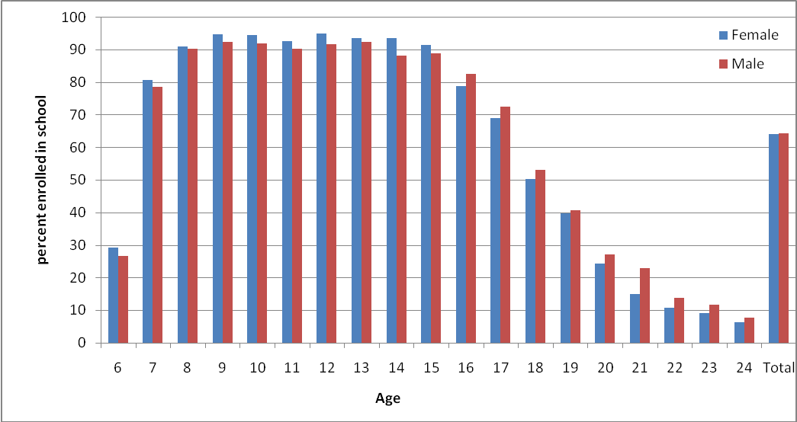

School enrolment rates are presented in single years for the population aged 6 – 24 years. On average, over 90 percent of all children aged 8-15 years attend school. Enrolment rates for females are significantly higher than those for males in the younger ages and lower in the older ages i.e.16 -24 years. The findings are in line with the targets set in the Vision 2030 of eliminating gender disparities in primary and secondary education by 2005 and achieving gender equality in education by 2015, emphasising girls’ full and equal access to and achievements in basic education of good quality.
Figure 5.5 School Enrolment Rates for the population aged 6-24 years by age, urban and rural Namibia, 2006 NIDS
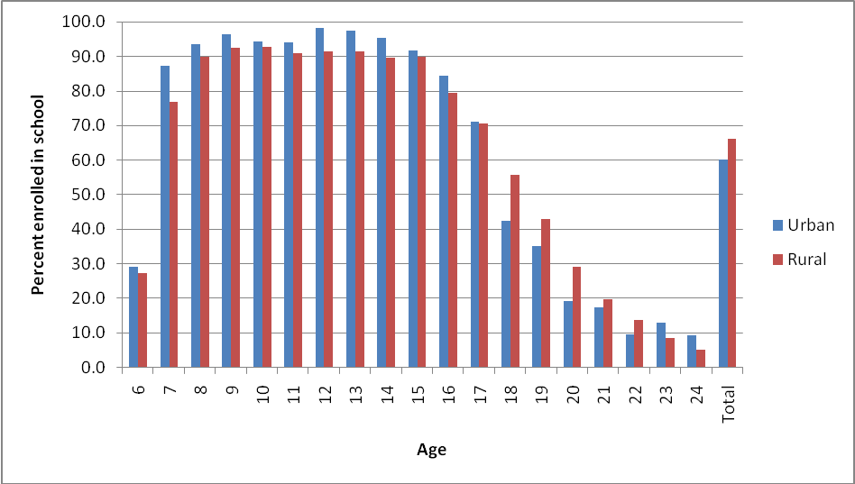

Figure 5.5 above shows that school enrolment at earlier ages is slightly higher in urban than in rural areas, while at older ages it is relatively lower. The highest enrolment rate is 98% at ages 12 years in urban areas.
Figure 5.6 School Enrolment Rates for the population aged 6-24 years by area, Namibia, 2006 NIDS

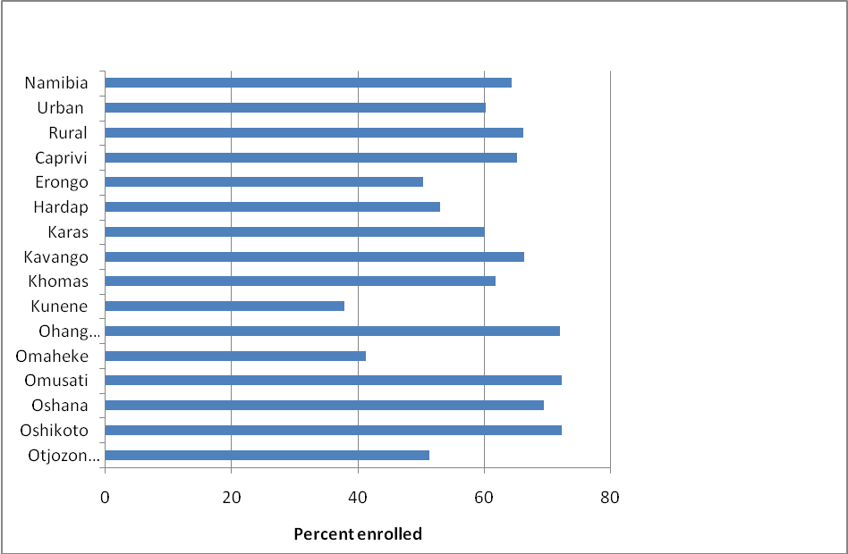

Figure 5.6 shows that at national level, 64% of the children aged 6-24 years are enrolled in schools. It can be observed that among regions Ohangwena, Omusati and Oshikoto region has the highest school enrolment rate of about 72%. In Kunene and Omaheke regions, the enrolment rates are below 50%.
Educational Attainment

Information on educational attainment was analysed for those who are aged 15 years and above and left school. Table 5.2 shows that close to 49 percent of all those aged 15 years and above and who had left school have completed primary education while about 19 percent of them had completed secondary education. About 23 percent did not complete primary school. The proportion of those who did not complete primary school has decreased significantly if compared to 2001 Census results. There are no significant differences in educational attainment between females and males in the country.

Table 5.2 Population aged 15+ those who left school by highest level of education attainment and Sex, Namibia, 2006 NIDS
Educational attainment | Number |  |  |  | Percent
Educational attainment | Total | Female | Male | Not stated | Total | Female | Male
Incomplete Primary | 194,385 | 104,651 | 89,327 | 408 | 23.3 | 23.2 | 23.5
Primary | 406,863 | 227,421 | 178,709 | 733 | 48.8 | 50.4 | 47.0
Secondary | 153,746 | 82,170 | 71,561 | 15 | 18.5 | 18.2 | 18.8
Tertiary | 33,914 | 16,285 | 17,629 |  | 4.1 | 3.6 | 4.6
Technical training Education | 5,878 | 2,598 | 3,194 | 86 | 0.7 | 0.6 | 0.8
Teachers training | 19,454 | 10,895 | 8,559 |  | 2.3 | 2.4 | 2.3
Not stated | 18,885 | 7,601 | 11,197 | 86 | 2.3 | 1.7 | 2.9
Total | 833,125 | 451,621 | 380,176 | 1328 | 100.0 | 100.0 | 100.0

Literacy
The approach that was used to collect the information – Can you write and read in any language with understanding? – tends, by experience, to overestimate the number of literate people since no literacy test was administered. There was a provision for two languages for each person. Overall, 85 percent of Namibian population is literate. The literacy education rate for adults was 80 percent in 2001, expected to increase to 90 percent in 2015 and ultimately 100 percent by the year 2030. Namibia is also expected to achieve a 50 percent improvement in levels of adult literacy by 2015, especially for women.
The literacy question was put to all persons aged 6 years and above. However, analysis on literacy level was carried out among persons aged 15 years and above. This age group is more relevant as it measures adult literacy level. Overall, urban areas have a higher proportion of literate person as compared to rural areas. This pattern is also reflecting in regions which are predominantly urban i.e. Erongo (94%); Khomas (95%) and Oshana (93%). Kunene region has the lowest literacy rate, but it has improved as compared to 2001 Census results.

Table 5.3 Population aged 15 years and above by literacy, Sex and area, Namibia, 2006 NIDS

 | Population |  |  |  | Literate |  |  |  | Literacy rate
 | Total | Female | Male | Not stated | Total | Female | Male | Not stated | Total | Female | Male
Namibia | 1,211,899 | 649,354 | 560891 | 1655 | 1,029904 | 544160 | 484427 | 1317 | 85.0 | 83.8 | 86.4
Urban | 482,876 | 242,953 | 238768 | 1154 | 456,346 | 229854 | 225487 | 1005 | 94.5 | 94.6 | 94.4
Rural | 729,024 | 406,401 | 322122 | 500 | 573,558 | 314306 | 258940 | 312 | 78.7 | 77.3 | 80.4
Caprivi | 50,968 | 27,074 | 23852 | 43 | 41,040 | 20123 | 20886 | 31 | 80.5 | 74.3 | 87.6
Erongo | 98,046 | 44,907 | 52933 | 207 | 92,273 | 42489 | 49615 | 169 | 94.1 | 94.6 | 93.7
Hardap | 49,045 | 24,614 | 24388 | 43 | 43,474 | 21950 | 21481 | 43 | 88.6 | 89.2 | 88.1
Karas | 43,725 | 21,904 | 21776 | 45 | 40,468 | 20206 | 20217 | 45 | 92.6 | 92.2 | 92.8
Kavango | 135,232 | 74,460 | 60685 | 88 | 104,182 | 54277 | 49862 | 44 | 77.0 | 72.9 | 82.2
Khomas | 216,032 | 106,877 | 108376 | 779 | 205,541 | 102665 | 102170 | 706 | 95.1 | 96.1 | 94.3
Kunene | 44,725 | 22,887 | 21748 | 90 | 27,726 | 13765 | 13930 | 30 | 62.0 | 60.1 | 64.1
Ohangwena | 131,497 | 80,628 | 50869 |  | 108,414 | 65561 | 42853 |  | 82.4 | 81.3 | 84.2
Omaheke | 37,989 | 18,077 | 19913 |  | 24,782 | 11358 | 13424 |  | 65.2 | 62.8 | 67.4
Omusati | 131,192 | 78,879 | 52314 |  | 106,505 | 63008 | 43497 |  | 81.2 | 79.9 | 83.1
Oshana | 100,928 | 59,525 | 41403 |  | 94,124 | 55451 | 38673 |  | 93.3 | 93.2 | 93.4
Oshikoto | 93,160 | 50,840 | 42069 | 250 | 80,244 | 43553 | 36551 | 140 | 86.1 | 85.7 | 86.9
Otjozondjupa | 79,359 | 38,683 | 40566 | 109 | 61,131 | 29753 | 31269 | 109 | 77.0 | 76.9 | 77.1
Table 5.3 reveals that over 60% of those aged 15 years and above, can write and read in English language with understanding. About 50% of persons aged 15+ are literate in Oshiwambo about 30% are literate in Afrikaans, making it the third most common language in which people are literate.

Table 5.4 Literate Population aged 15 years and above by sex and language in which they are literate, Namibia, 2006 NIDS

Language | Number |  |  |  | Percent
Language | Total | Female | Male | Not stated | Total | Female | Male
San languages | 555 | 246 | 310 |  | 0.1 | 0.0 | 0.1
Caprivian languages | 47,922 | 22,314 | 25,577 | 31 | 4.7 | 4.1 | 5.3
Otjiherero languages | 59,359 | 29,021 | 30,258 | 80 | 5.8 | 5.3 | 6.2
Kavango languages | 116,130 | 58,323 | 57,701 | 106 | 11.3 | 10.7 | 11.9
Nama/Damara languages | 48,188 | 28,096 | 20,034 | 58 | 4.7 | 5.2 | 4.1
Oshiwambo languages | 510,118 | 281,385 | 227,867 | 866 | 49.5 | 51.7 | 47.0
Tswana languages | 3,292 | 1,766 | 1,526 |  | 0.3 | 0.3 | 0.3
Afrikaans languages | 303,460 | 154,976 | 147,978 | 506 | 29.5 | 28.5 | 30.5
Europeans languages | 14,536 | 5,557 | 8,979 |  | 1.4 | 1.0 | 1.9
English | 656,141 | 341,986 | 313,425 | 729 | 63.7 | 62.8 | 64.7
German | 13,068 | 6,514 | 6,554 |  | 1.3 | 1.2 | 1.4
Other African languages | 5,390 | 2,309 | 3,081 |  | 0.5 | 0.4 | 0.6
Other languages | 3,703 | 1,354 | 2,349 |  | 0.4 | 0.2 | 0.5
Total Literate * | 1,029,904 | 544,160 | 484,427 | 1317 | 100.0 | 100.0 | 100.0
Note: * The total is the number of literate persons. This is not the total in the column as some persons are literate in more than one language

CHAPTER SIX: Labour Force
The 2006 NIDS asked several questions on economic activity for persons 8 years and above. These tables are described in this analytical report. Additional tables on the economic activity can be found in the detailed tables attached as appendices. The concepts and definitions used for the purpose of the survey can also be found in the report. The survey further asked about economic activity during the seven days prior to the survey night. A person was regarded as having worked, if he or she had worked at least for one hour for pay, profit or family gain during that period. Consequently, a person who worked for at least one hour but who had another activity as main activity, for example as student or homemaker, were economically active according to this definition. The main objective of the survey questions on economic activity was to divide the population into two categories, namely: economically active, those that belong to the labour force and economically inactive, those who are outside the labour force. Further questions allowed the breakdown of the employed population by major groups of occupation, industry and status in employment. Labour Force consists of the economically active persons who are either employed or unemployed. Persons regarded as economically inactive, i.e. outside the labour force, were grouped into eight categories. These were income recipients, retired/old age, students/scholar, homemakers/housewives, illness, severely disabled, cannot find suitable work and too young to work. These persons were not in any paid or self-employment (economically inactive) during the past seven days prior to the survey reference night. This chapter focuses mainly on the persons aged 15 years and above in order to conform with the international standards set by the International Labour Organization (ILO).
Figure 6.1 shows that 75.3% of the population aged 15 years and above belongs to the economically active category, which forms the labour force, while about 24% is outside the labour force. The labour force is made up of the employed (73.2%) and the unemployed (26.8%). In the economically inactive population category, students make up 49.3%, while others constitute the remaining percentage.
Figure 6.1 Population aged 15 years and above by activity status, Namibia, 2006 NIDS
Total Population 15 years and above 1,211,899
Economically Inactive Population 292,885 (24.2%)
Not Stated 6252 (0.5%)

Economically Active (Labour Force) 912,763 (75.3%)
Unemployed 244,875 (26.8%)
Employed 667,888 (73.2%)

Students 144,275 (49.3%)
Others 75,223 (25.7%)
Pensioners 73,387 (25.0%)

Labour force participation rate

The Labour Force Participation Rate is the proportion of the economically active population in a given population group, i.e. the number of economically active persons divided by the total population in the same population group. Table 6.1 shows that the labour force participation rate for the country is slightly over 75%. It can also be observed that the rate is higher for males (77.7%) than for females (73.3%). There is a slight difference between the total labour force participation rate in urban (80.3%) and rural (72.0%) areas. For urban areas the rates for females and males are 78.1% and 82.4% respectively, while the corresponding rates for rural areas are 70.4% and 74.1% respectively. The regions with the lowest labour force participation rates are Oshana (64.9%), followed by Ohangwena (68.5%) both having less than 70%. The regions with the participation rate above 80% are Erongo and Kunene (84.1% and (83.4%) respectively. Khomas region with 79.8 % takes the third place with the highest rate. The remaining regions are having the rates between 65% and 78%. The regions of Karas, Hardap and Omaheke have low labour force participation rate among females as compared to their male counterparts.

Table 6.1 Labour Force Participation Rates (%) by area and sex for the Population aged 15+, Namibia, 2006 NIDS
Area | Total | Female | Male
Namibia | 75.3 | 73.3 | 77.7
Urban | 80.3 | 78.1 | 82.4
Rural | 72.0 | 70.4 | 74.1
Caprivi | 70.4 | 69.5 | 71.5
Erongo | 84.1 | 79.5 | 88.2
Hardap | 74.0 | 66.6 | 81.4
Karas | 74.8 | 67.1 | 82.4
Kavango | 70.5 | 72.7 | 68.0
Khomas | 79.8 | 77.9 | 81.5
Kunene | 83.4 | 81.0 | 86.0
Ohangwena | 68.5 | 68.2 | 68.9
Omaheke | 73.5 | 66.0 | 80.4
Omusati | 76.6 | 76.0 | 77.5
Oshana | 65.6 | 64.9 | 66.5
Oshikoto | 78.5 | 77.5 | 79.9
Otjozondjupa | 78.8 | 76.0 | 81.4

Figure 6.2 : Labour Force Participation Rate by age and sex

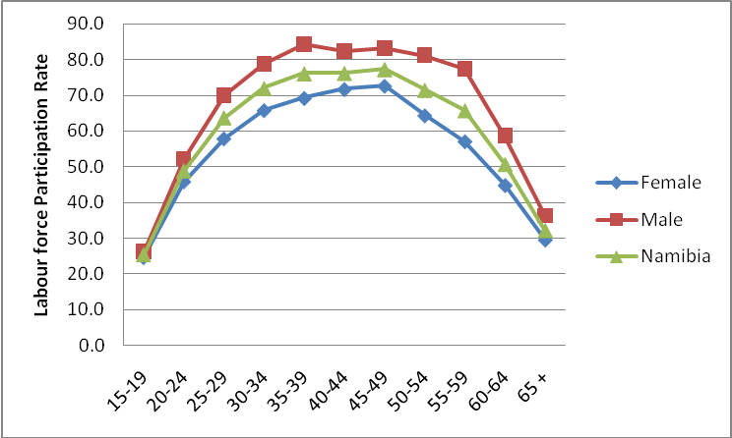

Labour force

About 75% of the population aged 15 years and above belongs to the labour force in Namibia. Table 6.2 shows that out of 912,763, about 73% are employed, while the remaining percent are unemployed. A person is regarded as employed if he or she had worked at least for one hour for pay, profit or family gain during that period or she/he has job or business or other economic or farming activity that he/she will definitely return to. The analysis of unemployment presented in this report follows the broad definition of unemployment, which is defined as people who are without work, available for work, and whether or not they were actively looking for work. The proportion of unemployed females is higher in both urban and rural areas when compared with that of their male counterparts. The pattern of the labour force for rural areas follows that of the national one.

Table 6.2 Economically Active Population aged 15 years and above by activity status, sex and area, Namibia, 2006 NIDS
Area | Activity Status | Number |  |  | Percent
Area | Activity Status | Total | Female | Male | Total | Female | Male
Namibia | Employed | 667,888 | 330,113 | 336,770 | 73.2 | 69.4 | 77.3
 | Unemployed | 244,875 | 145,737 | 98,828 | 26.8 | 30.6 | 22.7
 | Total | 912,763 | 475,850 | 435,598 | 100.0 | 100.0 | 100.0
Urban | Employed | 270,173 | 119,104 | 150,327 | 69.7 | 62.8 | 76.4
 | Unemployed | 117,408 | 70,638 | 46,461 | 30.3 | 37.2 | 23.6
 | Total | 387,581 | 189,742 | 196,788 | 100.0 | 100.0 | 100.0
Rural | Employed | 397,715 | 211,008 | 186,443 | 75.7 | 73.8 | 78.1
 | Unemployed | 127,467 | 75,099 | 52,367 | 24.3 | 26.2 | 21.9
 | Total | 525,181 | 286,108 | 238,810 | 100.0 | 100.0 | 100.0

Employed persons by age

Figure 6.3 indicates slightly higher proportion of males in ages 25-34 who are employed and higher proportion for females in the older ages of 40 and above.
Figure 6.3 Employed persons aged 15 years and above by age group and sex, Namibia, 2006 NIDS

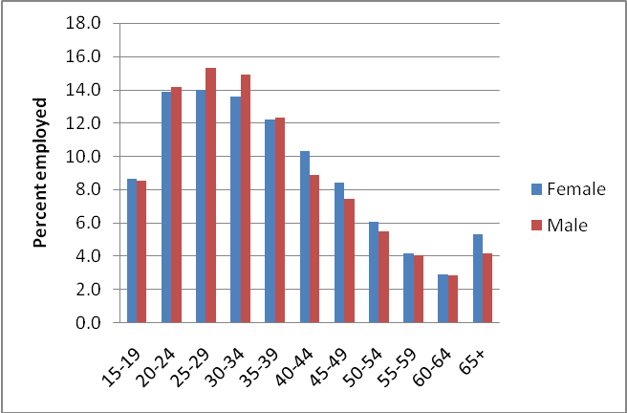

Employed persons by status in employment

Status in employment refers to all persons of either sex, aged 15 years and over who are classified in one of the categories listed in Appendix I. Table 6.4 reveals that about 32% of all employed persons are employees in the private sector. About 16% are unpaid family workers (subsistence/communal). Slightly over 15% are persons employed in the government or parastatal. About 12% of the employed persons are communal farmers without paid employees, followed by own account workers without hired or paid employees with 11%. Commercial farmers with paid employees contribute the lowest proportion with 0.7 % of the employed population. In terms of gender variations, females are mainly employed in private sector (27%), followed by those in the category of unpaid family workers (subsistence/communal) with 19.7% which means that about one out of every five females are unpaid family workers in the subsistence/communal farming sector. Males on the other hand are predominantly employed in private sector (36%), followed by those employed in government/parastatal (16%). The table further reveals that slightly over 12% of all employed males are unpaid family workers (subsistence/communal). These are persons who work in the family farming business without pay.

Table 6.3 Employed population aged 15 years and above by status in employment and sex, Namibia, 2006 NIDS

Employment Status | Number |  |  | Percent
Employment Status | Total | Female | Male | Total | Female | Male
Subsistence/Communal Farmer (with paid employees) | 5,821 | 2,842 | 2,978 | 0.9 | 0.9 | 0.9
Subsistence/Communal Farmer (without paid employees) | 77,742 | 45,626 | 32,037 | 11.6 | 13.8 | 9.5
Commercial Farmer (with paid employees) | 4,681 | 1,061 | 3,620 | 0.7 | 0.3 | 1.1
Other employer (with paid employees) | 14,387 | 6,070 | 8,317 | 2.2 | 1.8 | 2.5
Own Account Worker (without paid employees) | 69,988 | 42,717 | 27,143 | 10.5 | 12.9 | 8.1
Employee (communal farms) | 9,774 | 732 | 9,042 | 1.5 | 0.2 | 2.7
Employee (commercial Farms) | 19,052 | 4,477 | 14,574 | 2.9 | 1.4 | 4.3
Employee (Government/Parastatal) | 101,910 | 46,734 | 54,989 | 15.3 | 14.2 | 16.3
Employee (Private) | 210,918 | 88,437 | 121,940 | 31.6 | 26.8 | 36.2
Unpaid family worker (Subsistence/Communal) | 106,079 | 65,115 | 40,916 | 15.9 | 19.7 | 12.1
An unpaid family worker | 35,887 | 21,249 | 14,638 | 5.4 | 6.4 | 4.3
Not Stated | 11,647 | 5,051 | 6,574 | 1.7 | 1.5 | 2.0
Total | 667,888 | 330,113 | 336,770 | 100.0 | 100.0 | 100.0

Employed persons by occupation

Table 6.5 shows that skilled agricultural and fishery workers is the largest employing occupational group (32.5%), followed by elementary occupations with 18.7% which include labourers and other unskilled occupations. Craft and related trades workers constituted only 14.4%, while armed forces recorded the lowest number of employed persons (1.0%) due to army barracks and camps which were not covered during the survey. The few that have been captured are individual households. There are significant differences between females and males in most occupations. The occupational category with the highest employment is skilled agricultural and fishery service workers which is dominated by female (37.6%). The higher proportion of males is in craft and related trade work. Other occupations that are predominantly male-dominated are legislators, senior officials and managers and plant and machine operators.

Table 6.4 Employed population aged 15 years and above by occupation and sex, Namibia, 2006 NIDS

 | Number |  |  | Percent
Occupation | Total | Female | Male | Total | Female | Male
Armed Forces | 6,424 | 1,473 | 4,951 | 1.0 | 0.4 | 1.5
Legislators, senior official and manager | 14,409 | 5,148 | 9,261 | 2.2 | 1.6 | 2.7
Professionals | 43,777 | 24,708 | 18,924 | 6.6 | 7.5 | 5.6
Technician and associate Professionals | 25,445 | 12,016 | 13,356 | 3.8 | 3.6 | 4.0
Clerks | 30,392 | 22,265 | 8,090 | 4.6 | 6.7 | 2.4
Services workers and shop and market workers | 83,501 | 46,355 | 37,145 | 12.5 | 14.0 | 11.0
Skilled Agricultural and fishery workers | 217,282 | 124,095 | 93,139 | 32.5 | 37.6 | 27.7
Craft and Related trades workers | 97,860 | 29,215 | 68,343 | 14.7 | 8.8 | 20.3
Plant and machine operators and assemblers | 20,823 | 967 | 19,658 | 3.1 | 0.3 | 5.8
Elementary occupations | 124,603 | 62,032 | 62,371 | 18.7 | 18.8 | 18.5
Not stated | 3,372 | 1,839 | 1,533 | 0.5 | 0.6 | 0.5
Total | 667,888 | 330,113 | 336,770 | 100.0 | 100.0 | 100.0

Employed persons by industry

The distribution of employed persons aged 15 years and above by industry is presented in Table 6.6. Private and Public service industry alone employs about 52 % of all employed persons, followed by Agriculture, hunting, forestry and fishing which is slightly over 33%. The industry with the lowest proportion of employment is wholesale and retail trade contributing about 4% of which majority are males. Close to 60% of all employed females work in private and public service industry compared to 45% of their male counterparts. The industrial sector of manufacturing, mining and electricity is heavily male dominated.

Table 6.5 Employed Population aged 15 years and above by industry and sex, Namibia, 2006 NIDS

Industry | Number |  |  | Percent
Industry | Total | Female | Male | Total | Female | Male
Agriculture, hunting, forestry and fishing | 221,535 | 110,890 | 110,500 | 33.2 | 33.6 | 32.8
Manufacturing including mining, electricity | 72,420 | 15,645 | 56,450 | 10.8 | 4.7 | 16.8
Wholesale and retail trade | 24,561 | 8,981 | 15,580 | 3.7 | 2.7 | 4.6
Private and public service | 345,833 | 192,662 | 152,636 | 51.8 | 58.4 | 45.3
Not stated | 3,539 | 1,934 | 1,604 | 0.5 | 0.6 | 0.5
Total | 667,888 | 330,113 | 336,770 | 100.0 | 100.0 | 100.0
Note: * Private and Public Services include: Hotels and restaurants; Transport, storage and communications; Financial intermediation; Real estate, renting and business activities; Public administration and defence; Education; Health and social work; Other community, social and personal service activities; Private household; and Extra-territorial organisations and bodies.

Employed persons by educational attainment

Table 6.6 shows that 41.4% of the employed persons, aged 15 years and above have completed primary education, followed by those who did not complete primary education (18.3%). Out of the whole employed persons, only 7.9% have completed tertiary education.

Table 6.6 Employed persons aged 15 years and above by educational attainment and sex, Namibia, 2006 NIDS
Educational attainment | Number |  |  | Percent
Educational attainment | Total | Female | Male | Total | Female | Male
No Education | 87,896 | 41,055 | 46,788 | 13.2 | 12.4 | 13.9
Incomplete Primary school | 122,244 | 58,448 | 63,641 | 18.3 | 17.7 | 18.9
Primary | 276,221 | 141,800 | 133,888 | 41.4 | 43.0 | 39.8
Secondary School | 106,374 | 53,813 | 52,546 | 15.9 | 16.3 | 15.6
Tertiary | 52,789 | 26,498 | 26,145 | 7.9 | 8.0 | 7.8
Not Stated | 22,363 | 8,499 | 13,761 | 3.3 | 2.6 | 4.1
Total | 667,888 | 330,113 | 336,770 | 100 | 100 | 100

Figure 6.4 Dependency Ratio, Namibia, 2006 NIDS

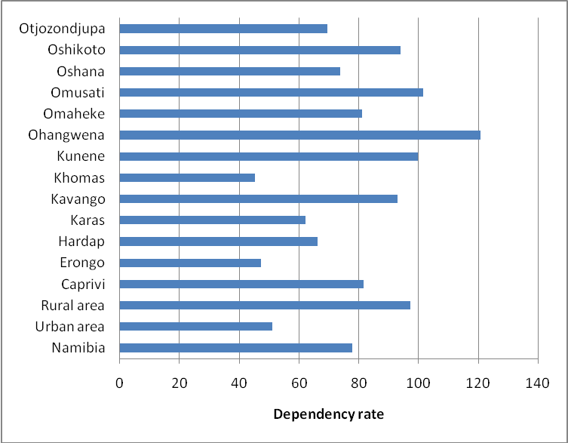

Dependency ratio is the proportion of the dependents aged (0 – 14) and elderly persons (65+) per 100 persons in the working age population (15 – 64) in a given area. This definition is adopted to allow for comparison with findings from Labour force survey which used 64 as the maximum age for working population instead of age 59. Relatively high dependency rates are found in the rural areas as well as in the regions of Ohangwena, Omusati, Kunene and Oshikoto (Figure 6.4).

Unemployment rate

Unemployment rate is the proportion of the unemployed persons in the labour force for a given population group, i.e. the number of unemployed persons divided by all people in the labour force in the same population group. Unemployment can be defined in a “broad” or “strict” sense, depending on the inclusion or exclusion of those without a job and are available for work but are not actually seeking it. The strict definition excludes those who are not actively looking for work. The 2006 Namibia Intercensal Demographic Survey utilises the broad definition, taking into account those who looked or did not look for work. The rate of unemployment in Namibia according to the broad definition of unemployment is 27 percent.

Figure 6.5 Unemployment Rate (%) by age group and sex, Namibia, 2006 NIDS
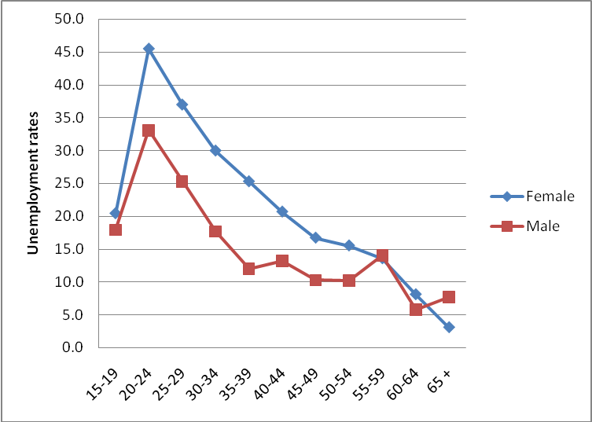
Figure 6.5 indicates significant differences over the unemployment rate by age for both sexes. Young people, notably females have the highest unemployment rates. The rate is higher for females in almost all ages. At age 65 and above unemployment rate is significantly low, because people are normally on retirement by age 65.
Figure 6.6 Unemployment rates (%) by area and sex, Namibia, 2006 NIDS

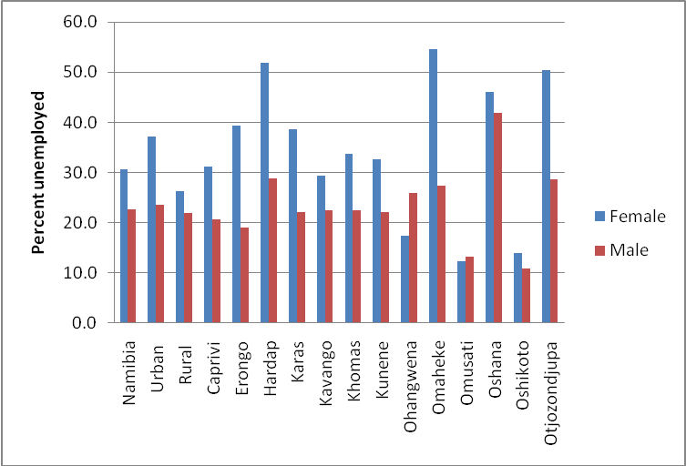

Overall, women in Namibia have the highest unemployment (Figure 6.6). Those in urban areas have higher unemployment rate compared to those in rural areas. Females in Omaheke, Hardap & Otjozondjupa regions have the highest unemployment rates of 55%, 52% and 50% respectively. The highest males unemployment rate is recorded in Oshana region (42%). Figure 6.7 shows that Oshikoto and Omusati regions have the lowest unemployment rates.
Figure 6.7 Unemployment rates (%) by area, Namibia, 2006 NIDS

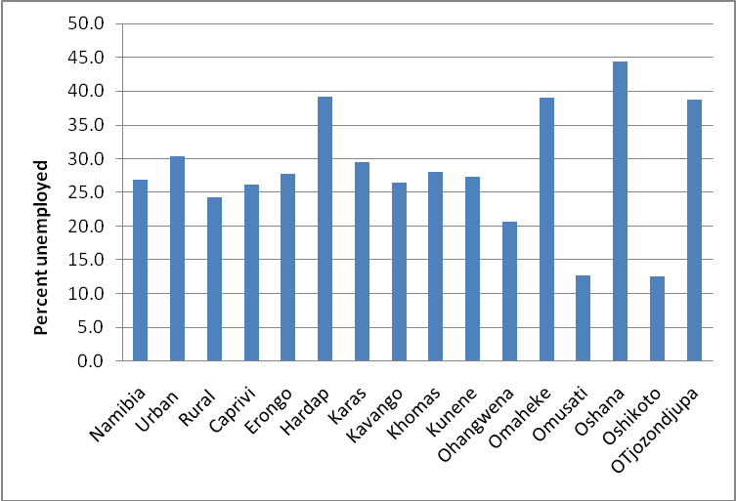

Table 6.7 Unemployed population aged 15 years and above by educational attainment and sex, Namibia, 2006 NIDS.

Educational attainment | Total | Female | Male | Total | Female | Male
No Education | 21,548 | 13,876 | 7,671 | 8.8 | 9.5 | 7.8
Incomplete Primary school | 40,743 | 23,116 | 17,499 | 16.6 | 15.9 | 17.7
Primary | 131,469 | 80,003 | 51,297 | 53.7 | 54.9 | 51.9
Secondary School | 39,061 | 23,110 | 15,951 | 16.0 | 15.9 | 16.1
Tertiary | 6,105 | 2,812 | 3,292 | 2.5 | 1.9 | 3.3
Not Stated | 5,950 | 2,819 | 3,118 | 2.4 | 1.9 | 3.2
Total | 244,875 | 145,737 | 98,828 | 100.0 | 100.0 | 100.0

Table 6.7 shows that more than 50% of unemployed persons for both sexes have attained primary level of education, while only 16% of unemployed persons have attained secondary level of education. The proportion of unemployed persons with tertiary level of education is slightly above 2%.

Population outside labour force

Persons who are outside the labour force are grouped into eight categories of which three are predominant. These are Student/scholar over 49%, Retired or too old to work (25%) and Homemaker/Housewife (accounts for about 8%. It can also be observed that the majority of the persons who are outside labour force are females (58.2%).

Table 6.8 Economically Inactive Population (Outside Labour Force) aged 15 years and above by activity status and sex, Namibia, 2006 NIDS

 | Number |  |  |  | Percent
Activity Status | Total | Female | Male | Not Stated | Total | Female | Male
Income Recipient | 2,470 | 1,608 | 863 |  | 0.8 | 0.9 | 0.7
Retired or too old to Work | 73,387 | 46,772 | 26,451 | 163 | 25.1 | 27.4 | 21.6
Student Or Scholar | 144,275 | 71,274 | 72,940 | 61 | 49.3 | 41.8 | 59.7
Homemaker/ Housewife | 23,235 | 22,225 | 946 | 64 | 7.9 | 13.0 | 0.8
Illness or unable to work | 21,534 | 12,968 | 8,566 |  | 7.4 | 7.6 | 7.0
Severely Disabled | 9,939 | 4,863 | 5,076 |  | 3.4 | 2.9 | 4.2
Cannot find Suitable work | 14,134 | 8,196 | 5,938 |  | 4.8 | 4.8 | 4.9
Too young to work | 1,350 | 812 | 538 |  | 0.5 | 0.5 | 0.4
Others | 2,316 | 1,606 | 710 |  | 0.8 | 0.9 | 0.6
Not stated | 244 | 92 | 152 |  | 0.1 | 0.1 | 0.1
Total outside labour force | 292,885 | 170,417 | 122,180 | 288 | 100.0 | 100.0 | 100.0

CHAPTER SEVEN: Household Composition and Characteristics

The definitions for household and head of household adopted for the Namibia InterCensal demographic survey are the same as in the 2001 Census (see definitions). The survey defines a private household as a group of people related or unrelated, who live in the same dwelling unit and share or have common catering arrangements. A person who lives alone and caters for himself/herself forms a one-person household. Any usual member of a household who was absent from such a household was not counted in that household but in the household where he or she spent the reference night. This chapter presents data on average size of households, relationship to the head of household, means of communication available, main language spoken at home and main source of income. Table 7.1 gives the estimate of households and household population made from NIDS. The average household is a summary measure that gives a number of persons in the household and is given by the total number of population over the total number of households in a given area at a particular point in time. The average household sizes by area are also presented in Table 7.1. On average, there are 5 persons per household in Namibia. In urban areas the average household size is around 4, and in rural areas the average household size is more than 5 persons. Likewise, there are significant differences among regions. Most of the regions in the north and north eastern part of the country have relatively larger households than those in the south. The average household size in both Kavango and Ohangwena regions is over 6 members. Erongo, Karas, Khomas and Omaheke are the only regions with an average household size below 4 persons.

Table 7.1.Average Household size by area, 2006 NIDS

Area | Households | Population | Average
Namibia | 419,804 | 1,952,454 | 4.7
Urban | 179,603 | 695,268 | 3.9
Rural | 240,202 | 1,257,186 | 5.2
Caprivi | 19,270 | 85,224 | 4.4
Erongo | 42,801 | 134,966 | 3.2
Hardap | 17,832 | 74,495 | 4.2
Karas | 16,788 | 64,872 | 3.9
Kavango | 34,111 | 237,657 | 7.0
Khomas | 77,604 | 301,050 | 3.9
Kunene | 16,236 | 76,329 | 4.7
Ohangwena | 40,174 | 247,103 | 6.2
Omaheke | 15,885 | 60,773 | 3.8
Omusati | 42,044 | 224,256 | 5.3
Oshana | 34,366 | 159,827 | 4.7
Oshikoto | 31,626 | 161,102 | 5.1
Otjozondjupa | 31,069 | 124,800 | 4.0

Household composition

In order to determine the composition of a household, the relationship of members of the household to the head of the household is taken into consideration. As expected, households in Namibia are predominant with son or daughter to head of household (Figure 7.2). In rural areas, households consist of high numbers of grand children of head or spouse, which is not the case in urban areas. Out of the 419 804 households in Namibia, about 18 percent are headed by females.

Tables 7.3 and 7.4 present the respective urban and rural household populations by relationship to the head/spouse. In both urban and rural areas, children of the head/spouse are still the predominant group with 33 and 31 percent, respectively. The proportion of other relatives to the head/spouse is relatively higher in urban (16%) than in the rural areas (12%). The opposite is the case for grandchildren with only 6 percent in urban as compared to 24 percent in the rural areas.

Table 7.2 Household Population by sex and relationship to head of household, Namibia, NIDS, 2006

 | Sex
Relationship | Total | Female | Male | Not stated |  | Total | Female | Male
 | Number | Number | Number | Number |  | Percent | Percent | Percent
Head | 419,804 | 180,686 | 238,433 | 685 |  | 21.5 | 17.7 | 25.8
Spouse | 167,537 | 151,014 | 16,404 | 119 |  | 8.6 | 14.8 | 1.8
Son/daughter of head/spouse | 618,726 | 318,236 | 299,053 | 1,437 |  | 31.7 | 31.1 | 32.3
Son/daughter in law of head/spouse | 19,047 | 11,245 | 7,774 | 28 |  | 1.0 | 1.1 | 0.8
Grand child of head/spouse | 350,286 | 171,266 | 178,518 | 501 |  | 17.9 | 16.7 | 19.3
Parent of head/spouse | 11,550 | 9,535 | 2,014 |  |  | 0.6 | 0.9 | 0.2
Other relative of head/spouse | 289,031 | 144,470 | 144,180 | 381 |  | 14.8 | 14.1 | 15.6
Domestic worker non-relative | 11,718 | 5,935 | 5,656 | 128 |  | 0.6 | 0.6 | 0.6
Other non-relative | 53,067 | 25,717 | 26,993 | 358 |  | 2.7 | 2.5 | 2.9
Not Stated | 11,689 | 5,408 | 5,778 | 503 |  | 0.6 | 0.5 | 0.6
Total | 1,952454 | 1,023511 | 924,804 | 4,139 |  | 100 | 100 | 100

Table 7.3 Urban Household Population by sex and relationship to head of household, Namibia, 2006 NIDS
 | Sex
Relationship | Total | Female | Male | Not stated |  | Total | Female | Male
 | Number | Number | Number | Number |  | Percent | Percent | Percent
Head | 179,603 | 67,875 | 111,308 | 419 |  | 25.8 | 19.3 | 32.7
Spouse | 75,654 | 66,113 | 9,481 | 60 |  | 10.9 | 18.8 | 2.8
Son/daughter of head/spouse | 227,929 | 115,925 | 110,676 | 1327 |  | 32.8 | 32.9 | 32.5
Son/daughter in law of head/spouse | 8,325 | 4,796 | 3,529 |  |  | 1.2 | 1.4 | 1.0
Grand child of head/spouse | 45,518 | 20,761 | 24,608 | 148 |  | 6.5 | 5.9 | 7.2
Parent of head/spouse | 3,894 | 2,918 | 976 |  |  | 0.6 | 0.8 | 0.3
Other relative of head/spouse | 117,627 | 54,566 | 62,797 | 264 |  | 16.9 | 15.5 | 18.4
Domestic worker non-relative | 4,253 | 3,415 | 710 | 128 |  | 0.6 | 1.0 | 0.2
Other non-relative | 29,108 | 14,009 | 14,977 | 122 |  | 4.2 | 4.0 | 4.4
Not Stated | 3,357 | 1,531 | 1,743 | 82 |  | 0.5 | 0.4 | 0.5
Total | 695,268 | 351,911 | 340,806 | 2,551 |  | 100.0 | 100.0 | 100.0

Table 7.4: Rural Household Population by sex and relationship to head of household, Namibia, 2006 NIDS
 | Sex
Relationship | Total | Female | Male | Not stated |  | Total | Female | Male
 | Number | Number | Number | Number |  | Percent | Percent | Percent
Head | 240,202 | 112,811 | 127,125 | 266 |  | 19.1 | 16.8 | 21.8
Spouse | 91,883 | 84,900 | 6,923 | 59 |  | 7.3 | 12.6 | 1.2
Son/daughter of head/spouse | 390,797 | 202,311 | 188,377 | 109 |  | 31.1 | 30.1 | 32.3
Son/daughter in law of head/spouse | 10,722 | 6,449 | 4,244 | 28 |  | 0.9 | 1.0 | 0.7
Grand child of head/spouse | 304,768 | 150,505 | 153,910 | 353 |  | 24.2 | 22.4 | 26.4
Parent of head/spouse | 7,655 | 6,617 | 1,038 | 0 |  | 0.6 | 1.0 | 0.2
Other relative of head/spouse | 171,404 | 89,904 | 81,383 | 116 |  | 13.6 | 13.4 | 13.9
Domestic worker non-relative | 7,465 | 2,520 | 4,946 | 0 |  | 0.6 | 0.4 | 0.8
Other non-relative | 23,959 | 11,708 | 12,016 | 235 |  | 1.9 | 1.7 | 2.1
Not Stated | 8,332 | 3,876 | 4,035 | 421 |  | 0.7 | 0.6 | 0.7
Total | 1,257186 | 671,600 | 583,998 | 1,588 |  | 100 | 100 | 100
Table 7.5 shows the distribution of households by area and by the sex of the head of household. It can be observed that, for the country as a whole, more households are headed by males (56.8 percent). The proportion of male-headed households is relatively higher in urban (62%) than in rural (37.8%) areas. The sex of the household head varies significantly between the regions. The northern regions of Ohangwena, Omusati, Caprivi, Oshana and Oshikoto are the only regions where the proportion of the female household heads is 50 percent or more.

Table 7.5 Total Number of households by sex of head of household

Area | Total Number of Households | Total Number of Households |  |  | Percent
 | Total Number of Households | Female | Male | Not Stated | Female | Male
Namibia | 419,804 | 180,686 | 238,433 | 685 | 43.0 | 56.8
Urban | 179,603 | 67,875 | 111,308 | 419 | 37.8 | 62.0
Rural | 240,202 | 112,811 | 127,125 | 266 | 47.0 | 52.9
Caprivi | 19,270 | 9,778 | 9,476 | 15 | 50.7 | 49.2
Erongo | 42,801 | 13,551 | 29,216 | 34 | 31.7 | 68.3
Hardap | 17,832 | 6,312 | 11,505 | 14 | 35.4 | 64.5
Karas | 16,788 | 5,626 | 11,116 | 45 | 33.5 | 66.2
Kavango | 34,111 | 13,295 | 20,773 | 44 | 39.0 | 60.9
Khomas | 77,604 | 27,193 | 50,124 | 287 | 35.0 | 64.6
Kunene | 16,236 | 5,845 | 10,360 | 30 | 36.0 | 63.8
Ohangwena | 40,174 | 24,376 | 15,798 |  | 60.7 | 39.3
Omaheke | 15,885 | 5,707 | 10,178 |  | 35.9 | 64.1
Omusati | 42,044 | 24,625 | 17,418 |  | 58.6 | 41.4
Oshana | 34,366 | 18,795 | 15,571 |  | 54.7 | 45.3
Oshikoto | 31,626 | 16,109 | 15,357 | 161 | 50.9 | 48.6
Otjozondjupa | 31,069 | 9,473 | 21,541 | 54 | 30.5 | 69.3

Table 7.6 indicates that the heads of most households which are headed by children under the age of 15 are females. In the age group 15 – 59, most head of households are males, while there is no significant difference in gender of household head with respect to those aged 60 years and above.

Table 7.6 Percent distribution of head of households by sex and broad age group
 | Number |  |  |  | Percent
 | Number of households | Female headed households | Male headed households | Not stated | Female headed | Male headed
0-4 | - | - | - | - | - | -
5-14 | 353 | 294 | 59 |  | 83.3 | 16.7
15-59 | 319,131 | 130,257 | 188,338 | 536 | 40.8 | 59.0
60+ | 100,320 | 50,135 | 50,036 | 149 | 50.0 | 49.9
Total | 419,804 | 180,686 | 238,433 | 685 | 43.0 | 56.8

Access to means of communication

All households were asked about accessibility to selected services/facilities as means of communication. These included television, radio, newspapers, telephone and computer. Table 7.7 below presents a picture of the diversity of access to these communication facilities. Worldwide, information and communication technology (ICT) is developing at an impressive rate. Access to ICT can lead to a significant impact on information sharing for instance on education, entertainment, health and lifestyle and business expansion, through either print media or internet, radio, TV etc. Namibia is a vast diverse country with multilingual and because of this access to communication is an important aspect. In most means of communication, the Khomas region has the highest percentage coverage, while the lowest access rate especially to television, daily newspaper and computer is recorded in Omusati and Ohangwena regions. On the other hand telephone and cell phone is as low as 8.4%and 29.7 respectively for Ohangwena and Omaheke regions. Almost all regions have households with access to radio. Access to cellphone is also high in most regions than even access to telephone. Overall, computer accessibility is high in urban areas than in rural areas.

Table 7.7 Percent of households with access to selected facilities by area, 2006 NIDS

Area | Number of households | TV | RADIO | Reading Newspaper Dairy | Reading Newspaper Occasionally | Use Telephone | Use Cell phone | Computer no internet | Computer with internet
Namibia | 419,804 | 43.8 | 87.5 | 18.7 | 45.9 | 37.5 | 68.4 | 12.2 | 12.3
Urban area | 179,603 | 74.1 | 90.5 | 37.9 | 56.4 | 56.1 | 88.3 | 23.4 | 24.4
Rural area | 240,202 | 21.2 | 85.2 | 4.4 | 38.1 | 23.6 | 53.5 | 3.9 | 3.3
Caprivi | 19,270 | 36.3 | 93.0 | 11.4 | 45.4 | 25.4 | 53.3 | 3.2 | 4.3
Erongo | 42,801 | 76.4 | 92.3 | 33.3 | 56.8 | 78.6 | 90.1 | 26.4 | 31.8
Hardap | 17,832 | 57.6 | 84.9 | 14.0 | 48.0 | 66.8 | 52.7 | 10.3 | 8.3
Karas | 16,788 | 64.0 | 90.0 | 24.1 | 52.5 | 64.9 | 63.3 | 16.7 | 15.0
Kavango | 34,111 | 19.1 | 67.2 | 5.2 | 27.1 | 13.9 | 36.8 | 2.7 | 1.6
Khomas | 77,604 | 72.9 | 91.3 | 47.1 | 51.5 | 50.6 | 90.9 | 26.0 | 27.1
Kunene | 16,236 | 26.9 | 88.4 | 7.7 | 38.5 | 28.7 | 35.5 | 5.4 | 4.5
Ohangwena | 40,174 | 18.3 | 90.9 | 7.0 | 34.2 | 8.4 | 67.9 | 1.6 | 1.6
Omaheke | 15,885 | 22.6 | 80.9 | 6.6 | 27.3 | 50.5 | 29.7 | 5.4 | 3.0
Omusati | 42,044 | 9.5 | 83.6 | 3.0 | 36.0 | 8.8 | 60.9 | 1.5 | 1.1
Oshana | 34,366 | 46.4 | 92.1 | 12.4 | 64.6 | 38.2 | 81.9 | 17.2 | 15.0
Oshikoto | 31,626 | 32.0 | 92.3 | 8.7 | 57.5 | 25.1 | 80.0 | 8.8 | 8.5
Otjozondjupa | 31,069 | 47.7 | 84.0 | 12.7 | 43.2 | 36.0 | 58.8 | 6.3 | 4.8

Main language spoken in the household

A question was asked on language usually spoken or mostly spoken at home. This should not be confused with languages in which people are literate. The former refers to the language which household members mostly use to communicate to each other while at home. Table 7.8 indicates the distribution of households by main language spoken. Oshiwambo is the most spoken language at home in the country, with 46% of the households communicating in it. Nama/Damara and Afrikaans are the next two most commonly spoken languages at home with 12.4% and 11.5% respectively.

Table 7.8 Distribution of households by main language spoken, Namibia, 2006 NIDS
Main Language | Number of Households | Percent
San Languages | 3,668 | 0.9
Caprivi Languages | 20,602 | 4.9
Otjiherero Languages | 37,260 | 8.9
Kavango Languages | 40,149 | 9.6
Nama/Damara Languages | 52,097 | 12.4
Oshiwambo Languages | 194,073 | 46.2
Tswana Languages | 2,218 | 0.5
Afrikaans Languages | 48,157 | 11.5
European Languages | 3,105 | 0.7
English | 11,517 | 2.7
German | 4,361 | 1.0
Other African languages | 1,461 | 0.3
Other languages | 188 | 0.0
Not Stated | 951 | 0.2
Total | 419,804 | 100.0

Main source of household income

Household source of income is one of the important aspects that measure the quality of life for households members. According to survey (2006 NIDS), wages and salaries is the main source of income for most households in Namibia (46.9%). Farming is the main source of income especially for households in the rural areas. In Omusati region, over 71% of households depend on farming as the main source of income. A considerable number of households (45.1%) in Kavango region also depend on farming as the main source of income. Table 7.9 below presents the distribution of households by their main source of income. About 70% of the households in urban areas reported wages and salaries as their main source of income, the corresponding percentage for the rural areas was only 27.2%. Predominantly more households in central and southern regions of Namibia such as Khomas, Erongo, Hardap and Karas reported wages and salaries as their main source of income. A significant number of households in Ohangwena (24.7%) and Oshikoto (16.3%) regions also depend on old-age pension as the main source of income.

Table 7.9 Percent distribution of households by main source of income, Namibia, 2006 NIDS
Area | Number of households | Farming | Business activities - non farming | Wages and Salaries | Old-age pension | Cash remittance | Old-age pension (retirement) | orphans' grant | Disability grant | Others, specify
Namibia | 419,804 | 24.6 | 8.1 | 46.9 | 9.6 | 5.7 | 2.6 | 0.5 | 0.6 | 1.0
Urban area | 179,603 | 1.6 | 10.9 | 73.2 | 3.3 | 6.1 | 2.6 | 0.3 | 0.4 | 1.4
Rural area | 240,202 | 41.8 | 6.1 | 27.2 | 14.3 | 5.5 | 2.5 | 0.7 | 0.8 | 0.8
Caprivi | 19,270 | 20.7 | 18.6 | 35.4 | 9.3 | 9.1 | 3.1 | 0.6 | 1.9 | 1.1
Erongo | 42,801 | 2.1 | 11.5 | 68.4 | 5.0 | 5.6 | 5.1 | 0.0 | 0.1 | 1.1
Hardap | 17,832 | 4.6 | 4.7 | 63.6 | 10.8 | 8.8 | 5.1 | 0.8 | 1.0 | 0.4
Karas | 16,788 | 8.6 | 1.5 | 65.9 | 10.7 | 8.3 | 2.7 | 0.8 | 1.1 | 0.4
Kavango | 34,111 | 45.1 | 7.3 | 28.9 | 10.1 | 4.1 | 2.7 | 0.4 | 0.5 | 0.7
Khomas | 77,604 | 1.1 | 10.0 | 79.2 | 2.1 | 4.2 | 1.2 | 0.1 | 0.2 | 1.6
Kunene | 16,236 | 35.0 | 6.7 | 40.2 | 8.2 | 5.3 | 1.3 | 0.2 | 1.4 | 1.3
Ohangwena | 40,174 | 39.7 | 7.7 | 14.6 | 24.7 | 7.9 | 2.7 | 1.4 | 0.9 | 0.4
Omaheke | 15,885 | 24.8 | 3.5 | 43.5 | 12.4 | 8.4 | 4.3 | 0.4 | 1.0 | 1.8
Omusati | 42,044 | 71.6 | 4.3 | 12.0 | 7.5 | 1.2 | 1.8 | 0.4 | 0.6 | 0.5
Oshana | 34,366 | 26.2 | 11.8 | 37.7 | 10.8 | 9.3 | 2.1 | 0.7 | 0.3 | 0.7
Oshikoto | 31,626 | 38.7 | 5.1 | 31.7 | 16.3 | 4.0 | 1.6 | 1.0 | 0.2 | 0.6
Otjozondjupa | 31,069 | 9.7 | 6.3 | 63.6 | 7.3 | 6.3 | 2.8 | 0.5 | 1.0 | 2.3

CHAPTER EIGHT: Housing Conditions

Housing is one of the basic human needs that have a significant impact on health, welfare, social attitude and economic productivity of an individual. It is one of the indicators of living standard of people in the society. This chapter provides information on housing conditions of the population, household sanitation, access to services and amenities available to household. The estimated number of dwellings in which people reside is 419 804 of which 179603 are located in urban areas and 240202 are in urban areas. The number of dwellings in 2001 was 346 455 and there is therefore a difference of 73 349 in the number of residential dwellings in Namibia during 2001-2006. Table 8.1 shows that traditional dwellings and detached/semi-detached houses are predominant in Namibia. In urban areas, detached and semi-detached dwellings make up 65% of all housing units. On the other hand, traditional dwellings are the most common housing units in rural areas constituting for 70.7% of the households. Improvised housing units (shacks) are the second most common dwellings in urban areas with 20.1% of households. The corresponding percentage in rural areas is only 7%. At regional level, traditional dwellings dominate in northern regions of Caprivi (73.4%), Kavango (86.1%), Ohangwena (91.3 %), Omusati (87.5 %), Oshana (50.7%) and Oshikoto (68.7%) while detached/semidetached housing units are more common in Hardap, Karas and Khomas regions.

Table 8.1 Percentage distribution of households by type of housing unit, Namibia, 2006 NIDS
Area | Number of households | Detached, semi detached House | Flats | Traditional dwelling | Improvised housing unit (shack) | Others
Namibia | 419,804 | 38.3 | 4.2 | 41.2 | 12.6 | 3.5
Urban area | 179,603 | 65.0 | 7.7 | 1.9 | 20.1 | 5.3
Rural area | 240,202 | 18.4 | 1.6 | 70.7 | 7.0 | 2.2
Caprivi | 19,270 | 12.0 | 0.8 | 73.4 | 0.7 | 13.1
Erongo | 42,801 | 61.0 | 5.3 | 1.8 | 24.5 | 7.0
Hardap | 17,832 | 75.8 | 4.1 | 0.4 | 17.3 | 2.2
Karas | 16,788 | 70.3 | 5.6 | 3.1 | 18.0 | 2.9
Kavango | 34,111 | 10.4 | 1.1 | 86.1 | 0.9 | 1.3
Khomas | 77,604 | 63.5 | 8.3 | 0.5 | 24.6 | 2.9
Kunene | 16,236 | 32.9 | 4.5 | 47.8 | 10.1 | 4.6
Ohangwena | 40,174 | 5.4 | 1.2 | 91.3 | 0.7 | 1.3
Omaheke | 15,885 | 50.3 | 1.8 | 28.8 | 17.4 | 1.5
Omusati | 42,044 | 8.9 | 1.7 | 87.5 | 0.8 | 1.0
Oshana | 34,366 | 30.7 | 8.7 | 50.7 | 5.0 | 4.8
Oshikoto | 31,626 | 21.9 | 2.9 | 68.7 | 4.9 | 1.4
Otjozondjupa | 31,069 | 56.7 | 1.6 | 9.3 | 27.3 | 5.0

Information on tenure is presented in Table 8.2. Most of the housing units (63.1%) in the country are occupied by owners, without any mortgage. This phenomenon is more common in rural areas (78.1%) than in urban areas (43.2%). Housing units occupied by owners with mortgage are found mainly in urban areas (24.8%). Likewise, households which reside in rented dwellings not tied to their jobs are found mainly in the urban areas. About 9.0 percent of the households live in dwellings provided by employers.

Table 8.2 Percentage distribution of households by type of Tenure, Namibia, 2006 NIDS

Area | Number of households | Rented (not tied to the job) | Owner occupied (with mortgage) | Owner occupied (without mortgage) | Rent free (not owner occupied) | Provided by employer | Other, specify
Namibia | 419,804 | 9.7 | 12.8 | 63.1 | 4.8 | 9.0 | 0.3
Urban area | 179,603 | 20.4 | 24.8 | 43.2 | 4.9 | 6.2 | 0.3
Rural area | 240,202 | 1.7 | 3.9 | 78.1 | 4.8 | 11.1 | 0.3
Caprivi | 19,270 | 3.1 | 8.4 | 80.4 | 3.3 | 4.1 | 0.7
Erongo | 42,801 | 25.7 | 24.5 | 31.4 | 10.2 | 7.6 | 0.3
Hardap | 17,832 | 6.4 | 16.5 | 51.9 | 3.7 | 20.7 | 0.7
Karas | 16,788 | 12.4 | 14.5 | 39.3 | 7.3 | 26.1 | 0.0
Kavango | 34,111 | 0.9 | 5.9 | 90.2 | 0.2 | 2.5 | 0.0
Khomas | 77,604 | 18.8 | 25.2 | 45.1 | 3.1 | 7.0 | 0.4
Kunene | 16,236 | 5.4 | 8.1 | 66.6 | 2.3 | 17.2 | 0.3
Ohangwena | 40,174 | 1.3 | 6.2 | 81.7 | 9.2 | 1.6 | 0.0
Omaheke | 15,885 | 2.2 | 9.4 | 67.0 | 9.8 | 11.4 | 0.0
Omusati | 42,044 | 1.5 | 2.4 | 92.7 | 0.7 | 2.4 | 0.2
Oshana | 34,366 | 10.9 | 6.0 | 75.2 | 3.9 | 3.5 | 0.3
Oshikoto | 31,626 | 10.3 | 3.8 | 72.5 | 5.4 | 7.6 | 0.2
Otjozondjupa | 31,069 | 5.4 | 16.6 | 40.4 | 6.4 | 30.2 | 0.7

Materials used for construction

Information on the main materials used for construction of roofs, walls and floors are given in Tables 8.3 to 8.5. It can be seen from Table 8.3 that the most commonly used material for roofing in the country are corrugated iron sheets, where more than half of the households reside in dwellings with such roofs. This proportion is even higher in urban with (76.6% and 38.3%) in rural areas. Households that live in dwellings whose roofing material is thatch/grass, constitute 33.4% of all households in the country. This percentage is far higher in rural (57.8%) than in urban (0.8%) areas. At regional level, dwellings with corrugated iron sheets predominate in Hardap, Karas, Khomas, Kunene, Omaheke and Otjozondjupa. Dwellings whose roofs are constructed from thatched grass are most commonly found in Caprivi, Kavango, Ohangwena, Omusati and Oshikoto regions. In Erongo region 50.4% dwellings have roofs covered with asbestos sheets. With respect to materials used for the floor in the whole country, cement is the most common material. Table 8.4 shows that 48.3% of the households occupy dwellings with this type of floor. This proportion is higher in urban areas (74.4%) as compared to the rural areas (28.9%). Dwellings with sand and mud/clay floors are the most predominant in the rural areas with coverage of 48.1% and 20.8% respectively. There are significant differences within the regions. Dwellings with cement floors predominate in the central and southern regions while floors made of sand and mud/clay are the most common for dwellings in the northern regions.

Table 8.3 Percent distribution of households by main material used for roof, Namibia, 2006 NIDS

Area | Number of Households | Corrugated-iron sheet | Asbestos sheets | Brick tiles | Slate | Wood covered with method | Thatch, grass | Sticks, mud and cow-dung | Other.specify
Namibia | 419,804 | 54.7 | 6.4 | 1.4 | 0.5 | 1.8 | 33.4 | 0.8 | 0.8
Urban area | 179,603 | 76.6 | 14.1 | 2.6 | 1.1 | 3.3 | 0.8 | 0.1 | 1.3
Rural area | 240,202 | 38.3 | 0.7 | 0.6 | 0.1 | 0.6 | 57.8 | 1.3 | 0.5
Caprivi | 19,270 | 32.9 | 0.3 | 1.3 | 0.6 | 0.2 | 64.4 | 0.5 | 0.0
Erongo | 42,801 | 20.0 | 50.4 | 7.0 | 3.4 | 13.7 | 0.8 | 0.2 | 4.3
Hardap | 17,832 | 97.4 | 1.0 | 0.1 | 0.2 | 0.7 | 0.0 | 0.0 | 0.4
Karas | 16,788 | 84.6 | 9.6 | 1.1 | 0.7 | 0.3 | 3.4 | 0.0 | 0.1
Kavango | 34,111 | 30.9 | 0.4 | 0.0 | 0.2 | 0.0 | 66.8 | 1.5 | 0.0
Khomas | 77,604 | 95.9 | 1.7 | 1.2 | 0.4 | 0.0 | 0.1 | 0.0 | 0.7
Kunene | 16,236 | 73.3 | 1.8 | 0.1 | 0.2 | 0.0 | 10.4 | 11.3 | 2.4
Ohangwena | 40,174 | 12.4 | 0.2 | 0.4 | 0.0 | 0.4 | 86.5 | 0.1 | 0.0
Omaheke | 15,885 | 95.5 | 0.7 | 0.3 | 0.0 | 0.0 | 1.8 | 0.2 | 1.5
Omusati | 42,044 | 24.4 | 0.1 | 0.6 | 0.0 | 1.9 | 72.8 | 0.1 | 0.0
Oshana | 34,366 | 52.8 | 0.2 | 2.4 | 0.1 | 1.0 | 43.3 | 0.0 | 0.0
Oshikoto | 31,626 | 33.7 | 0.4 | 0.5 | 0.0 | 0.2 | 64.6 | 0.4 | 0.2
Otjozondjupa | 31,069 | 87.4 | 4.1 | 0.5 | 0.4 | 0.2 | 4.8 | 1.5 | 0.8

Table 8.4 Percent distribution of households by main material used for the floor, Namibia, 2006 NIDS

Area |  | Sand | Cement | Mud/Clay | Other
Namibia | 419,804 | 36.9 | 48.3 | 12.8 | 1.8
Urban area | 179,603 | 21.8 | 74.4 | 2.0 | 1.5
Rural area | 240,202 | 48.1 | 28.9 | 20.8 | 1.9
Caprivi | 19,270 | 7.7 | 21.5 | 70.5 | 0.4
Erongo | 42,801 | 20.3 | 77.5 | 0.4 | 1.1
Hardap | 17,832 | 26.6 | 72.1 | 0.2 | 0.6
Karas | 16,788 | 16.4 | 78.6 | 2.9 | 2.1
Kavango | 34,111 | 37.9 | 16.6 | 44.8 | 0.5
Khomas | 77,604 | 26.1 | 71.2 | 0.0 | 2.5
Kunene | 16,236 | 18.3 | 46.7 | 15.0 | 19.4
Ohangwena | 40,174 | 51.6 | 15.1 | 33.0 | 0.2
Omaheke | 15,885 | 25.0 | 66.9 | 5.2 | 2.7
Omusati | 42,044 | 68.6 | 20.7 | 10.4 | 0.0
Oshana | 34,366 | 52.5 | 44.5 | 2.7 | 0.1
Oshikoto | 31,626 | 65.3 | 29.6 | 4.5 | 0.2
Otjozondjupa | 31,069 | 28.0 | 67.6 | 2.5 | 1.8

With regard to materials used for the construction of walls, cement blocks/bricks and wooden poles, sticks and grass predominate in the country. About 40% of households live in dwellings with walls made of cement blocks/bricks, while 25.8% reside in dwellings with walls made of wooden poles, sticks and grass. In urban areas, cement blocks/bricks (67.1%) and corrugated iron sheets (21.8%) predominate. On the other hand, in rural areas wooden poles, sticks and grass (42.9%) seems to be the most commonly used materials. Walls constructed from cement blocks/bricks predominate in the central and the southern regions. Dwellings with walls constructed from sticks, mud and cow dung are most commonly found in Caprivi and Kunene regions. Dwellings with walls constructed from wooden poles, sticks and grass are common in the regions of Kavango, Omusati, Oshana and Oshikoto.

Table 8.5 Percent distribution of households by main material used for the walls, Namibia, 2006 NIDS

Area | Number of households | Cement blocks/bricks | Burnt bricks/Face bricks | Mud/Clay bricks | Corrugated-iron sheets | Prefab | Wooden poles. sticks and grass | Sticks, mud,and cow-dung | Other, specify
Namibia | 419,804 | 39.5 | 0.7 | 6.6 | 15.6 | 1.8 | 25.8 | 8.7 | 1.1
Urban area | 179,603 | 67.1 | 0.6 | 1.7 | 21.8 | 3.6 | 2.8 | 1.4 | 1.0
Rural area | 240,202 | 18.9 | 0.8 | 10.2 | 11.0 | 0.6 | 42.9 | 14.1 | 1.2
Caprivi | 19,270 | 12.9 | 0.1 | 39.2 | 0.6 | 1.1 | 5.1 | 40.5 | 0.3
Erongo | 42,801 | 66.6 | 0.6 | 0.6 | 6.1 | 12.1 | 10.6 | 0.8 | 2.6
Hardap | 17,832 | 56.2 | 0.6 | 0.2 | 39.1 | 1.0 | 0.0 | 0.0 | 2.6
Karas | 16,788 | 64.3 | 2.2 | 2.0 | 22.5 | 2.7 | 4.2 | 0.0 | 2.1
Kavango | 34,111 | 11.3 | 0.5 | 22.5 | 2.4 | 0.4 | 26.0 | 36.4 | 0.4
Khomas | 77,604 | 64.8 | 0.4 | 1.5 | 31.8 | 0.9 | 0.2 | 0.0 | 0.3
Kunene | 16,236 | 32.0 | 0.2 | 2.6 | 11.2 | 0.4 | 5.0 | 45.1 | 3.2
Ohangwena | 40,174 | 6.4 | 0.1 | 0.5 | 2.4 | 0.2 | 82.1 | 6.0 | 2.2
Omaheke | 15,885 | 36.7 | 1.5 | 5.5 | 36.4 | 2.5 | 2.4 | 13.7 | 1.3
Omusati | 42,044 | 20.2 | 0.4 | 11.6 | 3.6 | 0.0 | 61.9 | 2.2 | 0.0
Oshana | 34,366 | 39.0 | 0.7 | 4.1 | 15.6 | 0.2 | 36.6 | 2.8 | 0.5
Oshikoto | 31,626 | 25.8 | 0.2 | 5.6 | 7.0 | 0.0 | 60.4 | 0.2 | 0.7
Otjozondjupa | 31,069 | 52.6 | 3.5 | 3.1 | 28.7 | 0.9 | 3.3 | 6.2 | 0.9

Household Amenities

Source of energy used for cooking, lighting and heating
Tables 8.6 to 8.8 present the percent distribution of households by sources of energy for cooking, lighting and heating. Table 8.6 indicates that about 3 out of 5 households in Namibia rely on wood and charcoal from wood for cooking. This proportion is higher in rural areas (close to 9 out of 10) than in urban areas (only 1 out of 5). More than half of the households (62.9%) in urban areas rely on electricity for cooking. Close to two thirds of the households in Erongo and Khomas regions use electricity for cooking. Most of the households in the rest of the regions use mainly wood and charcoal from wood for cooking purposes. With regard to main source of energy used for lighting, both electricity and the candle are quite common in the country as a whole. Two thirds of the households utilise these two sources. About 73 % of the households in the urban areas use electricity for lighting. Most rural households rely on the candle (54.1%), paraffin (19.5%) and wood (10.3%) for lighting purposes. Table 8.8 shows that about one third of the households in the country do not heat their dwellings. This is more pronounced in the rural areas (34.1%) than in the urban (39.4%) areas. About 38% of households use wood and charcoal from wood for heating purposes. Again, relatively more households (3 out of 5) in the rural areas make use of this source than those in the urban areas (12%). Electricity for heating is used mainly in urban areas where 43.1% of households utilise this energy source. With regard to the regions, Erongo and Khomas rely heavily on electricity for heating purposes where over 30 percent of the households make use of it. Most of the households in the regions of Kavango, Caprivi, Kunene and Omusati rely heavily on wood and charcoal from wood for heating purposes with more than 50 percent of them using this energy source. More than half of the households in Erongo and Oshikoto regions do not heat their dwellings.

Table 8.6 Households by source of energy for cooking, Namibia, 2006 NIDS

Area | Number of Households | Electricity | Paraffin | Wood/Charcoal from wood | Gas | Charcoal-coal | Solar | No cooking | Other, specify
Namibia | 419,804 | 31.1 | 5.3 | 57.1 | 6.1 | 0.1 | 0.1 | 0.1 | 0.1
Urban area | 179,603 | 62.9 | 11.2 | 15.0 | 10.6 | 0.0 | 0.0 | 0.1 | 0.0
Rural area | 240,202 | 7.3 | 0.8 | 88.5 | 2.7 | 0.1 | 0.2 | 0.0 | 0.2
Caprivi | 19,270 | 6.4 | 0.2 | 90.8 | 2.0 | 0.7 | 0.0 | 0.0 | 0.0
Erongo | 42,801 | 74.3 | 5.0 | 12.7 | 7.9 | 0.0 | 0.0 | 0.0 | 0.0
Hardap | 17,832 | 45.6 | 1.8 | 47.3 | 5.0 | 0.2 | 0.0 | 0.0 | 0.0
Karas | 16,788 | 37.5 | 1.7 | 36.1 | 24.5 | 0.2 | 0.0 | 0.1 | 0.0
Kavango | 34,111 | 7.0 | 0.7 | 89.8 | 2.1 | 0.1 | 0.2 | 0.0 | 0.0
Khomas | 77,604 | 66.9 | 18.9 | 6.2 | 7.5 | 0.0 | 0.1 | 0.2 | 0.0
Kunene | 16,236 | 9.8 | 0.8 | 85.1 | 3.7 | 0.0 | 0.0 | 0.4 | 0.2
Ohangwena | 40,174 | 5.3 | 0.9 | 92.7 | 0.7 | 0.0 | 0.0 | 0.0 | 0.0
Omaheke | 15,885 | 11.8 | 0.5 | 79.5 | 8.0 | 0.0 | 0.2 | 0.0 | 0.0
Omusati | 42,044 | 5.6 | 0.9 | 91.9 | 0.7 | 0.0 | 0.8 | 0.0 | 0.0
Oshana | 34,366 | 19.3 | 7.7 | 58.7 | 13.0 | 0.0 | 0.0 | 0.0 | 1.1
Oshikoto | 31,626 | 14.8 | 1.0 | 79.9 | 4.1 | 0.0 | 0.1 | 0.0 | 0.0
Otjozondjupa | 31,069 | 30.9 | 1.5 | 61.0 | 6.4 | 0.2 | 0.0 | 0.0 | 0.0

Table 8.7 Households by source of energy for lighting, Namibia, 2006 NIDS
Area | Number  of Households | Electricity | Paraffin | Candle | Gas | Solar | Wood | Other,specify
Namibia | 419,804 | 39.4 | 13.6 | 39.6 | 0.1 | 0.5 | 5.9 | 0.4
Urban area | 179,603 | 73.4 | 5.8 | 20.2 | 0.2 | 0.0 | 0.2 | 0.0
Rural area | 240,202 | 13.9 | 19.5 | 54.1 | 0.1 | 0.9 | 10.3 | 0.8
Caprivi | 19,270 | 16.3 | 6.9 | 76.5 | 0.0 | 0.0 | 0.0 | 0.3
Erongo | 42,801 | 77.1 | 8.3 | 13.8 | 0.0 | 0.5 | 0.0 | 0.0
Hardap | 17,832 | 63.1 | 10.0 | 25.6 | 0.0 | 0.8 | 0.0 | 0.0
Karas | 16,788 | 58.9 | 11.6 | 27.8 | 0.2 | 1.1 | 0.4 | 0.0
Kavango | 34,111 | 17.9 | 1.3 | 66.8 | 0.1 | 0.5 | 13.1 | 0.0
Khomas | 77,604 | 72.1 | 7.3 | 19.8 | 0.4 | 0.1 | 0.0 | 0.0
Kunene | 16,236 | 26.7 | 20.1 | 29.2 | 0.4 | 0.8 | 19.8 | 3.0
Ohangwena | 40,174 | 7.1 | 13.1 | 67.9 | 0.0 | 0.7 | 10.7 | 0.1
Omaheke | 15,885 | 23.4 | 37.1 | 32.5 | 0.1 | 1.2 | 1.6 | 3.9
Omusati | 42,044 | 6.9 | 26.0 | 45.6 | 0.0 | 0.3 | 20.5 | 0.4
Oshana | 34,366 | 28.2 | 19.3 | 49.2 | 0.3 | 0.7 | 1.5 | 0.3
Oshikoto | 31,626 | 21.1 | 13.8 | 52.7 | 0.0 | 0.9 | 9.7 | 0.7
Otjozondjupa | 31,069 | 51.3 | 20.1 | 26.1 | 0.0 | 0.4 | 1.4 | 0.5

Table 8.8 Households by source of energy for heating, Namibia, 2006 NIDS
Area | Number  of Households | Electricity |  | Paraffin |  | Wood/Charcoal from wood |  | Gas | Charcoal-coal |  |  | Solar | No heating |  |  | Other, specify
Namibia | 419,804 | 21.1 |  | 1.9 |  | 38.6 |  | 0.7 | 0.2 |  |  | 0.2 | 36.4 |  |  | 0.3
Urban area | 179,603 | 43.1 |  | 3.1 |  | 11.6 |  | 1.2 | 0.2 |  |  | 0.1 | 39.4 |  |  | 0.5
Rural area | 240,202 | 4.8 |  | 0.9 |  | 58.8 |  | 0.4 | 0.3 |  |  | 0.2 | 34.1 |  |  | 0.1
Caprivi | 19,270 | 3.0 |  | 0.3 |  | 51.8 |  | 0.2 | 0.3 |  |  | 0.3 | 43.7 |  |  | 0.1
Erongo | 42,801 | 31.6 |  | 0.4 |  | 7.6 |  | 0.5 | 0.3 |  |  | 0.1 | 58.8 |  |  | 0.4
Hardap | 17,832 | 24.4 |  | 0.3 |  | 26.5 |  | 0.7 | 0.8 |  |  | 0.2 | 46.6 |  |  | 0.0
Karas | 16,788 | 25.3 |  | 0.4 |  | 30.4 |  | 0.3 | 0.6 |  |  | 0.1 | 42.7 |  |  | 0.0
Kavango | 34,111 | 6.3 |  | 0.3 |  | 76.7 |  | 0.1 | 0.5 |  |  | 0.3 | 14.9 |  |  | 0.0
Khomas | 77,604 | 54.4 |  | 5.4 |  | 7.2 |  | 0.7 | 0.0 |  |  | 0.0 | 29.7 |  |  | 0.8
Kunene | 16,236 | 5.6 |  | 0.9 |  | 57.4 |  | 0.0 | 0.2 |  |  | 0.4 | 35.2 |  |  | 0.2
Ohangwena | 40,174 | 3.0 |  | 0.7 |  | 46.7 |  | 0.0 | 0.0 |  |  | 0.4 | 48.9 |  |  | 0.0
Omaheke | 15,885 | 10.1 |  | 0.7 |  | 37.7 |  | 1.5 | 1.4 |  |  | 0.2 | 48.1 |  |  | 0.2
Omusati | 42,044 | 4.3 |  | 1.8 |  | 76.7 |  | 0.1 | 0.0 |  |  | 0.2 | 16.5 |  |  | 0.1
Oshana | 34,366 | 16.9 |  | 3.8 |  | 36.9 |  | 4.5 | 0.0 |  |  | 0.1 | 37.0 |  |  | 0.6
Oshikoto | 31,626 | 7.8 |  | 0.3 |  | 36.5 |  | 0.0 | 0.0 |  |  | 0.0 | 55.1 |  |  | 0.1
Otjozondjupa | 31,069 | 25.3 |  | 1.5 |  | 53.9 |  | 0.9 | 0.4 |  |  | 0.0 | 17.3 |  |  | 0.2

Main source of drinking water

The percent distribution of households by source of water for drinking during the rainy season is shown in Table 8.9 for the country, urban and rural areas and regions. More than 50 percent of the households have piped water within their compounds, while about 25% of them get their water from public pipes and boreholes. A high proportion of households in Ohangwena (54.4%), Oshikoto (30.5%), Kavango (26.4%) and Omusati (21.4%) regions get water from the natural sources, i.e. rivers and streams, during rain season. However, during dry season, use of safe water in these regions increases. For public health purposes, water from pipes and boreholes, except those with open tanks, is regarded as safe for drinking and cooking. According to results presented in Table 8.9 and Table 8.10, about 75% of households in Namibia have access to safe drinking water during rain season and about 83 percent have access to safe water during dry season. Almost all households in urban areas (98.9%) have access to safe water as compared to those in rural areas (56.3%). Over 90 percent of the households in the central (Erongo, Khomas, Otjozondjupa) and southern (Hardap and Karas) regions have access to safe water, while households in some of the regions in the northern part of the country i.e. Omusati and Ohangwena regions have relatively low access to safe water during rain season. However, during dry season access to safe water especially in rural regions significantly increases.

Table 8.9 Percent of households by source of drinking water, during rain season in Namibia, 2006 NIDS

Area | Number of households | Piped Water Within | Public Pipe | Safe borehole | Safe Water | River, Streams, Dams, Canals | Others
Namibia | 419,804 | 50.1 | 18.3 | 6.2 | 74.5 | 15.4 | 9.8
Urban area | 179,603 | 78.8 | 19.8 | 0.3 | 98.9 | 0.2 | 0.6
Rural area | 240,202 | 28.6 | 17.2 | 10.6 | 56.3 | 26.7 | 16.8
Caprivi | 19,270 | 14.7 | 33.5 | 27.1 | 75.4 | 18.4 | 6.3
Erongo | 42,801 | 86.9 | 8.7 | 2.1 | 97.6 | 1.0 | 1.0
Hardap | 17,832 | 65.6 | 21.0 | 8.4 | 95.1 | 1.9 | 2.7
Karas | 16,788 | 83.7 | 7.9 | 4.5 | 96.1 | 3.4 | 0.6
Kavango | 34,111 | 29.5 | 16.6 | 21.5 | 67.6 | 26.4 | 5.5
Khomas | 77,604 | 71.0 | 26.5 | 1.2 | 98.8 | 0.2 | 0.6
Kunene | 16,236 | 38.4 | 10.3 | 10.5 | 59.2 | 28.4 | 11.8
Ohangwena | 40,174 | 13.9 | 13.4 | 5.7 | 33.0 | 54.4 | 12.6
Omaheke | 15,885 | 64.4 | 11.4 | 12.8 | 88.6 | 1.7 | 9.7
Omusati | 42,044 | 14.7 | 16.4 | 1.9 | 33.0 | 21.4 | 45.5
Oshana | 34,366 | 55.2 | 23.1 | 0.3 | 78.5 | 14.1 | 6.9
Oshikoto | 31,626 | 31.3 | 15.8 | 3.8 | 50.9 | 30.5 | 18.4
Otjozondjupa | 31,069 | 71.2 | 21.3 | 3.4 | 95.9 | 1.2 | 2.7

Table 8.10 Percentage of households by source of drinking water during dry season, Namibia, 2006 NIDS

Area | Number of households | Piped Water Within | Public Pipe | Safe borehole | Safe water | River, Streams, Dams, Canals | Others
Namibia | 419,804 | 51.5 | 25.8 | 6.5 | 83.8 | 7.7 | 8.4
Urban area | 179,603 | 79.1 | 19.6 | 0.3 | 99.0 | 0.3 | 0.5
Rural area | 240,202 | 30.9 | 30.4 | 11.1 | 72.4 | 13.2 | 14.2
Caprivi | 19,270 | 14.7 | 35.0 | 26.4 | 76.1 | 17.9 | 5.9
Erongo | 42,801 | 87.5 | 8.4 | 2.1 | 98.0 | 1.0 | 0.9
Hardap | 17,832 | 65.8 | 20.6 | 8.3 | 94.8 | 2.2 | 2.9
Karas | 16,788 | 83.7 | 7.9 | 4.5 | 96.1 | 3.4 | 0.6
Kavango | 34,111 | 29.4 | 17.0 | 21.6 | 68.0 | 26.6 | 5.2
Khomas | 77,604 | 71.0 | 26.3 | 1.3 | 98.7 | 0.3 | 0.7
Kunene | 16,236 | 39.0 | 11.2 | 14.8 | 64.9 | 16.1 | 18.7
Ohangwena | 40,174 | 19.4 | 31.1 | 5.6 | 56.0 | 17.5 | 26.5
Omaheke | 15,885 | 64.9 | 11.5 | 12.8 | 89.2 | 1.3 | 9.3
Omusati | 42,044 | 17.3 | 48.9 | 2.9 | 69.0 | 12.1 | 18.7
Oshana | 34,366 | 58.1 | 36.1 | 0.3 | 94.5 | 3.2 | 2.1
Oshikoto | 31,626 | 35.7 | 34.6 | 5.0 | 75.4 | 5.1 | 19.5
Otjozondjupa | 31,069 | 71.2 | 21.3 | 3.3 | 95.9 | 1.5 | 2.6

Distance to water sources in Namibia

Namibia is a dry (semi-arid) country and the accessibility to source of water varies from season to season and by region. Distance to water source can be used as a proxy measure of accessibility to safe water. Table 8.11 presents the percent distribution of households by distance to the water source during rainy season. For the country as a whole, 43.5 percent of the households do not cover any distance as they have water within their premises, 36.7 percent get their water within a distance of 500 metres, but 15.2% of households have to cover about one kilometre to fetch water during rainy season. It is also evident from the Table 8.11 and Table 8.12 that during dry seasons, a high proportion of households in rural areas cover a distance of more than one kilometre to water source. In Omusati region, about 24 percent of households cover a distance of more than 1km to water source during dry season as compared to only 6 percent of households which cover a distance of more than 1km during rain season.

Table 8.11 Percentage of households by distance to water sources during rainy season, Namibia, 2006 NIDS

Area | Number of households | On the Premises | Less than 500m | Between 500m and 1km | more than 1km
Namibia | 419,804 | 43.5 | 36.7 | 15.2 | 4.6
Urban area | 179,603 | 71.8 | 23.6 | 4.1 | 0.4
Rural area | 240,202 | 22.3 | 46.4 | 23.4 | 7.7
Caprivi | 19,270 | 13.9 | 63.6 | 15.3 | 7.1
Erongo | 42,801 | 74.8 | 21.1 | 3.1 | 0.8
Hardap | 17,832 | 60.4 | 33.6 | 5.3 | 0.4
Karas | 16,788 | 78.8 | 17.3 | 2.8 | 1.1
Kavango | 34,111 | 18.6 | 38.3 | 24.6 | 18.3
Khomas | 77,604 | 69.4 | 23.8 | 6.1 | 0.4
Kunene | 16,236 | 34.5 | 35.7 | 18.4 | 11.1
Ohangwena | 40,174 | 9.0 | 44.4 | 38.7 | 7.8
Omaheke | 15,885 | 56.6 | 29.0 | 11.8 | 2.6
Omusati | 42,044 | 13.0 | 50.9 | 30.6 | 5.5
Oshana | 34,366 | 39.6 | 43.3 | 14.5 | 2.5
Oshikoto | 31,626 | 28.1 | 51.8 | 14.8 | 5.3
Otjozondjupa | 31,069 | 56.2 | 36.4 | 5.9 | 1.4

Table 8.12 Percentage of households by distance to water sources during dry season, Namibia, 2006 NIDS
Area | Number of households | On the premises | Less than 500m | Between 500m and 1km | More than 1km
Namibia | 419,804 | 43.2 | 30.3 | 17.3 | 9.0
Urban area | 179,603 | 71.5 | 23.7 | 4.3 | 0.4
Rural area | 240,202 | 22.1 | 35.3 | 27.1 | 15.4
Caprivi | 19,270 | 13.7 | 61.8 | 16.2 | 8.3
Erongo | 42,801 | 74.1 | 21.8 | 3.1 | 0.8
Hardap | 17,832 | 60.7 | 33.5 | 5.3 | 0.4
Karas | 16,788 | 78.6 | 17.4 | 2.9 | 1.1
Kavango | 34,111 | 18.8 | 37.7 | 24.6 | 18.7
Khomas | 77,604 | 69.4 | 23.5 | 6.4 | 0.4
Kunene | 16,236 | 34.4 | 29.2 | 21.0 | 15.2
Ohangwena | 40,174 | 9.4 | 29.2 | 42.1 | 19.4
Omaheke | 15,885 | 56.8 | 28.7 | 11.9 | 2.6
Omusati | 42,044 | 12.7 | 26.0 | 37.8 | 23.5
Oshana | 34,366 | 37.7 | 37.1 | 17.6 | 7.4
Oshikoto | 31,626 | 27.9 | 31.5 | 23.7 | 16.8
Otjozondjupa | 31,069 | 55.6 | 36.9 | 6.0 | 1.4

Toilet Facility
Table 8.13 presents the percent distribution of households by type of toilet facility. There is a slight improvement in the proportion of households having toilet facility. The proportion of households with no toilet facility has decreased from 54 percent to 49 percent. More than 75.5% of the households in the urban areas use flush toilet while the corresponding rural percentage is 10.4. Over 75% of the rural households use the bush as against 13.8% in the urban areas. More than 80% of the households in Caprivi, Kavango, Ohangwena and Omusati regions have no access to a toilet facility. A similar pattern was also observed in 2001.

Table 8.13 Percentage of households by toilet facility, Namibia, 2006 NIDS
Area | Number of households | Flush toilet not shared | Flush toilet shared | VIP | Pit long drop | Bucket/Pail | Bush (No toilet facility) | Other, specify
Namibia | 419,804 | 27.9 | 10.3 | 2.4 | 8.6 | 1.0 | 49.1
Urban area | 179,603 | 54.7 | 20.8 | 2.9 | 6.4 | 0.7 | 13.8
Rural area | 240,202 | 7.9 | 2.5 | 2.0 | 10.2 | 1.3 | 75.6
Caprivi | 19,270 | 10.4 | 0.4 | 0.6 | 1.9 | 0.3 | 86.4
Erongo | 42,801 | 57.9 | 24.5 | 5.3 | 4.6 | 0.5 | 6.7
Hardap | 17,832 | 36.1 | 7.8 | 0.1 | 8.2 | 8.5 | 38.5 | 0.4
Karas | 16,788 | 46.7 | 15.1 | 0.0 | 10.1 | 2.5 | 25.3
Kavango | 34,111 | 5.4 | 2.6 | 0.2 | 9.7 | 1.0 | 80.6
Khomas | 77,604 | 54.1 | 22.1 | 2.1 | 3.2 | 0.4 | 17.4
Kunene | 16,236 | 22.3 | 4.9 | 0.6 | 3.9 | 2.3 | 65.1
Ohangwena | 40,174 | 2.8 | 1.9 | 3.2 | 4.7 | 0.3 | 86.8
Omaheke | 15,885 | 22.7 | 7.4 | 0.8 | 1.0 | 0.5 | 66.9
Omusati | 42,044 | 3.8 | 0.6 | 4.6 | 10.5 | 0.3 | 79.9
Oshana | 34,366 | 18.0 | 5.9 | 5.3 | 27.5 | 1.6 | 40.8
Oshikoto | 31,626 | 12.0 | 8.3 | 0.9 | 16.5 | 0.5 | 61.1
Otjozondjupa | 31,069 | 39.9 | 10.2 | 1.8 | 9.4 | 0.4 | 37.8

Garbage and refuse disposal
Table 8.14 shows the percent distribution of households by means of disposing garbage/refuse. The most common means of disposing garbage in Namibia are regular collection and burning, which are utilised by 35.1% and 33.6% of all the households respectively. In urban areas, garbage and refuse are regularly collected while in rural areas burning is used as the common way of disposing garbage and refuse The most common means of garbage disposal in most of the regions is using the rubbish pit or burning, however in more industrialised regions of Khomas and Erongo garbage are regularly collected.

Table 8.14 Percentage of households by means of garbage disposal, Namibia, 2006 NIDS

Area | Number of households | Regularly collected | Irregularly collected | Burning | Roadside dumping | Rubbish pit | Other, specify
Namibia | 419,804 | 35.1 | 4.8 | 33.6 | 8.2 | 14.1 | 3.8
Urban area | 179,603 | 75.5 | 9.3 | 4.4 | 6.5 | 3.4 | 0.4
Rural area | 240,202 | 4.9 | 1.4 | 55.5 | 9.5 | 22.1 | 6.2
Caprivi | 19,270 | 9.0 | 5.1 | 31.2 | 11.1 | 37.0 | 6.7
Erongo | 42,801 | 84.6 | 0.8 | 9.5 | 2.3 | 2.6 | 0.1
Hardap | 17,832 | 53.4 | 3.4 | 16.2 | 16.1 | 10.5 | 0.0
Karas | 16,788 | 55.0 | 10.4 | 21.8 | 5.0 | 7.4 | 0.2
Kavango | 34,111 | 3.5 | 2.8 | 55.3 | 12.9 | 25.2 | 0.0
Khomas | 77,604 | 74.8 | 9.7 | 7.7 | 3.2 | 3.2 | 0.7
Kunene | 16,236 | 14.3 | 5.6 | 52.9 | 18.5 | 5.0 | 3.0
Ohangwena | 40,174 | 0.7 | 1.7 | 68.2 | 1.7 | 25.6 | 2.1
Omaheke | 15,885 | 16.9 | 0.9 | 21.5 | 15.3 | 43.6 | 1.8
Omusati | 42,044 | 5.3 | 1.7 | 47.0 | 7.7 | 27.0 | 10.9
Oshana | 34,366 | 20.5 | 11.4 | 34.8 | 9.5 | 6.8 | 16.5
Oshikoto | 31,626 | 16.9 | 0.4 | 51.5 | 16.5 | 8.7 | 5.4
Otjozondjupa | 31,069 | 37.1 | 4.6 | 39.5 | 9.3 | 7.8 | 0.9

CHAPTER NINE: Fertility

Fertility refers to the number of children born to women. The basic goal in measuring fertility is to estimate the number of children that women are having. The data used for measuring fertility usually come from a combination of census and vital statistics sources. However detailed data are sometimes available from sample surveys. The indirect technique adjusts the levels of fertility estimated from reported births in the last twelve months by using the estimates from the average number of children ever born to women.

In the 2006 NIDS, all women of child-bearing ages (12-49) were asked questions on the number of live births as well as the month and year of the last live birth. For 2006 NIDS fertility results to be comparable, fertility measures were calculated for women of childbearing ages 15-49. The total number of live births provides an estimate of lifetime fertility while the information on the last live birth provides current estimates of the level of fertility. The latter are usually underestimated, hence the lifetime fertility estimates are used to adjust them to arrive at the expected current levels of fertility.

There are various measures of fertility. The indicator used here is the total fertility rate (TFR). This is the average number of children a woman would be expected to have if she survives through her reproductive period, i.e. from age 15 to 49 years. In addition to the total fertility rates, the pattern of fertility is also provided. This indicates the contribution by the various age groups of the women to the total fertility rate. Comparisons with the rates estimated from the 2001 Census are also made.

Levels of Fertility

The total fertility rate (TFR) is a basic measure of cohort fertility. It can be compared from one population to another because it takes into account the differences in age structure. The TFR estimates the average number of children born to each woman, assuming that current birth rates remain constant. Table 9.1 shows the total fertility rates for Namibia by urban and rural areas and by region. It is observed that the national TFR has slightly increased from 4.1 in 2001 to 4.5 in 2006. The TFR in rural areas is higher (4.9) compared to urban TFR (3.9); this indicates that rural women turn to have one child more in their life time compare to urban women. The 2006 NIDS data shows some regional variations with respect to the TFR. The pattern is similar to the 2001 Census for all the 13 regions, except that the fertility level has slightly increased. Ohangwena region has the highest TFR of 5.7 and Khomas region has the lowest TFR of 3.5. Kavango region shows a slight decrease in TFR while Otjozondjupa and Kunene regions showed significant increases in TFR when compare to 2001. Fertility measures should however be interpreted with caution. They were estimated using indirect method of estimation in Mortpak. The assumptions made may not be necessarily valid for Namibia.

Table 9.1 Levels of fertility by area, 2006 NIDS and 2001 Census

Total Fertility Rates
 | 2006 | 2001
Namibia | 4.5 | 4.1
Urban | 3.9 | 3.4
Rural | 4.9 | 4.6
Caprivi | 4.1 | 3.8
Erongo | 4.1 | 3.2
Hardap | 4.3 | 3.6
Karas | 3.6 | 3.1
Kavango | 5.2 | 5.5
Khomas | 3.5 | 3.3
Kunene | 5.4 | 4.7
Ohangwena | 5.7 | 5.3
Omaheke | 4.8 | 4.7
Omusati | 4.1 | 4.0
Oshana | 4.4 | 3.7
Oshikoto | 4.6 | 4.6
Otjozondjupa | 5.0 | 4.1

Fertility Pattern
The pattern of fertility for women in child-bearing ages in Namibia is shown in Figure 9.1. The pattern is N-shaped, indicating that fertility is low among women in the age group 15-19, peak at age 20-34 and decreases again women’s age increase. Age-Specific Fertility Rate (ASFR) is the average number of births per woman in a specific age group for all the women in that age group, irrespective of whether they had a live birth or not.

Figure 9.1 Age-Specific Fertility Rates (ASFR), Namibia, 2006 NIDS
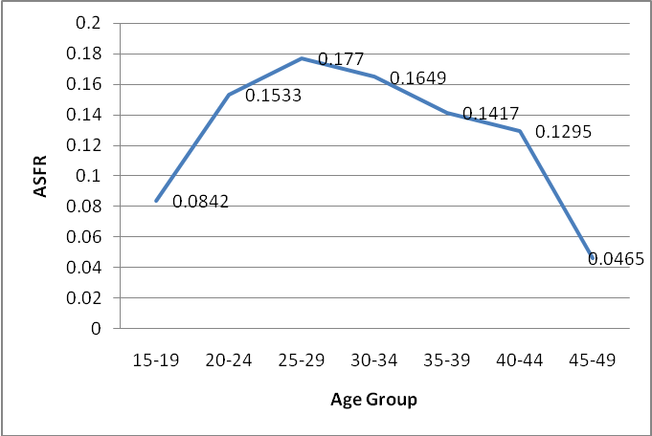

Fertility differentials

The level of fertility is influenced by various socio-economic characteristics of the mothers. Age of the mother is one of the factors that influence fertility. Education level, employment status and marital status among others influence the fertility level of a woman. The total fertility rates for these factors are presented in Tables 9.2.1 to 9.2.3. As expected, TFR is high among women in union (married or consensual). Fertility is generally low among never married women because in most populations these are young women who are either still at school and have not started childbearing. The level of fertility among divorced/ separate or widowed is not stable as this is usually influenced by age at divorcve/separation or widowed. The distribution by urban and rural is shown in Table and figure below.

Table 9.2.1 Total fertility rates by marital status of mothers, 2006 NIDS
Marital Status | Namibia | Urban | Rural
All women | 4.4 | 3.9 | 4.8
Never married | 3.5 | 3.4 | 3.6
Married legally | 5.4 | 4.9 | 5.8
Consensual union | 5.3 | 5.0 | 5.5
Divorced/separated | 4.3 | 3.0 | 4.8
Widowed | 4.0 | 4.5 | 3.8

Figure 9.2.1 Total fertility rates by marital status of mothers, 2006 NIDS
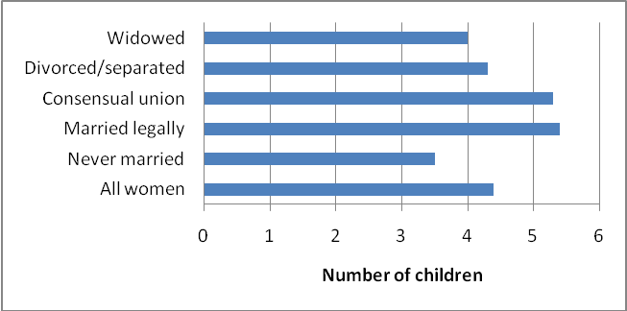

Fertility levels by mothers’ highest level of education completed is presented in Table 9.2.2 and Figure 9.2.2. In general it can be observed that, for Namibia as a whole, the higher the level of education for mother the lower the level of fertility. This is clearly seen in the case where the TFR for mothers with no education is double that of mothers with secondary or tertiary education. The pattern is the same for both rural and urban areas.

Table 9.2.2 Total fertility rates by mothers’ highest level of education completed, 2006 NIDS

Education level | Namibia | Urban | Rural
All women | 4.4 | 3.9 | 4.8
No education | 6.2 | 6.3 | 6.1
Primary | 4.7 | 4.3 | 5.0
Secondary | 3.1 | 3.1 | 3.1
Tertiary | 2.8 | 2.5 | 3.2

Figure 9.2.2 Total fertility rates by mothers’ highest level of education completed, 2006 NIDS

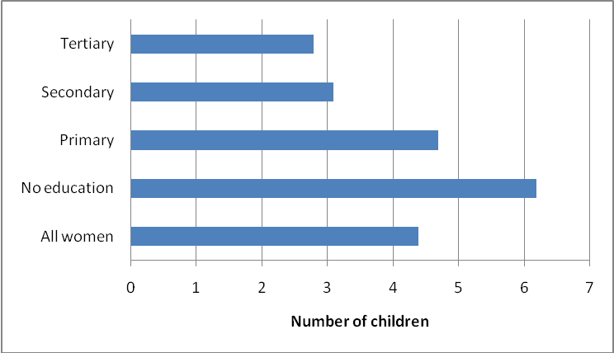

The total fertility rates by the activity status of mothers are presented in Table 9.2.3 and Figure 9.2.3. In 2006 NIDS, Namibia as a whole, mothers who are unemployed have highest fertility (4.8), followed by the employed. Overall, fertility level is high in rural areas. There is no significant difference in fertility level between employed and unemployed mothers who live in rural areas; however such a difference is significant in urban areas.

Table 9.2.3 Total fertility rates by mothers’ activity status, 2006 NIDS

Activity | Namibia | Urban | Rural
All Activities | 4.4 | 3.9 | 4.8
Employed | 4.3 | 3.8 | 4.8
Unemployed | 4.8 | 4.6 | 4.9

Figure 9.2.3 Total fertility rates by mothers’ activity status, 2006 NIDS

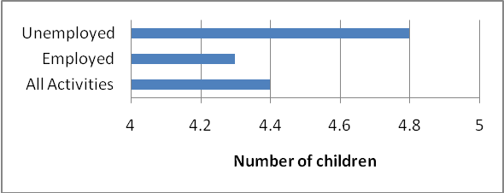

Coverage of registration of last live birth

It was previously noted that if the registration of births in the country was complete, it would not be necessary to estimate the levels of fertility using indirect methods. Table 9.3 shows the distribution of births by status of registration for the country, urban and rural areas as well as for all the regions. It can be observed that more than three quarters of all the births in the country were registered. There are significant differences between urban and rural areas. In urban areas, about 90% of births were registered, while in rural areas, about 66% of births were registered. The registration of births varies by regions ranging from about 45 percent in Kavango region to 94 percent in Hardap region.

Table 9.3 Distribution of last live birth by registration status and area, 2006 NIDS
Area | Total births | Registered | Not registered | Not stated | % registered
Namibia | 320,679 | 244,857 | 71,633 | 1,327 | 76.4
Urban area | 135,411 | 123,013 | 10,892 | 208 | 90.8
Rural area | 185,268 | 121,844 | 60,741 | 1,118 | 65.8
Caprivi | 15,472 | 12,221 | 3,007 | 82 | 79.0
Erongo | 24,111 | 21,436 | 2,133 | 82 | 88.9
Hardap | 13,401 | 12,603 | 727 | 17 | 94.0
Karas | 11,605 | 10,887 | 636 | 25 | 93.8
Kavango | 38,224 | 17,032 | 20,444 | 287 | 44.6
Khomas | 59,450 | 54,560 | 4,445 |  | 91.8
Kunene | 13,248 | 8,514 | 4,299 | 128 | 64.3
Ohangwena | 32,901 | 18,437 | 14,007 | 268 | 56.0
Omaheke | 10,146 | 7,806 | 2,116 | 94 | 76.9
Omusati | 27,808 | 19,710 | 7,576 | 229 | 70.9
Oshana | 28,100 | 24,249 | 3,715 | 38 | 86.3
Oshikoto | 23,802 | 19,587 | 4,139 | 54 | 82.3
Otjozondjupa | 22,412 | 17,815 | 4,390 | 22 | 79.5

CHAPTER 10: Mortality and Orphanhood

In measuring mortality, we are attempting to estimate the force of mortality, the extent to which people are unable to live to their biological maximum. The ability to measure accurately varies according to the amount of information available. Various techniques have been developed to provide reasonable estimates of the levels of mortality. In the 2006 NIDS, information on deaths was collected at two levels. Women in childbearing ages were asked about their total number of live births and those still surviving as well as the survival status of their last live birth. If these are reported correctly, then they would provide reasonable measures of infant and child mortality. At the same time, all households were requested to report on all deaths that occurred in the household since 2002. If there was a death in 2006, then the sex and age of the deceased was also recorded. This information will provide the sex and age pattern of mortality. Orphanhood information was collected for all members of the household. Each person was requested to state the survival status of his/her biological parents, i.e. both mother and father. This information is crucial for policy and programme interventions especially within the Ministry of Gender Equality and Child Welfare.

Table 10.1 shows the trend in the number of deaths reported by households and the Crude Death Rate from 2002 to 2006 in Namibia. The data shows a steady increase in the CDR over the five year period.

Table 10.1 Number of reported deaths, 2002 – 2006

Year | Female | Males | Total | Crude death rate
2002 | 9,599 | 11,919 | 21,518 | 11.6
2003 | 11,224 | 11,672 | 22,897 | 12.1
2004 | 11,908 | 11,891 | 23,798 | 12.4
2005 | 11,463 | 13,147 | 24,610 | 12.6
2006* | 12,299 | 13,566 | 25,865 | 13.2

Note * The deaths reported for 2006 were only for the first 10 months. Assumption of evenly distributed data was made and adjustments were made to cover all the 12 months.

Table 10.2 shows the percentage of deaths registered in 2006 for the whole country, urban and rural areas, as well as the regions. For Namibia, as a whole, 67% of deaths are registered with 76.2% and 64.1% deaths registered in urban and rural areas respectively. More than 80 percent of deaths reported in Otjozondjupa region had been registered while only 58.2% of deaths in Caprivi and 56.3% in Kavango regions were registered.

Table 10.2 Percent registered deaths in 2006 by area, 2006 NIDS

Area | Total deaths | Yes | No | Not stated | % registered
Namibia | 25,865 | 17,342 | 1,485 | 2,727 | 67.0
Urban | 6,370 | 4,853 | 145 | 310 | 76.2
Rural | 19,495 | 12,489 | 1,340 | 2,417 | 64.1
Caprivi | 1,240 | 721 | 23 | 290 | 58.2
Erongo | 814 | 652 |  | 26 | 80.1
Hardap | 1,753 | 1,235 | 33 | 193 | 70.4
Karas | 780 | 550 |  | 100 | 70.5
Kavango | 4,033 | 2,269 | 520 | 572 | 56.3
KHomas | 2,328 | 1,725 | 79 | 136 | 74.1
Kunene | 1,292 | 806 | 64 | 207 | 62.4
Ohangwena | 4,276 | 2,796 | 360 | 407 | 65.4
Omaheke | 1,466 | 973 | 41 | 208 | 66.4
Omusati | 2,748 | 1,880 |  | 410 | 68.4
Oshana | 1,918 | 1,431 | 44 | 124 | 74.6
Oshikoto | 2,002 | 1,291 | 323 | 54 | 64.5
Otjozondjupa | 1,214 | 1,012 |  |  | 83.3

Mortality indicators

There are many indicators, which are used for describing the levels of mortality. Two of these indicators are infant mortality rate, which is the number of infant deaths per one thousand live births. That is, the number of babies who die before their first birthday per 1 000 live births. The second measure is the under-five mortality rate, which is the number of children who die before they celebrate their fifth birthday per 1 000 live births. This indicator provides a good summary measure of child mortality.

The estimates of infant and under-five mortality rates are based on information from children ever born and those surviving. Various indicators of mortality are presented in Table 10.3. According to 2006 NIDS, infant mortality rate for Namibia was 47 and 53 per 1 000 live births for females and males respectively. The rate for both sexes was 50 infant deaths per 1 000 live births while in 2001 the rate for both sexes was 53. Infant deaths are higher in rural areas than in urban areas. The level of infant mortality also varies significantly by regions. The level of mortality for both sexes ranges between 38 for Omusati and Otjozondjupa regions to 68 for Oshikoto region. Thus, regions with higher infant mortality include Oshikoto, Ohangwena and Kavango in that order.

Table 10.3 Estimates of infant, under-five mortality rates and life expectancy at birth by area, NIDS, 2006
Area | Infant mortality rates |  |  | Under-five mortality |  |  | Life expectancy at birth
Area | Females | Males | Both sexes | Females | Males | Both sexes | Both sexes
Namibia | 47 | 53 | 50 | 64 | 61 | 63 | 66
Urban | 45 | 45 | 45 | 41 | 49 | 45 | 68
Rural | 49 | 57 | 53 | 81 | 71 | 76 | 65
Caprivi | 46 | 55 | 50 | 80 | 88 | 84 | 66
Erongo | 37 | 46 | 41 | 54 | 56 | 55 | 69
Hardap | 43 | 48 | 45 | 32 | 60 | 51 | 67
Karas | 40 | 41 | 42 | 44 | 38 | 31 | 68
Kavango | 57 | 66 | 61 | 123 | 77 | 101 | 63
Khomas | 55 | 48 | 51 | 40 | 47 | 43 | 66
Kunene | 47 | 46 | 46 | 61 | 76 | 69 | 67
Ohangwena | 61 | 67 | 63 | 78 | 112 | 94 | 62
Omaheke | 41 | 43 | 43 | 72 | 70 | 71 | 68
Omusati | 34 | 43 | 38 | 42 | 14 | 30 | 70
Oshana | 54 | 53 | 51 | 105 | 53 | 78 | 66
Oshikoto | 60 | 78 | 68 | 63 | 34 | 51 | 67
Otjozondjupa | 35 | 43 | 38 | 23 | 42 | 32 | 70

Under-five mortality refers to the number of children who die before they celebrate their 5th birthday per 1000 live births. Under-five mortality for Namibia is one of the lowest in sub-Saharan Africa. For Namibia, under-five mortality stands at 63 per 1000 live births. This was indirectly estimated using information on CEB, surviving and died for women of childbearing ages (15-49). There are some differentials in under five mortality level with respect to sex. In some regions i.e. Ohangwena, Caprivi and Hardap, under five mortality is higher among males than among females, while in Kavango and Oshana regions for instance, under five mortality is significantly high among females.

Mortality differentials

As with the levels of fertlity, child mortality levels are affected by the background characteristics of their mothers. These include, among others, marital status, the level of education attained as well as activity status. Estimates of under-five mortality rates are presented by these background characteristics of mothers in Tables 10.4.1 to 10.4.3 as well as in Figures 10.4.1 to 10.4.3. From Table 10.4.1 and Figure 10.4.1 it can be observed that the level of under-five mortality varies with their mothers’ marital status. Overall, the U5MR is lower in 2006 across all marital status compared to 2001, except among women who are legally married. It can also be observed that under five mortality is higher in rural areas than in urban areas. Under five mortality is significantly higher among children of widowed mothers (109 deaths per 1000 live births).

Table 10.4.1 Estimates of Under-five mortality rates by mothers’ marital status, 2006 NIDS

Marital Status | Namibia | Urban | Rural
All women | 63 | 45 | 77
Never married | 52 | 33 | 69
Married legally | 69 | 49 | 83
Consensual union | 64 | 60 | 66
Divorced/separated | 49 | 14 | 63
Widowed | 81 | 61 | 109

Figure 10.4.1 Estimates of under-five mortality rates by mothers’ marital status, 2006 NIDS

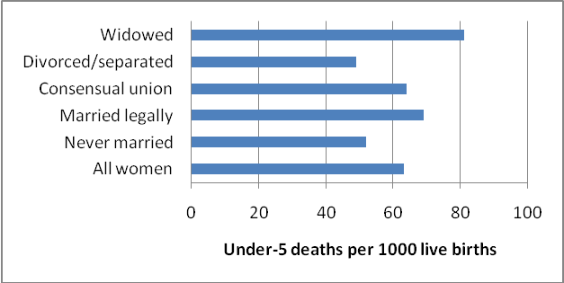

Levels of under-five mortality by mothers’ highest level of education completed are presented in Table 10.4.2 and Figure 10.4.2. There is an inverse relationship between mother’s education and under five mortality levels. Higher level of under five mortality was estimated among children whose mothers have no education level.

Table 10.4.2 Estimates of under-five mortality rates by mothers’ level of education, 2006 NIDS

Education level | Namibia | Urban | Rural
All women | 63 | 45 | 77
No education | 72 | 80 | 69
Primary | 67 | 45 | 81
Secondary | 42 | 42 | 41
Tertiary | 25 | 16 | 32

Figure 10.4.2 Estimates of under-five mortality by mothers’ level of education, 2006 NIDS

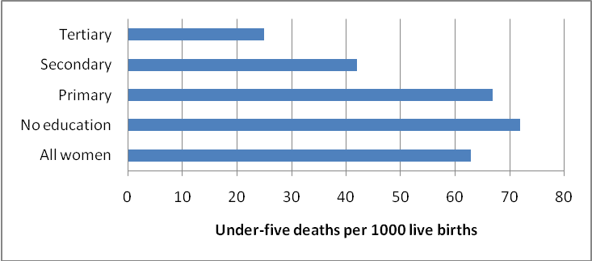

Under-five mortality rates by the activity status of mothers are shown in Table 10.4.3 and Figure 10.4.3. For Namibia as a whole, children belonging to unemployed mothers experience the high levels of under five mortality. The difference in under five mortality levels with respect to activity staus of mother is more significant between urban and rural areas.

Table 10.4.3 Estimates of under-five mortality rates by mothers’ activity status and by area, 2006 NIDS

Activity | Namibia | Urban | Rural
All Activities | 63 | 45 | 77
Unemployed | 64 | 49 | 76
Employed | 55 | 40 | 69

Figure 10.4.3 Estimates of under-five mortality rates by mothers’ activity status and by area, 2006 NIDS

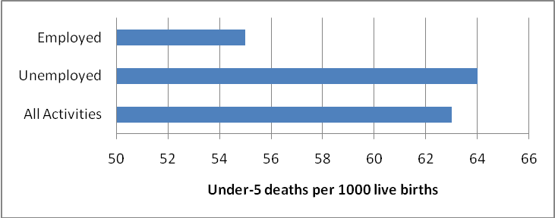

Orphanhood

Information on orphanhood, particularly for children, provides an indirect indicator for adult mortality. It also reflects on the degree of dependency at household level. Table 10.5 below presents the number of households with at least one orphaned member aged below 18 years. About 33 percent of the households in Namibia have a child under 18 years of age without one parent and 7.5 percent without both parents. There are marked differences between urban and rural areas. The percentage of households with children aged below 18 years who have only one parent is 19.7 and 41.1 for urban and rural areas respectively. The corresponding percentages of households with children who have lost both parents are 3.9 and 9.6 in urban and rural areas, respectively. Ohangwena region registered the highest number of households with children who lost one parent while Erongo region had the lowest number of households with children who lost one or both parents.

Table 10.5 Households with at least one orphaned member aged below 18 years by area, 2006 NIDS
Area | Household With children Under the age of 18 | Orphaned
Area | Household With children Under the age of 18 | By one Parent |  | Both Parents
Area | Household With children Under the age of 18 | Number | Percent | Number | Percent
Namibia | 291,506 | 97,053 | 33.3 | 21962 | 7.5
Urban area | 106,279 | 20,967 | 19.7 | 4157 | 3.9
Rural area | 185,227 | 76,087 | 41.1 | 17805 | 9.6
Caprivi | 15,195 | 5,383 | 35.4 | 1663 | 10.9
Erongo | 20,543 | 2,532 | 12.3 | 392 | 1.9
Hardap | 11,470 | 3,052 | 26.6 | 487 | 4.2
Karas | 10,010 | 1,901 | 19.0 | 407 | 4.1
Kavango | 31,089 | 13,371 | 43.0 | 3408 | 11.0
Khomas | 45,659 | 7,482 | 16.4 | 1441 | 3.2
Kunene | 11,078 | 2,339 | 21.1 | 278 | 2.5
Ohangwena | 34,416 | 19,763 | 57.4 | 4802 | 14.0
Omaheke | 9,633 | 1,757 | 18.2 | 259 | 2.7
Omusati | 34,279 | 15,986 | 46.6 | 3787 | 11.0
Oshana | 24,730 | 10,332 | 41.8 | 2391 | 9.7
Oshikoto | 24,391 | 9,333 | 38.3 | 2178 | 8.9
Otjozondjupa | 19,012 | 3,823 | 20.1 | 468 | 2.5

The number of orphaned children aged below 18 years is presented in Table 10.6. For the country as a whole, about 18.8 percent of all children under the age of 18 have lost one parent. The proportion of orphans under the same age without both parents is about 3 percent. In urban areas, about 12 percent of the children under 18 have lost one parent as compared to the rural areas where the corresponding percentage is 21.6. With regard to regions, Omusati, Ohangwena Oshana, Caprivi and Kavango regions, are the ones where more than 1 out of 4 under-18 children are survived by only one parent. Furthermore, the highest percentage of under 18 who have lost both parents were reported in Caprivi region.

Table 10.6 Number of orphans aged below 18 years by area, 2006 NIDS

Area | Number of Children Under the age of 18 | One Parent Both parent
Area | Number of Children Under the age of 18 | Number | Percent | Number | Percent
Namibia | 881,698 | 165,732 | 18.8 | 28,821 | 3.3
Urban area | 252,915 | 30,057 | 11.9 | 5,335 | 2.1
Rural area | 628,782 | 135,675 | 21.6 | 23,486 | 3.7
Caprivi | 40,273 | 9,664 | 24.0 | 2,483 | 6.2
Erongo | 42,452 | 3,396 | 8.0 | 488 | 1.2
Hardap | 30,462 | 4,597 | 15.1 | 772 | 2.5
Karas | 24,998 | 3,033 | 12.1 | 526 | 2.1
Kavango | 123,354 | 26,543 | 21.5 | 4,843 | 3.9
Khomas | 103,163 | 9,679 | 9.4 | 1,729 | 1.7
Kunene | 36,716 | 3,531 | 9.6 | 364 | 1.0
Ohangwena | 137,105 | 34,977 | 25.5 | 6,371 | 4.6
Omaheke | 25,364 | 2,854 | 11.3 | 309 | 1.2
Omusati | 113,187 | 28,932 | 25.6 | 4,860 | 4.3
Oshana | 72,045 | 17,593 | 24.4 | 2,956 | 4.1
Oshikoto | 80,945 | 15,303 | 18.9 | 2,492 | 3.1
Otjozondjupa | 51,634 | 5,632 | 10.9 | 628 | 1.2

CHAPTER ELEVEN: Migration

Migration refers to the permanent change of usual residence of a population. In most cases people migrate to where opportunities exist. It is therefore important to analyse the movement of people to examine the extent of urbanisation in the country and consequences associated with migration. The survey enumerated people at the place where they spent the Survey Reference Night of 19 November 2006. Some of these people were not counted at their usual place of residence. Likewise, some members of the population were no longer residing in their original place of birth. Others have moved to other regions. In an effort to capture information on inter-regional population movements, the survey collected information on place of birth, place of usual residence at the time of the Survey, and five years before the survey. Such information will provide indicators on lifetime as well as short time migration movements within the country. Table 11.1 presents the population by place of enumeration and place of usual residence. It can be observed that out of the total population of 1.95 million, which was enumerated in Namibia, slightly over one percent was not usually residing in the country. In the case of the enumerated urban population, only about 97 percent was actually residing in the urban areas. On the other hand, almost all the people enumerated in rural areas were usually residing there. The enumerated populations in the regions of Erongo, Karas, Khomas, Kunene, Oshana and Otjozondjupa were more than the populations which usually reside in them. On the other hand, small proportions of the populations which usually reside in the regions of Caprivi, Hardap, Ohangwena, Omaheke, Omusati and Oshikoto were enumerated elsewhere.

Table 11.1 Distribution of the population by place of enumeration and place of usual residence, 2006 NIDS

 | Population by Place of
Area | Enumeration | Usual residence | Percent
Namibia | 1,952,454 | 1,928,799 | 98.8
Urban | 695,268 | 677,110 | 97.4
Rural | 1257,186 | 1251,689 | 99.6
Caprivi | 85,224 | 86,837 | 101.9
Erongo | 134,966 | 121,926 | 90.3
Hardap | 74,495 | 76,597 | 102.8
Karas | 64,872 | 64,503 | 99.4
Kavango | 237,657 | 237,517 | 99.9
Khomas | 301,050 | 277,669 | 92.2
Kunene | 76,329 | 74,130 | 97.1
Ohangwena | 247,103 | 249,737 | 101.1
Omaheke | 60,773 | 64,668 | 106.4
Omusati | 224,256 | 232,539 | 103.7
Oshana | 159,827 | 155,010 | 97.0
Oshikoto | 161,102 | 164,313 | 102.0
Otjozondjupa | 124,800 | 123,353 | 98.8

Lifetime migration

Lifetime migration provides information on people who have moved from their place of birth and were currently residing elsewhere. Table 11.2 presents the population distribution by place of usual residence and place of birth. For Namibia as a whole, about 3 percent of the population currently residing in Namibia were born outside the country, which is about 1 percent lower than the 2001 Census figure. Urban areas depict a significant rate of lifetime in-migration where about 20 percent of the population residing in these areas was not born there. On the other hand, rural areas show a different scenario. Over 5 percent of the population born in rural areas were residing elsewhere. The regions of Erongo (35.1%) and Khomas (38.5%) have a very significant lifetime in-migration. In addition, about 20 percent of the population who were born in the regions of Ohangwena and Omusati were residing elsewhere.

Table 11.2 Population distribution by place of usual residence and place of birth, 2006 NIDS

 | Population by Place of
Area | Usual residence | Birth | Percent born in area
Namibia | 1,928,799 | 1,867,898 | 96.8
Urban | 677,110 | 551,382 | 81.4
Rural | 1251,689 | 1316,516 | 105.2
Caprivi | 86,837 | 91,714 | 105.6
Erongo | 121,926 | 79,086 | 64.9
Hardap | 76,597 | 82,296 | 107.4
Karas | 64,503 | 61,695 | 95.6
Kavango | 237,517 | 250,909 | 105.6
Khomas | 277,669 | 170,844 | 61.5
Kunene | 74,130 | 75,362 | 101.7
Ohangwena | 249,737 | 298,147 | 119.4
Omaheke | 64,668 | 59,263 | 91.6
Omusati | 232,539 | 277,858 | 119.5
Oshana | 155,010 | 147,545 | 95.2
Oshikoto | 164,313 | 160,674 | 97.8
Otjozondjupa | 123,353 | 112,505 | 91.2

Short-term migration
Inter-regional short term migration is one of the component regional population change. Table 11.3 presents the population movement at the regional level between 2001 and 2006. It can be observed that urban areas have significant net gain of 2.5 in 2006. The corresponding proportion for rural area is 0.6 percent. The regions of Omaheke, Erongo and Khomas had also a significant net gain of more than 5 percent in 2006, while Oshana and Omusati had a net loss of more than 3 percent.
The statistics on migration should be interpreted with caution though, some information collected required a person to recall events happened 5 years ago, and hence data may be subjected to recall memory errors. This is particularly the case for migration pattern of Omaheke region.

Table 11.3 Population distribution by usual place of residence in 2006 and 2001, 2006 NIDS
Area | Population | In-migration | Out Migration | Difference | % Net migration
Urban | 588,670 | 89,731 | 77,753 | 11,978 | 2.0
Rural | 1,051,246 | 84,578 | 78,549 | 6,029 | 0.6
Caprivi | 74,206 | 5,656 | 5,221 | 435 | 0.6
Erongo | 106,797 | 23,920 | 17,467 | 6,453 | 6.0
Hardap | 65,713 | 10,125 | 9,406 | 719 | 1.1
Karas | 56,520 | 8,376 | 8,920 | -544 | -1.0
Kavango | 199,358 | 9,971 | 9,084 | 887 | 0.4
Khomas | 244,135 | 56,627 | 42,545 | 14,082 | 5.8
Kunene | 59,030 | 7,281 | 7,109 | 172 | 0.3
Ohangwena | 208,583 | 24,472 | 26,906 | -2,434 | -1.2
Omaheke | 51,357 | 9,869 | 6,748 | 3,121 | 6.1
Omusati | 198,666 | 16,420 | 21,645 | -5,225 | -2.6
Oshana | 133,947 | 18,376 | 24,140 | -5,764 | -4.3
Oshikoto | 140,069 | 15,886 | 17,755 | -1,869 | -1.3
Otjozondjupa | 101,534 | 17,538 | 13,994 | 3,544 | 3.5

APPENDIX I: Glossary

Age
Total years completed by person on his/her last birthday.

Average household size
This is the average number of persons in a household

Adult literacy rate
Percentage of literate population aged 15 and more to total population aged 15 and more in a given area.

Annual exponential growth rate
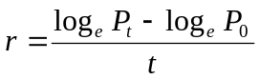 where P₀ is the census household population in 2001 and P_{t} is the estimated population in 2006.

Place of birth
The usual place of residence of respondent’s mother at the time of respondent’s birth.

Place of usual residence
The town or village where a person usually lived, i.e. where a person had lived for the past 6 months, or intended to live for the next 6 months.

Place of enumeration
Namibia consisted of 13 Regions, namely Caprivi, Erongo, Hardap, Karas, Kavango, Khomas, Kunene, Ohangwena, Omaheke, Omusati, Oshana, Oshikoto and Otjozondjupa. Place of enumeration refers to a region where the person spend the survey reference night.

Citizenship
The country of which the respondent was a legal citizen either by birth or by naturalization.

Disability
A limitation or difficulty in carrying out everyday activities at home, at work or at school, due to long term physical or mental condition resulting from health problems, birth defects or accidents. The categories are blind; Deaf; Impaired speech; mentally disabled and Impaired limbs

Marital status
It was defined as the personal status of persons in relation to the marriage laws or customs of the country. The categories are never married; married legally or customarily; married consensually; separated/divorced or widowed.

Type of housing unit
Type of housing refers to a separate and independent living premises occupied by the household.
Detached house: Is a house on its own or without an outhouse and not attached to another house
Semi- detached/town house: Is a house, which is attached to another but with its own facilities and a separate entrance.
Apartments/flat: Is a self-contained living premise in a building with one or more floors. All apartments or flats in the building will have a common entrance.
Guest flat: Is a self-contained, separated living premises in the same compound as a detached house, and usually on outhouse of the detached house.
Part commercial or industrial or business: These are living premises, which are also used for commercial or industrial purposes. A housing unit, which is partly used as a bottle store or a supermarket, or a workshop, will come under this category.
Mobile homes (caravans, tents): Refer to living premises, which could be shifted or transplanted or transported, such as tents, caravans, etc.
Single quarters: Consists of either a room or a set of rooms with shared toilet and kitchen facilities.
Traditional dwelling: A housing unit consisting of a hut or a group of huts walled or un-walled with sticks, poles with or without thatch or grass. Ongandas come under this category.
Improvised housing units (shacks): These are housing units built of discarded materials, such as cardboards, plastic sheeting, flattened empty tins, etc. Derelict vehicles and carts used as housing are also classified in this category.

Material used for outer walls
Cement blocks/bricks
Burnt bricks/face bricks
Mud/clay bricks
Prefabricated material
Wooden poles, sticks and grass
Sticks with mud or cow-dung
Other If the outer walls are constructed with materials other than the ones listed

Material used for the roof
Corrugated iron sheets
Asbestos sheets
Brick tiles:
Slate
Wood covered with melthoid
Thatch, grass
Sticks, mud and cow-dung
Other

Material used for the floor
Sand
Cement
Mud/clay
Other, specify

Main source of water for drinking and cooking and Distance to the water source
A measure of the well-being of Namibians is the proportion of households that have access to clean (potable) water. Distance to the water source also helps to derive times taken to collect household’s water needs. This information helps derive areas with serious water problems.
Piped water inside the house
Piped water outside
Public pipe:
Borehole
Borehole with open tank
Borehole with tank covered
River/stream/cam
Canal
Well, protected
Well, unprotected

Main source of energy for cooking, lighting and heating
The codes for source of energy for cooking were:
- Electricity
- Paraffin
- Wood/Charcoal from wood
- Gas
- Charcoal - coal
- Solar
- No cooking
- Other

The codes for the source of energy for lighting were:
- Electricity
- Paraffin
- Candle
- Gas
- Solar
- Wood
- Other

The codes for the source of energy for heating were:
- Electricity
- Paraffin
- Wood/Wood charcoal
- Gas
- Charcoal - coal
- Solar
- No heating
- Other

Access to means of communication
This question provides data on how news and other information reached the household. The categories below refer to accessibility to the facility/service and not ownership:
- Television
- Radio
- Newspaper, daily
- Newspaper, occasionally
- Telephone/cell
- Computer with internet
- Computer without internet

Type of toilet facility
- The household has water closet or flush toilet used only by the household members and their visitors
- The household shares water closet or flush toilet with other households
- The household members use VIP (Ventilated improved pit latrine),
- The household members use Pit latrine, long drop.
- The household members use bucket or pail
- The household members use the bush (no toilet facility)
- Other

Garbage and refuse disposal
This information can be used in obtaining the hygienic level of the household since these facilities are important for disease control and health improvement. The categories used were as follows:
- The household garbage is regularly collected
- The household garbage is irregularly collected
- The household garbage is incinerated
- The household garbage is dumped on the roadside
- Rubbish pit usage
- Other

The household’s main source of income
- Farming
- Business activities (non farming)
- Wages and salaries
- Pension
- Cash remittance
- Other

Status in employment
All employed persons of either sex, age 8 years and over, were classified in one of the categories below:
- Subsistence or communal farmer with paid employees: A person who, for at least one hour during the reference period, operated his or her own Subsistence or Communal farm and hired one or more employees.
- Subsistence or communal farmer without paid employees: Own account workers are those who, for at least one hour during the period, operated their own subsistence or communal farm, without paid employees, and worked for own consumption or profit. Included in this category are only the subsistence/communal farmers. These are people who are in crop farming (e.g. Mahangu farmers, Maize farmers, etc.) or animal farming (cattle, chickens, etc.)
- Other employer with paid employees: A person who, for at least one hour during the reference period, operated his or her own economic enterprise or engaged independently in a profession or trade, and hired one or more employees.
- Other own account worker without paid employees: Own account workers are those who, for at least one hour during the period, operated their own enterprise, e.g. farmer, petty trader or carpenter, without paid employees, and worked for own consumption or profit. These are people who are in business themselves, basket weavers, traditional beer makers, etc. Persons who were selling fruit or vegetables under trees; wayside barbers and homemakers who in addition to household duties collect and sell firewood, make and sell traditional beer, milk cattle and sell milk etc. are also included in this category.
- Employee, government and state enterprise (Parastatal): This category includes those who, for at least one hour during the reference period, worked for, and were paid from the government including state enterprises.
- Employee, private: These include those who, for at least one hour during the reference period, worked for a private employer and were paid either wages, salary, commission, tips, contract or in kind by the employer. Paid family workers are also included here.
- Unpaid family worker (subsistence/communal farmer): Unpaid family workers refer to those members of the household who are related to the head/spouse of the household and who, for at least one hour during the reference period, worked without pay or profit in the subsistence/communal farm owned by the household. 0
- Other unpaid family worker: Unpaid family workers refer to those members of the household who are related to the head/spouse of the household and who, for at least one hour during the reference period, worked in the enterprise operated by the household without pay or profit.

APPENDIX II: Estimates of sampling errors

The estimates from a sample survey are affected by two types of errors: nonsampling errors, and sampling errors. Nonsampling errors are the result of mistakes made in implementing data collection and data processing, such as failure to locate and interview the correct household, misunderstanding the questions on the part of either the interviewer or the respondent, and data entry errors. Although numerous efforts were made during the implementation of the 2006 NIDS to minimize this type of error, nonsampling errors are impossible to avoid and difficult to evaluate statistically.

Sampling errors, on the other hand, can be evaluated statistically. The sample of respondents selected in the 2006 NIDS is only one of many samples that could have been selected from the same population, using the same design and expected size. Each of these samples would yield results that differ somewhat from the results of the actual size sample selected. Sampling errors are a measure of the variability between all possible samples. Although the degree of variability is not known exactly, it can be estimated from the survey results.

A sampling error is usually measured in terms of the standard error for a particular statistic (means or averages, proportions or percentages, ratios or rates, totals, etc.), which is the square root of the variance. The standard error can be used to calculate confidence intervals within which the true value for the population can reasonably be assumed to fall. In the calculations of confidence intervals for the 2006 NIDS a 95% confidence interval is presented. This implies that for any given statistic calculated from a sample survey, the value of that statistic will fall within a range of plus or minus two times the standard error of that statistic in 95 percent of all possible samples of identical size and design.

The 2006 NIDS sample is the result of a two-stage stratified design, and, consequently, it was necessary to use more complex formulae. Hence, these calculations were carried out using the STATA software which takes into account the stratification, clustering and the weighting.

In addition to the standard errors, STATA computes the design effect (DEFF) for each estimate, which is defined as the ratio between the standard error using the given sample design and the standard error that would result if a simple random sample has been used. A DEFF value of 1.0 indicates that the sample design is as efficient as a simple random sample, while a value greater than 1.0 indicates the increase in the sampling error due to the use of a more complex and less statistically efficient design.

Sampling errors for the 2006 NIDS are calculated for selected variables considered to be of primary interest. They are presented only for average number of children ever born, total estimated population and proportion of unemployed population. For each variable, the type of statistic (mean, proportion, or rate) and the base population are given in Tables A.1 to A.3which also presents the value of the statistic (E), its standard error (SE), the number of unweighted (N) and weighted (WN) cases, the design effect (DEFF), the relative standard error (SE/E), and the 95 percent confidence limits (E±2SE) for each variable.
Overall, the relative standard error for most estimates for the country as a whole is small. There are some differentials in the relative standard error for the estimates of sub-populations. For example, to estimate the total population of Kunene region, the relative standard errors as a percent of the estimated total for the whole country is 12.5 percent. The confidence interval for Kunene region is also very wide and estimates should be interpreted with caution. The design effect (DEFF) is computed for each estimate. The DEFF for estimating the proportion unemployed are higher in each domain of estimation, i.e. DEFF is greater than 1.00 indicating an increase in sampling error due to the use of a more complex and less statistically efficient design.

Table A.1 Total Estimated Population

Domains of estimation | Estimate | Standard error | Number of observations |  | Relative error |  | 95% Confidence limits
Domains of estimation | E | SE | Unweighted | Weighted | RE=(SE/E) | RE%
Namibia | 1 952 454 | 36 726.04 | 41,892 | 1,952,454 | 0.02 | 1.9 | 1880287 | 2024621
Urban | 695 268 | 20894.68 | 15,101 | 695,268 | 0.03 | 3.0 | 654056.5 | 736478.9
Rural | 1 257 186 | 30202.88 | 26,791 | 1,257,186 | 0.02 | 2.4 | 1197732 | 1316641
Caprivi | 85 224 | 6407.09 | 2,657 | 85,224 | 0.08 | 7.5 | 72156.87 | 98291.56
Erongo | 134 966 | 8325.22 | 2,263 | 134,966 | 0.06 | 6.2 | 118139.8 | 151791.5
Hardap | 74 495 | 5393.61 | 2,466 | 74,495 | 0.07 | 7.2 | 63479.57 | 85510.02
Karas | 64 872 | 4 211 | 2,371 | 64,872 | 0.06 | 6.5 | 56284.61 | 73459.98
Kavango | 237 657 | 13331.2 | 5,397 | 237,657 | 0.06 | 5.6 | 197162.3 | 251092.1
Khomas | 301 050 | 16824.85 | 3,752 | 301,050 | 0.06 | 5.6 | 267303.9 | 334796.7
Kunene | 76 329 | 9555.38 | 2,157 | 76,329 | 0.13 | 12.5 | 56687.25 | 95969.99
Ohangwena | 247 103 | 15843.08 | 4,470 | 247,103 | 0.06 | 6.4 | 215002.1 | 279204.3
Omaheke | 60 773 | 3 986 | 2,006 | 60,773 | 0.07 | 6.6 | 52579.12 | 68966.89
Omusati | 224 256 | 10837.25 | 4,040 | 224,256 | 0.05 | 4.8 | 202316.7 | 246194.4
Oshana | 159 827 | 10595.21 | 3,668 | 159,827 | 0.07 | 6.6 | 138459.7 | 181194.5
Oshikoto | 161 102 | 6 330 | 3,567 | 161,102 | 0.04 | 3.9 | 148263.7 | 173940.4
Otjozondjupa | 124 800 | 10090.68 | 3,078 | 124,800 | 0.08 | 8.1 | 104421.6 | 145178.7

Table A.2 Average children ever born

Domain of estimation | Estimate | Standard error | Number of observations |  | Relative error |  | 95% Confidence limits |  | Design effect
Domain of estimation | E | SE | Unweighted | Weighted | RE=(SE/E) | RE% |  |  | Deff
Namibia | 2.98 | 0.03 | 20822 | 958406 | 0.01 | 1.01 | 2.92 | 3.04 | 1.46
Urban | 2.64 | 0.04 | 7,893 | 358,853 | 0.01 | 1.48 | 2.56 | 2.71 | 1.58
Rural | 3.23 | 0.04 | 12,929 | 599,553 | 0.01 | 1.24 | 3.15 | 3.32 | 1.4
Caprivi | 2.91 | 0.14 | 1,376 | 45,199 | 0.05 | 4.81 | 2.63 | 3.20 | 2.28
Erongo | 2.75 | 0.08 | 1,149 | 66,668 | 0.03 | 2.91 | 2.58 | 2.91 | 0.85
Hardap | 3.03 | 0.09 | 1,362 | 41,172 | 0.03 | 2.97 | 2.85 | 3.21 | 0.99
Karas | 2.8 | 0.13 | 1,198 | 32,500 | 0.05 | 4.64 | 2.54 | 3.06 | 2.22
Kavango | 3.11 | 0.08 | 2,705 | 118,451 | 0.03 | 2.57 | 2.95 | 3.26 | 1.06
Khomas | 2.55 | 0.07 | 1,893 | 152,885 | 0.03 | 2.75 | 2.42 | 2.70 | 1.35
Kunene | 3.46 | 0.14 | 1,269 | 45,754 | 0.04 | 4.05 | 3.18 | 3.74 | 1.29
Ohangwena | 3.39 | 0.13 | 2,115 | 111,996 | 0.04 | 3.83 | 3.12 | 3.66 | 1.68
Omaheke | 3.38 | 0.16 | 1,102 | 34,219 | 0.05 | 4.73 | 3.05 | 3.70 | 1.93
Omusati | 2.84 | 0.10 | 1,462 | 79,297 | 0.03 | 3.42 | 2.64 | 3.03 | 1.08
Oshana | 2.82 | 0.10 | 1,792 | 79,255 | 0.03 | 3.44 | 2.63 | 3.02 | 1.36
Oshikoto | 3.33 | 0.13 | 1,661 | 79,221 | 0.04 | 3.90 | 3.07 | 3.59 | 1.56
Otjozondjupa | 4.7 | 0.26 | 1,738 | 71,788 | 0.06 | 5.53 | 4.18 | 5.23 | 0.77

Table A.3 Estimated proportion unemployed

Domains of estimation | Estimate | Standard error | Number of observations |  | Relative error |  | 95% Confidence limits |  | Design effect
Domains of estimation | E | SE | Unweighted | Weighted | RE=(SE/E) | RE% |  |  | Deff
Namibia | 0.27 | 0.01 | 5,527 | 244,875 | 0.03 | 2.99 | 0.25 | 0.28 | 6.4
Urban | 0.30 | 0.01 | 2,571 | 117,408 | 0.03 | 3.27 | 0.28 | 0.32 | 3.8
Rural | 0.24 | 0.01 | 2,956 | 127,467 | 0.05 | 4.96 | 0.22 | 0.27 | 8.5
Caprivi | 0.26 | 0.02 | 328 | 9,404 | 0.08 | 8.40 | 0.22 | 0.31 | 3.0
Erongo | 0.28 | 0.02 | 394 | 22,888 | 0.08 | 7.58 | 0.24 | 0.32 | 2.9
Hardap | 0.39 | 0.03 | 447 | 14,233 | 0.08 | 7.91 | 0.33 | 0.45 | 4.9
Karas | 0.29 | 0.03 | 349 | 9,621 | 0.11 | 11.22 | 0.23 | 0.36 | 6.5
Kavango | 0.26 | 0.03 | 574 | 25,176 | 0.11 | 11.36 | 0.20 | 0.33 | 10.6
Khomas | 0.28 | 0.02 | 580 | 48,216 | 0.06 | 6.07 | 0.25 | 0.31 | 3.0
Kunene | 0.27 | 0.05 | 320 | 10,192 | 0.19 | 18.68 | 0.17 | 0.38 | 14.5
Ohangwena | 0.21 | 0.03 | 351 | 18,625 | 0.16 | 15.94 | 0.14 | 0.27 | 11.2
Omaheke | 0.39 | 0.03 | 365 | 10,903 | 0.08 | 7.69 | 0.33 | 0.45 | 3.6
Omusati | 0.13 | 0.01 | 253 | 12,797 | 0.11 | 11.02 | 0.10 | 0.16 | 3.2
Oshana | 0.44 | 0.03 | 689 | 29,354 | 0.07 | 6.98 | 0.38 | 0.51 | 5.9
Oshikoto | 0.13 | 0.03 | 250 | 9,237 | 0.25 | 24.60 | 0.06 | 0.19 | 14.1
Otjozondjupa | 0.39 | 0.03 | 627 | 24,229 | 0.07 | 6.98 | 0.33 | 0.44 | 4.9

