WILDLIFE MANAGEMENT & UTILISATION PLAN

For

Doro !Nawas Conservancy

OVERALL VISION

Doro !Nawas’ wildlife are restored to former levels and are sustainably managed and utilized for the economic and cultural benefit of present and future generations.

KEY PRINCIPLES

- A holistic approach to wildlife management will be adopted with an emphasis on sustainability of both wild animals and the veld.
- Veld condition and livestock are important and game population numbers will be encouraged to increase but not exceed levels that damage veld or impact negatively on livestock in the farming area.
- Doro !Nawas experiences severe and regular droughts. Management will avoid mass mortalities during these droughts by occasional removal of large numbers of common game, particularly ensuring that sufficient forage is left for valuable species such as black rhino.
- Where possible (in the exclusive wildlife areas) the historical range of wildlife species should be present but dangerous game should preferably not be in the farming and settlement areas of the Conservancy.
- Poaching will be viewed by Doro !Nawas as anti-social behavior and this attitude will be developed though education and awareness backed up by positive economic benefits such as income, meat, and employment in the wildlife & tourism sector.
- The increase of all species will be encouraged while trying to manage and reduce the conflict between people and wildlife (in particular large predators and elephant).
- Strategic wildlife introductions are needed to rapidly restore wildlife populations so that both biodiversity and benefit goals such as cultural, tourism and/or income generation objectives are obtained.
- Management decisions should be based on data which means that there needs to be good monitoring systems – including monitoring population trends, population health (young-adult ratios for key species), distributions of wildlife as well as rainfall, range condition and levels of HWC and Poaching.
- Decisions on the type of utilization will take into consideration the economic returns, the potential impacts on populations and conflict with other land-use activities. All utilization will be carefully monitored and regularly reported to members and to MET.

KEY OBJECTIVES

- To increase the numbers of existing wildlife species and to re-establish populations of certain wildlife species that have become locally extinct (e.g. red hartebeest)
- To manage human-wildlife conflict
- To involve and increase the understanding of the Community in wildlife management and the benefits that are derived.
- To obtain real benefits from wildlife populations
- To control game numbers with due recognition of rangeland conditions, climatic variability, and competition with rare wildlife species and with livestock.
- To manage according to good data derived from monitoring systems that provide information on rainfall, rangeland, game harvesting levels, game introductions, water distribution, poaching activity and any other management actions that may impact on game populations.

KEY STRATEGIES
- Separating conflicting forms of wildlife and land-use through zoning the area
- Increasing game populations through good management & encouraging natural population increase
- Law enforcement
- Water management
- Game introductions
- Encouraging natural immigration from surrounding areas
- Utilising wildlife, controlling numbers and reducing competition with rare wildlife species and with livestock through sustainable own use harvesting, sustainable trophy hunting and tourism development
- Monitoring to get information

An adaptive management system will be used to manage wildlife in Doro !Nawas. This means that the management strategies (in this management plan) will be regularly reviewed using information from monitoring systems, and changed if necessary. Significant changes will need a majority vote from the conservancy committee and endorsed by an AGM.

CURRENT STATUS OF WILDLIFE

Wildlife in Doro !Nawas has steadily been increasing over the past decade. Certain species namely the extremely rare and endangered black rhino exist in the Conservancy even thought these are at the very edge of their historical range. Numbers of common game species have been increasing or are stable.
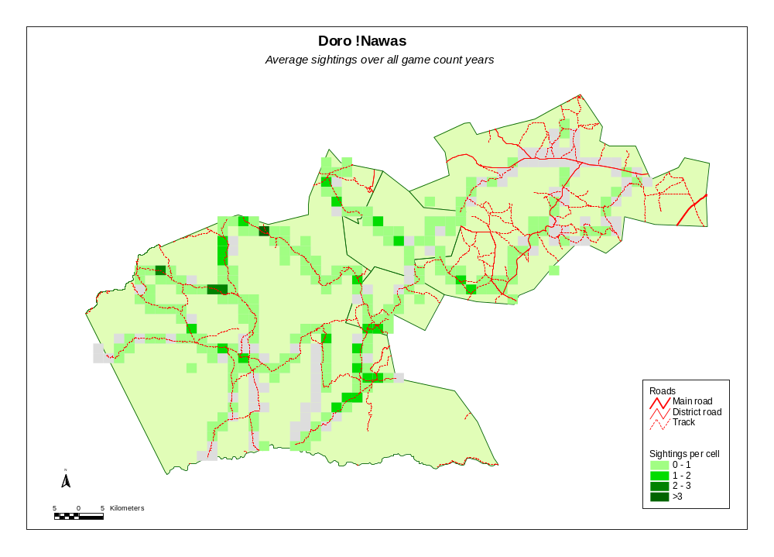
Approximate game distribution in Doro !Nawas

These are calculated from the number of sightings of all species over all years from 2000-8 made during the annual road counts in June of each year. Note that this distribution is relative to the blocks searched and thus the light grey blocks represent those areas searched but where no game was found during the annual game counts from 2000-2008. The areas between the blocks are areas not searched but this does not mean there are no animals in these areas

Based on a series of annual fixed route road counts undertaken during June of each year and adjustments using local knowledge, the following are estimated to be the approximate wildlife populations Doro !Nawas. Obtaining exact numbers of wildlife in such a large area characterized by extremely rugged terrain is impossible and thus the numbers in the following table are simply rough estimates.

Species  More detailed wildlife census results from these road counts (from June 2000) can be found in the conservancy’s filing box or in the North West Count Database to be found in CONINFO – the national knowledge management system for the CBNRM programme in Namibia. | Approximate Populations
Baboon  Bat Eared Fox  Caracal  Duiker  Elephant | Present  Rare  Rare  Rare  30
Gemsbok | 1,400
Giraffe | 30
Jackal | Common
Klipspringer | 100
Kudu | 200
Ostrich | 800
Rhino | Rare
Springbok | 8,000
Steenbok | 400
Zebra (Hartmans) | 500

It is important to note that the Conservancy is not fenced and wildlife moves freely into and out of the conservancy depending on season and where rain falls. Thus the population numbers of many species fluctuate widely from year to year and sudden increases or decreases should not be cause for major concern. Sustained decreases (or increases) over three to four consecutive years should however attract attention and possible action. The Conservancy has thus committed resources to undertake annual vehicle counts and local level-level monitoring to ensure that long-term trend data are available and is used for decision making.

The Graphs below show the trend of certain wildlife species over the period 2000 to 2008 since road counts have been conducted. The figures are based on the number of animals actually seen during the count along a number of fixed route roads that are counted each year.
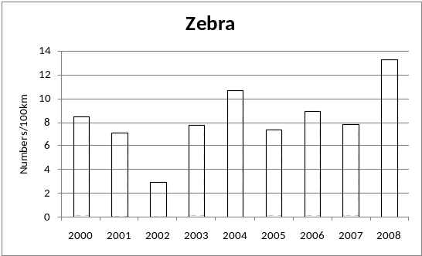
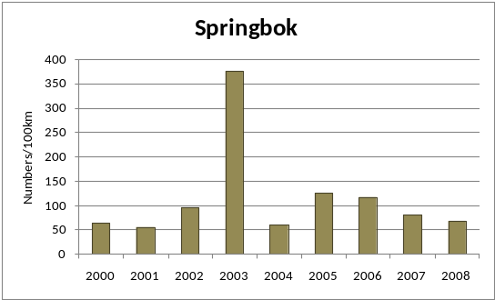
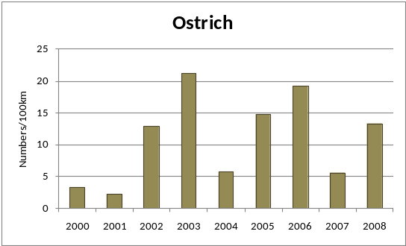
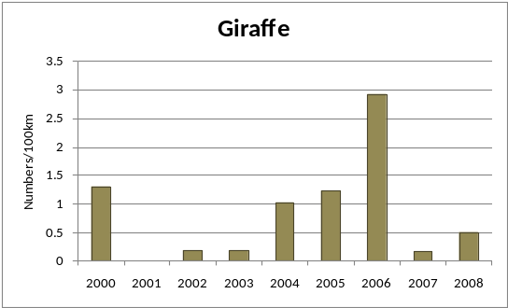
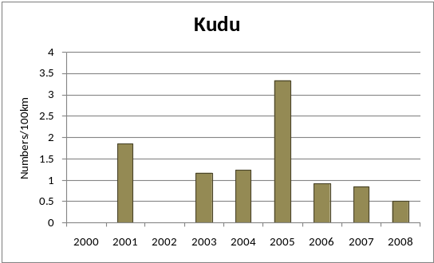
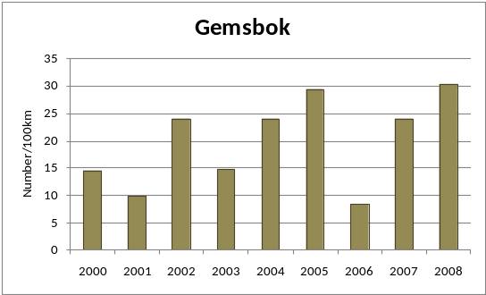

Trends of some of the more numerous species in Doro !Nawas

WILDLIFE MANAGEMENT STRATEGIES

- Objective: To separate conflicting forms of land-use through zoning the area

Vision: The land-use zones selected by members of Doro !Nawas Conservancy reduce conflicts between wildlife and people, between wildlife utilisation and other activities and to maximise returns for the various forms of land use.

Conservancy members have identified five land use zones as shown in the following table. These are indicated on the Doro !Nawas zonation map.

ZONE | ACTIVITIES
ZONE | ALLOWED | DISCOURAGED
- Joint management area with  (Doro !Nawas/Twyfelfontein-Uibasen) | Lodge; campsite; tourism; wildlife | Further infrastructure development; farming; hunting
- Exclusive Wildlife – Wildlife and Rhino sanctuary | Tourism; wildlife capture & introductions | Hunting, settlement, farming; lodges; camp sites
- Farming, livestock & general wildlife | Settlement; livestock; wildlife; lodges; camp sites; dam; tourism; own-use hunting | Introduction of dangerous game; trophy hunting
- Multiple use – wildlife & tourism area | Tourism; hunting; camp sites; trophy hunting; own-use hunting | Settlement; farming; lodges
- Wilderness lodge zone | Lodges; camp sites; wildlife; tourism | Hunting; settlement; farming

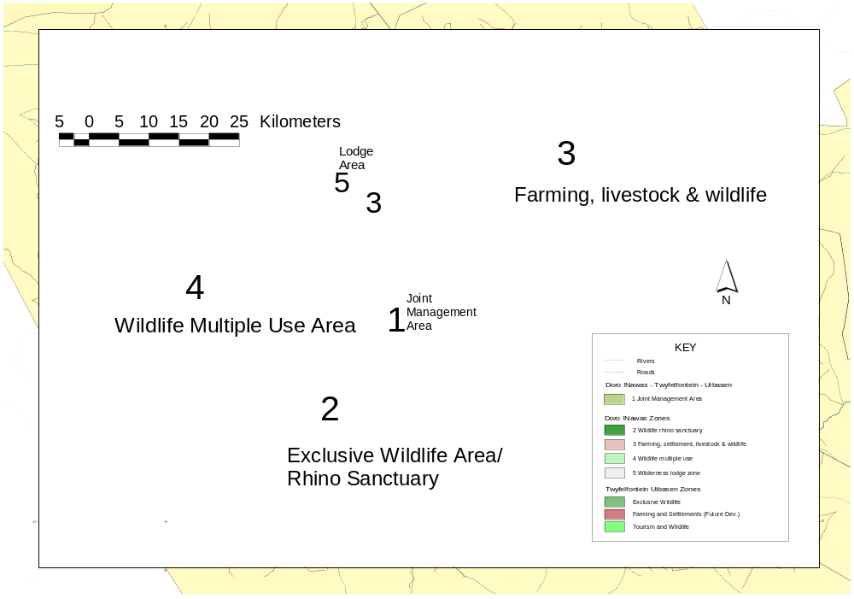

Figure 1 Doro !Nawas Conservancy Zonation Map
Zonation Strategies:

- The zonation map to be widely circulated amongst community members and conservancy stakeholders in order to develop a common zonation vision for the conservancy.
- It is necessary to work closely with key stakeholders and in particular the Traditional Authority, long term tourism partners (eg Doros Lodge) and relevant government departments to consolidate the zonation plan.
- Where possible actively enforce the zonation rules - if it is not possible to enforce the rules due to legal constraints find ways to discourage adverse activities.
- Attempt to secure tourism concessions in the Exclusive Wildlife - Rhino Sanctuary as soon as possible to justify its existence to community members through production of tangible benefits.
- Actively and immediately intervene if people begin to settle or use the Non-Farming Zone for livestock.
- Clearly indicate, on the ground through signs, where the different zones begin and end so that all stakeholders understand where the zones are and what is allowed and not allowed.
- Develop game utilization procedures to minimize the conflict between the different types of wildlife utilization

Actions | Timing
- Develop utilization manuals
- Distribute zone map to community and get agreement
- Inform stakeholders and neighbours
- Make and erect appropriate signage
- Change new hunting contract to reflect new zonation as soon as existing one expires

- Objective: Game population recovery including active re-introductions

Vision: Existing populations of wildlife are allowed to rebuild or are bolstered by reintroduction so that they become numerous enough to support own-use hunting, live sale and a quality tourism and trophy-hunting product.

Principles:

- Wildlife conservation and reintroduction will continue so that the Conservancy has, within its exclusive wildlife zones, a full complement of species that support a diverse range of tourism, hunting and game harvesting activities.
- In the Farming Zone the wildlife focus will be on plains game, not large predators and elephant, which cause considerable human wildlife conflict.
- The introduction of species that have never occurred naturally in the area will not be considered as this will distract from the wilderness product being marketed by both the tourism and hunting operators
- Game should always be introduced in sufficient numbers that viable breeding populations are established, rather than small token introductions
- The post–release monitoring of introduced animals is extremely important to determine whether the animals survive translocation, remain in the area and whether they are subsequently breeding.
- All game to be introduced should, where ever possible, be obtained from similar arid habitats (i.e. arid western parts of Namibia)

Strategies:

  - The main strategy will be to maximize breeding of existing populations by avoiding any adverse activity (such as poaching, incorrect harvesting, settlement and disturbance at water points, etc) that might harm breeding and survival.
  - In addition the Conservancy will constantly explore opportunities to acquire game through donations and mutually beneficial exchange deals with the private sector and other communities.
  - The Conservancy will ask specialists for advice on which species should be introduced in order to ensure that they have a reasonable chance of survival under current conditions, including community acceptance given the other forms of land use in the area.
  - Species that are not natural to the area will not be introduced.
  - The conservancy will be willing to enter into custodianship or stock-loan schemes in order to acquire high value species.

Actions | Timing
- Seek support for introductions of species still required (e.g. hartebeest, black faced impala, etc)
- Identify release sites and prepare water, fencing, etc
- Make community aware of the release of the animals
- Translocate the animals into the area | Winter
- Implement the post-release monitoring system | Straight after release
- Compile post-release monitoring report | One year after release

- Objective: Game Utilization

Vision: Sustainably utilize game in different ways to maximize economic returns, minimize ecological impacts and eliminate conflict with Tourism and between the different harvest enterprises such as Trophy hunting, own use, shoot and sell and game capture.

Game population management will address the challenge of balancing the different utilization needs of trophy hunting, biltong hunting, own use, and tourism. Own-use is also an objective and this will be carefully managed because harvesting game for own-use (and capture and sale) can impact on trophy quality and tourism. Careful cost benefit of all these utilization strategies will take place in order to ensure that the benefits of harvest in such a large and rugged area outweigh the costs.

As wild animals migrate in and out of the conservancy, ‘last minute’ changes will have to be made to planned large off-takes of game. Minor population fluctuations due to good breeding and slow attrition during wet and dry cycles will not be cause for concern.

Strategies:

- Game numbers for each species will be allowed to build up to the thresholds shown in the table below. In setting these thresholds, it needs to be borne in mind that livestock farming in Doro !Nawas is a core activity in much of the Conservancy and so stocking rates of wildlife need to be limited to also accommodate livestock. Numbers of elephant can fluctuate as they move in and out of the conservancy.

Conservancy size = 407,000 ha.
Species | Present Population | Desired Population | Density index for desired population
Species | Present Population | Desired Population | Numbers per ‘5000ha farm’
Elephant | 30 | 40 | 1/2
Rhino | Rare (3*) | 26 | 1/3
Springbok | 8,000 | 8000 | 100
Gemsbok | 1,400 | 3200 | 40
Zebra (Hart.) | 500 | 1000 | 13
Kudu | 200 | 1600 | 20
Duiker | Rare
Steenbok | 400 | 800 | 10
Ostrich | 800 | 1000 | 13
Giraffe | 30 | 80 | 1
Klipspringer | 100 | 160 | 2
Eland | - | 240 | 3
Impala (BF) | 49* | 240 | 3
Hartebeest | 185* | 240 | 3
To better visualise population numbers, imagine a 5000ha farm and calculate densities of the population for this farm by dividing the estimate by 80.

This gives a standard index - Numbers per 5000ha farm – which is easy to understand in practical terms.

Compare the density of what you have with the densities in the third column of the table. If greater, then that species has reached its threshold and can be harvested at higher off-take rates (see table below).

*animals introduced

- The following table contains the harvest off-take rates to be used. These should be adjusted in relation to changes in trophy quality and population response. Particular consideration is required in setting quotas for trophy elephants as they are shared with neighbours and are an important regional biodiversity asset.

 | Before Desired Population Size Reached |  | After Desired Population Size Reached
Species | Trophy (%) | Other-use (%)# | Trophy (%) | Other-use (%)##
Baboon | 2% | - | 2% | -
Caracal | 1 animal/yr | - | 1 animal/yr | -
Elephant | Don’t hunt unless very old, in poor condition & in consultation with MET & neighbours
Gemsbok | 2% | 3% | 2% | 15%
Giraffe | 1% | - | 1% | 5%
Jackal | 10 animals/yr | - | 10 animals/yr | -
Impala (black faced) | 2% | Never | 2% | 10% (Capture only)
Klipspringer | 2% | - | 2% | -
Kudu | 2% | 3% | 2% | 10%
Leopard | 1 animal/yr | - | 1 animal/yr | -
Ostrich | 3% | 5% | 3% | 10%
S. Hyena | 1 animal/yr | - | 1 animal/yr | -
Springbok | 2% | 5% | 3% | 20%
Steenbok | 2% | 3% | 2% | 10%
Zebra (Hart.) | 2% | - | 5% | 8%
Notes:
# Only males will be hunted until desired population sizes are reached
## Females may be harvested once population sizes have been reached
Off-take rates & types of off-take change as desired population sizes have been reached
- ‘Other-use' includes local meat consumption or live capture and sale. Where a species has a high capture value relative to meat value the preferred use will be capture and sale.
- An annual road game count will be conducted each year and used, together with other sources of information (the Event Book, local knowledge, MET aerial Census, hunters’ reports, etc.), to establish off-take quotas using the rates listed in the table above. Because of the movement of animals into and out of the Conservancy, the average of the last three population estimates will be used. If, however, there have been major mortalities, removals or game movements in the previous years, it might be necessary to rely only on the most recent population estimate.
- The annual road game counts will, as far as possible, be synchronized with counts on neighbouring properties so that the quotas can take account of regional movements of game. In some instances, the Conservancy will try to liaise with neighbours on the possibility of sharing quotas for rarer animals (e.g. very old elephant/rhino in poor condition).
- Quotas will also be dependent on population trends and health, trophy quality and trophy search effort.
- Quotas of predators and species such as duiker, steenbok and klipspringer will not change from those proposed in the table above until further information becomes available. Trends in indices of these populations, as well as search effort will be closely monitored to evaluate if the quotas are sustainable. The opinion of the trophy hunter from the previous year will also be used to make decisions on trophy quotas
- Hunting of predators, duiker, steenbok and klipspringer will not be allowed in the Wildlife Sanctuary area.
- The veld will also be monitored. Quotas of veld products for harvesting will be decreased as soon as signs of forage limitation (grass and browse) or veld degradation become evident.

Actions | Timing
- Develop posters to display annual game count results and local level wildlife monitoring outcomes in relation to off-take quotas | Annually
- Set Annual harvest quotas and submit to MET for approval | Annually in October
- Secure Trophy hunting contract | Annually in Nov/Dec
- Hold pre-hunt meeting with operator | March each year
- Hold regular co-ordination meetings between trophy hunter, game capture, conservancy hunters and tourist operators to reduce conflict incidents | During the hunt season
- Compile annual trophy hunting report | Annually in October
- Train a team to harvest animals for own-use and set up a local system to control utilization
- Develop game meat handling facilities and a meat distribution system
- Develop & Implement a system to monitor veld condition and modify quotas
- Ensure that all off-takes are recorded as soon as possible after event and reported to MET | Ongoing

- Objective: Law enforcement

Vision: A zero tolerance approach to law enforcement is followed.

Strategies:

- The conservancy will employ game-guards to educate the community and stop poaching
- Anti-poaching patrols will be conducted at regular but unpredictable intervals and in collaboration with MET
- The conservancy will consider developing a reward system and let it be widely known that such a system exists to deter poachers
- Conservancy members will be educated so that they understand the value of game, in particular the value of the different species
c) The zero tolerance approach to poaching will be widely promoted throughout the area and will involve a wide range of partners including the Traditional Authority
d) The conservancy will work with MET officials on joint patrols, monitoring, apprehensions and collection of evidence.
e) Game guards and staff will be trained to correctly preserve and collect evidence so that arrests result in convictions

Actions | Timing
- Encourage community members to report poaching | Immediate and at each AGM
- Develop a reward system for informers (to be discussed
- Law enforcement training for game guards
- Hold joint MET-Conservancy anti-poaching activities | As soon as possible and at least twice a year
- Generate materials to inform members as to the value of different game species
- Train guards to collect evidence

- Objective: To supply water for wildlife, people and livestock

Vision: All artificial water points are protected from damage by wildlife in particular elephant, and water is available at all these including natural water holes for wildlife so that there is no competition for water between humans, livestock and wildlife.

Strategies:

  - Game water points will be constructed so that they are aesthetically pleasing (have a natural appearance) and where possible used as tourism sites so as to ensure that they are maintained.
  - All pumping and water storage equipment in the entire conservancy will be protected against damage by elephant and other wildlife
  - All game and livestock water points in the areas where elephant occur will, in addition to protection, also make provision for the supply of clean water to elephant so that they do not break water equipment.
  - A strictly enforced water maintenance schedule will be maintained at all times and will include both pumping equipment as well as water point protection facilities.
  - In the farming areas and where possible and necessary, game water drinking facilities will be developed some distance away from homesteads to ensure that game can drink undisturbed.
  - Use conservancy revenues and seek additional funds from donors, operators and the game products trust fund to protect water points.

Actions | Timing
- Inventory of all water points detailing their status with respect to protection and supply of water for game
- Develop water protection plan and proposal and submit to donors to access funds.
- Acquire funds and implement the plan above

- Objective: To reduce Human-Wildlife Conflict

Vision: Systems in place that as far as practical reduce human-wildlife-conflict to minimal levels.

Elephant and large predators cause most of the serious human wildlife conflict incidents in Doro !Nawas. Large predators (cheetah, hyaena, leopard, jackal and lion) kill livestock whilst elephant compete with livestock for water, damage water installations, kill livestock (and sometimes people) and damage homestead gardens. All these species are protected and all with the possible exception of jackal, are valuable for both trophy hunting and tourism. It follows, therefore, that eliminating these species from the conservancy is not desired and should not be permitted nor desired. This will mean that innovative conflict management systems have to be put in place.

Strategies:

  - Ensure settlement and farming does not take place in the exclusive wildlife zones
  - Protect all water points from damage by elephant
  - Provide alternative water for elephant to keep them away from homesteads / kraals
  - Use techniques such as chili bombs to keep elephant away from gardens and homesteads
  - Ensure livestock are kept in secure kraals at night to protect them against lion, hyaena, jackal and leopard
  - Where possible use herders or guard dogs to protect livestock against attack from predators (mostly cheetah and jackal) during the day
  - Keep close watch over juvenile livestock, particularly small stock
  - Implement an early warning system for lion, should a pride move into a particular area – giving people an opportunity to take special care to kraal their animals at night
  - If feasible implement a self insurance scheme to cover those persons who have taken all due care but still suffer damage from wildlife
  - Implement a predator and problem animal monitoring system (using the Event Book) to keep track of Human Wildlife Conflict as well as abundance and trend of predators.

Actions | Timing
- Finalize, agree and enforce the zonation map
- See water plan for actions to protect water points
- Investigate use of Chili Bombs – consult with Caprivi colleagues
- Develop a practical plan to systematically over-time build protective kraals for livestock
- Investigate the practicality of establishing a self insurance scheme for HWC
- Develop or obtain and circulate a information brochure/poster on how community farmers can minimize HWC

- Objective: To provide information for effective management

Vision: Develop and maintain a monitoring system that will provide data for improved adaptive management decisions.

Principles

- The monitoring system will be owned and operated by the Conservancy
- All data will belong to the conservancy and will thus focus on issues of direct concern to the conservancy.
- Data will however, be shared with neighbours and stakeholders as necessary.

Doro !Nawas was one of the pioneering conservancies in establishing the ground based annual ‘Road Counts’. It also has implemented the Event Book monitoring system.

Strategies:

- The Event Book monitoring system will be maintained. It will include monitoring natural resources, financial, business and institutional management activities.
- This system will be used to provide monthly and annual summaries to provide long term trends over many years.
- Annual road based game counts will be conducted in partnership with MET and other service providers.
- Monitoring reports (monthly and annual) will be freely available to the broader membership and shared with relevant stakeholders (eg MET etc)
- Engage the Trophy hunting and Lodge operators and encourage them to establish monitoring systems and to contribute information to improve management.
- Maintain a neat and tidy record keeping system (Event Book Filing Box), renew and archive materials annually in early January and participate in an annual monitoring audit survey.
- Compile an annual monitoring report

Actions | Timing
- Maintain the Event book system: | continuously
- Hold annual monitoring audit meeting and analyse/summarise and report on monitoring information | January of each year
- Conduct an annual road count: | June each year
- Monitor introduced game (if game introduced then monitor these animals for at least two years

Doro !Nawas Annual Work Plan (draft)
 | 1st Quarter |  |  |  |  |  |  |  |  |  |  |  | 2nd Quarter |  |  |  |  |  |  |  |  |  |  |  | 3rd Quarter |  |  |  |  |  |  |  |  |  |  |  | 4th Quarter
 | Jan |  |  |  | Feb |  |  |  | Mar |  |  |  | Apr |  |  |  | May |  |  |  | Jun |  |  |  | Jul |  |  |  | Aug |  |  |  | Sep |  |  |  | Oct |  |  |  | Nov |  |  |  | Dec
Law Enforcement
Undertake regular patrols
Gather intelligence
Conduct joint MET-Conservancy anti-poaching activities
Conduct road blocks
Game Count
Planning meeting - routes & dates set
Logistics, participants, training
Conduct Game Count
Update population trend charts
Water mgt plan
Inventory water points
Wildlife utilisation
Hold planning meeting/quota setting
Hold meeting with MET for approval of quota
Advertise tender for trophy hunting
Secure trophy hunt contract
Plan own-use hunting
Conduct own-use hunts
Distribute meat
Obtain reports from hunts
Compile/obtain annual trophy hunting report
Human-wildlife conflict
Investigate incidents
Communications
Conduct monthly event book meetings
Present wildlife report to management meetings
Present wildlife report to AGM
Display wildlife info for members
Conduct Event Book audit
Order new Event Book materials

Doro !Nawa’s Five Year Development Plan (to be completed by conservancy)
WILDLIFE | done | 2010 | 2011 | 2012 | 2013 | 2014
Implement event book system for monitoring
Establish Community Game Guards (CGGs) team
Train CGGs in:
event book system monitoring
patrolling
law enforcement (as per MET Peace Officers)
dealing with tourist infringements (off road driving etc)
Train Committee in:
Information interpretation
Management decision-making
Train selected members in best hunting practices
Train selected members in livestock protection
Develop law-enforcement guide to include:
Policies for law-enforcement
Conservancy rules
Zonation rules
Relevant Laws (see below)
Obtain wildlife introduction/translocation plan
Develop detailed human-wildlife conflict mitigation plan
Develop comprehensive self-insurance scheme
TOURISM
Develop comprehensive tourism plan to include:
development options
policies for sustainable tourism
Signage & information
select suitable lodge sites
Tender joint venture lodges

