IMPACT OF EMERGING CHARCOAL PRODUCTION IN THE MIOMBO WOODLAND OF CHITEMBO – BIÉ PROVINCE, ANGOLA
Introduction
Africa uses approximately 90% of its wood removal for energy production, and about 30% of wood fuel extraction is used directly for charcoal production (FAO, 2011a). Africa alone accounts for 63% (~ 30 million tons) of global charcoal production, and since 2004 the production of charcoal in the continent has increased by 30%, the highest rate of increase globally (FAO, 2011a).
Charcoal production involves different steps, which starts with selecting of the kiln site, selective logging of tree stems of a preferred size and species, where extraction is concentrated around temporary traditional earthen kilns (Chidumayo, 1991). The earthen kilns have low efficiency requiring large amount of biomass for low charcoal returns, and take several months for combustion completion, where after they are abandoned. The charcoal is sold mainly along roads for transport to larger urban centres, causing forest disturbance and degradation to occur along roads (Luonga et al. 2002; Malimbwi et al. 2005). Areas with high demands for charcoal production can become almost completely deforested, as selectivity of trees for size and species is superseded by economic incentives (Ahrends et al. 2010).
In Angola about 62,3% of the population lives in urban areas and only about 37,7% lives in rural areas (2014 Angolan population census preliminary results), and has on fire wood, charcoal, bush meat, honey, insects, wild fruits, fresh fish water as main source of subsistence (MINADER/MINUA, 2006). This significant part of population in rural areas uses also firewood and charcoal as main source of domestic energy and additionally as income. The annual demand of firewood and charcoal is estimated in 6 millions of cubic meters per year, which corresponds, at market prices, of approximately 510 million US dollars not taking in PIB account. Angola has an enormous potential of forest biomass. The use of biomass to generate energy is responsible for 57% of total energy consumed in the country, the firewood and charcoal represents a primary source of energy for domestic needs. In this context Luanda is the major centre of charcoal consumption produced in others provinces, particularly in Huambo, Bié and Cuando Cubango provinces, where high level of biomass extraction has been resulted in serious implications in the environment, resulting in deforestation and biodiversity loss.
The study aims to understand the impact of charcoal production on deforestation and land degradation in the study area, under the frame of The Future Okavango Project SP05. The project has funded by Germany Federal Ministry of Education and Research (BMBF) aiming to provide scientific support for sustainable land and resource management in the Okavango basin of Angola, Namibia and Botswana.
Methodology
The charcoal production in the core site were assessed in four villages (Sove, Munda, Satchijamba and Kempo grande) along the main road toward Menongue. Assessment was done by kiln site and charcoal producer identification, followed by short interview consisting in two different parts: The first part addresses to understand the livelihood within the families and the second part addresses to understand the charcoal production in the villages and income derived from.
The earth kiln was measured its size, the number of trees (stumps) felled were counted. The largest and smallest trees were also measured its DBH with measuring tape and tree height canopy measured with Haglöf Digital Clinometer.
Charcoal production in the study areas
The charcoal production in Sove (core site village) is few and recent, but increases along the road toward Menongue, the earth kiln can be seen easily along the road (Figure 13) and representing now the first source of income following agriculture and honey production. The charcoal produced is normally sold along the main road for a very low price and sometimes is produced in large scale for traders coming mainly from the main urban centers such as Luanda. At Caiundo core site the charcoal production is insignificant and does not exists in fact. The charcoal production process comprises according Herd, 2007 in five different steps. Step (1) Kiln site identification, this step involves the identification of a suitable site for charcoal production and includes many factors such as preferred tree species and size and proximity to the village and main road; (2) Material preparation, comprises the felling of trees, the felled trees are then disbranched and crosscut into uniform length to laid the arrangement of logs during the construction; (3) Kiln construction, this step involves the construction of the kiln base, the second stage involves the stacking and arrangements of logs for the main body of the kiln, finally covering the kiln with grasses, fresh leaves and sand; (4) Carbonization process in initiated by lighting a fire in the ignition at the base of the kiln; (5) Sorting and selling is the final step of charcoal production, the charcoal produced is separated from kiln insulation material and is bagged and transported to the villages to be sold along the road or stored for selling to traders from the main cities (Figure 14).
Results on charcoal production in Chitembo core site
Livelihood
During the long period of civil war in Angola, many people from rural areas moved to the main urban centres for security reasons. It was the main cause of deforestation around the main cities of the country. With the end of war the people is returned to its places of origin and they have on agriculture and charcoal production as main source of income and subsistence, causing significant impacts on vegetation also in rural areas.
In the Chitembo core site for instance the agriculture, based on shifting cultivation and charcoal production contributes for income and subsistence of families and in other hand these activities are the main cause of deforestation and land degradation. Maize, cassava, beans and pumpkin are the most important cultivated products. The forest products are also important and play an important role in improving the diet of families (Figure 1).
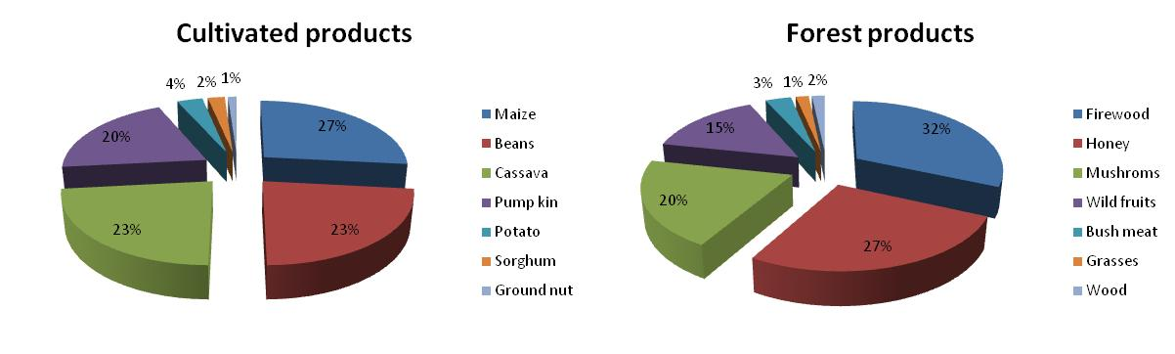
Figure 1 .: Percentage of cultivated products and forest products in the villages assessed (n = 27)
In the majority of cases, the interviewers said that the cultivated products only serve to maintain the family. They have also to buy food and other important products such as oil, soap, salt, dried fish etc. The money obtained from charcoal production and honey contributes more for family income and to make some savings to be used in critical situations such as diseases or death in the family. Both activities (charcoal production and honey production) have a strong impact on the vegetation. It has been observed that the removal of bark from trees for the beehives causes the death of the whole tree. Hunting is also decreasing in the core site, the wild animals were severely reduced after the end of war with the introduction and no controlled shooting guns.
Age and size of families
The population of charcoal makes has age ranged from 18 years and older than 51 years old. Although the charcoal activity appears to be dominated by age ranged from 21-30 to 31-40 years old. Related the size family the number of family members is in general large with children age ranged from 0 to 10 years, it was observed that the number of children is mainly dominated by female than male (Figure 2).
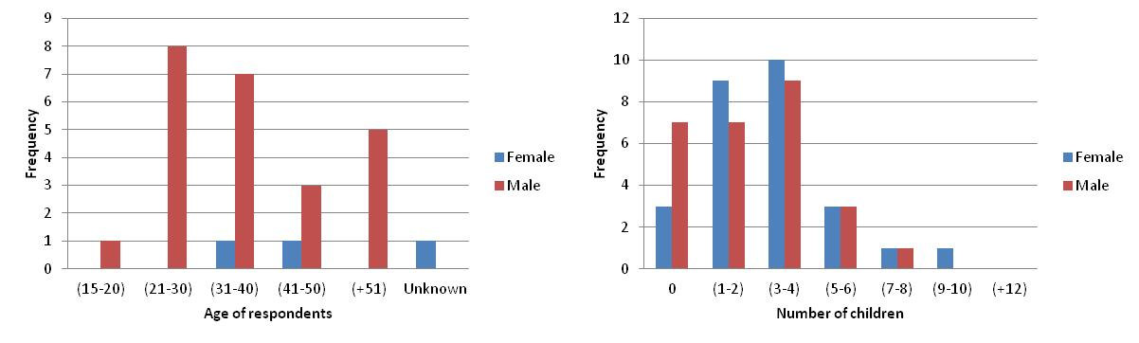
Figure 2 .: Histogram of age of respondents and number of children between charcoal makers (n = 27)
Sex and marital status of respondents
The sex of respondents is mainly composed by men compared with women, normally they are married, few respondents corresponding to 7 % are single, not married and 4 % are divorced (Figure 3). The charcoal production is mainly made in families and men are responsible for felling the trees, the rest of family helps with the next steps of the process including transportation to the village to be sol along the road. When the kiln is done by women, normally they pay someone in general men to help of felling trees and cut it into small logs and during the kiln construction.
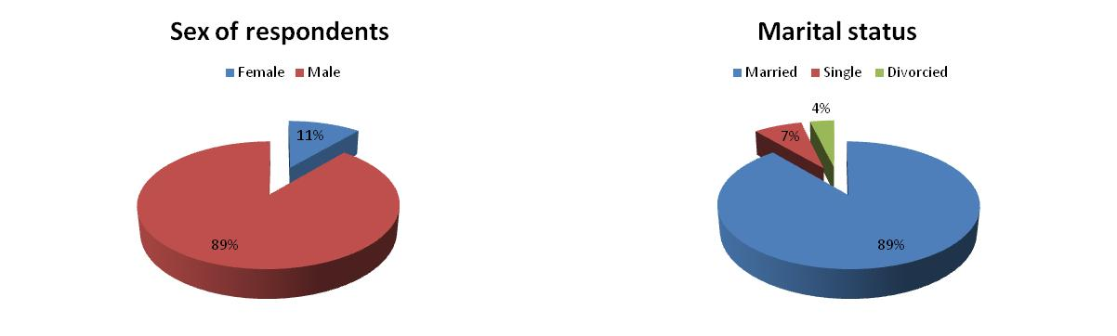
Figure 3 .: Percentage of sex and marital status in charcoal producers (n = 27)
Schooling and employment
In general there are few infrastructures within the villages, such as schools, hospitals and churches. When exist it works in very rudimentary infrastructures made normally by the community. Only children are allowed to attend the school up to 6.ª grade and 4.ª in some cases. The adult population normally never attended the school, or only attended in colonial time up to 4.ª or 6.ª grade. At the same time no one is employed, in the villages apart from the traditional authorities “sobas”, which receive a amount of about 16.000 Angolan kwanzas monthly, corresponding to approximately 160 U$ American dollars (Table 1). This situation implies that the major proportion of population have in nature and natural resource as the main source to satisfy their daily needs, allowing the fact that low or no attention has been given by the authorities to the forestry sector.
Table 1 .: School attendance and employment in charcoal producers by sex at the core site (n = 27)
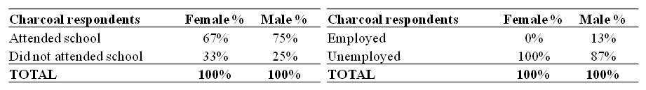
Provenance of charcoal producers
The majority of charcoal producers is not native of the villages assessed, but came for different reasons. The most important reason cited by interviewers was family corresponding to 73 %, War corresponding to 14 %, charcoal, marriage and religious reasons represents each 4 % of the answers (Figure 4). They came mainly from others villages close to the core site like: Camitcha, Malonga, Muandumba, Mumbué, Njamba and Tchingueia. And from others important urban centres such as: Camacupa, Chitembo, Luena in Moxico province and Menongue in Cuando Cubango province.
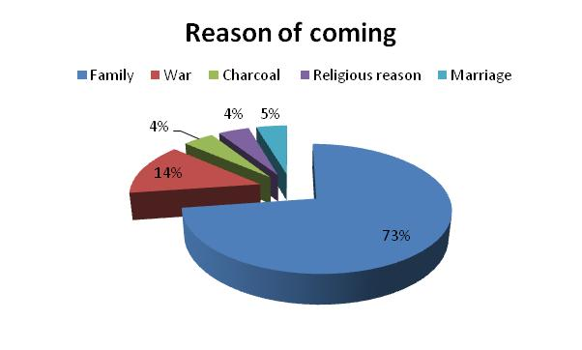
Figure 4 .: Percentage of reason of coming in the charcoal producers interviewed (n = 27)
Kiln characteristics
The charcoal kilns at the villages assessed varied in size and number of bags sorted out. In general the shape of charcoal kilns is rectangular varying in size. According the measurements obtained on ground we divided it into three categories: Small kilns ranged from 0 – 10 m³, Medium kilns ranged from 10 – 20 m³ and large kilns greater than 20 m³ in size. The stage of construction varied from beginning (initial stage of construction), burning and final stage, when the charcoal is removed out and packed for commercialization. The number of bags per kiln varied from 29 bags in small and medium and 70 bags in large kilns (Table 2).
The local of kiln construction is normally in woodland for the large kilns. The small kilns are normally constructed along the road for women and due to the ease to be transported to the main road.
Table 2 .: Volume size and number of bags sorted out per charcoal kiln at the core site (n = 27)
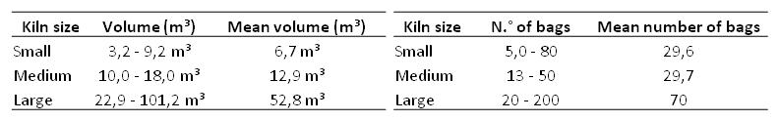
Kiln construction and efficiency
The time of kiln construction varied within the respondents (Figure 6). Many of them mentioned that they take one to two weeks for completion of charcoal production divided into three main phases (Felling trees, construction phase and burning).
The kiln construction in the study area follows the same standard in southern Africa with only one difference in the kiln base, which consists in the removal of sand where the logs will set. The sand removed is later used as insulation material of the kiln (Figure 5).
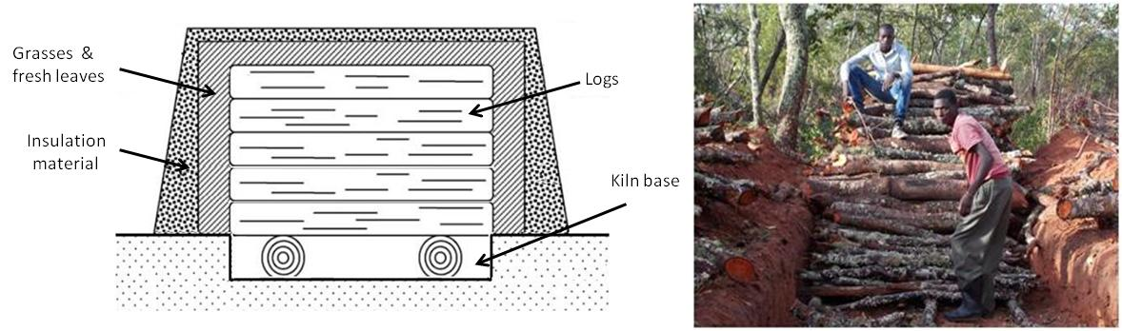
Figure 5 .: The kiln construction in the study area, the figure in left was adapted from Herd, 2007.
According to the respondents their kilns are efficient and burns well. The estimated period of burning, depending on size is from three to four weeks.
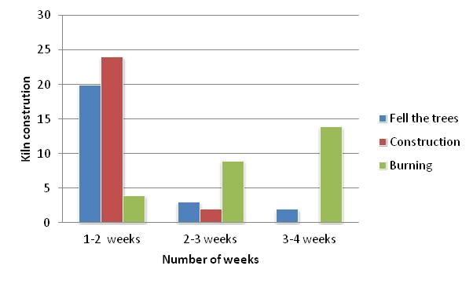
Figure 6 .: Histogram of kiln construction divided into three different phases.
Used trees in the kiln & preferred trees
The four most important trees found in the kilns assessed were respectively Julbernardia paniculata, Brachystegia spiciformis, Cryptosepalum exfoliatum subsp. pseudotaxus and Burkea africana. The charcoal producers also give importance at the same species as preferred species for charcoal making, with exception of Diplorhynchus condylocarpon and Uapaca nitida, which normally are not good for charcoal and consequently are not used frequently (Figure 7).
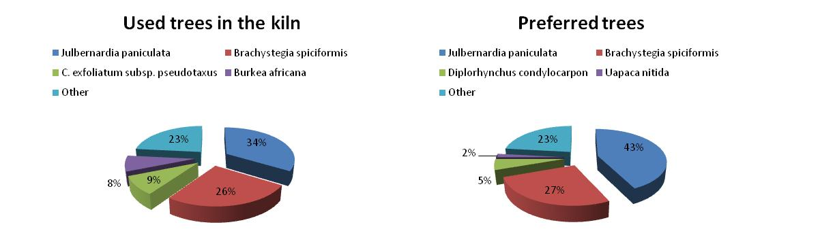
Figure 7 .: Percentage of used trees in the kilns assessed and preferred trees species for charcoal.
Non preferred trees & Prohibited species
Charcoal producers have certain species on which they never fell, the reason is that those species are not good for charcoal or because of hardness of its trunk or because are charcoal smoke makers. The top five of non preferred species is represented by the following species: Pterocarpus angolensis, Lonchocarpus capassa, Parinari curatelifolia, Erythrophleum africanum, Bobgunia madagascariensis and many other species referred (Figure 8).
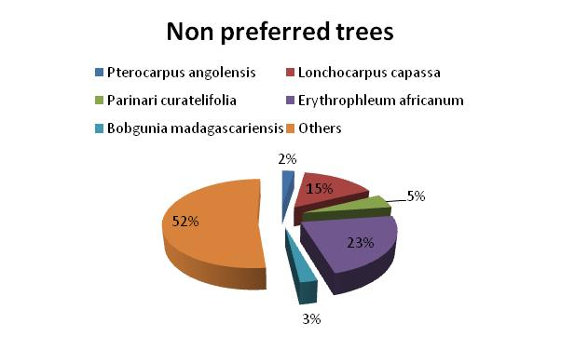
Figure 8 .: Percentage of non preferred tree species for charcoal production at the core site.
Due to lack of information on the Angolan legislation applied to the forestry sector and to the fact that the existing legislation is not clear on the prohibited species for charcoal, we try to contact some of the stakeholders. At local level we established contacts with the responsible of Agricultural Department in Chitembo and at provincial level the Directorate of the “Instituto de Desenvolvimento Florestal”, as executing agency of the Provincial Department of Agriculture in Menongue, Cuando Cubango province and Lubango, Huíla province. It’s important to refer that it’s always difficult to get a information with the key players, apparently due to the sensitivity on which this matter is usually discussed in Angola.
According to our stakeholders the trees that produce edible fruits are not allowed to be felled for charcoal. However in practice it’s not happen, because of absence of appropriate mechanism of control.
Tree selection method
The tree selection method is normally defined by size of trees (priority is given large and medium size) and quality of tree to produce good charcoal (Table 3). A good observation in the surveyed area is that the charcoal producers never fell any tree for charcoal, if the target trees does not exists, simply they move to another area. This can be attributed to the fact the that amount of preferred trees is relatively high in the study area, when compared with others areas of the country where there is no choice and in many cases regeneration and stumps of trees are also removed for charcoal production.
Table 3 .: Percentage of tree selection method in surveyed area (n = 27)
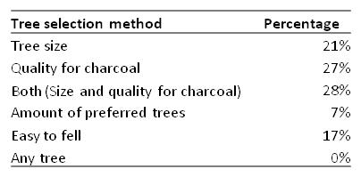
Tools
The most important tool required for charcoal production at the core site and villages assessed is axe, followed by hoe and shovel at the phases of construction and removal of charcoal produced. These tools belong normally to the owner of kiln or rarely is rented and paid to the person who helps with felling of trees. In the study area only women normally pay another person who helps to fell the trees. The price varies from 100 to 250 Kzs/day, corresponding to 1 to 2,5 U$ dollars.
Size of trees
The size of felled trees varied between the charcoal kilns assessed, we measured the DBH and height of largest and smallest tree per kiln. The results in (Figure 9) shows that the preferred tree size for charcoal is mainly between DBH of 25 to 50 cm. largest trees (> 50) normally are not felled due to the difficult to cut into small logs.
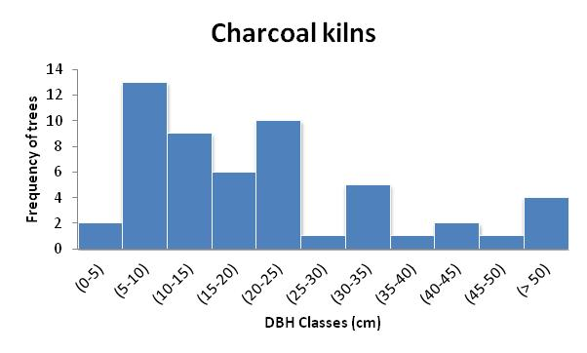
Figure 9 .: DBH classes distribution in charcoal kilns assessed
Number of stumps and bags of charcoal produced
The number of stumps and charcoal produced per kiln varied significantly (101 ± 27 stumps/ha) and (48 ± 17 bags/kiln). The relationship between number of stumps and number of charcoal bags produced can be seen in Figure 10. The R value demonstrates that there is no correlation between the parameters assessed. It can be attributed to the fact that the charcoal produced is always low and requires a large amount of trees, or to the fact that the number of bags produced per kiln was only based on the answers of charcoal producers. We consider that in the many cases they only super-estimate or sub-estimate the number of bags produced or simply they did not tell the truth.
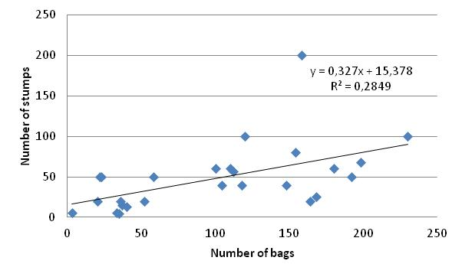
Figure 10 .: Relationship between number of stumps per kiln and number of bags
Charcoal pricing
The price of a bag of charcoal varies according to the village. The total amount paid per bag must include the payment of a person who normally helps with felling trees, which varies also according the village with a mean of 370 kzs/day, corresponding to 3,7 U$. The charcoal produced is mainly sold along the main roads at a price of 500 – 700 kzs, with a mean of 596 Kzs, 5,9 U$ (¹). The number of bags sold in the main road can be seen in Figure 11.
The charcoal producers have to buy empty sacks (depending on size) at the informal market, the price of a empty sack varies between 100 – 250 Kzs, with a mean of 107 Kzs, corresponding to 1,07 U$. But in many cases the charcoal is produced in large scale for traders coming from others provinces mainly from Luanda, where the charcoal is commercialized at a price of about 2500 kzs (25 U$), in this case the trader is responsible for the empty sacks, to the price of a bag of charcoal is reduced an amount of 100 kzs (1 U$). This depending on the village and the moment of the charcoal is commercialized.
- Online currency rate based in: http://www.oanda.com/lang/pt/currency/converter/
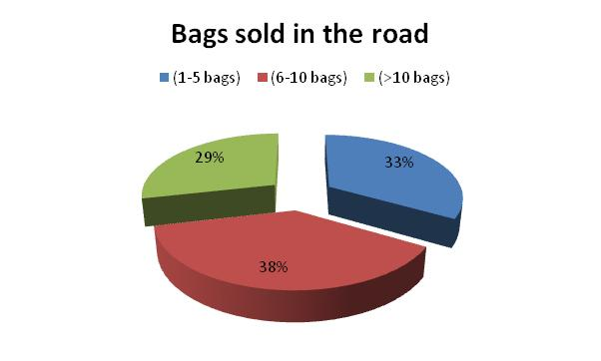
Figure 11 .: Percentage of number of bags sold in the main road
Based on the number of bags produced (911) multiplied by the expected kilns produced per year (87) we estimate (79.257 bags) per year, corresponding to 3.963 tons of charcoal year. This value may be even higher due to the increased activity of charcoal production in the study area.
Discussion
Baptista, N. (2014) provides an important overview of the miombo literature in Angola available for the colonial time. Based on this we extracted some important notes on the tree species occurring in the Okavango basin and its uses by local population. Several trees are important for the region and have also important commercial value at least in colonial time. Some trees like Guibourtia coleosperma (Mussivi) together with Pterocarpus angolensis (Mukula) has cited for its wood quality. At Chitembo core site these species are and often only found in lower structure, at Caiundo are common and abundant found mainly in tree structure. Other species like Burkea africana (Mussesse), Erythrophleum africanum (Mukosso) were used for building huts and palisades and Cryptosepalum exfoliatum subsp. pseudotaxus (Mukue) for honey extraction and Shinziophyton rautanenii (Mungongo) for fruit consumption (Baptista, N. 2014). Based on the data obtained in the field many tree species are cited as good charcoal producers, however some of these are not felled due to its hard trunk and quality of charcoal production or firewood (Table 6).
In general Brachystegia spiciformis (Mumanga), Julbernardia paniculata (Munhumbe), Cryptosepalun pseudotaxus (Mussamba), Cryptosepalum exfoliatum subsp. pseudotaxus (Mukue) and Isoberlinia angolensis (Mut’ho) (Table 4), that one does not exists in the core site are referred by charcoal producers as good charcoal producers. It’s coincident with studies made in colonial time. However Erythrophleum africanum (Mukosso) referred by Guerra et al. 1956 cit. by Baptista, 2014 as good charcoal producer and firewood, was cited in the core site as one of not felled tree species due to its hard trunk and smoke producing when used as firewood. The trunk of Burkea africana (Mussesse) it’s also referred as existing in some kilns and many of the interviewers referred the low quality of its charcoal. Monteiro, 1970a cit. by Baptista, 2014, referred the use of the specie in construction of houses due to the resistance to insects and fungi infection, locally the fresh leaves of the specie is used to produce smoke during honey extraction (personal observation).
In General Brachystegia and Julbernardia spp. are the most common species used for charcoal production. Herd, (2007) found Swartzia madagascariensis, Brachystegia boehmii, B. spiciformis, Julbernardia globiflora, Pterocarpus rotundifolius rotundifolius and Burkea africana used in the kiln and as preferred species for charcoal production in Chicale Regulado region in Mozambique. Malimbwi et al. (s.d.) and Luonga et al. (2000) found also Julbernardia globiflora, Brachystegia bohemii and B. spiciformis as suitable tree species for charcoal in Tanzania.
Conclusions
During the colonial the conservation of nature was the responsibility of the Directorate of Agriculture and Forestry. In practice this organization was only responsible for timber harvesting regulation. Many so-called forest reserves existing in the country only served as places reserved to the right for new conceptions (Huntley, 1974).
With the intensification of political and military situation in the country whole families took over the production of charcoal as illegal form in the main cities for survival reasons, this practice such as been referred above was the main cause of deforestation around the main cities, in addition to have absorbed in part the activity of concessionaries. This situation has led to huge losses in the forestry sector and consequently for the government. It’s also observed that people with some financial capacity have taken rural communities to produce charcoal in large-scale to be finally transported to the main urban centres without any legal authorization. To alleviate the over-exploitation of these resources with huge losses not only for forestry sector but also for the government, the Agriculture Departments through its executing agency the “Instituto de Desenvolvimento Florestal” issues an document known as “Guia de Trânsito” (Figure 12) which allows the charcoal traders to transport charcoal from local of production to the main cities, where the product is commercialized.
This document allows the authorities charging a fee calculated from the amount of charcoal that is reversed as a source of income for the government. In practice this situation has led to a rapid degradation of forest cover and land degradation, since there is no any control by the authorities regarding the quantities of charcoal transported, species that should be explored or not or indication of local of exploration. From the point of view of the authorities the production made by households is handmade with little or no impact on vegetation, that’s why it is not, applied any fees or penalties to this illegal but authorized activity.
However there has been seen in recent years a considerable increase in coal exploration among rural households due to the energy demand in urban areas and the needs of consumption of our materialist society. The lack of well trained technicians, combined with weak institutional capacity related to the forestry sector, absence of forest rangers and poverty in rural areas are without doubt the main difficulties that the sector is currently facing.
The villages assessed are characterized by families with large members. The number of children is high with more female than male. This number will increase in the next years due to the proportion of early marriage in rural areas, with negative impacts in the environment. The schooling and employment levels are low, which causes high dependence on natural resources, adding the fact that the majority of charcoal makers came from other villages and provinces.
The kiln size is in general large, with large amount of wood and long period of burning. Preferred tree species is given to the miombo species indicators like Julbernardia paniculata and Brachystegia spp. The trees producing edible fruits are prohibited for charcoal, but there is no any control regarding this matter and size of trees to be felled. The size of explored trees are in general large, but there is no relationship between number of stumps per kiln and number of bags produced, it’s probably due to the fact that normally the charcoal production requires large amount of biomass, the amount of bag per kiln was based only on estimation done by interviewers.
Regarding the price of charcoal was considerable low, compared the price practiced in Luanda where the price of charcoal is quadruplicated. In general few bags of charcoal are sold along the road. Many of the charcoal produced is mainly made for urban demand of main cities.
It’s understood at local context that none of the respondents have a license. Most charcoal makers has no perception of the current state of the miombo woodland and in many case they consider the current state of miombo as good, because provides livelihood for their families, based mainly on charcoal production. A wide minority of respondents consider the current state of woodland worse compared to 10 years ago, when there was no coal in the region. The wildlife does not exist anymore due to the introduction of shooting guns in the villages.
Conclusively, it is agreed that charcoal production activity in the core site is increasing. The business seems to support the livelihood of rural people more than the agriculture, because requires low capital. But is dangerous for healthy in rural areas. At moment the current state of the forests in Angola is dependent on the results of a national forest inventory in progress, but the results based on the study area reflects very well the situation on the forestry sector. The awareness of political class on the problems of forestry sector is important due to the low attention given by the authorities and the needs of the country in terms of energy. Also the creation of alternatives in urban areas where most people are the main users of charcoal produced in rural areas. There is also need to increase the level of schooling, employment and other practical mechanism of fighting poverty in rural areas. The identification and recognition of charcoal makers in areas where they are not, in order to be educated in environmental issues and issued with license it’s also crucial to alleviate the negative impacts on miombo woodlands in the core site. The implementation of environmental laws and programs based on national forestry policies approved recently for Angola is also urgent.
References
- AHRENDS, A. et al. (2010) Predictable waves of sequestral forest degradation and biodiversity losses spreading from an African city. Proceedings of the National Academy of Science of the United States of America 107 : 14556 - 14561
- BAPTISTA, N. (2014) Literature study of the woody Miombo vegetation and forest management in southeastern Angola with focus on data from the colonial era. A study conducted for the Polytechnic of Namibia in frame of The Future Okavango Project SP05 Task 6.
- CHIDUMAYO, E. N. (1991) Woody biomass structure and utilization for charcoal production in Zambian miombo woodland. Bioresource Technology 37: 43 – 52.
- FAO (2011a) Highlights on wood charcoal: 2004 – 2009 FAO Forestry Department. FAOSTAT – ForesSTAT.
- HERD, A. R. C. (2007) Exploring the socioeconomic role of charcoal and the potential for sustainable production in Chicale Regulado, Mozambique. A dissertation presented for the degree of Master of Science. University of Edinburgh
- HUNTLEY, B. J. (1974) Outlines of Wildlife Conservation in Angola. J. sth. Afr. Wildl. Mgmt. Ass. 4 (3): 157 – 166.
- LUONGA, E. J.; WITKOWSKI, E.T.F.; BALKWILL, K. (2000) Economics of charcoal production in miombo woodlands of eastern Tanzania: some hidden costs associated with commercialization of the resources. Ecological Economics 35, 243-257
- LUONGA, E. J.; WITKOWSKI, E. T. F.; BALKWILL, K. (2002) Harvested and standing wood stocks in protected and communal miombo woodlands of eastern Tanzania. Forest Ecology and Management 164:15-30
- MALIMBWI, R. E.; ZAHABU, E. KAJEMBE, G. C.; LUONGA, E. J. (S. D.) Contribution of Charcoal Extraction: Experience from CHAPOSA Research Project. Department of Forest Mensuration and Management, Faculty of Forestry and nature Conservation, sokoine University of Agriculture. Morogoro, Tanzania
- MALIMBWI, R.E.; ZAHABU, E.; MONELA, G. C. (2005) Charcoal potential of miombo woodlands at Kitulangalo, Tanzania. Journal of Tropical Forest Science 17:197-210
- MINADER/MINUA (2006) Política Nacional de Florestas, Fauna Selvagem e Áreas de Conservação. Documento de Discussão (Segunda Versão). República de Angola.
- SADC (1993) Energy Statistics Year Book for 1991. Energy Sector, TAU, Luanda, Angola.

Annexure
Table 4 .: List of used, preferred and non-preferred trees for charcoal production at the core site.
Species name | Local name | Used in kiln | Preferred | Non-preferred
Julbernardia paniculata | Munhumbe | 28 | 24 | 1
Brachystegia spiciformins | Mumanga | 18 | 16 | 1
Cryptosepalum pseudotaxus | Mussamba | 8 | 3
Burkea africana | Mussesse | 5 | 1 | 2
Uapaca nitida | Mundengo | 2 | 1 | 1
Diplorhynchus condylocarpon | Muhli | 3 | 2 | 3
Lonchocarpus capassa | Muambo |  |  | 11
Erythrophleum africanum | Mukosso | 1 |  | 20
Guibourtia coleosperma | Mussivi |  |  | 2
Protea rochetiana | Muzungue |  |  | 3
Syzygium guineense | Mutewa | 1
Brachystegia bakeriana | Tchicungo | 1 |  | 1
C. exfoliatum subsp. pseudotaxus | Mukuwe | 6 | 3 | 6
Pseudolachnostylis maprouneifolia | Mussalia | 2 |  | 1
Burkea africana | Mussesse | 2 |  | 1
Parinari curatelifolia | Mut'hongo |  |  | 4
Pterocarpus angolensis | Mukula |  |  | 2
Uapaca benguellensis (kirkiana?) | Mumbula |  |  | 2
Monotes glaber | Muhala | 2 | 1 | 3
Bobgunia madagascariensis | Mutete |  |  | 7
Hymenocardia acida | Mukatcha-kabonga |  |  | 1
Terminalia brachystelma | Mueia |  |  | 2
Strychnos cocculoides | Mukolo |  |  | 1
Monotes katangensis | Tchipalameia | 1 | 1 | 1
Syzygium cordatum | Muzele |  |  | 1
Isoberlinia angolensis | Mut'ho |  | 1
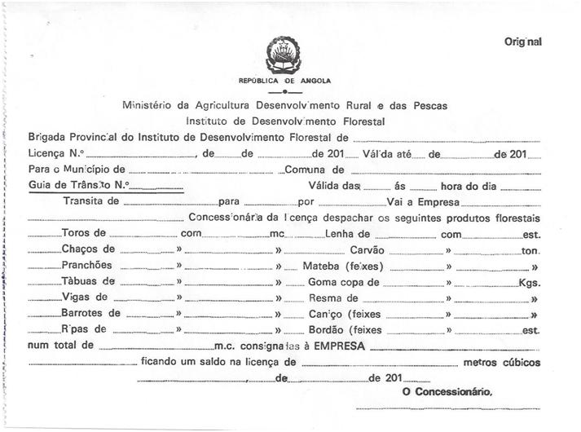
Figure 12 .: Documentation used by the charcoal traders to transport charcoal from local of production to the final destination.

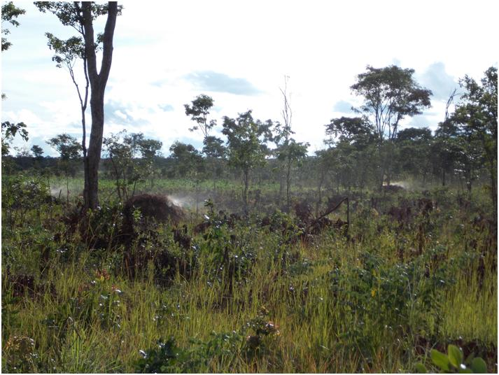
Figure 13 .: Earth kiln in the miombo woodland between Satchijamba and Kempo grande villages.

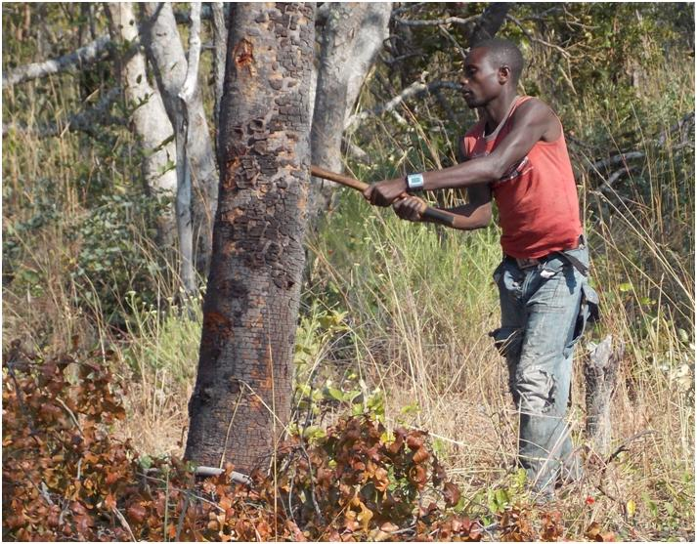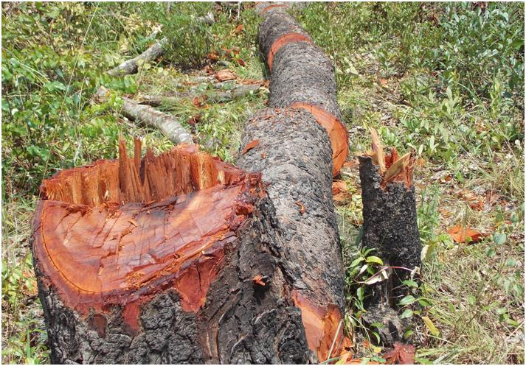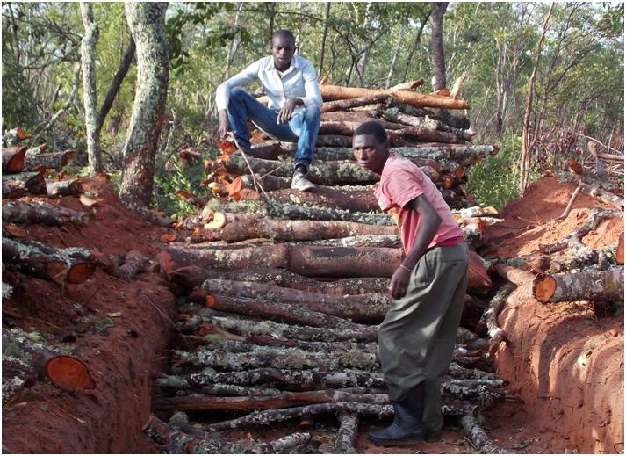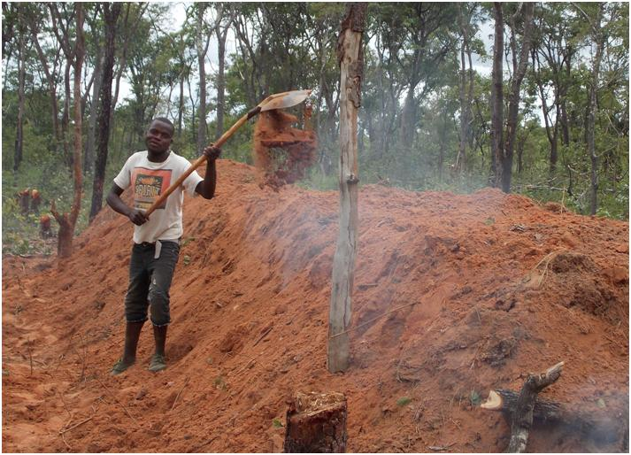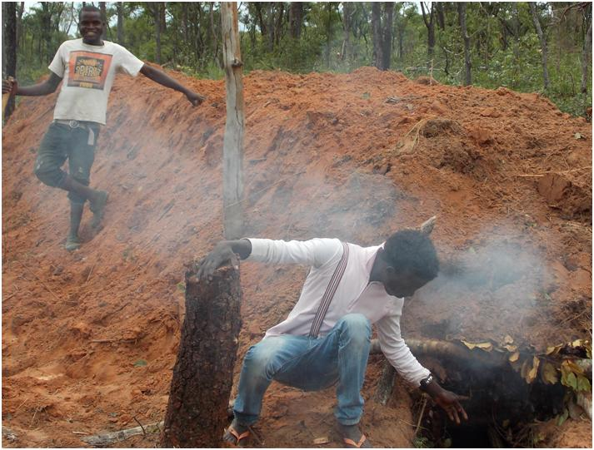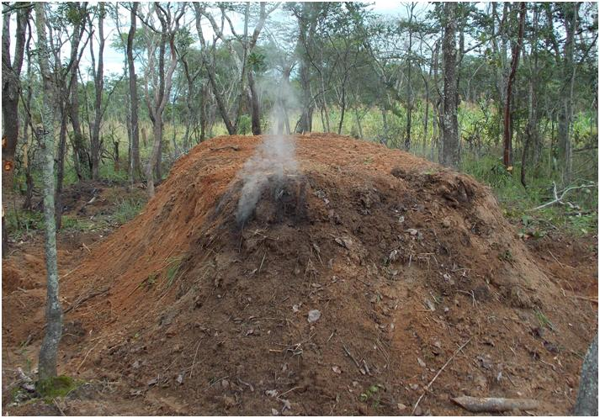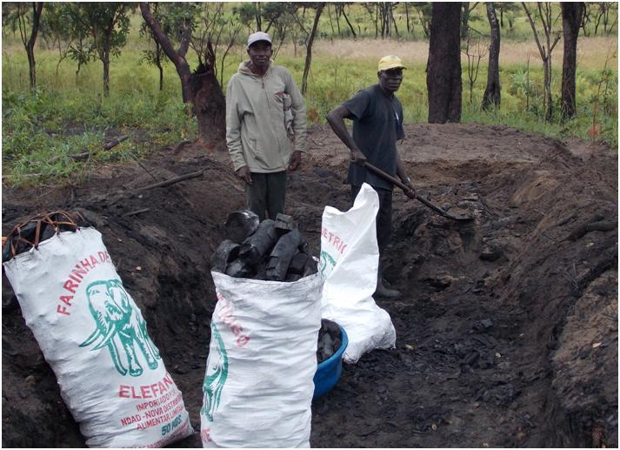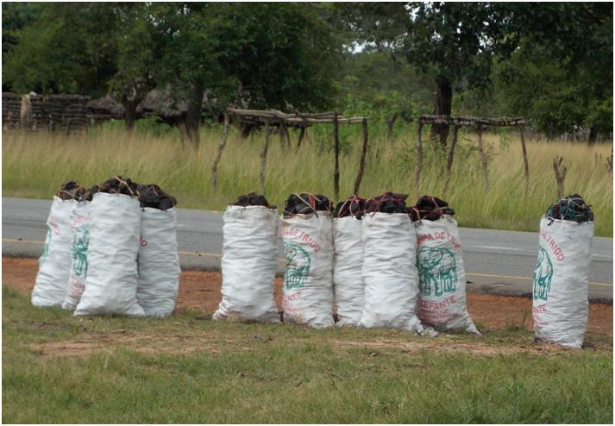
a
g
f
e
d
b
c
h
Figure 14 .: Charcoal production process (a) Tree felling, (b) Cross cutting into short logs, (c) Kiln base structure, (d) Kiln insulation with grass, fresh leaves and soil, (e) Ignite kiln and carbonization control, (f) Carbonization, (g) Sorting of charcoal and packing, (h) Transport to road and selling.

