Gössling, S. and Buckley, R. 2015. Carbon labels in tourism: Persuasive communication? Journal of Cleaner Production, DOI: 10.1016/j.jclepro.2014.08.067
Stefan Gössling,
Ralf Buckley

a b s t r a c t

Ecolabels are widespread tools for policy and marketing in many industry sectors. Carbon labels focussing on carbon dioxide and other greenhouse gas emissions are one specialised category of ecolabel in use by tourism corporations. All ecolabels, including carbon labels, rely on persuasive communication: i.e., providing technical information to individuals in ways that induce them to change relevant be- haviours. This requires that individuals understand that information, appreciate its signiﬁcance, trust its reliability, and know how to act more sustainably. Here, these four criteria are applied to a set of tourism carbon label schemes, to assess whether the information provided by existing labels is comprehensive. Secondly, results are presented from a survey of environmentally aware tourists and their perspectives of two different types of carbon labels. Results indicate that tourism carbon label schemes suffer signiﬁcant shortcomings both from the theoretical perspective of communications analysis and from the practical perspective of tourist understanding and action. Results indicate that even if tourists care about their climate change impacts, carbon labels are currently ineffective because of deﬁciencies in communica- tions. Since such deﬁciencies can be overcome, there are opportunities for carbon labels to become more widely and successfully used.

- Introduction

The contribution of tourism to global climate change has become increasingly signiﬁcant. Tourism contributed an estimated 5% of global carbon dioxide (CO2) emissions in 2005 (UNWTO- UNEP-WMO, 2008), and about 8% of the total anthropogenic contribution to radiative forcing (Scott et al., 2010). Radiative forcing refers to the warming caused by all greenhouse gas (GHG) emissions, and considers the additional impact of short-lived GHG at ﬂight altitude. The largest component of tourism-related CO2 emissions is from aviation (40%), followed by cars (32%), and ac- commodation (21%). These three sub-sectors, and their GHG emissions, are all growing, because global tourist numbers are increasing, now exceeding 1 billion international tourist arrivals, and reaching an expected 1.8 billion by 2035 (UNWTO, 2012). Moreover, average distance travelled and frequency of travel, as well as average degree of luxury in accommodation are all

increasing. As a result, despite gain in efﬁciency, emissions from tourism are predicted to grow by 135% over the three decades from 2005 to 2035 (UNWTO-UNEP-WMO, 2008). This contrasts starkly with global efforts to curb GHG emissions across all economic sectors, and tourism is consequently seen as a particularly energy-
intense, difﬁcult to decarbonize sector (Go€ssling et al., 2013). Yet,
current evidence indicates that GHG emissions must be cut by an estimated 80% from current levels by 2050 for mean global warming, relative to pre-industrial levels, to remain within the 2 oC maximum warming guardrail (IPCC, 2013). This ambitious goal would necessitate strong mitigation across economic sectors,
including tourism (Go€ssling et al., 2013).
As continuous, observed growth in emissions from global tourism indicates, legal, economic and technological approaches to reduce GHG emissions from tourism have all proved largely inef-
fective to date (Scott et al., 2010; Go€ssling et al., 2013; OECD and
UNEP, 2011). Despite stated commitment by the tourism industry to considerably reduce GHG emissions (e.g. World Travel and Tourism Council, 2009), there is thus currently very limited evi- dence of how such reductions could realistically be achieved
(Cohen et al., 2014; Go€ssling et al., 2013; Scott et al., 2010). Delays in
deﬁning binding goals for emission reductions within the Inter- national Framework Convention on Climate Change (UNFCCC) have

led to political stalemate and stalling at the international level (UNFCCC, 2013). At the level of individual nations, there is minimal new policy or legislation to achieve binding and monitored emis- sion reductions, particularly with regard to tourism (OECD & UNEP, 2011; OECD, 2014), which has been identiﬁed as a signiﬁcant and
“overlooked” emissions sector (Go€ssling, 2013). In light of this, in-
dustry advocates such as IATA and ICAO have argued for hypo- thetical technological solutions. However, even if unprecedented technological breakthroughs were to occur, efﬁciency gains would
be outpaced by growth (Go€ssling et al., 2013). In addition, proposed
approaches such as biofuels also present major sustainability ob- stacles (UNEP, 2009).
In the absence of effective legal, economic or technological approaches, attention has turned to weaker soft policy instruments (Cohen et al., 2014), such as ecolabels. Ecolabels are widespread in tourism (Buckley, 2002, 2012, 2013; Font and Buckley, 2001; Honey, 2002), and deﬁned in this paper as communication sys- tems intended to inﬂuence consumer behaviour towards greater consideration of environmental concerns. For instance, of over 430 ecolabels listed by the worldwide Ecolabel Index (2014), 128 apply in tourism (Table 1). As weak policy instruments, ecolabels are only effective if they can induce environmentally signiﬁcant change amongst a large number of consumers (Cohen et al., 2014), including the use of low-carbon transport or accommodation; voluntary carbon offsets; choosing closer destinations; or travel- ling less frequently and instead, staying for longer periods of time
at each destination (Buckley, 2011a,b; Go€ssling, 2010; UNWTO-
UNEP-WMO, 2008).
The social context for consumer change through carbon labels in tourism is generally favourable, but behavioural change to date has been very limited. Reported attitudes towards sustainable practices and environmental management are generally positive both for travellers speciﬁcally, and for the broader populations of developed nations (e.g. Eurobarometer, 2011; Hall, 2013). Public awareness of the consequences of energy consumption for climate change is increasing (e.g. Barr et al., 2010; Higham and Cohen, 2011). Understanding of climate change impacts of travel amongst actual air travellers is also improving (Cohen and Higham, 2011; Higham and Cohen, 2011). However, despite this concern, and growing awareness and knowledge, there has been very limited change in actual behaviour, as demonstrated either by
travel patterns or purchase of offsets (Aran~a et al., 2012; Cohen and
Higham, 2011; Go€ssling et al., 2009; Hall, 2013; Miller et al., 2010).
Such disparities between expressed values and demonstrated ac- tions are commonplace where individuals compare personal costs and effort against diffuse social beneﬁts (Kollmuss and Agyeman, 2002; Stoll-Kleemann et al., 2001).
Psychological barriers and substitutions may also be particu- larly signiﬁcant in tourism, since people perceive holidays as short-lived but socially legitimate opportunities for more hedo- nistic behaviour than at home (Cohen et al., 2014; Hibbert et al.,
2014), or as opportunities to gain social capital through travel (Go€ssling and Nilsson, 2010; Urry, 2011). People also travel for
business, and to fulﬁl social obligations such as visiting family, which they may perceive as overriding environmental consider- ations (Buckley, 2011aec). Carbon labels must thus overcome signiﬁcant psychological barriers before they can inﬂuence indi- vidual actions.
The principal factors which must be considered in order to change individual behaviour are well established, including perceived costs and beneﬁts, moral and normative concerns, affect, context, and habits (Steg and Vlek, 2009). These have been dis- cussed, for example, in analysing individual use of cars (Schwanen and Lucas, 2011). Broad-scale climate-change campaigns, in contrast, have to date used three approaches, successively but
separately (van der Linden, 2014): Early campaigns used cognitive- analytical approaches, assuming that knowledge changes attitudes and attitudes change behaviour. Subsequent campaigns used affective-experiential approaches, with negative emotional appeals and guilt messaging. The most recent campaigns use social- normative approaches, promoting social and moral norms to trigger behavioural change. While cognitive-analytical approaches and affective-experiential have had limited effects, it remains to be seen whether social-normative approaches can be more successful. For the best chance at persuading individuals to overcome psychological barriers to low-carbon travel choices, therefore, evi-
dence to date indicates that carbon labels in tourism should:

- Incorporate declarative, procedural and effectiveness knowledge;
- Explicitly communicate the context and relevance of climate change;
- Appeal to cognitive, experiential and normative dimensions of behaviour; and
- Target speciﬁc behaviours within their broader psychological context (Denicolo, 2008; van der Linden, 2014; Hall, 2013).

This paper tests how well carbon labels in current use actually comply with these various criteria for effectiveness, both from a theoretical perspective and in the perceptions of environmen- tally well informed tourists, and whether labels require speciﬁc degrees of carbon literacy (Whitmarsh et al., 2011).

- Methods

To conduct these tests, the use of carbon labels in tourism is treated as an exercise in persuasive communication (Bettinghaus, 1968). Factors outlined by van der Linden (2014), Whitmarsh et al. (2011) and Hall (2013) are condensed into three criteria which are necessary and sufﬁcient for adequate communication, itself necessary for individual action based on such communi- cation. Even if all these criteria are satisﬁed, that does not guarantee action if individuals do not care about their climate- change impacts, the dimension of affect (Steg and Vlek, 2009). This factor varies greatly between individuals, and is beyond the scope of this study. Individuals who do care, however, can only take action based on carbon labels if those labels provide effec- tive communication, the aspect against which carbon labels are tested in this study. In a second step, it is tested how well, in the perception of environmentally well-informed travellers, carbon labels in tourism perform. This second test is based on a survey of German tourists, and hence not representative.
The three criteria address whether, and to what degree, tourists: (i) understand the information communicated; (ii) appreciate its signiﬁcance; and (iii) know what action to take in consequence. These reﬂect the dimensions factural, procedural and effectiveness knowledge as outlined by van der Linden (2014) as a precondition for comprehensive communication. Notably, this does not address the perceived reliability of the information communicated, or the perceived credibility of the organization, institution or government body behind the label, both of which are likely to have some relevance. With regard to the three criteria, comprehensibility is a function of clarity in the label itself. Energy-efﬁciency labels in Europe (EC, 2013), for example, use green e a signiﬁer of the climatically most sus- tainable products - , yellow or red bars, readily comprehensible by consumers with limited knowledge of energy and emissions. Signiﬁcance requires that the label shows clearly how the product or service contributes to global warming, i.e. the amount of emissions associated with its consumption. This information

Table 1
Tourism ecolabels.

Label/certiﬁcation Tourisma

  - 100% Energie Verde, Italy
  - Audubon Green Leaf Eco-Rating Program, North America (M)
  - Austrian Ecolabel for Tourism (M)
  - Bayerisches Umweltsiegel für das Gastgewerbe, Germany (M)
  - BioHotels (ehc-Zertiﬁzierung), Europe (M)
  - BIO Hotels, Europe
  - Blaue Schwalbe, Europe (M)
  - Blue Flag, international
  - Brazilian Sustainable Tourism Standard
  - Calidad Galapagos, Galapagos
  - California Green Lodging Program, USA (M)
  - Certiﬁcation for Sustainable Tourism (CST), Costa Rica

Table 1 ( continued )
Label/certi ﬁ cation Tourism a
- Green Restaurant, USA (M)
- Green Seal, USA (M)
- Green Star Hotel, Egypt
- Green Stay South Africa (M)
- Green Suitcase rating system, international (M)
- Green Tourism Business Scheme, UK & Ireland (M)
- Green Business Program, Hawaii (M)
- Heritage Environmental Rating Programme, international
- International Eco Certiﬁcation Program
- ISO 14000, international

- Chouette Nature, France
- Clean Tourism Certiﬁcate, Poland
82. Leadership in Energy and Environmental Design (LEED) for Hospitality, USA
(M)

- Climate Action Certiﬁcation Program (CACP), Australia (M)
- Connecticut Green Lodging Certiﬁcation Program, USA (M)
- CSR-Tourism, Europe (M)
- David Bellamy Conservation Award, Great Britain (M)
- Delaware Green Lodging, USA (M)
- Discover Eco-Romania, Romania (M)
- EarthCheck, international (M)
- ECEAT Quality Label, Europe (M)
- eco awards Namibia (M)
- Legambiente Turismo, Italy (M)
- Maine Green Lodging Certiﬁcation Program, USA (M)
- Maryland Green Travel Program, USA (M)
- MINERGIE, international
- Missouri Certiﬁed Green, USA
- National Tourism Accreditation Framework NTAF, Australia
- Naturemade, Switzerland
- Nature's Best Ecotourism, Sweden (M)

- ECO certiﬁcation, Malta (M)
- ECOCAMPING, Europe (M)
91. New Hampshire Sustainable Lodging and Restaurant Program, USA
(M)

- ECObiz Queensland, Australia (M)
- ECO certiﬁcation, Malta (M)
- Ecogite, France (M)
- eco hotels certiﬁed, Austria (M)
- Eco Hotels Certiﬁed, Europa (M)
- Eco-label “Donana 21”, Spain
- EcoLabel Lu embourg (M)
- Ecolodge Japan (M)
- Nordic Swan for hotels and youth hostels, Europe (M)
- Normas de Turismo Sostenible, Colombia
- OK Power, Germany (M)
- Oregon Bed and Breakfast Guild Green Certiﬁcation Program, USA
- O€ KOPROFIT, international (M)
- PAN PARKS Initiative, Europe
- Partnership for a Sustainable Georgia (M)

- Eco-Friendly STAR Accreditation, Australia
- Ecotel, international (M)
- Ecotourism, Australia (M)
- Ecotourism Kenya's Eco-rating scheme
- Ecotourism Label, Ireland
- Ecotourism Norway
- EIFEL e Qualita€t ist unsere Natur, Germany
- EKOenergy, international
- EMAS, Europe
- Peak District Environmental Quality Mark, United Kingdom
- Programa Nacional de Auditoría Ambiental (PNAA), Mexico
- Prüfzeichen Schorfheide-Chorin, Germany
- PUG audit (TOFTigers), India, United Kingdom
- Q certiﬁcation Tourism, Spain
- Qualit€ats- und Umweltsiegel für den Kanutourismus, Germany
(M)

- Emblem of Guarantee of Environmental Quality,
Spain
- Encouraging Conservation in Oklahoma, USA (M)
- EnerGuide for Appliances, Canada
- Qualmark, New Zealand (M)
- Rainforest Alliance Certiﬁed, international (M)
- RECS International Quality Standard, Europe (M)
- Respecting our Culture (ROC), Australia (M)

- Energy Labelling of Buildings: EU (M)
- ENERGY STAR®, international
- Enviro-Mark®, international  - Estonian Ecotourism Quality Label  - European Ecolabel for tourist accommodation services and camp site services | (M) | - Rhode Island Hospitality Green Certiﬁcation for the Hospitality and Tourism Industry, USA  - SmartVoyager, Ecuador, Colombia, Honduras, Chile  - South Carolina Green Hospitality Alliance, USA | (M)  (M)  (M)
51. European Ecotourism Labelling Standard (EETLS) | (M) | 113. South Luangwa Eco Awards, Zambia
52. European charter for sustainable tourism in |  | 114. Stay Green Illinois, USA | (M)
protected areas |  | 115. Steinbock, Switzerland
53. Fair Trade in Tourism South Africa | (M) | 116. Sustainable Tourism Eco-Certiﬁcation Program | (M)
54. Florida Green Lodging Program, USA | (M) | STEP, USA
55. Gîtes or Guest Rooms “Panda”, Belgium |  | 117. Sustainable Tourism Education Program (STEP), | (M)
56. Gites Panda, France |  | international
- GREAT Green Deal Guatemala  - Green Business Certiﬁed, USA  - Green Certiﬁcate: Latvia | (M) | - Sustainable Tourism Standards, Mexico  - Tourisme Responsable, France  - Travel Green Wisconsin, USA | (M)
60. Green-e Energy, USA, Canada | (M) | 121. Travelife Awards, international | (M)
61. Green-e Marketplace, USA, Canada | (M) | 122. TÜV SÜD Mark EE01/EE02, Germany
- Green Flag Award, United Kingdom  - Green Globe Certiﬁcation, international | (M) | 123. Umweltgütesiegel auf Alpenvereinshütten, Alps; Italy, Germany, Austria, | (M)
64. Green Hospitality Award, Ireland | (M) | 124. UNESCO World Heritage, international
65. Green Key, international | (M) | 125. Vermont Green Hotels, USA | (M)
66. Green Key Eco-Rating Program, international | (M) | 126. Viabono, Germany | (M)
67. Green Leaf Business Scheme, United Kingdom | (M) | 127. Virginia Green, USA | (M)
68. Green Leaf Environmental Standard, South Africa | (M) | 128. WindMade, international

109. Responsible Tourism System e Biosphere Hotels, international
(M)

- Green Leaf Foundation, Thailand (M)
- Green Lodging Michigan, USA
- Green Power Australia (M)

a (M) Mitigation: certiﬁcation considers element of energy saving or avoided greenhouse gas emissions.

must be relative to an easily understandable reference point such as other comparable products, or annual average per capita emissions, to clarify how the purchase of another, climatically more sustainable product reduces emissions. Difﬁculties arise if these reference points are not standardised between label schemes (Buckley, 2002, 2009, 2011; Lee, 2011; Six Senses, 2009;
Stawreberg and Wikstro€m, 2011). Carbon labels for airlines, for
example, may consider only CO2, or equivalent effects including short-lived GHG; and they may or may not consider load factors, differentials between seat classes, and the effects of freight, all of which have relevance with regard to the climate impact measured (Lee et al., 2009). Such complexities are appraised in terms of carbon capability, i.e. the degree of knowledge required to make sense of the information provided by the label, though without accurately assessing whether this information is factu- ally correct.
Data for the ﬁrst test, of the label formats and contents, are derived from publicly available carbon labels throughout the tourism industry. Most major stakeholders in tourism, including airlines, cruise operators, car retailers and rental agencies, train operators, tour operators, travel agents, online reservation plat- forms, accommodation, restaurants, and offset providers, now provide information on GHG emissions and other environmen- tally relevant activities. Over 50% of IATA members now provide information on their environmental initiatives, and 15% offer
carbon offsets (Go€ssling et al., 2013). Many airlines, railways, and
other businesses also offer carbon calculators (e.g. Finnair, 2013; Deutsche Bahn, 2013; Atmosfair, 2013). As shown in Table 1, even most of the existing eco-certiﬁcation programmes now include criteria of energy use or GHG emission reductions. As energy and emissions are only part of the criteria for certiﬁcation in the respective programmes, labels as listed in Table 1 generated no direct input to the paper, however, and are included for illus- tration only. Carbon labels in four major subsectors of the tourism industry, namely airlines, air travel online distribution and offsetting, car rental, accommodation and catering were identiﬁed based on a literature review and additional searches on

Table 2
Comprehensibility and knowledge domains for leading carbon labels in tourism.

Tourism subsector Information Degree of carbon Knowledge
literacy requireda domain
coveredb
the Internet. No carbon labels speciﬁc to cruise ships or railways were identiﬁed, though some corporations do publish data on carbon intensities and overall GHG emissions (e.g. TUI cruises, 2013; AIDA, 2013; SJ, 2013; Deutsche Bahn, 2013). All carbon labels that were identiﬁed are presented in the results, even though more may exist. For each subsector carbon labels were screened against the criteria outlined above, and examined with regard to shortcomings in relation to each criterion and hence to effective communication.
Data for the second test, the perception of environmentally well-informed travellers, was derived from a survey of customers of a special interest tour operator association, Forum Anders Reisen. This is a German-language group whose title translates to “Alternative Travel Forum”. It is an association of ~100 small, environmentally aware German tour operators, providing infor- mation on the CO2 emissions of different packages to their cus- tomers. It publishes an English-language set of membership criteria, which effectively also form a member code of practice (Forum Anders Reisen, 2014). The forum consequently represents a special interest customer base that is likely to be more envi- ronmentally aware than other travellers. As it is not possible to
test a globally representative sample of travellers, results need to be seen as speciﬁc to this population, and as yielding ﬁrst

- Aviation e Flybe ecolabel kg CO2 per
ﬂight, per seat Colour scheme

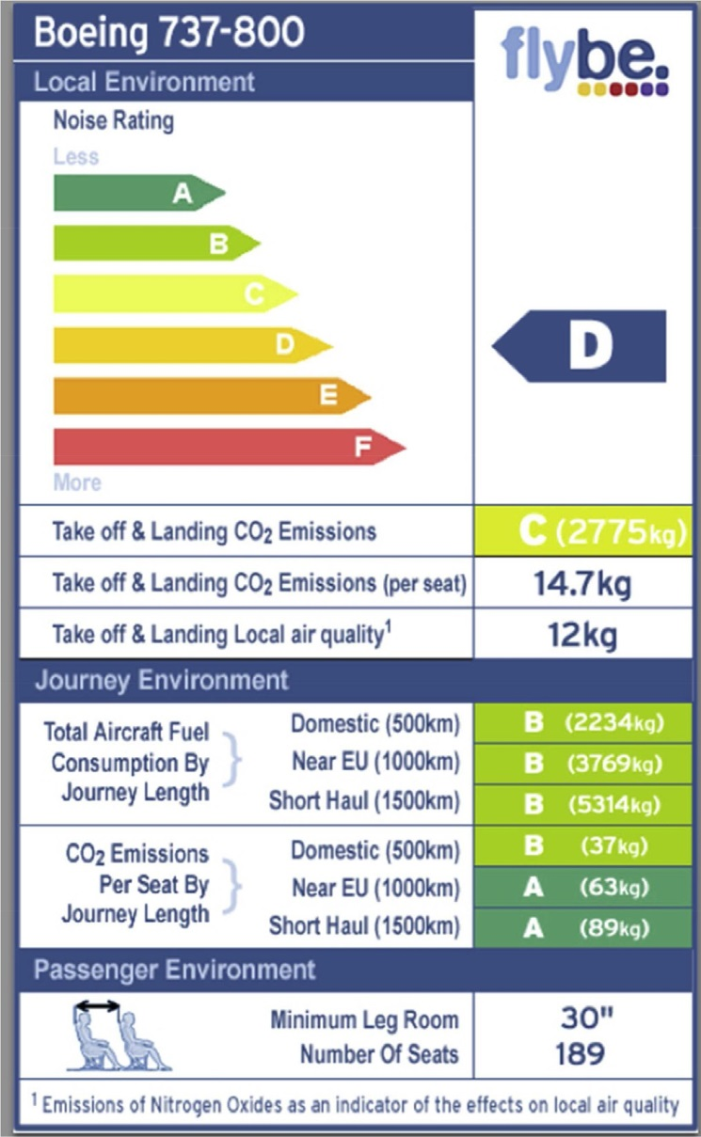
High F

- Aviation e Atmosfair Airline Index
Ranking based on efﬁciency
Low F, P

- EU e carbon label for cars kg CO2 per km,
Low F, P

(version used in Brazil)
fuel use
Colour scheme

- Car rental e Europcar kg CO2 per km
Colour scheme
Low F, P

- Car rental e Drive now Star-based ranking Low P

- Tour operator e Forum anders reisen
kg CO2 per journey Medium F

- Online distribution e
Direct Flights
Colour scheme Numeric ranking
Low P

- Hotel e Viabono kg CO2 per guest night
Colour scheme
- Hotel e Fuerte Hoteles kg CO2 per guest
night
Low F, P

Medium F, P

- Restaurants e Max Hamburgers
kg CO2eequivalent Medium-High F, P per meal

a Referring to the understandability of the carbon label; to understand the method used for calculation would in virtually all cases require high degree of carbon literacy.
b Factual (F), procedural (P) and effectiveness (E) knowledge. Fig. 1. Flybe ecolabel. Source: Flybe (2013).

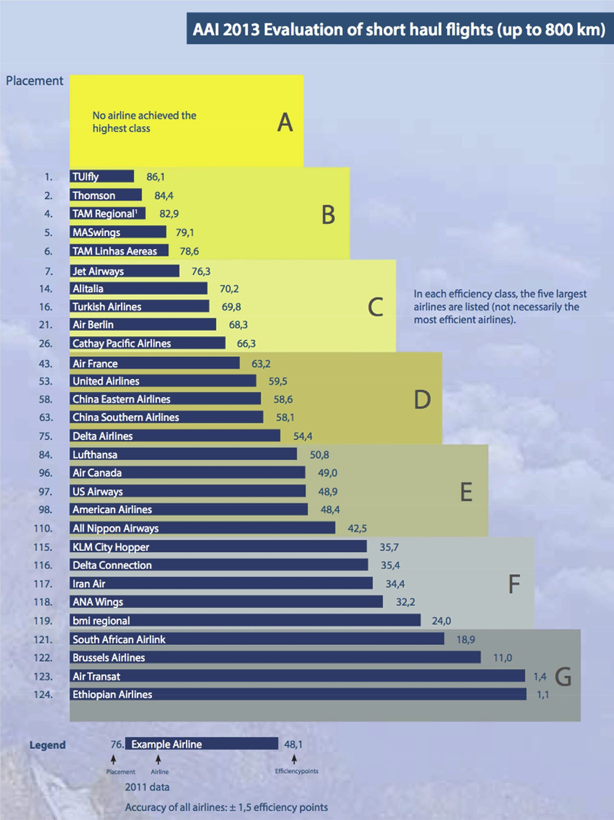

Fig. 2. Atmosfair Airline Index. Source: Atmosfair (2013).

insights regarding traveller perceptions of carbon labels that may be expanded in subsequent studies.
The survey was carried out from March to June 2013, in co- operation with the Forum Anders Reisen. It was announced through the Forum newsletter, with 6000 subscribers, and its Facebook page, with over 2000. No incentives were provided, which resulted in a comparably low response rate (n ¼ 251). In addition to questions addressing perceptions of carbon labels and their impact on travel choices, the survey also included questions relating to respondent demographics, environmental awareness, attitudes to climate change and GHG emissions, and purchase of offsets. Questions were framed as dichotomous, 5-point Likert- scale, or open-text responses. Travellers were asked how they, individually, perceived the carbon label used by the Alternative Travel Forum (kg CO2), and how another type of label based on a colour scheme was seen in comparison. Questions examined how well travellers understood the information communicated
by labels, how signiﬁcant they assessed it to be, how reliable they considered it to be, and to what degree they took action as a result.

- Results

Carbon labels as identiﬁed include airlines, air travel online distribution and offsetting organizations, car rentals, accommoda- tion providers and catering. Labels are illustrated in Figs. 1e9, summarised in Table 2, and represent the current spectrum of ap- proaches to carbon labelling, as well as the range of businesses/ organizations using these.
Only one label showing carbon intensities of different ﬂights was identiﬁed. British carrier Flybe (2013) uses a label comparing aircraft models and journey lengths (Fig. 1). It provides colour- coded and numerical information on noise, kg NOx and CO2 released at take-off and landing, and emissions for 500 km,

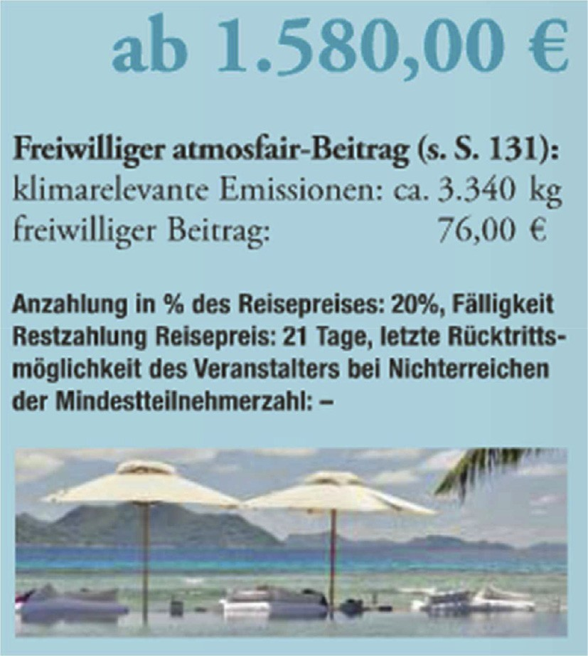

Fig. 3. Tour operator information on journey-speciﬁc emissions. Source: Forum Anders Reisen (2014).

1000 km and 1500 km ﬂights. The non-proﬁt carbon offset orga- nisation Atmosfair (2013) ranks airlines in carbon efﬁciency classes on the basis of observed (actual) fuel use for identical city-pair connections (Fig. 2). Depending on fuel use in comparison to the technically best possible standard, efﬁciency points are given, which determine the position of the airline by efﬁciency class (AeG) and in the comparative ranking. Labels provided by German tour operator association Forum Anders Reisen (in Reiseperlen 2014) show kg CO2-equivalent emissions (Fig. 3; note that this is also the information referred to by survey respondents, see following section). The label also offers to sell offsets. The example
in Fig. 3 shows a 15-day journey to the Seychelles, with emissions of 3340 kg CO2-equivalent offsettable for 76 Euro. The online airline distribution platform Direct Flights (2013) provides a Carbon Friendly Flight Search, which uses colour codes to show carbon intensity as an overlay on prices (Fig. 4). Similarly, The Responsible Tourism Partnership (2013) offers a CO2-efﬁciency application known as Calasi, which is uploadable to online booking platforms such as Cheaptickets, Orbitz, EBookers, Expedia, and Voyages-SNCF. It claims that data are from Brighter Planet (2013) and based on recommendations of the Intergovernmental Panel on Climate Change, governments and airlines, i.e. using “Greenhouse Gas Protocol Scope 3, ISO 14064-1 and the Climate Registry standards”. A number of car rental companies provide information on emission intensities, generally through color codes (Fig. 5). In the
European Union, car retailers are legally obliged to publish data on the emission intensities of different car models (European Parliament, 1999). Formats, however, are inconsistent (World Energy Council, 2013). The fuel economy label is now also in used in other countries in the world, and illustrated in Fig. 6 for Brazil. It uses a color code and numerical data on CO2 emissions per km. A comparable scheme in Australia uses green stars (Fig. 7).
Accommodation providers have adopted a variety of carbon
labelling systems (De Grosbois and Fennell, 2011; Go€ssling, 2010). Hotel association Viabono (2013) provides colour codes (Fig. 8),
and numerical data on CO2 emissions per guest night. It lists speciﬁc emissions from operational subsectors such as mobility, building, food and beverages, print materials, and cleaning, and refers to a calculation method developed by CO2OL (2013), how- ever, without providing further details. Hotel chain Fuerte Hoteles
(2013) also provides information on kg CO2 emissions per guest night, but with no information on calculation (Fig. 8). In the catering subsector, only one corporation providing carbon labels was found, the fast-food chain Max Burgers (2013). The label (Fig. 9) shows emissions in kg CO2-equivalent (kg CO2-e), covering energy use in restaurants, transport, packaging and foodstuffs, and considering CO2, CH4, and N2O, based on the greenhouse emission calculation standard ISO14.065 (Max Burgers, 2013). The company also claims to purchase carbon compensation for its products, based on tree planting in Uganda (Fig. 9). According to Max Bur-
gers, ~15% of meal choices are low-carbon (Go€ssling, 2010).
Several patterns emerge from these cases. Most labels incor- porate factual knowledge (Table 2). The principal numerical indi- cator is kg CO2 or CO2-e, per person or per unit distance/ consumption. Rankings and colour-coded infographics are commonplace. Many labels incorporate procedural knowledge, expressed as comparability in climate sustainability between similar products. None of the labels incorporates effectiveness knowledge, such as fuel savings achieved through choice of car model, or emissions ‘saved’ through avoidance of a particular ﬂight, or alternative air transport choice. An exception with regard to
effectiveness knowledge is the EU fuel economy labels for cars in Ireland (and possibly in other European countries), which contains information on fuel use, and hence allows for an assessment of the fuel ‘saved’ as a result of a speciﬁc car model choice. Results also show that different labels require different degrees of carbon lit- eracy, with colour schemes offering the simplest and easiest to understand choice of carbon label. With regard to reliability, bases for calculation are not shown on labels themselves, but only in background documents if at all. Available background documen- tation indicates a wide range of calculation standards, and some- times a combination of different standards.
A number of carbon labels offer linked offset sales. Their credibility depends, as a minimum requirement, on the technical offset measures adopted, reliability and precision of calculations, inclusion of all relevant GHG, additionality, baseline calculations, leakage, and veriﬁcation and certiﬁcation (Strasdas et al., 2010).
However, take-up of offsets is low, 1e2% for international ﬂights and 5e10% for European domestic ﬂights (Go€ssling et al., 2009; Lu
and Shon, 2012; Mair, 2011; McKercher et al., 2010). Travellers purchasing offsets may also travel more, a rebound effect (Eijgelaar and de Kinderen, 2014). This indicates a potential for carbon offsetting as part of carbon labelling, though a greater effort needs to be made to address the readability of carbon labels, the credibility of offsets, and the potential for rebound effects.
These results of the theoretical analysis of carbon labels can be compared to the perceptions of tourists. As outlined, the explor- atory survey of environmentally aware tourists included a total of 251 respondents, 61% female. Respondents were aged 22e74 years and on average took 2.3 journeys annually where they spent at least
5 nights spent at the destination. Over 75% of respondents considered themselves to be ‘environmentally aware’ or ‘very environmentally aware’. Over 80% considered mitigating climate change as either ‘important’ or ‘very important’, and 79% ‘agreed’ or ‘strongly agreed’ that in order to achieve this, anthropogenic GHG emissions had to be reduced. Yet, only 45% felt themselves to be ‘well informed’ or ‘very well informed’ about CO2 as a greenhouse gas, and only 57% felt that it was ‘important’ or ‘very important’ to
compensate travel emissions. A share of 17% claimed to actually have offset GHG emissions during their most recent holiday travel, and 47% supported the idea of mandatory compensation, i.e. the price for offsetting to be included in all journeys. In comparison, only 14% strongly opposed this suggestion.
Tourists were asked about their general perceptions of the car- bon label used by the Forum. Results indicate that 27% considered

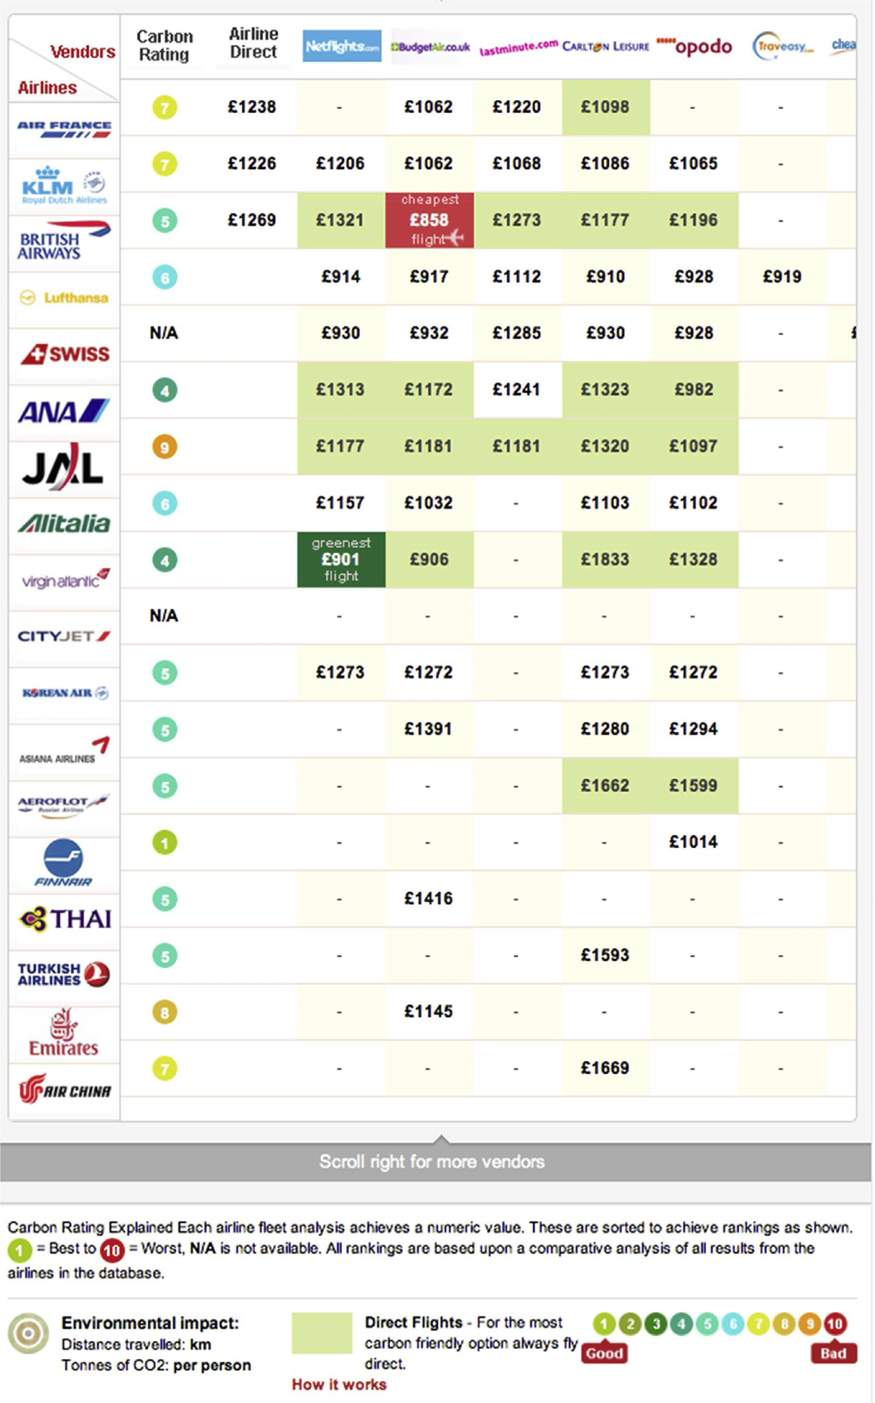

Fig. 4. Global distribution systems (air travel). Source: Direct Flights (2013).

‘kg CO2’ as a ‘very intelligible’ or ‘intelligible’ indicator, while 34% suggested that it was an ‘unintelligible’ or even ‘extremely unin- telligible’ measure of climate impact, the remainder being unde- cided. Consequently, only 14% said that this indicator was providing information of any importance to them, while 30% underlined that it had no importance at all. Another 26% considered the indicator as too abstract, or lacking the opportunity for comparison. For example, one respondent asked “What is the meaning of 650 kg
CO2? Is that a lot, very little, is it good or bad?” In contrast, 11%
acknowledged that kg CO2 values do shed light on emissions in- tensities, and another 6% suggested that the values raised aware- ness. Only 5% believed, however, that the indicator helped decision- making.
In comparison, respondents were asked to consider an alter- native colour-coded carbon label for a Dutch tour operator, origi- nally developed by Eijgelaar and Peeters (2013), though not currently operational (Fig. 10). Approval rates for this label were considerably higher. Overall, 60% suggested that the concept was

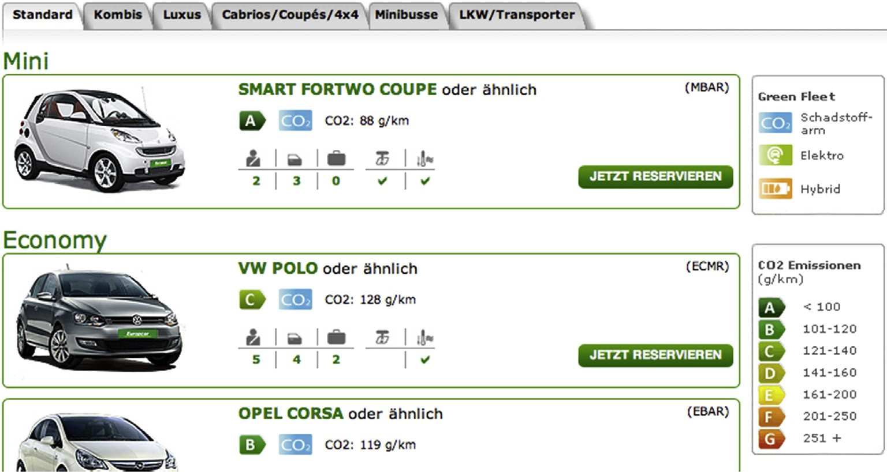

Fig. 5. Emission intensities for different rental car choices. Source: Europcar (2013).

either “good”, “easy to understand” or “well-known”, owing to its similarity with the EU label for white appliances. One respondent commented: “Very good! I have seen such a ‘trafﬁc light’ label before, in the context of white appliances. Efﬁcient and easy to understand.” Only 13% considered the label of little help in assessing the impact of the journey. For example, one respondent said that it was “Maybe a little more enlightening than just CO2.

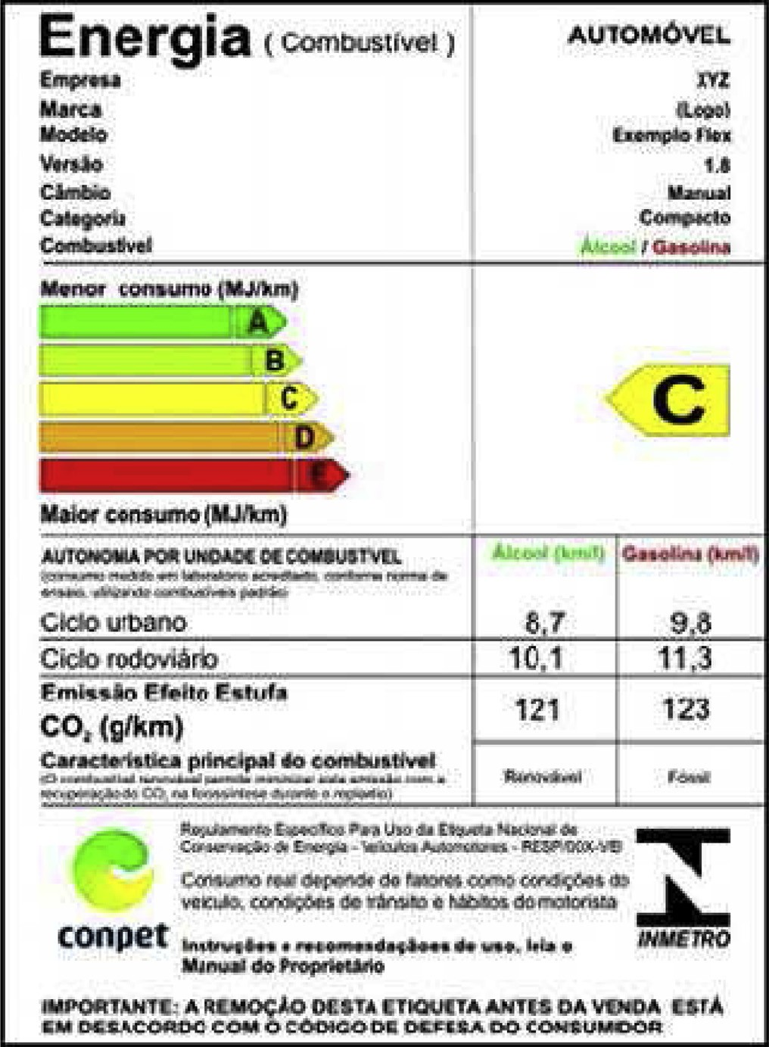

Fig. 6. Information on emission intensities of cars (Brazil). Source: UNEP (2013).
Still, I am not convinced. I am missing additional information. I mean, what is this really telling me?” Even though only 2% of re- spondents said that the carbon label would exercise a strong in- ﬂuence on their travel decisions, 26% said that the label would have ‘some’ inﬂuence, 10% would rethink holiday choices, and 11% would chose ‘greener’ alternatives if this were an option: “If different holiday types were made comparable, such a label would inﬂuence my decision making.” A substantial proportion of respondents, however (15%), were adamant that carbon labelling “has absolutely no inﬂuence on my decision … Such a label would rather scare me off to book my holiday travel with this tour operator, because I would think they try to make me feel guilty about travelling.”

- Discussion

Eco-certiﬁcation is now widespread, though there remains some controversy regarding the impact of eco-labels on consumer choices. For instance, Buckley (2012) argues that certiﬁcation schemes in tourism have limited market penetration, that they have a low degree of reliability, are not transparent to consumers, that they are based on few or no audits, and that there are few sanctions for non-compliance with standards. As a result, tourists have largely ignored labels. This argument would be conﬁrmed by survey results, as less than one third of respondents (27%) consid- ered the carbon label of the Forum Anders Reisen intelligible, while a majority (56%) found it to be of no importance, too abstract, or lacking the opportunity for comparison. These perceptions would echo ﬁndings of the theoretical analysis of existing carbon labels, which suggest that the Forum Anders Reisen presupposes a higher degree of carbon capability (medium; Table 2), while lacking in- formation relating to procedural and effectiveness knowledge. Notably, approval rates of the carbon label are low in a sample that can otherwise be considered environmentally aware.
Testing a different type of carbon label in this group leads to different results. A colour-coded carbon label providing factual and procedural information was perceived positively by 60% of re- spondents. Some 26% ascertained that the label would have some inﬂuence, and another 21% would rethink holiday choices or chose ‘greener’ alternatives. 2% even suggested that the label would have a strong inﬂuence on their travel decisions. The colour scheme thus had considerable impacts on perceptions, with only 15% stating that carbon labels affect their decisions under no circumstances.

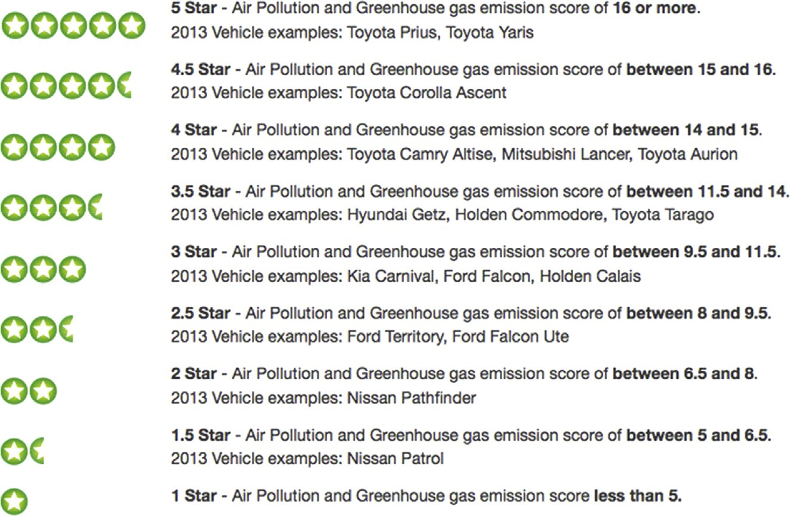

Fig. 7. Car efﬁciency star rating system, Australia. Source: Drive Now (2013).

These ﬁndings indicate that persuasive communication is of great relevance, and that carbon labels need to address issues of carbon capability, and to comprise different knowledge dimensions. Where this is the case, carbon labels may more generally be perceived as positive, and become critical in consumer choices (Hartikainen et al., in press; Lin and Huang, 2012; Van Birgelen et al., 2009). Lee et al. (2010) suggest, for instance, that green ho- tel branding enhances recognition and intention to revisit and recommend, as well as to pay premiums, while also serving as value and quality attribute. Likewise, Steinhart et al. (2013) ﬁnd that eco- labels increase the value of a product, though this may be product- dependent. For utilitarian products, eco-labels increase perceptions of functionality, speciﬁcally when global rather than personal beneﬁts are emphasized. For luxury products, on the other hand, eco-labels increase the perception of the consumer as being ‘green’, and hence justify consumption of the product. Other certiﬁcations
have been shown to signiﬁcantly inﬂuence consumer choices, such as the EU energy label (e.g. Heinzle and Wüstenhagen, 2012).
Various conclusions relevant for the improvement of carbon labels can be derived from the literature as well as the insights of the review and survey presented in this paper. In general terms, the readability and relevance of carbon labels in tourism can be improved, which is of importance as the environmental friendli- ness of a product is generally ranking low in the perception of consumers, while their carbon illiteracy is high. Hartikainen et al. (in press) found, for instance, that 90% (n ¼ 1010) of respondents were unable to describe the term “product carbon footprint” accurately (see also Upham et al., 2011). Adding a colour code to emissions data addresses factual and procedural knowledge re- quirements, and thus different degrees of carbon capability. Labels may be further optimized by integrating additional information, such as averaged sustainable per capita per day emissions. This

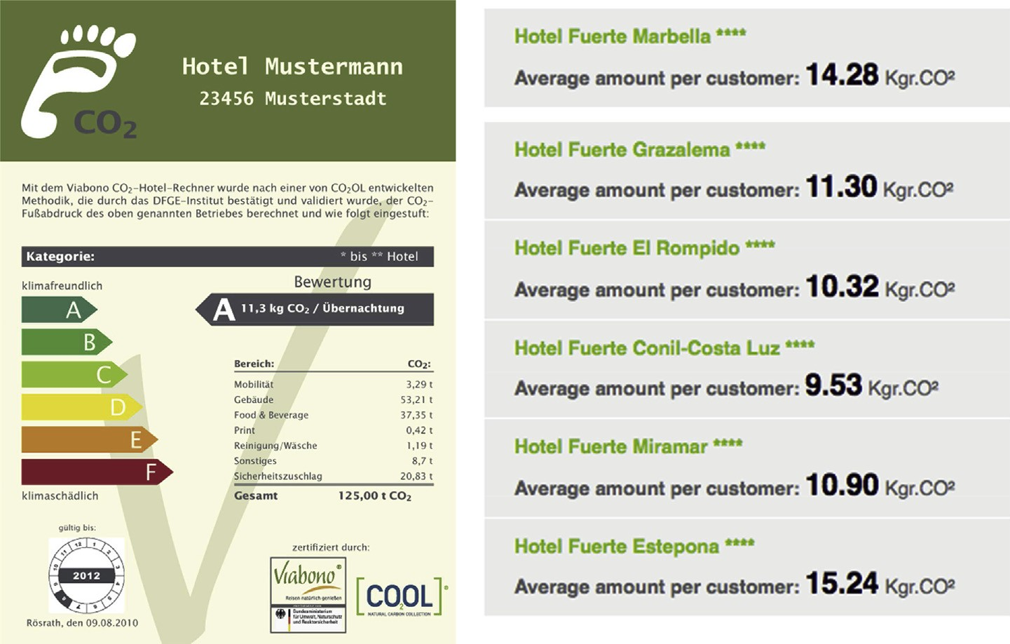

Fig. 8. Carbon labelling in hotels, Viabono (left) and Fuerte Hoteles (right). Source: Viabono (2013); Fuerte Hoteles (2013).

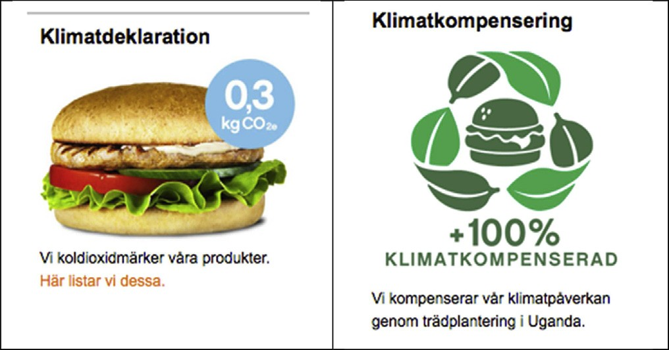

Fig. 9. Carbon labelling of food. Source: Max Burgers (2013).

would add the currently missing dimension of effectiveness knowledge needed to encourage behavioural change. To improve the credibility of carbon labels, it is also necessary to ﬁnd common assessment methods, possibly in combination with third party auditing (cf. Cohen and Vandenbergh, 2012): the review of existing carbon labels revealed that such information is often not provided, or based on different assessment methods.
As results also indicate indifference by a considerable share of travellers to carbon labels, it needs to be noted that eco-labelling

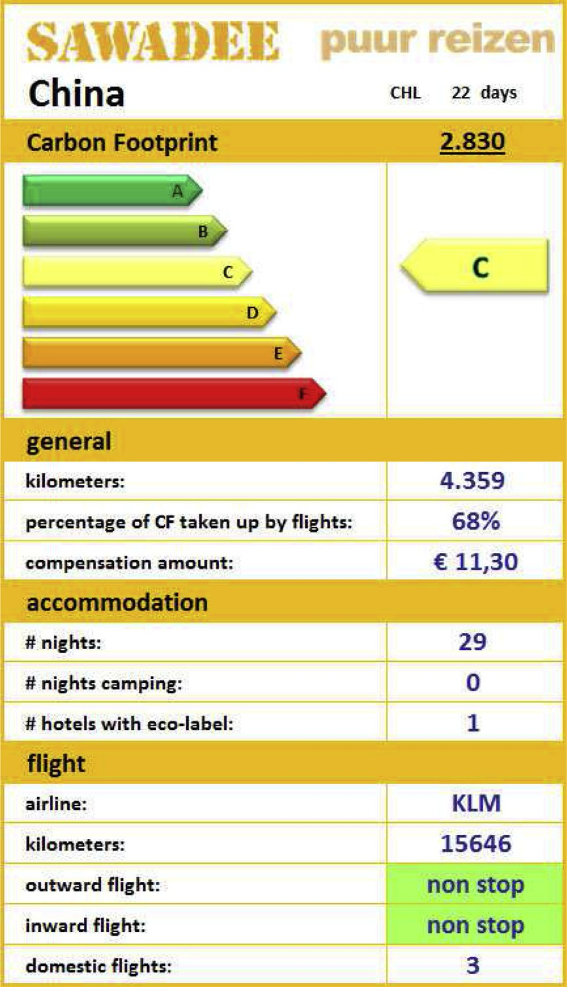

Fig. 10. Suggestion for an alternative combined carbon label. Source: Eijgelaar and Peeters (2013).
cannot overcome some of the psychological determinants that underlie travel behaviour. For instance, where high mobility is
associated with social status, or constitutes social capital (Go€ssling
and Nilsson, 2010), where issues of personality and identity are involved (Hibbert et al., 2014), or where travel patterns are founded in more complex psychological conditions, labels may have no in- ﬂuence on holiday choices, transport behaviour, or the consump- tion of tourism-related services. This is possibly reﬂected in the 15% of the sample of environmentally aware travellers, for whom labels have no importance. However, where consumer behaviour is adjustable, carbon labels represent a form of social marketing that may appeal to consumers (Corner and Randall, 2011), particularly if combined with positive, empowering messages as used by the transition movement (Howell, 2013).
Carbon labels make it in many cases possible to choose a greener alternative, also increasing environmental awareness and affecting moral norms. Speciﬁcally where labels are understood to indicate a qualitatively better product there is considerable scope to affect consumer behaviour (Oxera, 2006). In such cases, carbon labels become “endorsement labels” (Heinzle and Wüstenhagen, 2012), identifying a best-in-class product. As noted by Wiser (1998: 116), “only the ‘greenest’ of consumers will be satisﬁed solely with an opportunity for altruism”. Enhancing notions of quality would thus, in line with Stern et al.'s (1999) Value-Belief-Norm theory, allow to align altruistic and biospheric values with egoistic values, thus facilitating changes in personal norms, and, ultimately, pro- environmental behaviour. Carbon labels may thus make a contri- bution to awareness, knowledge, and, to a more limited degree, behavioural change.
Finally, it needs to be noted that depending on the service, there are differences between carbon labels that need to be taken into consideration. With regard to road transport, fuel efﬁciencies for both owned or hired cars can be easily deducted from labels, as long as these consider and rank all cars. Germany, with an approach to rank cars in classes, compares SUVs only with SUVs, with the obscure result that a large, emission-intense car may be ranked as a “green” choice, while a small, low-emission car may be ranked “orange”. This is likely to confuse consumers, also requiring a higher degree of carbon literacy. Air transport can be compared of the basis of identical routes, though various factors e such as freight, stopovers, or load factors e need to be considered in the comparison. In the case of cruise ships, speciﬁc journeys would have to be compared, rather than vessel type, itinerary or speed, i.e. the factors inﬂuencing speciﬁc per passenger per kilometre emis- sions. Hotels and other providers primarily using electricity would have to detail the source of the power purchased, with for instance nuclear power being a low-carbon, high-risk choice that is likely to be perceived less favourably by customers. Overall, this indicates that more groundwork has to be done to implement carbon labels on a broad basis, using similar standards, considering issues of carbon literacy, knowledge domains, and the overall reliability and validity of such labels.

- Conclusions

Carbon labels can make a contribution to more climatically sustainable choices, as they allow for comparison between similar products. In tourism, carbon labels can now be found in almost all sub-sectors, but they are developed on the basis of incoherent approaches, and suffer from a lack of persuasive communication. Research as presented in this paper suggests that colour schemes in combination with factual emissions information better address different degrees of carbon capability, allowing a wide range of travellers to understand these labels, while also providing factual information on CO2 emissions. To optimize carbon labels would

likely result in improved readability and appeal, facilitating behavioural change among a greater share of travellers. To improve the impact of carbon labels, it is also advisable to market carbon labels as endorsement or quality labels, i.e. referring to low carbon products as higher quality products. Further studies of different traveller types and e cultures are needed to conﬁrm these ﬁndings, however. Apart from these speciﬁc ﬁndings, the study suggests that it is of great relevance to increase tourists' carbon literacy. Clearly, even though evidence as presented in this paper suggests that carbon labels can make a contribution to behavioural change, these are no substitute for climate policy.

References

AIDA, 2013. Aida in Zahlen. Available at: http://www.aida.de/aida-cruises/ nachhaltigkeit/aida-cares-2013/erfolge/aida-in-zahlen.25868.html (accessed 28.12.13.).
Aran~a, J.E., Leo'n, C.J., Moreno-Gil, S., Zubiaurre, A.Z., 2012. A comparison of tourists'
valuation of climate change policy using different pricing frames. J. Travel Res. 52 (1), 82e92.
Atmosfair, 2013. Atmosfair Airline Index 2013. Available at: https://www.atmosfair. de/en/air-travel-climate/airline-index/ (accessed 18.12.13.).
Barr, S., Shaw, G., Coles, T., Prillwitz, J., 2010. “A holiday is a holiday”: practicing sustainability, home and away. J. Transp. Geogr. 18, 474e481.
Bettinghaus, E.P., 1968. Persuasive Communication. Holt, Rinehart and Winston, New York.
Buckley, R.C., 2013a. Sustainability: three reasons for eco-label failure. Nature 500, 151.
Buckley, R.C., 2013b. Social beneﬁt certiﬁcation as a game. Tour. Manag. 37, 203e209.
Buckley, R., 2012. Sustainability reporting and certiﬁcation in tourism. Tour. Recreat.
Res. 37 (1), 85e90.
Buckley, R.C., 2011a. 20 Answers: reconciling air travel and climate change. Ann.
Tour. Res. 38 (3), 1178e1181.
Buckley, R.C., 2011b. Tourism under climate change: will slow travel supersede short breaks? Ambio 40, 328e331.
Buckley, R.C., 2011c. Tourism and environment. Annu. Rev. Environ. Resour. 36 http://dx.doi.org/10.1146/annurev-environ-041210-132637E.
Buckley, R.C., 2009. Evaluating the net effects of ecotourism on the environment: a framework, ﬁrst assessment and future research. J. Sustain. Tour. 17 (6), 643e672.
Buckley, R.C., 2002. Tourism ecolabels. Ann. Tour. Res. 29, 183e208.
Cohen, M.A., Vandenbergh, M.P., 2012. The potential role of carbon labelling in a green economy. Energy Econ. 34 (1), S53eS63.
Cohen, S., Higham, J., Peeters, P., Go€ssling, S., 2014. Understanding and Governing
Sustainable Tourism Mobility: Psychological and Behavioural Approaches. Routledge, London.
Cohen, S.A., Higham, J.E.S., 2011. Eyes wide shut? UK consumer perceptions on aviation climate impacts and travel decisions to New Zealand. Curr. Issues Tour. 14 (4), 323e335.
Corner, A., Randall, A., 2011. Selling climate change? The limitations of social marketing as a strategy for climate change public engagement. Glob. Environ. Change 21, 1005e1014.
De Grosbois, D., Fennell, D., 2011. Carbon footprint of the global hotel companies: comparison of methodologies and results. Tour. Recreat. Res. 36 (3), 231e245. Denicolo, V., 2008. A signaling model of environmental overcompliance. J. Econ.
Behav. Org. 68 (1), 293e303.
Deutsche Bahn, 2013. Der UmweltMobilCheck e Das Instrument für Ihre Reise- planung. Available at: http://www.bahn.de/p/view/service/umwelt/ umweltbilanz_hintergrund.shtml (accessed 28.12.13.).
Direct Flights, 2013. Carbon friendly ﬂight search. Available at: http://www. directﬂights.com (accessed 27.12.13.).
Drive Now, 2013. A guide to car hire eco-ratings. Available at: http://www. drivenow.com.au/travel-centre/eco-ratings-vehicle.jspc (accessed 28.12.13.).
EC, 2013. Energy efﬁciency. Energy labelling of products. Available at: http://ec. europa.eu/energy/efﬁciency/labelling/labelling_en.htm (accessed 28.12.13.).
Eijgelaar, E., Peeters, P., 2013. Toenemende ‘vakantievoetafdruk’ en hoe hiermee om te gaan. In: Changes in Tourism - Vakantiebeurs 2013, 9.1.2013. ANVR, Utrecht, Netherlands.
Eijgelaar, E., de Kinderen, D., 2014. Carbon offsetting: motives for participation and impacts on travel behaviour. In: Cohen, S.A., Higham, J.E.S., Peeters, P.,
Go€ssling, S. (Eds.), Understanding and Governing Sustainable Tourism Mobility:
Psychological and Behavioural Approaches. Routledge, London, pp. 125e143. Eurobarometer, 2011. Attitudes of European citizens towards the environment.
Available at: http://ec.europa.eu/environment/pdf/ebs_365_en.pdf (accessed 28.12.13.).
Europcar, 2013. Green Fleet. Available at: http://microsite.europcar.com/green/ green-ﬂeet.shtml (accessed 28.12.13.).
European Parliament, 1999. Directive 1999/94/EC of the European Parliament and of the Council of 13 December 1999 relating to the availability of consumer
information on fuel economy and CO2 emissions in respect of the marketing of new passenger cars. Available at: http://eur-lex.europa.eu/LexUriServ/ LexUriServ.do?uri¼CONSLEG:1999L0094:20081211:EN:PDF (accessed 27.12.13.).
Finnair, 2013. Emissions calculator. Available at: http://www.ﬁnnairgroup.com/ responsibility/responsibility_10.html (accessed 28.12.13.).
Flybe, 2013. Eco-labelling 2013. Available at:http://www.ﬂybe.com/corporate/
sustainability/eco_labelling_scheme.htm. (accessed 13.12.13.).
Font, X., Buckley, R.C. (Eds.), 2001. Tourism Ecolabelling. CAB International, Wallingford.
Forum Anders Reisen, 2014. Membership Criteria. Available from: http:// forumandersreisen.de/content/dokumente/Kriterienkatalog%20far_en.pdf Accessed 10 September 2014.
Fuerte Hoteles, 2013. Huella de Carbono. Available at: http://www.fuertehoteles. com/grupo-el-fuerte/huella-de-carbono/ (accessed 27.12.13.).
Go€ssling, S., Nilsson, J.H., 2010. Frequent Flyer programmes and the reproduction of
mobility. Environ. Plan. A 42, 241e252.
Go€ssling, S., 2010. Carbon Management in Tourism: Mitigating the Impacts on Climate Change. Routledge, London.
Go€ssling, S., 2013. National emissions from tourism: an overlooked policy chal- lenge? Energy Policy 59, 433e442.
Go€ssling, S., Haglund, L., K€allgren, H., Revahl, M., Hultman, J., 2009. Swedish air travellers and voluntary carbon offsets: towards the co-creation of environ-
mental value? Curr. Issues Tour. 12, 1e19.
Go€ssling, S., Scott, D., Hall, C.M., 2013. Challenges of tourism in a low-carbon economy. Wiley Interdiscip. Rev. Clim. Change 4 (6), 525e538.
Hall, C.M., 2013. Framing behavioural approaches to understanding and governing sustainable tourism consumption: beyond neoliberalism, ‘nudging’ and ‘green growth’? J. Sustain. Tour. 21, 1091e1109.
Hartikainen, H., Roininen, T., Katajajuuri, J.-M., Pulkkinen, H., 2014. Finish consumer perceptions of carbon footprints and carbon labelling of food products. J. Clean. Prod. 73, 285e293.
Heinzle, S.L., Wüstenhagen, R., 2012. Dynamic adjustment of eco-labeling schemes and consumer choice e the revision of the EU Energy label as a Missed op- portunity? Bus. Strategy Environ. 21 (1), 60e70.
Hibbert, J., Dickinson, J., Go€ssling, S., Curtin, S., 2014. Identity and tourism
mobility: an exploration of the attitude-behaviour gap. J. Sustain. Tour. 21 (7), 999e1016.
Higham, J., Cohen, S.A., 2011. Canary in the coalmine: Norwegian attitudes towards climate change and extreme long-haul air travel to Aotearoa/New Zealand. Tour. Manag. 32, 98e105.
Honey, M., 2002. Ecotourism and Certiﬁcation: Setting Standards in Practice. Island Press, Washington, DC.
Howell, R.A., 2013. “It's not (just) the environment, stupid!” Values, motivations, and routes to engagement of people adopting lower-carbon lifestyles. Glob. Environ. Change 23, 281e290.
International Panel on Climate Change, 2013. Working Group I, Approved Summary for Policymakers. Available at: http://www.climatechange2013.org/images/ uploads/WGIAR5-SPM_Approved27Sep2013.pdf (accessed 17.10.13.).
Kollmuss, A., Agyeman, J., 2002. Mind the gap: why do people act environmentally and what are the barriers to pro-environmental behaviour? Environ. Educ. Res. 8 (3), 239e260.
Lee, D.S., Fahey, D.W., Forster, P.M., Newton, P.J., Wit, R.C.N., Lim, L.L., Owen, B., Sausen, R., 2009. Aviation and global climate change in the 21st century. Atmos. Environ. 43, 3520e3537.
Lee, J.-S., Hsu, L.-T., Han, H., Kim, Y., 2010. Understanding how consumers view green hotels: how a hotel's green image can inﬂuence behavioural intentions. J. Sustain. Tour. 18 (7), 901e914.
Lee, K.-H., 2011. Integrating carbon footprint into supply chain management: the case of Hyundai Motor Company (HMC) in the automobile industry. J. Clean. Prod. 19, 1216e1223.
Lin, P., Huang, Y., 2012. The inﬂuence factors on choice behavior regarding green products based on the theory of consumption values. J. Clean. Prod. 22, 11e18.
Lu, J.-L., Shon, Z.Y., 2012. Exploring airline passengers' willingness to pay for carbon offsets. Transp. Res. Part D 17, 124e128.
Mair, J., 2011. Exploring air travellers' voluntary carbon-offsetting behaviour.
J. Sustain. Tour. 19, 215e230.
Max Burgers, 2013. Klimatma€rkt meny (carbon-labelled menu). Available at: http:// www.max.se/sv/Ansvar/Klimatdeklaration/ (accessed 13.12.13.).
McKercher, B., Prideaux, B., Cheung, C., Law, R., 2010. Achieving voluntary reductions in the carbon footprint of tourism and climate change. J. Sustain. Tour. 18, 297e317.
Miller, G., Rathouse, K., Scarles, C., Holmes, K., Tribe, J., 2010. Public understanding of sustainable tourism. Ann. Tour. Res. 37 (3), 627e645.
Organization of Economic Co-operation and Development (OECD) and United Na- tions Environment Programme (UNEP), 2011. Climate Change and Tourism Policy in OECD Countries. OECD and UNEP, Paris, France.
Organization of Economic Co-operation and Development (OECD), 2014. Review of Policies and Practices in Tourism Taxation. OECD, Paris, France.
Oxera, 2006. Policies for Energy Efﬁciency in the UK Household Sector. Report prepared for Defra. Available at: www.Defra.gov.uk/environment/ climatechange/uk/energy/research/pdf/oxera-report.pdf (accessed 27.12.13.).
Schwanen, T., Lucas, K., 2011. Understanding auto motives. In: Lucas, K., Blumenberg, E., Weinberger, R. (Eds.), Auto Motives. Understanding Car Use Behaviours. Emerald, Bingley, pp. 3e38.
Scott, D., Peeters, P., Go€ssling, S., 2010. Can tourism deliver its aspirational green-
house gas emission reduction targets? J. Sustain. Tour. 18, 393e408.

Six Senses, 2009. Carbon Inventory Report. Evason Phuket 2008-2009. Six Senses Resorts & Spas, Bangkok, Thailand.
SJ, 2013. En hållbar resa a€r mer a€n bara gro€n. Available at: http://www.sj.se/sj/jsp/
polopoly.jsp?d¼260&l¼sv (accessed 28.12.13.).
Stawreberg, Wikstro€m, 2011. Does the energy labelling system for domestic tumble dryers serve its purpose? J. Clean. Prod. 19, 1300e1305.
Steg, L., Vlek, C., 2009. Encouraging pro-environmental behaviour: an integrative review and research agenda. J. Environ. Psychol. 29, 309e317.
Steinhart, Y., Ayalon, O., Puterman, H., 2013. The effect of an environmental claim on consumers' perceptions about luxury and utilitarian products. J. Clean. Prod. 53, 277e286.
Stern, P.C., Dietz, T., Abel, T., Guagnano, G.A., Kalof, L., 1999. A value-Belief-Norm theory of support for social movements: the case of environmentalism. Hum. Ecol. Rev. 6 (2), 81e97.
Stoll-Kleemann, S., O'Riordan, T., Jaeger, C.C., 2001. The psychology of denial con- cerning climate mitigation measures: evidence from Swiss focus groups. Glob. Environ. Change 11, 107e117.
Strasdas, W., Go€ssling, S., Dickhut, H., 2010. Treibhausgas-Kompensationsanbieter in
Deutschland. Abschlussbericht. Verbraucherzentrale Bundesverband, Berlin, Germany.
The Responsible Tourism Partnership, 2013. Fly smart. Available at: http://www. responsibletourismpartnership.org/FlySmart.html (accessed 27.12.13.).
TUI cruises, 2013. Umweltbericht. Available at: http://tuicruises.com/nachhaltigkeit/ umweltbericht/ (accessed 28.12.13.).
UNEP, 2009. Towards sustainable production and use of resources: assessing bio- fuels. Available at: www.unep.fr/shared/publications/pdf/WEBx0149xPA- AssessingBiofuelsSummary.pdf (accessed 28.12.13.).
UNEP, 2013. Brazil fuel economy label. Available at: http://www.unep.org/transport/ gfei/autotool/case_studies/samerica/brazil/cs_br_images/big_Brazil-fuel- economy-label.jpg (accessed 02.01.13.).
UNFCCC, 2013. Report of the Ad Hoc Working Group on the Durban Platform for Enhanced Action on the First and Second Parts of its Second Session. Held in
Bonn from 29 April to 3 May 2013 and from 4 to 13 June 2013. Available at:
http://unfccc.int/resource/docs/2013/adp2/eng/02.pdf (accessed 09.08.13.).
UNWTO, 2012. UNWTO Tourism Highlights, 2012 ed. UNWTO, Madrid.
United Nations World Tourism Organization, United Nations Environment Pro- gramme, World Meterological Organization (UNWTO-UNEP-WMO), 2008. Climate Change and Tourism: Responding to Global Challenges. UNWTO, Madrid.
Upham, P., Dendler, L., Bleda, M., 2011. Carbon labelling of grocery products: public perceptions and potential emissions reductions. J. Clean. Prod. 19, 348e355.
Urry, J., 2011. Social networks, mobile lives and social inequalities. J. Transp. Geogr.
21, 24e30.
Van Birgelen, M., Semeijn, J., Keicher, M., 2009. Packaging and pro environmental consumption behavior. Environ. Behav. 41, 125e146.
van der Linden, S., 2014. Towards a new model for communicating climate change. In: Cohen, S.A., Higham, J.E.S., Peeters, P., Go€ssling, S. (Eds.), Understanding and
Governing Sustainable Tourism Mobility: Psychological and Behavioural Ap- proaches. Routledge, London, pp. 243e275.
Viabono, 2013. Viabono® CO2-Fußabdruck für das Gastgewerbe. Available at: http://
www.viabono.de/CO2Fussabdruck.aspx (accessed 27.12.13.).
Whitmarsh, L., Seyfang, G., O'Neill, S., 2011. Public engagement with carbon and climate change: to what extent is the public ‘carbon capable’? Glob. Environ. Change 2011, 56e65.
Wiser, R.H., 1998. Green power marketing: increasing customer demand for renewable energy. Util. Policy 7, 107e119.
World Energy Council, 2013. Energy efﬁciency policies around the world: review and evaluation. Available at: http://www.worldenergy.org/publications/ energy_efﬁciency_policies_around_the_world_review_and_evaluation/3_ evaluation_of_energy_efﬁciency_policies_and_measures/1194.asp (accessed 27.12.13.).
World Travel and Tourism Council (WTTC), 2009. Leading the Challenge. WTTC, London. Available from: http://www.wttc.org/site_media/uploads/downloads/ leading_the_challenge_on_clima.pdf (accessed 20.08.13.).

