Caprivi Crocodile Research Project

Project Report 2007

Patrick Aust
Caprivi Crocodile Research Project
Box 8013 Mayuni
Email: patrickwaust@hotmail.com

Index

Introduction…………………………………………………………………..1
Section A: Population surveys……………………………………………....1
Section B: Human Crocodile Conflict: Event Book……………………….5
Section C: Social Surveys……………………………………………………8
Section D: Discussion………………………………………………………..13
Section E: Management recommendations..................................................15
Acknowledgements…………………………………………………….……18
References……………………………………………………………………18

Introduction

This report contains information on aspects of the ecology, conservation and management of crocodiles in North Eastern Namibia. It is intended to give an overview of the research work carried out by the Caprivi Crocodile Research Project over the last two years (2006/2007). More detailed information on various aspects of the project will be provided in the form of scientific publications and a PhD thesis. Copies of these will be presented to the Ministry of Environment and Tourism and the Namibia Nature Foundation towards the end of 2008.

Section A:

Population surveys

Methods

Boat surveys
Boat surveys were carried out on sample lengths of the Kwando, Zambezi, Chobe and Okavango river systems. Boat surveys consisted of three components: a) counting riverside human activities during the day. These included cattle, humans, canoes, lodges and tourist boats; b) counting crocodiles at night using a standard spotlight survey technique; and c) capture and processing of smaller crocodiles. Processing included photographing belly skins, taking tissue samples, measuring various morphometrics and marking individuals by means of coded scute clipping. In total 21 boat surveys were carried out between the 14 July 2006 and the 7 October 2007. The total distance covered during boat surveys was 720.4 km.

Aerial survey
An aerial survey was flown over 11 days between 29 August and 21 September 2007. A similar methodology to the 2004 NNF/MET wetland survey was used. 1,778 km² were surveyed totalling 42 hours flying time. In addition to wildlife species, canoes and cattle were also counted.

Results

1.) Crocodile population estimates.

Estimating the number of crocodiles in any given system is a difficult task. Not only are crocodiles aquatic animals spending much of their time submerged but they also tend to live in cryptic environments that do not lend themselves to conventional survey techniques. As a result of this, population estimates in North Eastern Namibia are derived from a combination of survey techniques and associated correction factors (Table 1).

Table 1. Results from aerial and boat survey data

Boat sample surveys (density) | 2007 | 2004
Kwando | 0.9 | 1.06
Chobe | 2.84 | n/a
Okavango | 0.44 | n/a
Zambezi | 0.47 | 0.44
Aerial survey total count | 2007 | 2004
Zambezi | 59 | 55
Mamili | 48 | 37
Chobe | 60 | 58
Kwando | 40 | 40
Okavango | 35 | 17

In 2004 crocodile population estimates were derived from six sample spotlight surveys on the Kwando and Zambezi River and a total aerial count of crocodiles >2m. The first correction factor used was a ‘submerged or concealed’ correction factor which accounts for the percentage of the population not counted during spotlight surveys. Correction factors of 30% were used for the Kwando, Mamili and Chobe/Linyanti stratum and 40% for the Zambezi and Okavango stratums. The second correction factor used was a ‘spotlight to aerial’ correction factor which accounts for the difference between aerial counts and spotlight counts. The population of crocodiles <2m was determined by multiplying the number of crocodiles seen from the air by the ratio of <2 to >2m seen during spotlight surveys. Ratios derived from the Kwando system were used for the Mamili and Chobe/Linyanti stratum whilst ratios from the Zambezi were used for the Okavango stratum. Total population was then calculated by multiplying the aerial count by the two correction factors and adding this to the derived number of <2m crocodiles. Following are the final results of the 2004 survey:

2004 Survey | Large (>2m) | Small  (<2m) | total
Okavango | 66 | 38 | 104
Chobe/Linyanti | 828 | 3,916 | 4,744
Mamili | 529 | 2,500 | 3,029
Kwandu | 571 | 2,703 | 3,274
Zambezi | 214 | 122 | 336
Total | 2,208 | 9,279 | 11,487

If the exact same methodology is applied to the 2007 data, we get the following figures:

2007 | Large (>2m) | Small  (<2m) | total
Okavango | 179 | 256 | 435
Chobe/Linyanti | 52 | 281 | 333
Mamili | 44 | 238 | 282
Kwandu | 50 | 269 | 319
Zambezi | 250 | 358 | 608
Total | 575 | 1,402 | 1,977

Despite very similar numbers counted in both the aerial and spotlight surveys, the estimated population numbers are vastly different. The reason for this is due to one of the correction factors. In 2004 the ‘aerial to spotlight’ correction factor for the Kwando stratum was 5, whilst in 2007 it was 0.5. This highlights the problems associated with extrapolating correction factors derived from relatively small sample sizes.

In order to eliminate this problem, this study used a single standardised aerial to spotlight correction factor of 2.9. This correction factor was derived from averaging all spotlight surveys carried out in 2006/2007 and therefore represents a significantly larger sample size. This figure (2.9) is used to readjust the 2004 figures and it is used in the 2007 population estimates (see table 2).

Table 2. Nile crocodile population estimates for 2004 and 2007

Readjusted 2004 population estimates | Kuvango | Kwandu | Mamili | Linyanti/Chobe | Zambezi | Total
>2m | 109 | 332 | 307 | 481 | 354 | 1,583
<2m | 62 | 1,569 | 1,452 | 2,275 | 201 | 5,560
Total | 172 | 1,901 | 1,758 | 2,756 | 556 | 7,144
2007 | Kuvango | Kwandu | Mamili | Linyanti/Chobe | Zambezi | Total
>2m | 225 | 290 | 257 | 390 | 316 | 1,478
<2m | 322 | 1692 | 1383 | 2,097 | 451 | 5,946
Total | 547 | 1,983 | 1,640 | 2,487 | 767 | 7,424

By using the standard aerial to spotlight correction factor of 2.9, the difference between the 2004 and 2007 actual counts are reflected more accurately.
2.) Population size structure.

Crocodiles counted during the spotlight surveys were assigned to one of five size classes. These included hatchling, small (<1m), medium (between 1m and 2m) and large (>2m). Where the size class could not be ascertained (e.g. crocodile submerged before examination), animals were placed in an unknown class and later assigned to a size class based on the frequency of size class recordings during that particular survey. Table 3 outlines size class distribution for the various river stratums.

Table 3. Size class distribution by river

Average number of crocodiles per size class per survey | Hatchling | Small | Medium | Large
Kwando | 10.74 | 12.5 | 2.48 | 2.58
Zambezi | 0.33 | 2.48 | 1.65 | 6.22
Chobe | 10.44 | 22.81 | 6.56 | 24.95
Okavango | 1.41 | 2.83 | 5.05 | 1.73

Assuming the hatchling and small size classes represent the breeding activity of crocodiles within a particular area, it is also useful to group size classes further into >1m and <1m in order to ascertain recruitment rates of the various rivers (table 4 and fig 1).

Table 4. Size ratios of different rivers

 | <1m | >1m | Ratios
Kwando | 23.24 | 5.06 | 4.59
Zambezi | 2.81 | 7.87 | 0.36
Chobe | 33.25 | 31.51 | 1.06
Okavango | 4.24 | 6.78 | 0.63

Figure 1. Crocodile recruitment potential of various rivers.
Recruitment rates
0
0.5
1
1.5
2
2.5
3
3.5
4
4.5
5
Kwando
Chobe
Okavango
Zambezi
Size class ratios <1m/>1m)

Conclusions

In general the population of crocodiles in North Eastern Namibia appears stable at between 7,000 to 8,000 animals. There is some concern that anthropogenic factors may be having an impact on the size structure (and consequently the health) of the population in some areas, particularly the Okavango and Zambezi Rivers.

Section B
Human Crocodile Conflict: Event book data

Methods

Human crocodile conflict (HCC) surveys consisted of collecting existing data from local conservancy Event Books. HCC data from the Okavango system was gathered through interviews carried out by a local youth group. Additional information on conflict was obtained from social surveys (see below)

Results

In total 489 cases of crocodile attack were recorded from 1993 to 2005 inclusive. Table 5 summarizes records of crocodile attacks by survey site. Study sites on the Chobe River (Impalila and Kasika) recorded the highest numbers of attacks as well as the highest density of attacks per kilometre of river frontage. Figure 2a summarizes species composition. Other species recorded included dogs, goats, a horse and a pig. 23 cases of human attacks were recorded however at least four of these did not result in fatalities. Figure 2b summarizes some age and sex criteria of cattle records. Adult female cattle made up nearly three quarters of cattle depredations.

Figure 3 summarizes crocodile attacks recorded by month from 1993 to 2005. Close to half the attacks (43%, n=212) occurred in the hot dry season months of September, October and November. After the dry season peaks incidents decline sharply towards December before rising again in January. Few attacks are recorded in the cool winter months of May, June and July (n=58).

Approximately 89 cattle (or 0.29 cattle per kilometre of river frontage) are killed per year within the six study sites (table 2). Extrapolation estimates approximately 255 cattle attacked per year in North Eastern Namibia. There is no significant increase or decrease in attack rates between years (fig 4)

Table 5. Summary of attack records per study site from 2001 to 2005 inclusive

Survey site (river) | Cattle (n) | Human (n) | Other (n) | Total (n) | % of total number of attacks recorded (%) | Km river frontage per survey site | Number of attacks per km river frontage
Kasika (Chobe) | 171 | 2 | 0 | 173 | 36 | 62 | 2.8
Impalila (Chobe) | 201 | 12 | 1 | 214 | 45 | 127 | 1.7
Kwando (Kwando) | 25 | 3 | 7 | 35 | 7 | 35 | 1
Mayuni (Kwando) | 34 | 0 | 0 | 34 | 7 | 23 | 1.47
Mashi (Kwando) | 7 | 0 | 0 | 7 | 1 | 39 | 0.2
Shamvura (Kuvango) | 7 | 6 | 2 | 15 | 3 | 18 | 0.8
Totals | 445 | 23 | 10 | 478 | 99 | 304

Figure 2. (a) Species composition of crocodile attacks from 2001 to 2005 inclusive. (b) Breakdown of cattle records from 2001 to 2005 inclusive
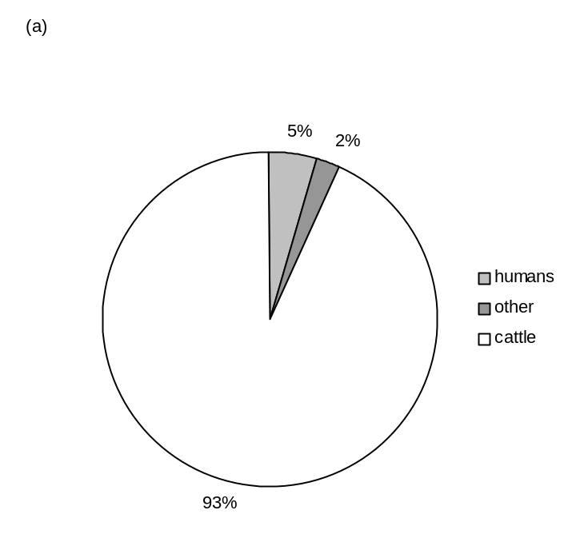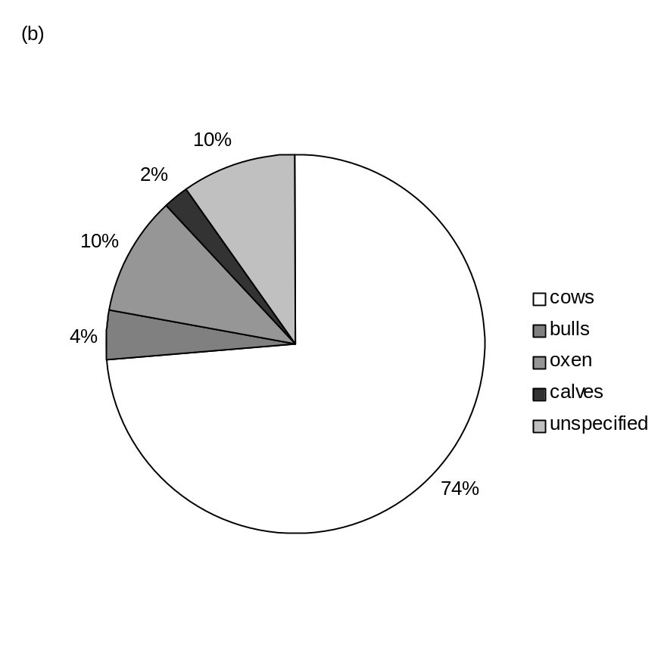
Figure 3. Total number of attack records by month from 1993 to 2005 inclusive.

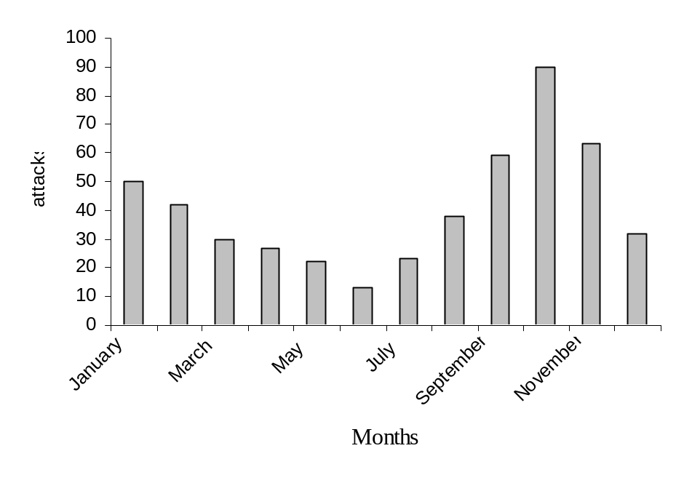

Figure 4. Total recorded crocodile attacks from 2001 to 2005 inclusive.

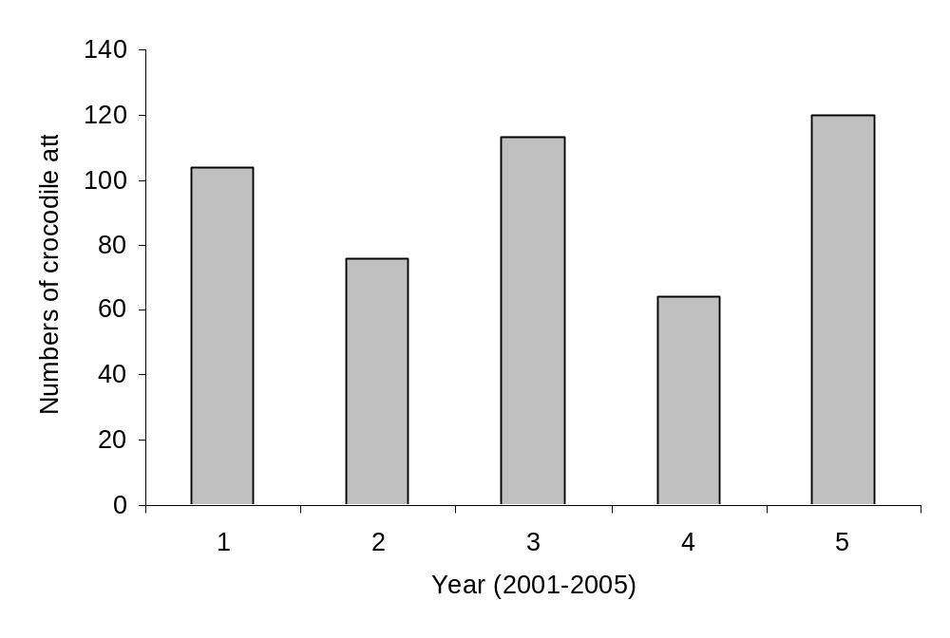

Section C
Social Surveys

Methods

Community surveys were carried out along all the major rivers in North Eastern Namibia by means of semi structured interviews. Interviews were designed to address the attitudes of local communities towards crocodiles and to estimate levels of crocodile human conflict. A total of 146 interviews were conducted in 101 villages during May and June 2007.

A tourist survey was carried out throughout the region (including Windhoek, Kavango region, Caprivi region, Kasane (Botswana) and Victoria Falls (Zimbabwe) by means of questionnaires. Questionnaires were used to gain a better understanding of tourism in Caprivi and in particular assess tourist attitudes towards crocodiles and crocodile based tourism. They were also used as part of a feasibility study into crocodile cage diving tourism. A total of 86 tourist questionnaires were completed during May and June 2007.

Results

1. Community surveys

The questionnaires yielded a large volume of interesting information. The data most relevant to HCC was analysed and is reported here.

a. Livelihood strategies and dependency on the river

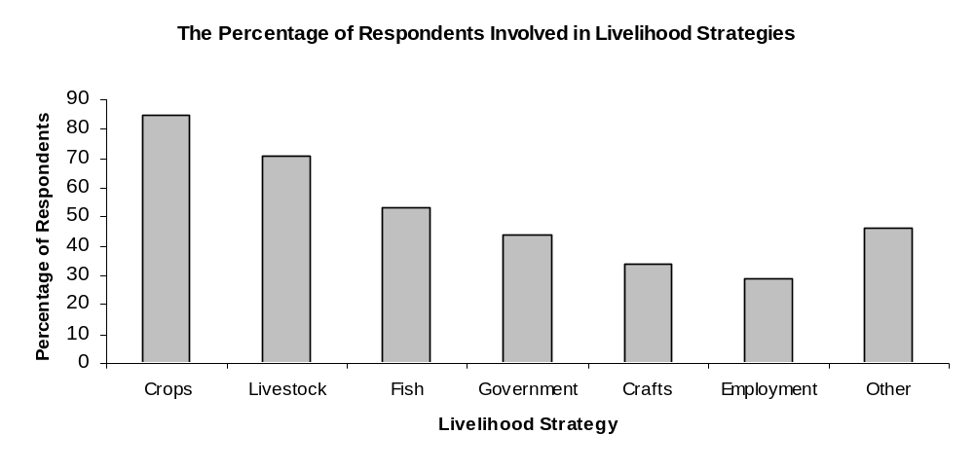Figure 5. The percentage of respondents involved by livelihood strategies

Livestock keeping, fishing, vegetable growing, water lily and reed collection and hence craft production are all livelihood strategies strongly tied to the river. 100% of livestock owners (N =104) reported that their animals drink from the river.
34% of respondents (N=50) are fully dependent on the river for drinking water and 38% for washing and bathing (N=55). 49% of respondents swim in the river (N = 69).

b. Cattle and cattle losses to crocodiles

This particular exercise was carried out in an attempt to quantify the difference between the recorded (event book – see above) and unrecorded (failed to report incident) number of crocodile attacks. Results will later be triangulated for a more robust estimate of livestock losses.

71% of respondents currently keep cattle (N=96). The average head of cattle per household from the total sample is 13.56, this is greatest on the Chobe River (22.15; Kwando = 4.39, Okavango = 9.4, Zambezi =18.6).

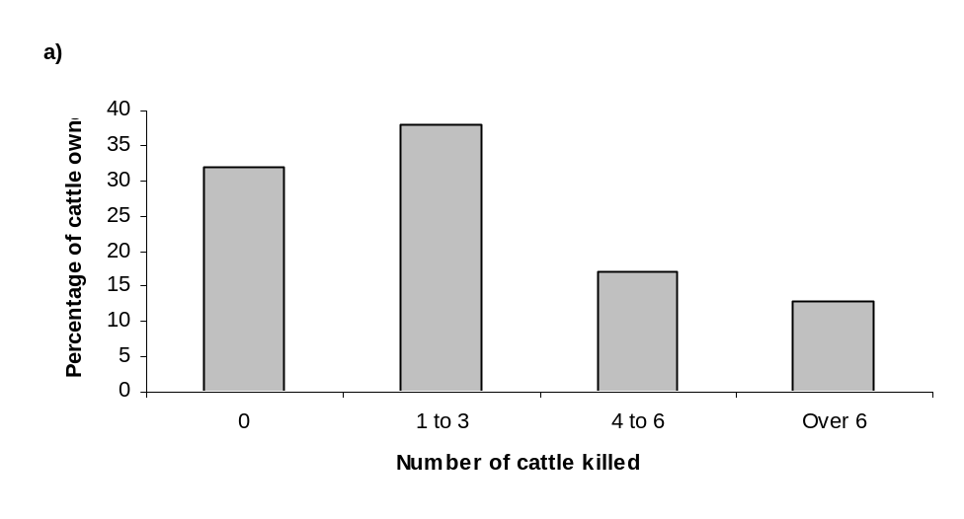
b)

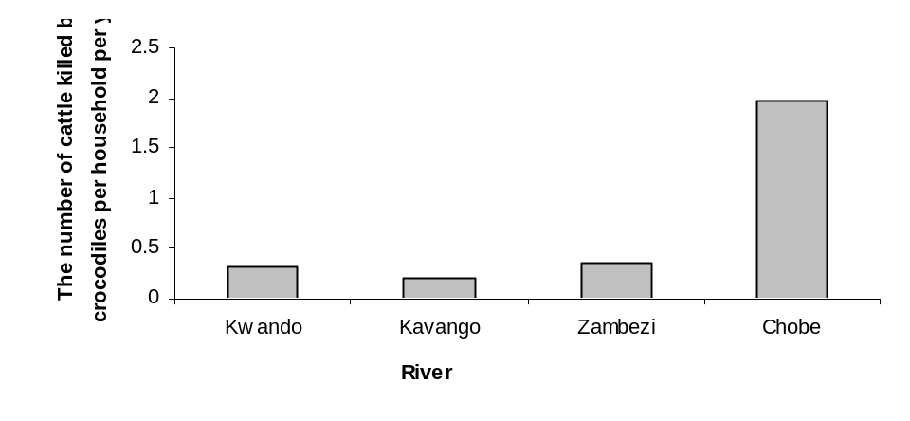
Figure 4. a) The numbers of cattle that owners have had killed by crocodiles in the last five years b) The number of cattle killed by crocodiles per household per year on each river (data from the past five years).

Respondents reported a total of 173 cattle killed in the last year. Most lost a single animal (N=21, 14%). Respondents on the Chobe River reported the greatest number of cattle predations in the last five years with an average of 9.88 head of cattle killed per household. Using a similar scaling process to that used for the Event Book HCC analysis, we estimate 2,780 cattle losses per year in North Eastern Namibia (significantly more than what is recorded).

c. Fishing and fishing net damage

Fishing nets are the most utilised method of catching fish (N = 56, 48% of fishermen).
86% of net fishermen (N=49) reported experiencing net damaged by crocodiles, 80% (N= 45) within the last year (Figure 6)
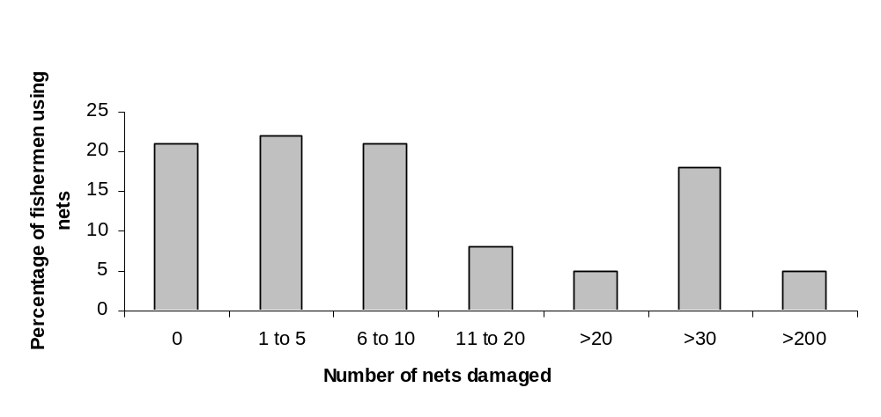
Figure 5. The numbers of nets that fishermen have had damaged by the crocodile in the last year.

Most fishermen experiencing net damage in the last year reported damaged to between 1 and 5 nets (24% of net fishermen).

In total respondents reported damage to approximately 824 fishing nets in the last year, or 10.62 nets damaged per fisherman, or 5.6 nets damaged per household. Respondents on the Chobe River reported much greater levels relative net damage (33 nets per fishermen per year damaged) compared with the other rivers (Kwando=1.2, Kavango=2, and Zambezi=6.22).

d. Crocodile attacks on humans

41% of respondents reported experiencing a crocodile attack in their family (N=60). The Zambezi had the highest percentage of respondents with an attack in family (50%) followed by the Chobe (46%), Kavango (42%) and Kwando (27%). The fatality rate is 51%. Most attacks occurred on adult males (17%), followed by adult females (15%).

The majority of attacks occurred when the victim was fishing (N=21, 35%). Standing in the river whilst fishing is the most dangerous method (N=13, 13% of all attacks). Swimming and washing are the next most dangerous activities (N=20, 34%)

In 10 cases within the past 5 years the attack occurred on the immediate family of the respondent, giving an estimate of 1 attack every 70 households each year.

e. Attitudes towards crocodiles

68% of respondents (N=98) would like crocodiles to be removed from their area, indicating a general low tolerance. The Kwando River has significantly more respondents liking crocodiles than on any other river.

f. Crocodile off takes

25% of net fishermen (N=14) reported finding a crocodile caught in one of their nets within the last 5 years. From this it can be estimated that 1 out of 10 households find a crocodile trapped in a fishing net each year. Ensnared crocodiles have a 33% survival rate (N=7); 43% were dead when found (N=9) and 24% (N=5) were killed by the fisherman.

Table 6. The number of crocodile killing incidents as reported by respondents, categorised according to who killed the animal and the reason for the termination.

Who / Reason | Killed a person | Killed cattle | Trophy /skin | Don’t know | Total | Percentage
Community | 3 | 12 | 0 | 3 | 18 | 51%
Government | 11 | 1 | 0 | 1 | 13 | 37%
Conservancy | 1 | 0 | 0 | 1 | 2 | 6%
Hunter | 0 | 0 | 2 | 0 | 2 | 6%
Total | 15 | 13 | 2 | 5 | 35
Percentage | 43% | 37% | 6% | 14%

The most common reason given for why community members don’t kill more crocodiles is that it is prohibited to do so (N = 107, %=73). 85% of respondents (N =55) believed that if crocodiles were not protected people would kill more.

2. Tourist surveys

Tourists were asked if they were interested in seeing measures taken to conserve crocodiles in the Caprivi. A significant proportion (79.5%) of respondents answered yes to this question (χ²= 1362.036, df = 25, p= 2.2e-16), indicating that a higher proportion of respondents were interested in crocodile conservation in the area than would be expected by chance.

a. Cage diving with crocodiles

Cage diving with crocodiles is a unique adventure tourism activity designed to help rural communities derive some benefit out of wild crocodile populations. The concept itself is very similar to the much publicise shark cage diving in South Africa and involves allowing tourist to watch wild crocodiles feeding underwater from the safety of a secure enclosure.

38.4% of respondents were interested in the idea of cage-diving with crocodiles. Common reasons for not being interested included, ‘Too scary’, ‘Don’t like diving’, ‘Don’t agree with cage diving’.

A much higher proportion of those under the age of 40 (61%) said ‘Yes’ to cage diving with crocodiles. It proved much less popular with the 40-60 and Over 60’s. The idea appeared much less popular with Australians than with any other nationality. Reasons given for this in the questionnaires were that they had seen plenty of crocodiles in the Northern Territory of Australia.

Respondents were asked how much they would be willing to pay for the experience, and were placed into categories accordingly (Figure 6). In total 46.5% of respondents would pay Namibian $300 or more. As would be expected, the proportion of those willing to pay decreased as the amount proposed increased (Figure 6).
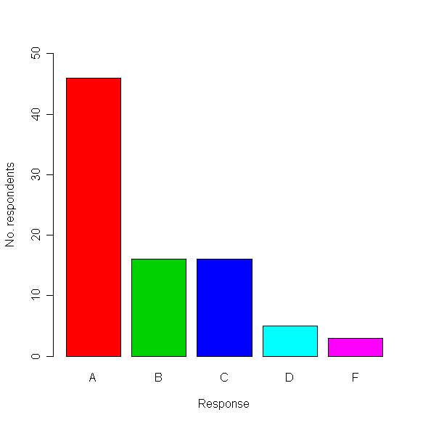
A – Not willing to pay up to $300
B – Definitely willing to pay $300
C – Definitely willing to pay $500
D - Definitely willing to pay $800
E – Definitely willing to pay $1000
F – Definitely willing to pay over $1000
Figure 6. How much respondents would be willing to pay to go cage-diving with crocodiles (all prices in Namibian Dollars)

Approximately 15,000 tourists visit the Caprivi every year. If a conservative estimate of 20% of these tourists (3,000 in total) undertook the cage diving activity, this would generate N$900,000 per year.

Section D

Discussion

As an apex predator living in a human dominated landscape Nile crocodiles are responsible for considerable human wildlife conflict in North Eastern Namibia. We attempt to quantify some environmental determinants, feeding biology and costs to rural communities and crocodile populations.

In Southern Africa Nile crocodiles occur throughout most large tropical rivers and wetlands. Crocodiles are poikilothermic, becoming most active at warmer temperatures and less so at cooler temperatures (Branch 1990). In southern Africa they usually breed in the hot summer months, the female laying a clutch of approximately 16-80 eggs (Branch 1990). In countries bordering the Caprivi Strip (e.g. Zimbabwe and Zambia) egg laying peaks in the third week of September (Fergusson, personal communication). The female guards the nest and in most cases does not eat during this time. Adult Nile crocodiles feed predominantly on large vertebrates and are adept at ambushing terrestrial mammals at the waters edge. As a result of this Nile crocodiles are one of the most dangerous of all crocodilians to humans (Revol 1995).

Every year Nile crocodiles kill a substantial number of humans and livestock animals in North Eastern Namibia. We estimate approximately one human attack per 70 households per year and a total of five fatal attacks per year in North Eastern Namibia. Based on triangulation of recorded crocodile attacks on cattle (event book) and reported attacks (community surveys) we estimate approximately 654 cattle per year are lost to crocodiles. It is interesting to note that in Australia, where an estimated 70 000 saltwater crocodiles live but virtually all humans have access to pumped water, Caldicott et al (2005) reported only 62 attacks on humans in 33 years (1971 to 2004).

The cost of crocodile attack to local communities is substantial. Crocodiles are responsible for approximately 30% of wildlife related stock losses in Caprivi, second only to lion (60 %) (Mulonga et al. 2003). Cattle are the most important sources of social and financial security in Caprivi (Murphy & Mulonga 2002). The average price for slaughter cattle in Namibia in 2001 was N$1,332.00 per animal (Mulonga et al. 2003), which is more than three times the monthly minimum wage of N$429 (Matongela, Namibian Economist, May 2003). Even so, the pure financial value is surpassed by the multitude of basic needs values cattle represent. These include meat, milk, draught power, dung for manure and social and cultural activities relating to prestige, bride wealth and social status. (Ashley & LaFranchi 1997). With an average of only three cattle per person, it is not difficult to see how the loss of a single animal to crocodile attack can have significant impacts on individuals’ future prospects.

Crocodiles also prey on many economically important fish species and are often perceived to be major competitors to subsistence fisheries (Graham & Beard 1990, McGregor 2005). They destroy valuable fishing equipment, particularly nets, and they interfere with fishing efforts (McGregor 2005). Increasingly crocodile human conflicts are having secondary social and political implications. For example the failure of governments to deal with problem crocodiles effectively has resulted in fractious relationships between local communities and government departments in Mozambique (Anderson & Pariela 2005). Crocodile human conflict may also have wider implications on development. For example, in Caprivi where many rural communities are encouraged to protect and conserve wildlife as a valuable natural resource capable of generating foreign income through tourism, crocodile conflict is seen as a major obstacle because many local communities cannot sustain long-term conservation and tourism objectives if the short-term impacts are perceived as being too costly.

Despite the rise in crocodile human conflict the international community has heralded the recovery of crocodilian populations as a conservation success story (McGregor 2005). In the USA and Australia, where only a small percentage of the human population remain directly dependent on natural water bodies, comparatively few human fatalities are reported and the economic and social costs of resurgent crocodilian populations are perceived to be relatively negligible. Conflict in these countries is meticulously documented and widely publicized and current management and conservation policies are considered adequate.

By comparison, in Africa, where a large percentage of the population remains dependent on natural water bodies, very little is known about modern trends in crocodile human conflict. In relation to the current distribution and abundance of Nile crocodiles our knowledge of human crocodile conflict is limited. In the absence of this information, crocodile conservation and management policies have continued to be directed by international attitudes with limited reverence for current local opinion. This study suggests that the recovery of Nile crocodile populations has resulted in substantial levels of human crocodile conflict. In particular, the effects on subsistence communities are acute and could potentially undermine development initiatives. Furthermore, growing human pressure and diminishing tolerance levels could ultimately compromise crocodile conservation efforts.

The conservation threat arises largely from the fact that the last strongholds of crocodile populations – perennial rivers and wetlands - are seldom impervious to human threats. In Namibia, like in many parts of Africa, major water bodies represent natural barriers often used to demarcate human landscapes, including the divides between protected wildlife and communal areas. Seldom do both banks of a major river lie within protected habitat. And therein lays the problem. Most perennial rivers and wetlands, even those adjacent protected wildlife areas, remain vulnerable to mismanagement. If long-term crocodile conservation is to be successful, it is important to recognize the critical role subsistence communities’ play as part custodians of crocodile habitat, and indeed crocodiles themselves.

How can crocodile human conflict be reduced? Further research on crocodile human conflict outside of protected wildlife areas is essential. Crocodile conservation policies need to be restructured to accommodate the rapidly changing development patterns altering freshwater ecosystems. Once these parameters have been established, management policies should be directed towards more aggressive means of conflict resolution within the framework of sustainable utilization. In the short term, current conflict resolution measures need further attention. These include conflict reduction and benefit generation schemes such as: improving alternative (e.g. pumped) and/or protected (e.g. fenced harbours) water sources adjacent rivers and wetlands; more timely and effective control of confirmed problem animals and education of local communities on crocodile ecology, conflict avoidance measures and tourism potential. Lastly the benefits of trophy hunting and compensation schemes need further streamlining to offset the costs of conflict in a more effective and meaningful manner.

Section E
Management recommendations

Following are broad guidelines for the future management and conservation of Nile crocodiles in North Eastern Namibia. More robust recommendations will be possible once analysis is complete.

Key parameters to take into consideration:

- Converging conflict between humans and crocodiles is compromising both rural development and crocodile conservation efforts.
- Current Namibian crocodile management and conservation policies are ill equipped to deal with modern trends in human/crocodile conflict in Namibia.
- New management policies should focus on benefit generation and conflict reduction with specific reference to rural communities.
- Most of the freshwater ecosystems of North Eastern Namibia represent international boundaries. It will be essential to adopt a trans-boundary approach to the development and implementation of a management plan.
- Human crocodile conflict is a complex problem the dynamics of which are poorly understood. Consequently an adaptive management approach will be essential.

Proposed approach

This project proposes zoning crocodile habitat based on the degree of protected habitat available. Three principle zones have been identified:
- Both banks of the river/wetland lie in protected wildlife areas
- One bank of the river/wetland lies in protected wildlife area. The other bank of the river/wetland lies in communal land.
- No protected wildlife habitat available. Both banks of the river/wetland lie in communal land.

Figure 7 Example of crocodile management zones in the Caprivi.
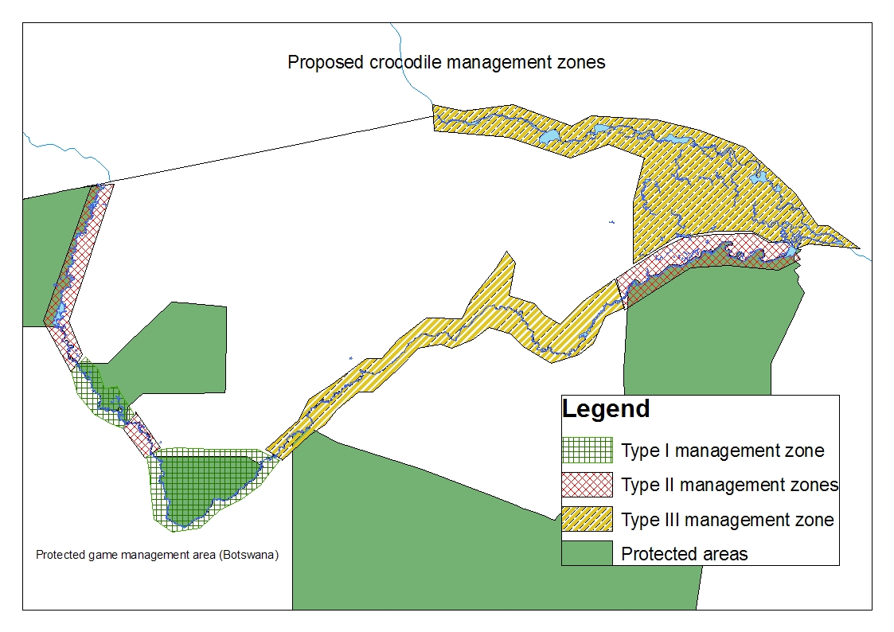

Proposed management activities within the zones:

Type I zone:

Objective: Preservation of natural crocodile population and associated ecological processes.
Key attribute: Both banks of the river/wetland lie within fully protected wildlife areas.
Key management strategy: ‘Hands off’ approach. No hunting/harvesting or otherwise interfering with the crocodile population. Photographic tourism only.
Benefits:
- Robust conservation strategy for Nile crocodiles and associated natural ecological processes.
- Photographic tourism
Costs:
- Minimal. Management of a protected wildlife area.

Type II zone
Objective: Maintain a healthy crocodile population whilst reducing human crocodile conflict to acceptable levels.
Key attribute: One bank of the river/wetland lies in protected wildlife area, the other lies within communal land.
Key management strategy: management focused on conflict reduction and benefit generation for local communities. Possible activities:
a) sustainable egg collection
b) sustainable trophy hunting
c) sustainable harvest of wild skins
d) crocodile cage diving (interactive crocodile based tourism)
e) construction of crocodile proof harbours
f) fitting of high visibility flags to large crocodiles
g) education and awareness campaigns amongst local communities
h) Alternative water sources (e.g. additional boreholes, cattle watering points)
Benefits:
- Local communities and conservancies generate financial returns from crocodiles
- Increased local tourism and/or associated rural development
- Reduced human crocodile conflict
- Conservation of crocodiles and freshwater ecosystems.
Costs:
- Relative high cost of developing and implementing management plans
- Some level of human crocodile conflict will persist.
- Some aspects of crocodile conservation will be compromised (e.g. evolutionary processes)

Type III zone
Objective: To eliminate the most critical components of human crocodile conflict.
Key attribute: No protected wildlife habitat on either bank of the river.
Key management strategy: Actively manage the population for certain size classes. This will involve ongoing removal of all animals over 2m in length (trapping or catching at night with spotlight).
Benefits:
- Reduced risk of attack on humans and livestock is the main benefit.
- Decreased levels of damage to fishing equipment.
- Local communities can utilise river resources in safety (e.g. swim, wash, fish, cut reeds etc.)
- Tourist operators can offer additional water activities (eg water skiing, swimming)
- Profits from sale of removed crocodiles (assuming sold live to crocodile farms)
Costs:
- Removal of apex predator could potentially jeopardise the health of aquatic ecosystems
- High cost associated with an ongoing removal program. This may be offset somewhat by sale of removed animals.

Acknowledgements

There are many people who made this project possible. First and foremost I would like to thank the Beit Trust for funding my PhD, including the majority of our living and fieldwork costs in Namibia. I wish to thank the Namibian Nature Foundation for acting as our host institution in Namibia, and for the use of a boat and vehicle. The Integrated Rural Development and Nature Conservation team for crucial support within the Caprivi region. The owners and staff of Lianshulu, Shamvura and Kings Den lodges, for support in the field. The Makena Environmental Group for surveys on the Kavango River. The Namibian Government, in particular the Ministry of Environment and Tourism, for permission to carry out the research throughout the region. In the UK I would like to thank the members of Team Coulson for their much needed analytical and general scientific writing assistance. Lastly I would like to thank the community conservancies of the North Eastern Namibia, the members of which provided not only much of the information but also provided endless assistance wherever needed.

References

Anderson, J.L. and F. Pariela. 2005. Strategies to mitigate human wildlife conflict in Mozambique. Report submitted to The Direccao Nacional de Florestas e Fauna Bravia (DNFFB), Mozambique. September 2005

Ashley, C. and C. LaFranchi. 1997. Livelihood strategies of rural households in Caprivi: Implications for conservancies and natural resource management. DEA research discussion paper 20. Directorate of Environmental Affairs, Ministry of Environment and Tourism. Namibia.

Branch, W.R. 1990. Field Guide to Snakes and Other Reptiles of Southern Africa. Second impression. Struik Publishers, Cape Town, South Africa.

Brown, C.J., Stander, P., Meyer-Rust, R., Mayes, S. 2005. Results of a Crocodile Crocodylus niloticus survey in the river systems of north-east Namibia during August 2004. CoP13 Inf. 26 CITES Proceedings of the Thirteenth meeting of the Conference of the Parties in Bangkok, Thailand.

Caldicott, D.G.E., D. Croser, C. Manolis, G. Webb and A. Britton. 2005. Crocodile Attack in Australia: An Analysis of Its Incidence and Review of the Pathology and Management of Crocodilian Attacks in General. Wilderness and Environmental Medicine. 16: 143-159.

Graham, A. and P. Beard. 1990. Eyelids of Morning: The Mingled Destinies of Crocodiles and Men. San Francisco, CA: Chronicl Books.

McGregor, J. 2005. Crocodile crimes: people versus wildlife and the politics of postcolonial conservation on Lake Kariba, Zimbabwe. Geoforum 36 (3): 353-369.

Mulonga, S., H. Suich and C. Murphy. 2003 The conflict continues: Human wildlife conflict and livelihoods in Caprivi. DEA research discussion paper 59. Directorate of Environmental Affairs, Ministry of Environment and Tourism. Namibia.

Murphy, C. and S. Mulonga. 2002. A profile of the livelihoods of people in two conservancies in Caprivi. Wildlife Integration for Livelihood Diversification (WILD) Project Working Paper 7. Namibia.

Musambachime, M. C. 1987. The Fate of the Nile Crocodile in African Waterways. African Affairs, 86: 197-207.

Naesje, T.F., C.J. Hay, N. Nickanor, J.H. Koekemoer, R. Strand and E.B. Throstad. 2004. Fish populations, gill net catches and gill net selectivity in the Kwando River, Namibia. – NINA Project Report 27: 1-64.

Revol, B.1995. Crocodile Farming and Conservation, the example of Zimbabwe. Biodiversity Conservation 4 (3): 299-305

