Okavango River Basin Transboundary Diagnostic Analysis:
Environmental Flow Module

Specialist Report

Country: Namibia

Discipline: Birds (Avifauna)

Author: Mark Paxton

Date: May 2009

EXECUTIVE SUMMARY
A series of field trips to the two sites (Kapako and Popa Falls) was undertaken during the period from October 2008 until March 2009, involving myself and various other specialists. These excursions were primarily orientation and information gathering visits but also involved a fair degree of information sharing between the available disciplines. This information sharing helped to clear up many aspects within each discipline and how each section relates to the other. The group discussions and interactions gave me some valuable insight although living in the area and on the river system itself for sixteen years allowed for more of an understanding along with subsequent visits to each sight for further familiarisation regarding the changing river levels and how it affected the birds at each individual site thereby broadening the knowledge base for the birding indicators. From 30th March to 4th April 2009 during the “knowledge capturing” workshop, that was held in Windhoek with the participation of specialists in all other disciples from all of the three countries. Here we collaboratively generated response curves for each of the indicator species and tied this into hydrological and rainfall information over the past forty five years since 1964. Available relevant literature on this aspect i.e. birds was extremely difficult to find or access being plainly unavailable, this being a very much understudied river system with regard to bird species and their relationship with the changing river water levels. We therefore had to rely heavily on “gut-feeling” based on over 16yrears of living on this river system and involving personal knowledge with birds as one of the prime areas of interest.
In this report it has been difficult in most cases to isolate specific indicators into individual species and we have had to combine many species into sometimes large and diverse groups. These groups of indicators consequently differ in various ways in their biology while sharing one common characteristic which qualifies them for group inclusion in a common indicator category. With the more intricate analysis of these indicators categories it is sometimes impossible to generalise within a large group of diverse species and therefore predictions on behaviour are far from accurate. Minimising the diversity would have been easier to analyse but would risk exclusion of possibly vital species only to reveal themselves as in the future. This river system is a dynamic ecosystem and home to a huge diversity of birdlife dependent on its many facets of habitat and food resources. It is also a fragile river system which has remained relatively ecologically sound and pure in nature while supporting a human population from three countries, Angola, Namibia and Botswana without major detrimental effects. Being a dynamic and ever changing river system in its very nature the bird life dependent on it has learned to adapt to these changes and in some cases thrive. However, these natural changes or variable characteristics have been gradual enough to allow adaptation and not so sudden as to cause mass migrations and population declines. The species diversity handled in this report is a testament to its stability as an ecosystem and the adaptability of most bird species within it and their tolerance of most natural changes.

TABLE OF CONTENTS

LIST OF TABLES

ACKNOWLEDGEMENTS
I have to say that without my wife Charlie I would not have been able to transcribe my hand written notes into the required format for this report given my very limited computer skills. Barbara Curtis was always available for the most sensible advice with nobody else was. I also have Jackie King to thank for tolerating my sometimes untimely phone calls with what were often quite stupid questions but for which I needed answers. Shirley Bethunie went to a great deal of trouble to organize the very valuable field trips to the sites and was always there to “directionalize” a sometime vague group of people into a productive and cohesive team. Personally these were of great benefit to me primarily for the information sharing forum they provided.

INTRODUCTION

Background
An Environmental Protection and Sustainable Management of the Okavango River Basin (EPSMO) Project is being implemented under the auspices of the Food and Agriculture Organization of the United Nations (UN-FAO). One of the activities is to complete a transboundary diagnostic assessment (TDA) for the purpose of developing a Strategic Action Plan for the basin. The TDA is an analysis of current and future possible causes of transboundary issues between the three countries of the basin: Angola, Namibia and Botswana. The Okavango Basin Steering Committee (OBSC) of the Okavango River Basin Water Commission (OKACOM) noted during a March 2008 meeting in Windhoek, Namibia, that future transboundary issues within the Okavango River basin are likely to occur due to developments that would modify flow regimes. The OBSC also noted that there was inadequate information about the physico-chemical, ecological and socio-economic effects of such possible developments. OBSC recommended at this meeting that a preliminary Environmental Flow Assessment (EFA) be carried out to predict possible development-driven changes in the flow regime of the Okavango River system, the related ecosystem changes, and the consequent impacts on people using the river’s resources.

This preliminary EFA is a joint project of EPSMO and the Biokavango Project. One component of the preliminary EFA is a series of country-specific specialist studies, of which this is the Aquatic Macroinvertebrates Report for Namibia.

1.2 Okavango River Basin EFA Objectives and Workplan

1.2.1 Project objectives
The goals of the preliminary EFA are:
To summarize all relevant information on the Okavango River system and its users, and collect new data as appropriate within the constraints of this preliminary EFA to use these to provide scenarios of possible development pathways into the future for consideration by decision makers, enabling them to discuss and negotiate on sustainable development of the Okavango River Basin; to include in each scenario the major positive and negative ecological, resource-economic and social impacts of the relevant developments; to complete this suite of activities as a preliminary EFA, due to time constraints, as input to the TDA and to a future comprehensive EFA.

The specific objectives at a preliminary level are:
to ascertain at different points along the Okavango River system, including the Delta, the existing relationships between the flow regime and the ecological nature and functioning of the river ecosystem; to ascertain the existing relationships between the river ecosystem and peoples’ livelihoods; to predict possible development-driven changes to the flow regime and thus to the river ecosystem; to predict the impacts of such river ecosystem changes on people’s livelihoods. To use these preliminary EFA outputs to enhance biodiversity management of the Delta. To develop skills for conducting EFA’s in Angola, Botswana, and Namibia.

1.3 Layout of this report
Chapter 1 gives a brief introduction, to the background of the project and lists project objectives. Chapter 2 describes the broad study area of the Okavango River Basin and gives more detail on the two specific sites chosen for this preliminary EFA within the Namibian section of the river- Kapako and Popa rapids. In Chapter 3, the agreed bird indicators are described for the two Namibian sites. Flow categories are also indicated. A short literature review pertinent to birds work in the Okavango River and other similar systems is given in Chapter 4, with indicators listed in full. The field survey work undertaken for the aquatic invertebrate investigation within Namibia in both the dry season (October 2008) and wet season (February 2009); together with data collection, analysis and results are outlined in Chapter 5. Chapter 6 is a first attempt to link aquatic invertebrates to flow and provide information on the flow-response relationships for use in the Okavango EF-DSS. References are found in Chapter 7. Appendix A gives a full description of indicators and Appendix B contains my raw field data.

STUDY AREA

2.1 Description of the Okavango Basin
The Okavango River Basin consists of the areas drained by the Cubango, Cutato, Cuchi, Cuelei, Cuebe, and Cuito rivers in Angola, the Okavango River in Namibia and Botswana, and the Okavango Delta (figure 2.1). This basin topographically includes the inactive drainage area of the Omatako Omuramba. Although this ephemeral river still regularly floods along its southern portion, it has not contributed any flow to the Okavango River. Outflows from the Okavango Delta are drained through the Thamalakane and then Boteti Rivers, the latter eventually joining the Makgadikgadi Pans. The Nata River, which drains the western part of Zimbabwe, also joins the Makgadikgadi Pans. On the basis of topography, the Okavango River Basin thus includes the Makgadikgadi Pans and Nata River Basin (figure 2.2). This study, however, focuses on the active drainage parts of the basin in Angola and Namibia, and the Okavango delta in Botswana. The Omatako Omuramba, Makgadikgadi Pans and Nata River are not included.

Figure 2.1 Upper Okavango River Basin from sources to the northern end of the Delta

Figure 2.2 The Okavango River Basin, showing drainage into the Okavango Delta and the Makgadikgadi Pans

2. 2 Delineation of the Okavango Basin into Integrated Units of Analysis
Within the Okavango River Basin, no study could address every kilometre stretch of the river, or every person living within the area, particularly a pilot study such as this one. These representative areas that are reasonably homogeneous in their ecological characteristics and can be delineated and used to choose several sites in which focus for data-collection and monitoring can be done. The results from each representative site can then be extrapolated over the respective wider areas.

Using this approach, the Basin was delineated into Integrated Units of Analysis (EPSMO/Biokavango Report Number 2; Delineation Report) by:
dividing the river into relatively homogeneous longitudinal zones in terms of:
hydrology;
geomorphology;
water chemistry;
fish;
aquatic macroinvertebrates;
vegetation;
wildlife
birds
harmonising the results from each discipline into one set of biophysical river zones;
dividing the basin into relatively homogeneous areas in terms of social systems;
harmonising the biophysical river zones and the social areas into one set of Integrated Units of Analysis (IUAs). See delineation report for details

The 19 recognised IUAs were then considered by each national team as candidates for the location of the allocated number of study sites:
Angola: three sites
Namibia: two sites
Botswana: three sites.

The sites chosen by the national teams are given in (table 2.1).

Table 2.1 Location of the eight EFA sites
EFA Site No | Country | River | Location
1 | Angola | Cuebe | Capico
2 | Angola | Cubango | Mucundi
3 | Angola | Cuito | Cuito Cuanavale
4 | Namibia | Okavango | Kapako
5 | Namibia | Okavango | Popa Rapids
6 | Botswana | Okavango | Upper Panhandle around Shakawe
7 | Botswana | Xakanaka lagoon and Khwai River | Xakanaka in Delta
8 | Botswana | Boteti Rivers | Maun and Chanoga

2.3 Overview of sites

In the Namibian section of the Okavango River, the majority of the human population lives along the river and the main road, with several hot spots such as Rundu, Divundu and Nkurenkuru which have a high population density. The river can be divided into four clear units of analysis, the longest section that extends from where the river enters Namibia at Katwitwi to the Cuito confluence that is typified by the meandering mainstream and large seasonally-flooded floodplains on either side to the river (Kapako site 4, was chosen as a typical floodplain and mainstream site within this section); the section immediately downstream of the Cuito confluence that has permanently swamped areas and large islands (not included in the preliminary survey but essential to include in a later more detailed EFA study); the southward flowing rocky, braided section from Mukwe to just below the Popa Rapids where the river is largely confined to the mainstream and flows around several sand and rock based islands (Popa rapids Site 5, was chosen as a typical rocky river site within this section) and the protected section of the river downstream of Popa to the border with Botswana at Mohembo that lies within the newly declared Bwabwata National Park which as two of its core conservation areas on either side of the river, the Buffalo core area on the west bank and the Muhango core area on the east bank.

2.3.1 Site 4: Kapako

The main focus point for socio-economic work at the Kapako floodplain site 4 is Kapako village: S-17.94 E– 19.56, situated some distance inland from the river on the other side of the main road.

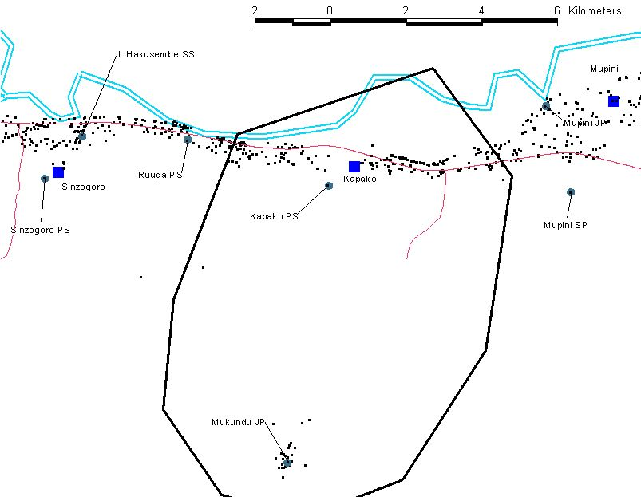
Figure Site 4: Kapako showing the village of Kapako, the surrounding town and the position of the main road and the villages in relation to the river. Most of the area between the road and the river is floodplain. The border shows the area covered by the socio-economics team. Map by Socio-economics team.
The main villages close to Kapako village are Mupini to the east (downstream) , Mukundu to the south, Ruugua and Sinzogoro to the weat (upstream).

The floodplain site itself is situated on the Okavango River and three main sites on the floodplain and the mainstream were used for sampling. They were:
Kapako site 1 S-17.87775 E- 19.58200 (start south bank) S- 17.87850 E-19.58211 (end of site 1)
Kapako site 2 S- 17.86557 E-19.58057 (start at floodplain – only 3 observations due to flooding)
Kapako site 3 S- 17.86209 E-19.57855 (deep pool)

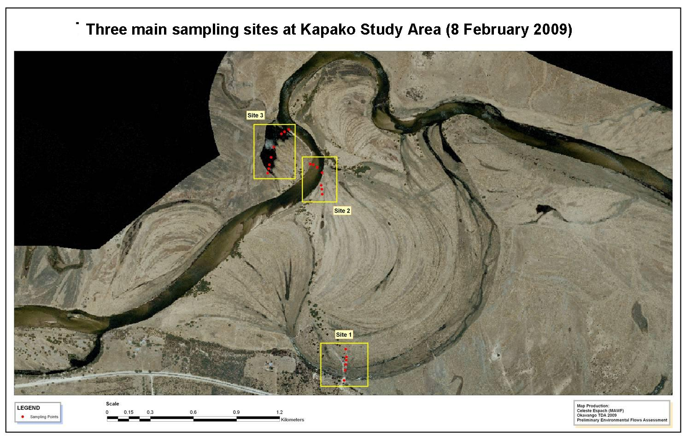

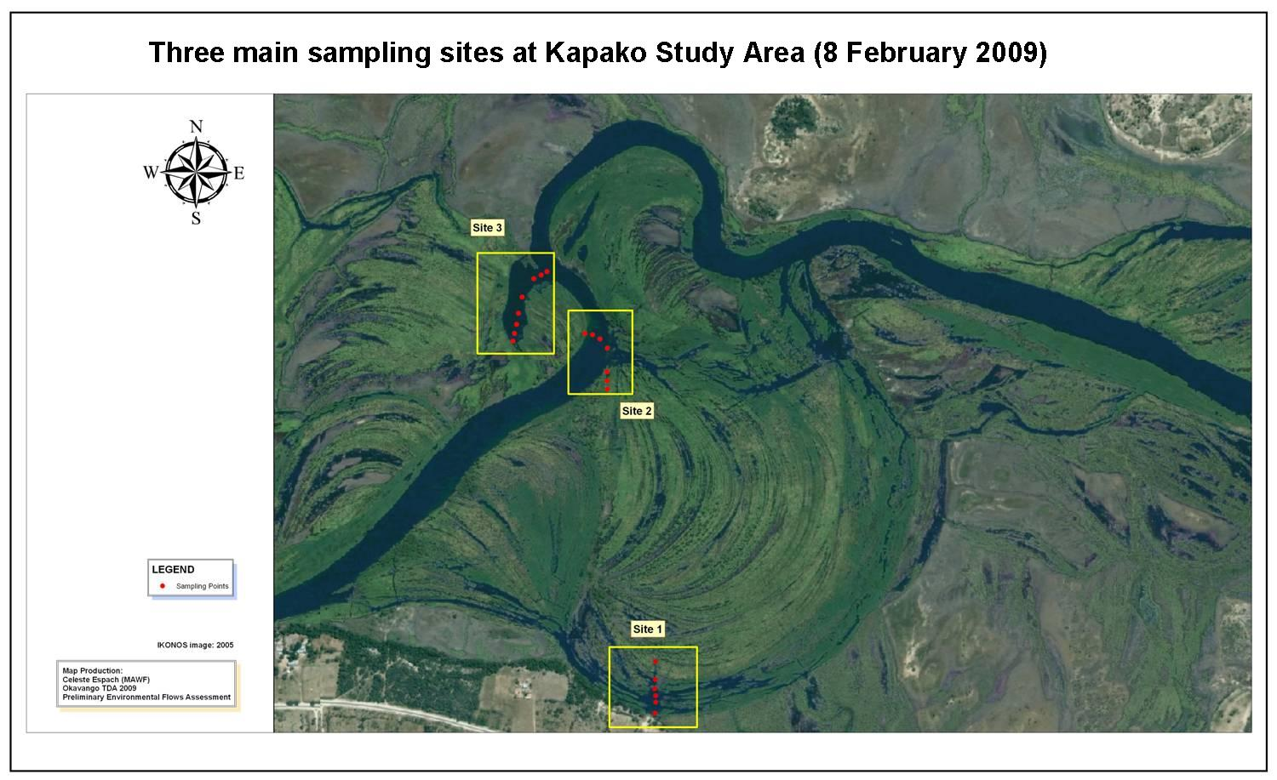

Figure shows two satellite images of the Kapako floodplain site 4, one in the dry season and one in the wet or flood season, the main sampling sites used are indicated.Maps by Celeste Espach.

The riverine landscape includes the main Okavango River channel or mainstream, the annually flooded floodplains with several braided side channels and deeper pools or backwaters, as well as the higher fluvial terrace with alluvial deposits are very seldom flooded. There is a steep, well vegetated bank at the edge of the floodplain close to the main road that rises to several meters above the floodplain.

Kapako area has a population of approximately 2,500 people within 10 km of Kapako village. The greatest density of people (over 100 per km² ) live alongside the river in the area just west of the Kapako study site whilst at the site itself the density varies from no people on the floodplain, 6 – 25 / km² at the Ebenezer mission, to a density of 25 – 50 /km² closer to the road and 51 – 100 /km² on the other side of the main road, rapidly decreasing again with distance inland. (See Map 3 in Poplations Demographics Report prepared by Celeste Espach). We can assume that some of these people make some use of the floodplain site at Kapako and elsewhere along this stretch of river.

During the focus group discussion held at Kapako village, the basin residents mentioned that, the flooding starts when the rising river and channel waters push out over flat surrounding ground and the biggest floodplains form in years when river levels are highest. They said that the most important feature of the flooded areas is that they are rich in nutrients. The floodplains also offer the young fish refuge from larger, predatory species and thus offer the greatest survival of young fish. They had noted that an overall increase in fish population occurs in years when water levels are high and flooding lasts longest. Local people have recognised that water quality and fish resources are decreasing in the Okavango River. Fish and fishing remain significant features in the lives of people at Kapako, who fish for food or to earn incomes by selling their catches. In addition some earn money by providing trips for tourists. They estimate fish stocks in the floodplains to be four times higher than in the main channel.

About 47% of households at Kapako catch fish, and each person consumes an average of 10-20 kilograms of fish per year. September to December is the peak fishing period at Kapako when the river is at its lowest and fish are concentrated in the mainstream. The kinds of traps or gear used to catch fish are separated into traditional and modern methods. The most used traditional gear are fish funnels, kraal traps, scoop baskets, push baskets, bows and arrows, set fish hooks and spears.
Modern gear consists of line and hooks, wire mesh fykes, illegal mosquito nets, and gill and seine nets. The use of fish for recreational angling forms part of the tourism value associated with the river. Biophysical response curves for the angling species would feed into the tourism values for the river reducing them partially. Only a small part of tourism value is attributable to angling.

At Kapako, as elsewhere along the Namibian section of the river, the ever -increasing human population and clearing for crops and livestock has put increasing pressure on the natural resources along the main channel. The vegetation along the river bank is overgrazed and in some areas depleted, thus at Kapako the residents graze their livestock across the river on the Angolan floodplain. Cattle were routinely seen being swam across the river at this site during fieldwork.
Associated with this population growth, has been an increase in livestock, fire frequency as well as the area of land cleared for crops and fuel. These associated land use changes are an undeniable factor of increasing settlement and development at a Kapako and indeed all along the Okavango.

The road westwards from Rundu has been upgraded and is currently being tarred. It runs parallel to the Okavango River all the way to the border post with Angola at Katwitwi.
This has opened up the region allowing people to exploit the land alongside the road. As expected highest densities are alongside the road parallel to the river. As the population continues to increase, exploitation of the land that new roads have opened up should disperse the pressure on the Okavango River floodplains and its resources to land further inland from the river, although the river will always remain the main source of water even for livestock watering.

The extent of erosion and clearing and thus of bare ground has also increased; yet the people perceive the overall water quality not to have declined substantially. The only exceptions mentioned were an increase in phosphate concentrations, a decrease in water clarity and a related increase in suspended sediments. There are more short term, seasonal variations in water quality particularly in the floodplain pools, than any long term water quality change. So far there does not seem to have been an excessive exploitation of the water resources in the main channel, although the basin further inland has some serious water shortages at times and a lack of deep boreholes. The Kalahari sands that overlay the area are deep.

2.3.2 Site 5: Popa rapids

The main focus for the socio-economic work at the Popa rapids Site 5 was the village of Popa and the Popa Falls Rest Camp run by Namibia Wildlife Resorts. The main transect used for the physical and biological field survey work was a transect across the river immediately above the Popa Rapids from the irrigation water drawoff point used by the Prison Services on the eastern ban (West Caprivi) where the gauge plate was put up to the protected section close to the Popa Falls Rest Camp on the western bank. Popa rapids: S-18.15316 E- 21.6045 (Popa Falls rest camp)
Popa falls (gauge plate) S- 18.11603 E- 21.57900. Figure XXX below shows the main villages.

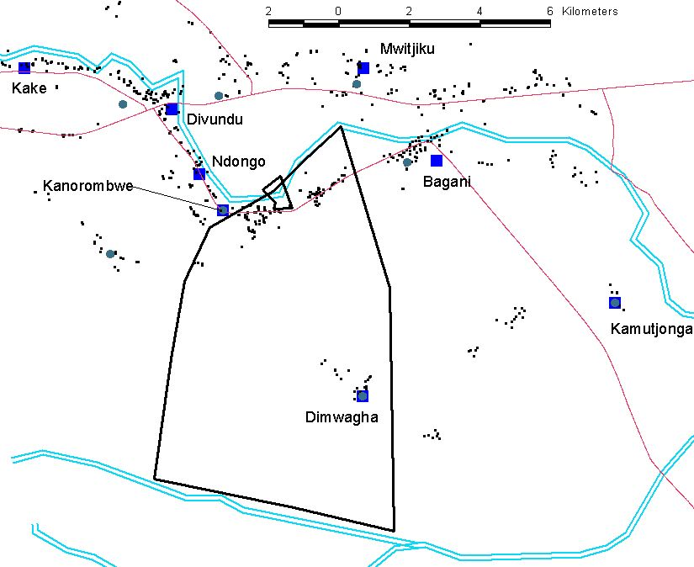
Figure Site two, Popa rapids is shown in the map above; The majority of population lives along the river and the main road. Map from the socio-economic team.
Figure below shows the Popa rapids site 5 in both the dry and the wet season and indicates the main field survey transect and team sampling sites. The individual discipline reports all have more specific maps of their sampling sites.
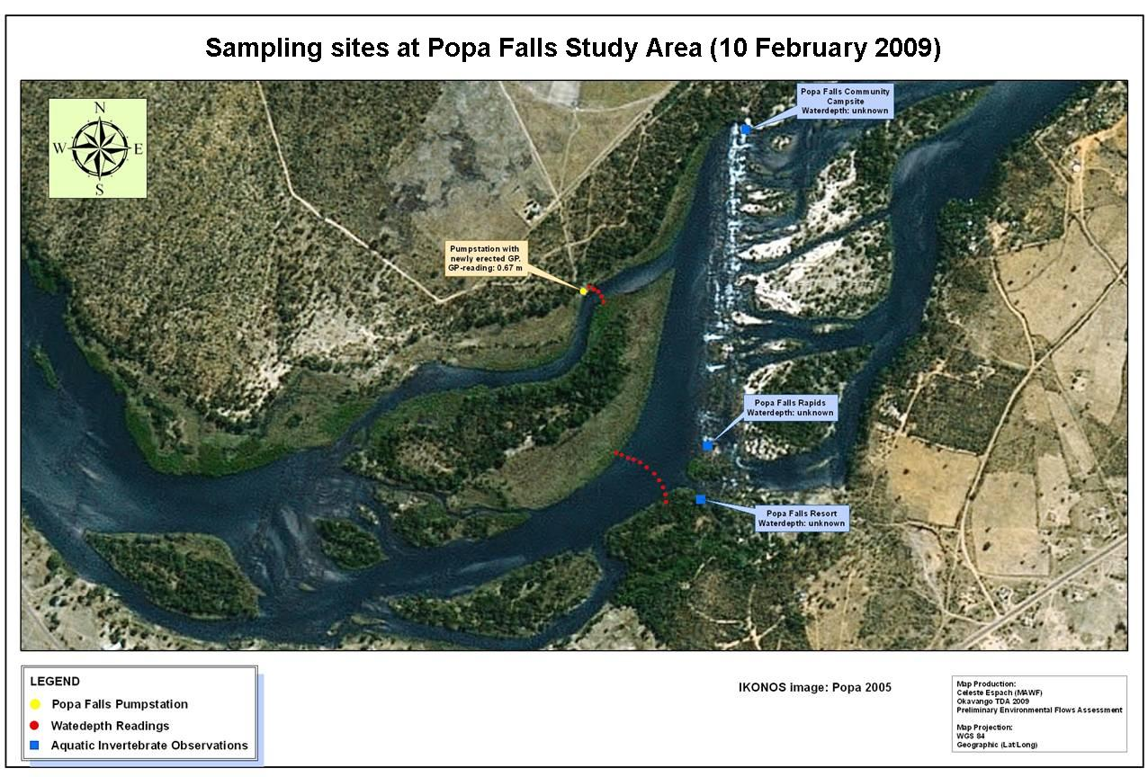

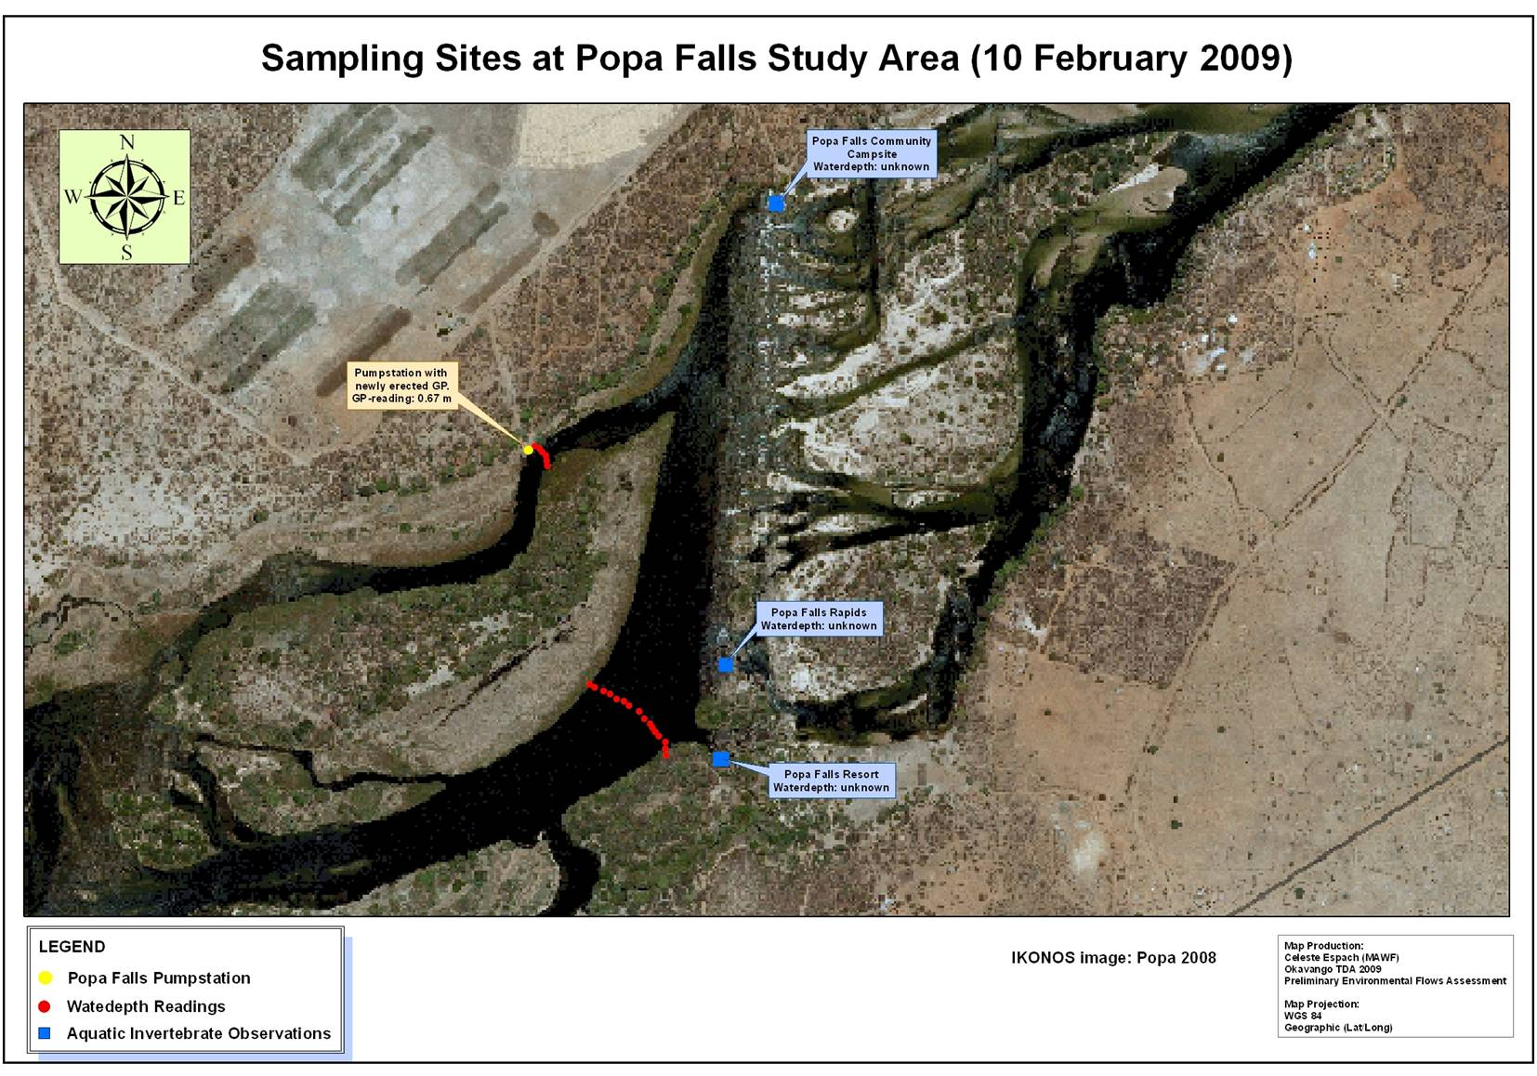

Figure Satellite images of the wet and dry season for Popa rapids here showing transect and main sampling sites. Maps prepared by Celeste Espach.
About 3,000 people live in the area surrounding Popa. The highest population density in the area is immediately upstream of the Popa rapids at the Bagani/Divundu settlement, within an area of over 12 km² . At the Popa rapids site itself the population density is much lower at 6 – 25 people/km² and it must be remembered that the Popa camp is within an 8 km² park, the islands are uninhabited and the opposite bank supports a community campsite reserved for tourists. Immediately downstream of Popa camp the riverside population increases to 26-50 people/km² and includes several lodges. See Map 3 in the Population Demographics report prepared by Celeste Espach for the TDA.

At the Popa rapids, the entire width of the river cascades down several meters before resuming its normal slow and leisurely flow. The quartzite rocks were formed from sediments deposited in rift valleys about 900 million years ago, (el Obeid, S., Mendelsohn 2004).

During the focus group discussion, it was mentioned that due to the Popa rapids and rocky areas, it’s difficult for the local fishermen to catch fish as desired. Therefore, only a few individuals that own local mukoros, hook and line, and gill fish nets have access to fish catches in the main channel. Thus fishing is a secondary activity for most people at the Popa area, contributing little to the overall cash or in-kind incomes of the majority of households. People also pay much less attention to fishing than to farming and business activities. Each household depends on a different mix of incomes derives from wages, business earnings, pensions and remittances

Papyrus cyperus, papyrus, dominates the deepest water margins alongside the main channels. Water can seep through the walls of papyrus to the reedbeds behind the papyrus and in places where they exits into backwaters and side channels. The sandy sediments are confined to the channels. These are flanked by reed beds of Phragmites, Typha capensis or bulrushes and the sedge Miscanthus junceus in the shallower waters. The resident donot experience floods as there are no floodplains in this area. They depend in the main channel for most of their water and wetland resources. Most houses at Popa village are thatched with grass and reeds, while reeds are used extensively to make sleeping mats, walls, palisades, courtyards and fences.

Farming activity is an important source of income; households are engaged in both crop and livestock farming. Planting is staggered through the raining reason and is initiated only after a good rainfall event. This increases the chance of crop survival during the hot dry periods. Livestock farming is dominated by cattle and goats, not kept within fields but are moved for grazing and between water sources, mainly the Okavango River.

Tourism is a major source of income to the Popa resident; most of them are employed within the lodges around the Popa area. They value tourism as their major source of income.

2.4 Discipline specific description of Namibian sites

3. Discipline-specific description of Namibia sites

3.1 Site 4: Kapako
This site is situated within a seasonal floodplain which is exposed to cattle/livestock grazing, fires and reed/grass harvesting by the local population in the low water periods. During this time the fires and trampling hoof action of livestock actually creates favourable nesting and feeding habitat for some of the indicator species and therefore constitutes a positive influence. The harvesting of reeds/grass by the local community however, has a more negative affect on the floodplain bird species by removing suitable nesting and feeding habitat.

During the high-water periods this site would be exposed to fishing practices by the local community. These practices would negatively impact fish availability for some of the indicator bird species as all sizes of fish are harvested and even residual pans are depleted of fish stocks leaving little or no feeding opportunities for fish eating bird species.

This site offers diverse habitat selection suitable for most of the indicator species. Particularly the floodplain breeders and feeders

3.2 Site 5: Popa Rapids
This site does not have any significant floodplains and is made up mostly of fast flowing water with many intermittent rocky outcrops and flows between banks that are too high to allow overflow during normal years. The river spreads out substantially here forming papyrus and phragmites dominated islands. The vegetation on these islands have well established climax trees located above the high water level up against the banks, where they have been afforded some protection against deforestation, as such, there is some well established forests offering prime habitat for some of the indicator species. With almost total exclusion of any significant flood plain habitat this site offers only limited habitat for the remaining few the indicator species which prefer this habitat. Particularly the species relying on trees lining the banks as well as those requiring rocky outcrops and islands

3.3 Habitat integrity of the sites in Namibia
Team Leaders – please lead your teams to complete this assessment as a group effort, following the process we started at each site in Namibia and Angola and referring to the Guidelines manual. The final score has to be computed with a small .xls programme, which I will send. The same write-up of this exercise can be inserted into each Specialist Report so please make it available to all your team once complete for them to include.

IDENTIFICATION OF INDICATORS AND FLOW CATEGORIES

Indicators

Introduction
Biophysical indicators are discipline-specific attributes of the river system that respond to a change in river flow by changing in their:
abundance;
concentration; or
extent (area).

Social indicators are attributes of the social structures linked to the river that respond to changes in the availability of riverine resources (as described by the biophysical indicators).

The indicators are used to characterise the current situation and changes that could occur with development-driven flow changes.

Within any one biophysical discipline, key attributes can be grouped if they are expected to respond in the same way to the flow regime of the river. By example, fish species that all move on to floodplains at about the same time and for the same kinds of breeding or feeding reasons could be grouped as Fish Guild X.

Indicator list for Bird Indicators
In order to cover the major characteristics of the river system and its users many indicators may be deemed necessary. For any one EFA site, however, the number of indicators is limited to ten (or fewer) in order to make the process manageable. Despite logistical and technological communication problems, the list of indicators was developed collaboratively by the country representatives for the discipline of birds – i.e. Carmen Santos (Angola), Mark Paxton (Namibia) and Pete Hancock (Botswana) and finalised in a workshop in April 2009. The final list is provided in Table 4.1. Further details of each indicator, including the representative species of each, are given in Appendix 1 and discussed fully in Chapter 8

4.1 List of indicators for Birds/Avifauna
Indicator Number | Indicator name | Sites represented – no more than ten indicators per site
Indicator Number | Indicator name | 1 | 2 | 3 | 4 | 5 | 6 | 7 | 8
1 | Piscivores of open water |  |  |  | Kapako | Popa
2 | Piscivores of shallow water & lagoons etc. |  |  |  | Kapako | Popa
3 | Piscivores and Invertebrate feeders, floodplains, isolated pools |  |  |  | Kapako | Popa
4 | Specialist feeders on floodplains, receding waters |  |  |  | Kapako | Popa
5 | Specialist feeders in water-lily covered inlets |  |  |  | Kapako | Popa
6 | Specialist feeders in riverine fruit trees |  |  |  | Kapako | Popa
7 | Breeders in reedbeds, floodplains |  |  |  | Kapako | Popa
8 | Breeders in riverine overhanging trees |  |  |  | Kapako | Popa
9 | Breeders on banks |  |  |  | Kapako | Popa
10 | Breeders on emergent rocks, sandbars & islands |  |  |  |  | Popa

4.1.3 Description and location of indicators
Eleven indicators were collaboratively agreed for Angola, Namibia and Botswana. Please refer to this table when reading this section. A more detailed description and a list of representative bird species for each is given in the table – App. 1.

5. BIRD INDICATORs

5.1 Bird Indicator 1 Piscivores of open water
Description:
Fish-eating birds which prey on larger fish species generally in the main river system. They
catch fish directly from above, by using bank vegetation as hunting perches or by swimming
underwater to explore the river bottom or rocky crevices

Representative species:
African Fish Eagle, Osprey, Pied Kingfisher, Malachite Kingfisher, Giant Kingfisher, Reed
Cormorant, African Darter
Other characteristic species:
None

Flow-related location:
The main faster flowing mainstream margin or side stream channels and inlets.

Known water needs:
They need fast flowing mainstream river currents where only larger fish species occur during
most of the year. Also needed are the slower flowing water where larger fish breed during the
high water periods in shallower water making them easier to prey on.

5.2 BIRD INDICATOR 2: Piscivores of shallow water and lagoons etc.
Description:
Fish eating birds preying on variable size fish species which inhabit shallow slow flowing
water provided by lagoons, inlets, channels directly connected to the mainstream river or by
sandbanks.

Representative species:
Pel’s Fishing Owl, Purple Heron, Grey Heron, Great Egret, Little Egret, Pied Kingfisher,
Malachite Kingfisher, Whiskered Tern, White-winged Tern.

Other characteristic species:
Great While Pelican, pink-backed Pelican

Flow-related location:
The slow flowing water within lagoons, inlets and channels directly connected to the main
river, also the slower and shallower water flowing around the sand banks within the main
river system.

Known water needs:
They need a regulated water level adjustment to create sandbanks and lagoons with similar slow
water habitat for prey availability

5.3 BIRD INDICATOR 3: Piscivores and invertebrate feeders of floodplains and isolated pools.
Description:
Bird species which feed on fish and a variety of other invertebrates, amphibians,
crustaceans and aquatic animals which require a floodplain system in which to flourish

Representative species:
Squacco Heron, Rufous-bellied Heron, White-backed Night-heron, Black-crowned Night-
heron, Green-backed Heron, Little Bittern, Yellow-billed Stork, African Spoonbill,
Hammerkop, African Sacred Ibis, Painted Snipe, African Snipe, Lesser Moorhen, Black
Crake, African Rail, Wattled Crane, Three-banded Plover, White-fronted Plover, African
Wattled Lapwing, Blacksmith Lapwing, Ruff, Little Stint, Common Sandpiper, Wood
Sandpiper, Common Greenshank.

Other characteristic species:
Yellow-bellied Egret, Black Heron, Slaty Egret, Dwarf Bittern, Saddle-billed Stork, Woolly-
necked Stork, Glossy Ibis, Great Snipe, Common Moorhen, African Crake, Spotted
Crake, Baillon’s Crake, Common Ringed Plover, Kittlitz’s Plover, Long-toed Lapwing, Curlew
Sandpiper, Marsh Sandpiper.

Flow-related location:
With the rising water during the rainy season, the river inundates several sometimes vast
expanses of low-lying flat areas called floodplains. These expanses of relatively shallow
water and slow to negligible flow, provide habitat for a variety of plant species, which in turn,
provide ideal and essential habitat for a variety of invertebrates, aquatic animals and fish
species. This wealth of life attracts a large diversity of birds some of which migrate from the
northern hemisphere to this bountiful food source on the river system.

Known water needs:
They need a substantial seasonal input of water into the main river, enough to overflow the
banks and fill up the surrounding floodplains and otherwise isolated pools. Without an
annual rejuvenation of these areas the system would dry up and become barren.

5.4 BIRD INDICATOR 4: : Specialist feeders on floodplains, rising and receding water
Description:
Bird species occupying specific habitats provided in the floodplain when rising and lowering water levels provide ideal
conditions, where specific prey items, such as snails, molluscs, frogs and other invertebrates or other
food provided by water plants are located.

Representative species:
African Openbill, Pygmy Goose, Purple Swamphen, Allen’s Gallinule

Other characteristic species:
None

Flow-related location:
Rising water levels create ideal essential conditions for particular plant species on which
these birds feed like water lilies (Nymphaea spp). Rising water levels in the floodplain areas
also dislodge mollusc species and make them more accessible to particular birds
physically adapted to feed on them. Alternatively receding water levels leave these food
items stranded and easily available.

Known water needs:
Rising and receding water-levels in the main river system are essential to fill up the
surrounding floodplains and create suitable conditions for the food items of these specialised
feeders.

5.5 BIRD INDICATOR 5: : Specialist feeders in water-lily covered inlets and pools
Description:
Bird species which are physically adapted to use the lily covered inlets and floodplain pools
as a food source.

Representative species:
African Jacana, Lesser Jacana

Other characteristic species:
None

Flow-related location:
Water-lily species grow abundantly in slow-flowing inlets, channels and pools within the
floodplains and eventually cover the surface with their large, flat leaves during the high water
periods.

Known water needs:
High water periods are essential to the overflow into the inlets and pools of the adjoining
floodplains. These flowing or even stagnant water bodies covered over by water lilies are
crucial feeding and breeding areas for specially adapted bird species. Deeper floodplain pools may remain long after the floods have receded retaining this important habitat into the dry season too

5.6 BIRD INDICATOR 6: : Specialist feeders in riverine fruit trees

Description:
Several predominantly frugivorous bird species utilizing fruit bearing trees of riverine forests
lining the riverbanks.

Representative species:
Meyers Parrot, Grey go-away Bird, Grey Hornbill, Dark-capped Bulbul, Yellow-bellied
Greenbul, Violet-backed Starling, Glossy Starling, Greater Blue-eared Starling, Red-faced
Mousebird, Green Pigeon, Black-collared Barbet, Black-headed Oriole, Arrow-marked
Babbler.

Other characteristic species:
Other insectivorous bird species which feed on the insects attracted to the fruit bearing trees, as well as
Grey-headed Parrot, Bradfield’s Hornbill, African red-eyed Bulbul, Terrestrial Brownbul,
Burchell's Starling, Meves Starling, African Golden Oriole, European Golden Oriole,

Flow-related location:
The high water mark and above on the banks of the river system where the soil type and
structure offers suitable stability for deep-rooted trees.

Known water needs:
Seasonal high-water periods are essential for these trees which require large amounts of
ground water to bear enough fruit to sustain a large diversity of bird species.

5.7 BIRD INDICATOR 7: : Breeders in reed beds and floodplains
Description:
Bird species which require thick reed beds or grassy areas surrounded by water in which to
safely nest and successfully rear offspring.

Representative species:
Village weaver, Golden Weaver, Southern Brown-throated Weaver, Red-billed Quelea,
Southern Red Bishop, Fan-tailed Widowbird, Tawny-flanked Prinia, Little Rush Warbler,
Luapula Cisticola, Chirping Cisticola, African Purple Swamphen, Allen’s Gallinule, Black
Crake, Lesser Moorhen, African Rail, African Marsh Harrier, Spur-winged Goose, Red-billed
Teal, White-faced Duck, Purple Heron, Little Egret, Squacco Heron, Rufous-bellied Heron,
Black-crowned Night-heron, Little Bittern.

Other characteristic species:
Thick-billed Weaver, Southern Masked-Weaver, Lesser Masked-weaver, Spectacled
Weaver, Lesser Swamp Warbler, Greater Swamp Warbler, African Reed Warbler, Zitting
Cisticola, Common Moorhen, Baillons Crake, White-backed Duck, Black Heron, Slaty Egret,

Flow-related location:
Although most reedbeds and floodplains remain as such during low-water periods they only
become suitable breeding areas during high water levels. The overflow from the main river
then fills them up thereby adding a safety factor as well as a nest material source for the
dependent bird species.

Known water needs:
High water levels with filled-up floodplains and reedbeds are necessary to ensure safe and
adequate breeding habitat for this large diversity of bird species.

5.8 BIRD INDICATOR 8: Breeders in riverine overhanging trees
Description:
Bird species which require the safety aspect provided by overhanging trees on the river edge
to successfully nest and rear young.

Representative species:
Green-backed Heron, White-backed Night-heron, Hammerkop, Pygmy Goose, Comb Duck,
Reed Cormorant, African Darter.

Other characteristic species:

Flow-related location:
High water levels that surround riverine trees with water thereby making them relatively
inaccessible to most predators which prey on eggs or nestlings.

Known water needs:
A sustained high water level which partially submerges riverine trees and which lasts long
enough to provide a safety factor to birds throughout the nesting period.

5.9 BIRD INDICATOR 9: Breeders on banks
Description:
Birds which require vertical exposed banks on the river in which to burrow nesting holes, or
dry, grass covered banks on which their eggs are laid.

Representative species:
Carmine Bee-eater, White-fronted Bee-eater, Little Bee-eater, Collared Pratincole, Wattled
Lapwing, Blacksmith Lapwing.

Other characteristic species:
None

Flow-related location:
At low-water levels river banks become exposed and offer suitable nest location sites for
birds.

Known water needs:
Sustained low water periods leaving river banks and adjoining grassland exposed for long
enough for the birds to complete their nesting period.

5.10 BIRD INDICATOR 10: Breeders on emergent rocks, sandbars and islands
Description:
Birds which require emergent rocks, sandbars and islands on which to nest and rear young.

Representative species:
Rock Pratincole, African Skimmer, Water Thick-knee, White-fronted Plover.

Other characteristic species:
None

Flow-related location:
At low-water levels exposed bare to partially vegetated sandbars and completely bare rocks
which are located in the centre of the river and surrounded by fast flowing water.

Known water needs:
Sustained and reliable low water levels are required to provide these emergent habitats
crucial for successful breeding of these birds which migrate here from the Northern Hemisphere
especially for breeding purposes.

6. Flow categories – river sites
One of the main assumptions underlying the EFA process to be used in the TDA is that it is possible to identify parts of the flow regime that are ecologically relevant in different ways and to describe their nature using the historical hydrological record. Thus, one of the first steps in the EFA process, for any river, is to consult with local river ecologists to identify these ecologically most important flow categories. This process was followed at the Preparation Workshop in September 2008 and four flow categories were agreed on for the Okavango Basin river sites:
Dry season
Transitional Season 1 (rising flood waters)
Flood Season
Transitional Season 2. (receding flood waters)

Tentative seasonal divisions for river Sites 1-5 are shown in Figure . These seasonal divisions will be formalised by the project hydrological team in the form of hydrological rules in the hydrological model. In the interim they provide useful insights into the flow regime of the river system suggesting a higher within-year flow variability of the Cuebe River and a higher year-on-year variability of the Cubango River.
It is planned to use similar flow seasons for the remaining river sites: 6 and 8.

Figure 6.1 Three representative years for Site 4: Okavango River @ Kapoka (hydrological data from Rundu), illustrating the approximate division of the flow regime into four flow seasons

Figure 6.2 Three representative years for Site 5: Okavango River @ Popa (hydrological data from Mukwe), illustrating the approximate division of the flow regime into four flow seasons

The literature review (Chapter 4) and data collection and analysis exercises (Chapter 5) are focused on addressing what is initially expected to be nine main questions related to these flow seasons (Table ).

Table 3.2 Questions to be addressed at the Knowledge Capture Workshop, per indicator per site. In all cases, ‘natural’ embraces the full range of natural variability
Question number | Season | Response of indicator if:
1 | Dry Season | Onset is earlier or later than natural mode/average
2 | Dry Season | Water levels are higher or lower than natural mode/average
3 | Dry Season | Extends longer than natural mode/average
4 | Transition 1 | Duration is longer or shorter than natural mode/average - i.e. hydrograph is steeper or shallower
5 | Transition 1 | Flows are more or less variable than natural mode/average and range
6 | Flood season | Onset is earlier or later than natural mode/average – synchronisation with rain may be changed
7 | Flood season | Natural proportion of different types of flood year changed
8 | Transition 2 | Onset is earlier or later than natural mode/average
9 | Transition 2 | Duration is longer or shorter than natural mode/average – i.e. hydrograph is steeper or shallower

6.2 Inundation categories – delta sites
The recognised river flow categories are not relevant in the Delta, where inundation is the major driver of ecosystem form and functioning. The main inundation categories recognised by the inundation model developed by the Harry Oppenheimer Okavango Research Centre (HOORC) are used here

7. LITERATURE REVIEW

7.1 Introduction
There is a wealth of information available on the birds of this region, their breeding biology, feeding habits and many other aspects. Most of this information is collectively available in the recently published Roberts Birds of Southern Africa VIIth Edition which has a comprehensive list of all other relevant publications. There is, however, little or no available literature which focuses specifically on the responses of birds to changes in flow regime and more specifically on this particular river. I have however conducted some work of my own over the years e.g. African Skimmers breeding in Mahango Game Park and almost 15yrs of bird counts for Wetlands International on two areas of this river system. Many capture and ringing exercises over this period that have also been conducted along this river system by myself and this has contributed substantially to my knowledge.

What follows therefore is based largely on personal observations, interest and knowledge gleaned from literature and active experience over a 16 year period while living and working on the Okavango River.

8 Namibia Bird Indicators (10)

8.1 Indicator 1: Piscivores of open water

8.1.1 Main characteristics
This is a group of bird species which are adapted to only eating fish species captured generally from an open water situation existing in the main river system. In this location the fish are captured in different ways;
- From an aerial attack directly overhead where the bird is flying or hovering, i.e. African Fish Eagle, Osprey, Pied Kingfisher, Giant Kingfisher
- From a vantage point along the river bank like a tree, other riverine vegetation or from the bank itself, i.e. African Fish Eagle, Pied Kingfisher, Malachite Kingfisher, Giant Kingfisher
- Underwater where the bird submerges itself entirely and swims around to actively search out and capture fish within rocky crevices and underwater vegetation, i.e. Reed Cormorant, African Darter
These birds make use of the main river where currents are stronger and larger specially adapted fish exist comfortably against strong currents. This category contains the top predatory bird species and they can only exist comfortably in a healthy environment providing for ideal conditions of habitat and food source. Their presence on the river system is therefore a good indicator of a healthy ecosystem.

8.1.2 Life cycle attributes
Although this group of birds utilize open water situations they are opportunistic in nature and during the high water periods when the floodplains fill up and many fish species move into these shallower areas to breed and they are more easily captured. Their methods of capture however remain the same though but their success rate during these easier times is higher and therefore generally coincides with the breeding time when young birds need to be fed regularly. Their variable use of river characteristics makes it possible for this group of birds to stay on the same river system throughout the year with its variable water level changes.

Links to flow
During the high water months (January to May) these birds are generally utilizing the shallower water habitats in the floodplains where breeding fish are more vulnerable to the larger aerial predators and the young newly born fry are in greater numbers.
During the low water level months (June – December) these birds species move towards the main river system once the floodplains have dried up. The Kingfishers in this group breed during these months when vertical sandbanks are exposed and available for them to excavate their nest tunnels while food supply is still available as most of the smaller current adapted fishes are found along the edges of the river or in the inlets where they occupy the top strata just below the surface and are more vulnerable to aerial predation by these smaller aerial predators. African Fish Eagles also peak their breeding activities during this period presumably to coincide with the swelled number of fish species available in the main stream after the breeding season.

8.2 Indicator 2: Piscivores of shallow water and lagoons etc.

8.2.1 Main characteristics
This group of bird species are all fish eating but are mostly only adapted to capturing their food items in shallow or sluggish water systems created in the floodplains with lagoon, inlets and tree lined pools offering the ideal conditions. These predatory birds use the following capture techniques;
- Aerial attack using overhanging trees as hunting perches, i.e. Pel’s Fishing Owl, Aerial attack using grassy vegetation on the edges of shallow water or by wading into the shallow water and waiting completely immobile for unsuspecting fish to swim within striking distance of beaks adapted to piercing and holding onto wriggling fish, i.e. Purple Heron, Grey Heron, Great Egret, Little Egret.

8.2.2. Life cycle attributes
Shallow and sluggish water conditions created in the floodplains during the high water level months create ideal feeding situations with an abundance of prey. This period of growth and abundance is also ideal for breeding opportunities when excessive plant cover provides nesting material as well as secure and safe nesting sites. Food abundance makes the rearing of every-hungry young birds less of a hardship for the parent birds. For these reasons most of the species in this group will breed during this period and in this habitat.

8.2.3 Links to flow
Rising water levels during the rainy months reach a point where they overflow into adjoining floodplains generally during January and February. Breeding fish then move into these filling up and as yet shallow areas to breed. At this time they become very vulnerable to predatory birds that are unable to catch them in deeper waters. This situation is repeated again in the months May to July when the water levels drop and the flood plains empty back into the main river system, this time exposing both adult fish and the newly hatched young fish making their way back into the main stream. Receding waters also leave shallow and often isolated pools with an abundant food supply.

8.3 Indicator 3: Piscivores and invertebrate feeders, floodplains and isolated pools

8.3.1 Main characteristics
This is a group of bird which feed on fishes or other invertebrates and aquatic animals found in floodplains either during filling up or receding water levels creating isolated pools. Prey or food items are collected in the following ways;
- Aerial attack from above on small fish near the surface or insects attracted to the water surface or surrounding vegetation’ i.e. Whiskered Tern, White-winged Tern
- Sitting motionless on the edges or within shallow water to capture unsuspecting fish within reach of specially adapted piercing and holding beaks, i.e. Yellow-bellied Egret, Squacco Heron, Black Heron, Slaty Egret, Rufous-bellied Heron, White-backed Night-heron, Black-crowned Night-heron, Green-backed heron, Dwarf bittern, Little Bittern Yellow-billed Stork, Saddle-billed Stork, Woolly-necked Stork, Hamerkop, Glossy Ibis, African Sacred Ibis, Wattled Crane
- Patrolling the outer edges of a wetland and amongst floating or half submerged vegetation foraging for insects, amphibians and other invertebrates not found in the water itself, i.e. Painted Snipe, Great Snipe, African Snipe, Common Moorhen, Lesser Moorhen, Long-toed Lapwing, African Wattled Lapwing, Blacksmith Lapwing, Ruff, Curlew Sandpiper, Little Stint, Common Sandpiper, Wood Sandpiper, Common Greenshank, Marsh Sandpiper
- Swimming or floating on the water surface and either foraging from surrounding vegetation or diving to the bottom to feed off detritus or invertebrates within, i.e. White-faced Duck, Red-billed Teal, Egyptian Goose, Comb Duck, Spur-winged Goose.

This diversity of bird species utilizes a large spectrum of aquatic invertebrates and fish species which use this floodplain system as breeding grounds.

8.3.2 Life cycle attributes
Shallow and sluggish water conditions are ideal for an abundance of aquatic invertebrates that breeds in these pools and associated vegetation as well as within the water bodies where fish species breed at this time only. This situation creates profitable feeding opportunities for a diversity of bird species some of which migrate from the Northern hemisphere to make us of this limited seasonal food source. This situation may last for an extended period from December (where the rains bring fresh plant growth to the dry floodplains) until July when the waters of the floodplain have receded leaving isolated pools and the onset of the colder winter months brings a gradual lull in most invertebrate breeding activities.

8.3.3 Links to flow
During the rainy months January to February when the water level rises and feeds into the adjoining floodplains the fish breeding activity intensifies and the large piscivorous birds of this group thrive. Later from March to July when the floodplains extend and swell with burgeoning plant growth the insects, invertebrates and other aquatic life go into frenzied breeding mode. This situation them becomes more suitable for the rest of this indicator bird group with food acquisition habitat more suitable to their specific physical adaptations and they then move into this system. Staying for the duration until the winter months from July when the isolated pools are mostly dry and essentially lifeless with all the water having retreated back to the mainstream. As the pools gradually dry out, the vegetation dries and rots increasing nutrient levels and eventually providing fertile soils for “mulapo” gardens.

8.4 Indicator 4: Specialist feeders on floodplains, rising and receding waters

8.4.1. Main characteristics
Bird species with special physical adaptations to deal with selected food items or species which require a specialized habitat in which their food requirements are located.
- These birds will source their individual food items by wading and probing or merely by moving around within their specific habitat in search of selected food items, i.e. African Openbill, Purple Swamphen, Allens Gallinule

8.4.2 Life cycle attributes
Their specific food items or habitat requirements are generally not suitable or easily available on this river system throughout the year, but rather during the rainy season months when the floodplains are inundated with either rising or receding water. During this time these birds occupy the area in large numbers which dwindle to a mere remnant population as conditions become less suitable or when the majority migrate to other more suitable river systems or areas that suit their needs. A small remnant number of these birds do however remain here during these unsuitable times and undoubtedly modify their food or habitat requirements temporarily during this period to survive on what is available at the time.

8.4.3 Links to flow
Rising water levels and rain cause soggy floodplains through to April, exposing specific food items like snails and molluscs, and accelerating water lily growth to create suitable conditions for these birds. When the waters recede from April through to August some areas still provide adequate conditions for these birds in smaller numbers.

8.5 Indicator 5: Specialist feeders on water-lily covered inlets

8.5.1 Main characteristics
This small group of birds is physically adapted to walk on or move around within water-lily covered water surfaces, nesting on floating vegetation in this habitat and with specific dietary requirements associated with water-lilies (Nymphaea spp)
- African Jacana, Lesser Jacana, Allens Gallinule, Pygmy Goose, White-backed Duck

8.5.2 Life cycle attributes
The habitat created by water lilies which cover surfaces of water bodies within floodplains like pools, channels and the associated inlets and lagoons is specific in nature and only a few select bird species have adapted to utilize it successfully. These species have adapted their breeding and dietary requirements and even behavioral habits around this ecosystem otherwise un-utilized by other bird species. Although water lilies are found during all months of the year on this river system and most of this bird group with them, they are more prolific with larger numbers and accelerated growth during the rainy months November through to March. It is during these months that larger numbers of these bird species move into this habitat to feed and breed, some of which migrate here from the more northerly parts of Africa.

8.5.3 Links to flow
Water-lily growth is only suited to slower flowing, sluggish shallow water on the edges of the main river, inlets, lagoons or the vast adjoining floodplains when they fill up with water during the high water-level months.

8.6 Indicator 6: Specialist feeders in riverine fruit trees

8.6.1 Main characteristics
This group opportunistically utilizes the fruit-bearing riverine trees for the relatively short period when ripened fruits are available.
- Some of this group would be entirely frugivorous and these riverine trees would only be occupied during their fruit bearing period, after which they then would move inland to utilize other fruit sources, i.e. Grey-headed Parrot, Meyers Parrot, Green Pigeon, Red-faced Mousebird,
- Others of this group utilize these fruit-bearing riverine trees as only part of their dietary requirements and when this source is exhausted will change their dietary requirements to insects or other food items available without leaving this environment, i.e. Grey Go-away Bird, Bradfield’s Hornbill, Grey Hornbill, African red-eyed Bulbul, Dark-capped Bulbul, Terrestrial Brownbul, Yellow-bellied Greenbul, Violet-backed Starling, Burchells Starling, Meve’s Starling, Glossy Starling, Greater Blue-eared Starling, Black-collared Barbet, Black-headed Oriole, Arrow-marked Babbler.

Many of this group of birds would alter their distribution or change their migratory patterns if this food source were altered or eliminated.

These birds could be more extensive as these fruit bearing riverine trees, when in fruit, have a secondary function as a feeding source and breeding location for a variety of insects which in turn attract many more species of insectivorous birds during the fruiting period. The presence of these birds indicates a healthy and sustainable riverine ecosystem and their absence may indicate deforestation.

8.6.2 Life cycle attributes
This habitat remains relatively dormant during most of the year until the rainy months December, January and February when the fruits of these trees ripen in abundance. At this time the birds alter their normal movement patterns to make use of this favoured resource for the relatively short fruiting period.

8.6.3 Links to flow
As these riverine trees are located on the edges of the river channel or in copses or clusters on higher ground within the floodplain itself, or on islands within the main-stream their productive fruiting period is directly linked to the rising water levels providing sufficient water to the root system. The bird activity related to them is then also similarly regulated to the high water levels being high and good enough to generate fruit production.

8.7 Indicator 7: Breeders in reedbeds and floodplains

8.7.1 Main characteristics
- This wide category of birds requires fully-matured reedbeds and floodplain vegetation surrounded by water of varying depths in which to safely build their nests and rear young. The reedbeds are utilized by the following species, Village Weaver, Thick-billed Weaver, Southern Masked Weaver, Lesser Masked Weaver, Spectacled Weaver, Southern-brown-throated Weaver, Red-billed Quelea, Southern Red Bishops, Tawny-flanked Prinia, Little Rush Warbler, Lesser Swamp Warbler, Greater Swamp Warbler , African Reed Warbler, Luapula’s Cisicola, Chirping Cisticola, Purple Heron, Little Egret, Squacco Heron, Rufous-bellied heron, Black Heron, Slaty Egret, Black-crowned Night-heron, Little Bittern, African Marsh Harrier.
- The floodplain areas with low grass vegetation is utilised by the following species; Fan-tailed Widowbird, Zitting’s Cisticola, African Purple Swamphen, Allen’s Gallinule, Black Crake, Common Moorhen, African Rail, Baillon’s Crake, Spur-winged Goose, Red-billed Teal, White-backed Duck, White-faced Duck.

The distribution of these bird species indicates a healthy and undisturbed habitat which provides the required safety and nesting needs. The absence of these birds would indicate human disturbance, over-utilization of the reed resource and inadequate high-water levels.

8.7.2 Life cycle attributes
These groups of birds choose this habitat because it provides the necessary nest construction requirements i.e. upright mature reeds for tightly woven, attached or hanging nests, thickly matted low floodplain grasses in which to hide nests or floating floodplain vegetation on which to construct a well camouflaged nest platform. All these birds however, choose their nest locations within this habitat primarily for the safety factor from predators which surrounding water provides. Some also choose to nest colonially or in loose colonies for the safety factor provided by the colony (safety in numbers).

8.7.3 Links to flow
As maximum high water levels are a critical safety factor for these bird species particularly the reedbed nesters, most will wait until the highest water level is reached before actively constructing their nests and resuming their relatively short nesting period, thereby deriving the most benefit from the high water levels. These are normally the months of February to April.

8.8 Indicator 8: Breeders in riverine overhanging trees

8.8.1 Main characteristics
- This is a smaller group of birds that choose to construct their nests in trees on the river bank or floodplain edges generally overhanging the water; eg. Village Weave, Southern Masked Weaver, Lesser Masked Weaver, Golden Weaver, Green-backed Night Heron, White-backed Night-heron, Hamerkop, Pygmy Goose, Comb Duck, Reed Cormorant, African Darter.

The presence of these bird species would indicate the availability of an adequate amount of mature riverine trees either on the main river system or on islands or higher ground within a floodplain.

8.8.2 Life cycle attributes
The choice of this nesting habitat is related to the size and weight of the nest needing a strong support structure, the close proximity of water to the newly hatched young or the safety factor involved from being over the water and not easily accessible to most predators. Some of the birds within this group are large, heavy and colonial nesters with dense colonies which require a strong structural system to support the weight of a large colony of nests and young. Some are adapted to living on water and the newly-hatched young need to get safely to water as soon after hatching as possible to minimize mortalities. All, however, benefit from the safety factor provided by being surrounded by, or overhanging, water thereby minimizing access from predators.

8.8.3 Links to flow
The nesting trees remain unutilized until the maximum high water levels have been reached and these birds regulate nest construction and breeding activities until the ideal water levels have been reached. This occurs during February to April during normal rainy seasons.

8.9 Indicator 9: Breeders on banks

8.9.1 Main characteristics
This group of birds are specific about their nesting requirements being riverbank habitat. Some of this group require the vertical cliff-like surface of the washed away riverbank in which to burrow horizontal tunnels sometimes as deep as two metres with a breeding chamber at the end, e.g. Carmine Bee-eater, White-fronted Bee-eater, Little Bee-eater.

The rest of this group require the short grassy areas found along the upper part of the riverbanks on which to nest in shallow well camouflaged scraped hollows among the short grass stubble provided in this habitat particularly after being burnt. They sometimes breed in loose colonies eg. Collared Pratincoles or singularly, e.g. African Wattled Lapwing, Blacksmith Lapwing. The vertical bank breeding birds require a specific soil type in these sandbanks which is soft enough to burrow long tunnels into, yet compact enough to resist caving in on themselves when structurally weakened by sometimes hundreds of colonial nest tunnels very close together. Only some banks are used which conform to these soil type requirements while others are completely ignored. This group of birds may then be indicating a specific soil type by this selectivity. The grassy bank birds can only occupy this habitat throughout the year if their specific food requirements are met with and their presence here would therefore indicate a nutrient rich ecosystem.

8.9.2 Life cycle attributes
These birds will occupy this riverbank habitat for as long as it is available during the dry season during the months July to December or January. Here they will congregate and feed before and during the breeding season. For the vertical bank breeders these banks are critical as the vertical surface with water below substantially minimizes predator accessibility to their otherwise completely exposed and unprotected burrow/tunnel entrances.

8.9.3 Links to flow
Low water periods are required to leave these banks exposed for breeding purposes, while the high water periods are necessary to rejuvenate the otherwise poorly nourished grassy areas with food items required for these birds to exist here throughout the year. At the high water periods when this habitat should be underwater they will temporarily move inland to the floodplain edges to feed on the food source provided there.

8.10 Indicator 10: Breeders on emergent rocks, sandbars and islands

8.10.1 Main characteristics 9
This very small and select group of birds choose these otherwise inhospitable specific areas and no other habitat on which to nest and breed, e.g. African Skimmer, Rock Pratincole and, to a lesser extent, White–fronted Plover and Water Thick-knee. The exposed nature of this habitat makes their nests difficult or impossible to hide from predators particularly human interference and their absence from a river system would therefore indicate excessive interference levels.

Life cycle attributes
The majority of this indicator group will only occupy this habitat during the breeding periods of June – December, after which they leave, either to other higher ground like tree copses within the floodplains, or to other river systems within Africa which offer them suitable living conditions. One species of this group, African Skimmer, has exceptionally short tarsi and can therefore only perch or settle on a sandy area entirely devoid of vegetation.

8.10.3 Links to flow
A regular sustainable low water cycle is essential to expose the rocks and sandbars critical for these birds to nest and breed on at the correct time of the year. Water levels too low will make their isolated rock and sandbar nest locations vulnerable to predators and other disturbance. Water levels too high will force them to vacate the river system entirely.

9. Summary

“Birds have wings and can fly”. This is a statement I have heard often, and which goes a long way to explain bird responses to changing habitat conditions. Trying to predict the indicator bird responses to changing river flow responses is therefore often quite easy – if they don’t like the situation and cannot adapt to the changes in the river flow they simply leave to search elsewhere for more suitable conditions. Obviously this is not what we all want, and one is constantly trying to adapt ones thoughts to reflect the specific bird indicators tolerance level of changes and integrate this aspect into the report. Many of the indicators are too specialized in their habitat requirements to withstand any changes and are forced to leave almost immediately once changes are detected. Others however have the capacity to adapt and these birds have a prolonged tolerance level. One factor always to be considered is the fact that there are no or very few nearby and available alternative water systems for many of the indicator bird species to relocate to, should this Okavango River become intolerable to them. Therefore habitat changes here could very likely negatively affect whole populations of bird species in the whole region.

The Okavango River Basin is one of the few remaining significant life sustaining ecosystems for many bird species, particularly those that move southwards from the Northern Hemisphere and pause here to restore condition before resuming their long waterless journey to their Southern African destinations. Therefore any interference with this vital resource could seriously interfere with bird populations in the rest of the African Sub-region.

Bearing this in mind, it is surprising that there is an obvious lack of informative studies made to emphasize this in the available bird literature. This study, is to the best of my knowledge, one of the first and possibly too short and not specific enough to obtain quantifiable results of high quality.

10. DATA COLLECTION AND ANALYSIS
Timing of project did not allow for this sequence of events for a literature survey preempts to fieldwork. Field work commenced prior to specialist report template being available and late “agreement of indicators”.

10.1 Methods for data collection and analysis
Both sites were visited during October 21st in order to establish the sites and make an initial assessment. During this time a basic bird list was drawn up to give me a general idea of what to expect in the two sites before concentrating on the actual indicator list (Table Chapter 3.1.2) Subsequent visits to Popa Falls site were made on 18 November 2008, 23 December 2008, 7 January 2009, 20 January 2009 and 14th March 2009. The Kapako site was visited on 20 December 2008, 9 January 2009 and 23 January 2009.

On these occasions the basic bird lists were updated but with an emphasis on the indicators especially over these changing months with many migratory bird species occupying suitable habitat created by the rainy season.

Most observations were done on foot using binoculars however when the opportunity presented itself the sites were explored by boat while assisting with fish sampling. Other observations were done from vehicle while driving to and from as well as within the site areas.

While working on this report all available literature was consulted given the time constraint. Much of my analysis was made based on over 16 years o experience with birds as my major interest and income generation activities on the Okavango River where I live and work.

In addition, observations on birds and their activity patterns related to the beginning of the rainy season and the subsequent rise in the river water levels were made at my home base situated at Shamvura Camp on the Okavango River almost midway between both sites.

11. Results
River water levels seemed to rise some 2 to 3 weeks earlier this year presumably as a direct result of early good rains in the Angolan catchment areas. This early rising level seemed to catch some Collared Pratincoles in the last stages of their breeding activity, with very young hatchlings unable to fly well and thus threatened by rising water levels covering the nesting banks.

Carmine Bee-eaters arrived about a month earlier to commence colonial bank breeding activities this season. This behavior may be linked to their breeding colony of the previous year being seriously affected by over 40 mm of early rain which soften the banks and caused their nesting tunnels to cave in, exposing the nests to human and predator depredations and negatively affecting their nesting success rate.

At the Kapako site the water levels appeared to rise earlier than normal in January and then drop while floodplains were being filled up. This caused some colonial Weavers and Bishops here to nest earlier than usual. This was not the case at the Popa site where the Cuito tributary seemed to normalize the rise and drop of water levels. Here these groups of birds are not yet nesting seriously still waiting for the true high water period in February – March. The Kapako situation may result in a double clutch situation if this section starts rising again. It is uncertain if this is a normal situation or true for this year only.

Purple Swamphen population seemed to have increased in many areas except within the confines of Mahango Game Park. This may be due to more suitable feeding and breeding habitat being created by increased trampling effect of cattle herds grazing the floodplain areas.

A summary of present understanding of the predicted responses of all bird indicators to potential changes in the flow regime.

Indicator 1 Piscivores of open water
Table 0.2 Predicted response to possible changes in the flow regime in the Okavango River ecosystem
Question number | Season | Possible flow change | Predicted response of indicator | Confidence in prediction (very low, low, med, high)
1 | (Sept, Oct, Nov)  Dry Season | Onset is earlier or later than natural | The opportunistic nature of most of this group enables them to adapt and they will follow the fish species from the mainstream to the flood plains when suitable levels exist. Those others that migrate will adjust their migration accordingly. | High
2 | (Sept, Oct, Nov)  Dry Season | Water levels are higher or lower than natural | This group have the ability to change their preferred hunting habitats. This allows them to adjust to climatic changes affecting water levels which are naturally variable in normal times anyway | High
3 | (Sept, Oct, Nov)  Dry Season | Extends longer than natural | This extension may affect their breeding dates to fit in with prey availability. For those dependent on shallow water the effect will be positive | High
4 | (Dec, Jan, Feb)  Transition 1 | Duration is longer or shorter than natural - i.e. hydrograph is steeper or shallower | Very little significant affect, they will be able to adjust here | High
5 | (Dec, Jan, Feb)  Transition 1 | Flows are more or less variable than natural | Very little significant effect. They adjust their habitat preference to changes in prey availability except for Skimmers which will have to adjust migration times to move to more suitable habitat availability | High
6 | (Mar, Apr, May) Flood season | Onset is earlier or later than natural – synchronisation with rain may be changed | Changes affecting prey will impact these top predatory birds which rely heavily on this period and they may have to leave | Medium
7 | (Mar, Apr, May) Flood season | Natural proportion of different types of flood year changed | This will undoubtedly change the prey species behaviour and availability and cause this group to move on not being able to adjust to these conditions | Medium
8 | (June, July, Aug)  Transition 2 | Onset is earlier or later than natural | Breeding months and breeding success rate may be negatively affected | High
9 | (June, July, Aug)  Transition 2 | Duration is longer or shorter than natural – i.e. hydrograph is steeper or shallower | Breeding aspects will be negatively affected with fledglings dependent for too long on parents unable to provide food or fledglings not allowed enough time to develop if the period is too short. | High

Indicator 2 Piscivores of shallow water & lagoons etc.
Table 0.3 Predicted response to possible changes in the flow regime in the OkavangoRiver ecosystem
Question number | Season | Possible flow change | Predicted response of indicator | Confidence in prediction (very low, low, med, high)
1 | (Sept, Oct, Nov)  Dry Season | Onset is earlier or later than natural | Birds arriving from other regions will be adversely affected as their arrival may not coincide favourably with prey availability | High
2 | (Sept, Oct, Nov)  Dry Season | Water levels are higher or lower than natural | Very little significant effect so long as the water levels are high enough to inundate the floodplains and provide shallow water systems with prey available | High
3 | (Sept, Oct, Nov)  Dry Season | Extends longer than natural | Fish stocks may be exhausted and birds may starve being unable to move to other suitable habitats in other regions quick enough to survive | Medium
4 | (Dec, Jan, Feb)  Transition 1 | Duration is longer or shorter than natural - i.e. hydrograph is steeper or shallower | Starvation due to fish stock exhaustion levels and birds being unable or unwilling to move long distances to other more suitable habitats. | High
5 | (Dec, Jan, Feb)  Transition 1 | Flows are more or less variable than natural | Variability in flow is not critical unless prey species are adversely affected | High
6 | (Mar, Apr, May) Flood season | Onset is earlier or later than natural – synchronisation with rain may be changed | Migratory birds of this group move in response to rain. They may then be adversely affected by prey availability if their arrival doesn’t coincide with favourable prey conditions. In other words having been misled by the rain. | High
7 | (Mar, Apr, May) Flood season | Natural proportion of different types of flood year changed | Disruption of prey species my be advantageous if conditions are such to make them vulnerable | Medium
8 | (June, July, Aug)  Transition 2 | Onset is earlier or later than natural | Food availability may not coincide with arrival times and cause disruption in movement patterns | High
9 | (June, July, Aug)  Transition 2 | Duration is longer or shorter than natural – i.e. hydrograph is steeper or shallower | Breeding aspects will be affected | High

Indicator 3 Piscivores and Interbrates feeders. Floodplains, isolated pools
Table 0.4 Predicted response to possible changes in the flow regime in the OkavangoRiver ecosystem
Question number | Season | Possible flow change | Predicted response of indicator | Confidence in prediction (very low, low, med, high)
1 | (Sept, Oct, Nov)  Dry Season | Onset is earlier or later than natural | Food items becoming unavailable or hard to locate will cause competition in this large group and result in most species to move if the season is earlier than usual. Later than usual may cause the opposite effect and result in these birds staying longer or increasing their concentrations. | Medium
2 | (Sept, Oct, Nov)  Dry Season | Water levels are higher or lower than natural | High water levels will negatively affect food availability and decrease the concentration of this group however water levels will probably have the opposite effect and concentrations will be higher with food items being more easily available | Medium
3 | (Sept, Oct, Nov)  Dry Season | Extends longer than natural | Most birds in this group will be adversely affected by the unavailability of food and unsuitable habitat. They will therefore leave or concentrations will decrease | Medium
4 | (Dec, Jan, Feb)  Transition 1 | Duration is longer or shorter than natural - i.e. hydrograph is steeper or shallower | Long duration will be advantageous with increased food availability and habitat. Shorter duration my not affect this group too negatively as the rainy season, if normal, will help to create suitable conditions for most of this group | High
5 | (Dec, Jan, Feb)  Transition 1 | Flows are more or less variable than natural | No real affect should be detected as suitable habitat is usually affected by the rain | High
6 | (Mar, Apr, May) Flood season | Onset is earlier or later than natural – synchronisation with rain may be changed | An early flood would increase concentration of this group that are resident or close enough to make use of early abundance of food items. The migratory species of this group may arrive too late and be adversely affected with a later flood season | Medium
7 | (Mar, Apr, May) Flood season | Natural proportion of different types of flood year changed | As long as there are flooded situations this group of birds should be able to exist and breed adequately without these conditions they will be affected negatively. | Medium
8 | (June, July, Aug)  Transition 2 | Onset is earlier or later than natural | Early onset will affect breeding success negatively for most of this group a later onset should have the same effect | Low
9 | (June, July, Aug)  Transition 2 | Duration is longer or shorter than natural – i.e. hydrograph is steeper or shallower | A longer duration will cause food shortages and adversely affect breeding success for most of this group. A shorter duration my be advantageous but likely only for the more resident species of this group, as the food shortage period will be shorter too, probably lessening the need to leave for greener pastures. | Medium

Indicator 4 Specialist feeders on floodplains, receding and rising waters
Table 0.5 Predicted response to possible changes in the flow regime in the OkavangoRiver ecosystem
Question number | Season | Possible flow change | Predicted response of indicator | Confidence in prediction (very low, low, med, high)
1 | (Sept, Oct, Nov)  Dry Season | Onset is earlier or later than natural | A late onset would prolong the better feeding months and therefore be advantageous. An early onset would decrease food availability and force movement to other more suitable ecosystems | High
2 | (Sept, Oct, Nov)  Dry Season | Water levels are higher or lower than natural | Higher water levels extends food availability periods and would increase concentrations however water levels may not necessarily cause stress and force movement away | Medium
3 | (Sept, Oct, Nov)  Dry Season | Extends longer than natural | A long dry season would cause stress and force movement away | High
4 | (Dec, Jan, Feb)  Transition 1 | Duration is longer or shorter than natural - i.e. hydrograph is steeper or shallower | A long duration will increase food availability and encourage larger concentrations, of this group to occupy this system. A shorter duration should not have much affect and only hasten on the flood season | Medium
5 | (Dec, Jan, Feb)  Transition 1 | Flows are more or less variable than natural | In an already variable system this should not adversely affect this group | High
6 | (Mar, Apr, May) Flood season | Onset is earlier or later than natural – synchronisation with rain may be changed | Being the time of plenty depending on rising water levels the presence or absence of rain should not be a factor. The longer this season lasts the better for this group | Medium
7 | (Mar, Apr, May) Flood season | Natural proportion of different types of flood year changed | Being the time of plenty depending on rising water levels the presence or absence of rain should not be a factor. The longer this season lasts the better for this group | Medium
8 | (June, July, Aug)  Transition 2 | Onset is earlier or later than natural | An early onset would cause evacuation and movement out of the areas whereas a later onset would extend food availability and increase concentrations | Medium
9 | (June, July, Aug)  Transition 2 | Duration is longer or shorter than natural – i.e. hydrograph is steeper or shallower | Being the time of plenty depending on rising water levels the presence or absence of rain should not be a factor. The longer this season lasts the better for this group | Medium

Indicator 5 specialist feeders in water lily covered inlets
Table 0.6 Predicted response to possible changes in the flow regime in the OkavangoRiver ecosystem
Question number | Season | Possible flow change | Predicted response of indicator | Confidence in prediction (very low, low, med, high)
1 | Sept, Oct, Nov  Dry Season | Onset is earlier or later than natural | Early onset will result in food shortage and cause movement out. Later onset will lengthen period of food availability and extension of this groups occupation period | High
2 | Sept, Oct, Nov  Dry Season | Water levels are higher or lower than natural | Higher water levels may increase water lily flowering periods and extend this time these birds can occupy this habitat. Lower water levels should have little or not effect | High
3 | Sept, Oct, Nov  Dry Season | Extends longer than natural | Migrations period could be affected with food shortages causing mortality or unsuccessful breeding | High
4 | Dec, Jan, Feb  Transition 1 | Duration is longer or shorter than natural - i.e. hydrograph is steeper or shallower | A longer transition period would increase period of food availability and encourage a longer stay. A shorter period will hasten the flood season and have little or not effect on these birds | High
5 | Dec, Jan, Feb  Transition 1 | Flows are more or less variable than natural | Increased variability will cause too much uncertainty of the food resource and negatively influence movement into this system. | High
6 | March, Apr, May  Flood season | Onset is earlier or later than natural – synchronisation with rain may be changed | An early flood season would increase the length of good food availability and probably encourage increased concentrations. A late flood season should cause food stress and decreased concentrations. Rains too early will encourage lily growth and influence movement into the area too early to sustain increased concentrations. | High
7 | March, Apr, May  Flood season | Natural proportion of different types of flood year changed | Confusion and vacation of the system | High
8 | June, July, Aug  Transition 2 | Onset is earlier or later than natural | An early winter could negatively affect breeding success. A later winter could encourage a longer stay and a change in migratory patterns which could have long term detrimental affects | High
9 | June, July, Aug  Transition 2 | Duration is longer or shorter than natural – i.e. hydrograph is steeper or shallower | A long winter will impact negatively on breeding success and concentrations. A short winter could influence migration patterns and unnatural over wintering behaviour which may not be sustainable in the long term | High

Indicator 6 Specialist feeders in riverine fruit trees

Table 0.7 Predicted response to possible changes in the flow regime in the OkavangoRiver ecosystem
Question number | Season | Possible flow change | Predicted response of indicator | Confidence in prediction (very low, low, med, high)
1 | (Sept, Oct, Nov)  Dry Season | Onset is earlier or later than natural | An early dry season will cause food stress and negatively affect breeding success and influence movement to other resources regions. A late dry season will only have a positive influence if fruiting trees extend their fruit bearing period which is unlikely so this situation should have no effect generally | High
2 | (Sept, Oct, Nov)  Dry Season | Water levels are higher or lower than natural | There should be not effect as water levels should not affect the fruit bearing potential of the trees these birds depend on | High
3 | (Sept, Oct, Nov)  Dry Season | Extends longer than natural | A long dry season can cause food shortage, stress and movement | High
4 | (Dec, Jan, Feb)  Transition 1 | Duration is longer or shorter than natural - i.e. hydrograph is steeper or shallower | A long duration will cause stress and movement to seek alternative sources. A short duration will speed up the flood season on arrival and cause increased concentrations and breeding | High
5 | (Dec, Jan, Feb)  Transition 1 | Flows are more or less variable than natural | Flows being variable should have no effect | High
6 | (Mar, Apr, May) Flood season | Onset is earlier or later than natural – synchronisation with rain may be changed | An early flood season | High
7 | (Mar, Apr, May) Flood season | Natural proportion of different types of flood year changed | Confusion but adaptation may occur | High
8 | (June, July, Aug)  Transition 2 | Onset is earlier or later than natural | Early winter may negatively affect breeding success due to food shortages. A late winter may have the opposite effect and encourage double clutches | High
9 | (June, July, Aug)  Transition 2 | Duration is longer or shorter than natural – i.e. hydrograph is steeper or shallower | Early winter may negatively affect breeding success due to food shortages. A late winter may have the opposite effect and encourage double clutches | High

Question number | Season | Possible flow change | Predicted response of indicator | Confidence in prediction (very low, low, med, high)
1 | (Sept, Oct, Nov)  Dry Season | Onset is earlier or later than natural | Food shortages will negatively affect the breeding success | Medium
2 | (Sept, Oct, Nov)  Dry Season | Water levels are higher or lower than natural | So long as the water levels are high enough to fill up the flood plains and encourage plant growth to create suitable nesting habitat there should be no effect | High
3 | (Sept, Oct, Nov)  Dry Season | Extends longer than natural | Birds should adapt and hold off breeding until conditions are suitable if food is available | High
4 | (Dec, Jan, Feb)  Transition 1 | Duration is longer or shorter than natural - i.e. hydrograph is steeper or shallower | A short duration will hasten the floods and be advantageous. A long duration will probably cause stress but can be adapted to. This group can wait for the right conditions | High
5 | (Dec, Jan, Feb)  Transition 1 | Flows are more or less variable than natural | Variability can be adapted to | High
6 | (Mar, Apr, May) Flood season | Onset is earlier or later than natural – synchronisation with rain may be changed | An early onset will increase breeding success whereas a late onset will not negatively affect the groups occupation period | Medium
7 | (Mar, Apr, May) Flood season | Natural proportion of different types of flood year changed | Confusion that can be adapted to | Medium
8 | (June, July, Aug)  Transition 2 | Onset is earlier or later than natural | An early winter will negatively affect breeding success and may affect the return of some of these species the following year | Medium
9 | (June, July, Aug)  Transition 2 | Duration is longer or shorter than natural – i.e. hydrograph is steeper or shallower | A short winter may encourage over wintering whereas a longer winter may cause mortalities and change in migration patterns | Medium

Indicator 7 Breeders in Reedbeds and Floodplains
Table 0.7 Predicted response to possible changes in the flow regime in the Okavango River ecosystem

Indicator 8 Breeders in riverine over-hanging trees

Table 0.8 Predicted response to possible changes in the flow regime in the Okavango River ecosystem
Question number | Season | Possible flow change | Predicted response of indicator | Confidence in prediction (very low, low, med, high)
1 | (Sept, Oct, Nov)  Dry Season | Onset is earlier or later than natural | This group should be able to adapt their breeding activity to either of these conditions | High
2 | (Sept, Oct, Nov)  Dry Season | Water levels are higher or lower than natural | High water levels should be advantageous to breeding success with an early start to breeding activity. Low waters should have little or not effect during this time | High
3 | (Sept, Oct, Nov)  Dry Season | Extends longer than natural | This group should be able to adapt | High
4 | (Dec, Jan, Feb)  Transition 1 | Duration is longer or shorter than natural - i.e. hydrograph is steeper or shallower | Changes here should not affect the majority of this group except the Pygmy Geese which may adapt | Medium
5 | (Dec, Jan, Feb)  Transition 1 | Flows are more or less variable than natural | Variability can be adapted | High
6 | (Mar, Apr, May) Flood season | Onset is earlier or later than natural – synchronisation with rain may be changed | Either changes may have little or not effect as their breeding activities should have ceased by now and they will be dispersed with fully fledged young | Medium
7 | (Mar, Apr, May) Flood season | Natural proportion of different types of flood year changed | Should have little or no effect | Medium
8 | (June, July, Aug)  Transition 2 | Onset is earlier or later than natural | Breeding activities should be adapted to these conditions | High
9 | (June, July, Aug)  Transition 2 | Duration is longer or shorter than natural – i.e. hydrograph is steeper or shallower | A long winter may cause some degree of food stress and decrease breeding success with the opposite effect for a short winter period | High

Indicator 9 Breeders on banks

Table 0.9 Predicted response to possible changes in the flow regime in the OkavangoRiver ecosystem
Question number | Season | Possible flow change | Predicted response of indicator | Confidence in prediction (very low, low, med, high)
1 | (Sept, Oct, Nov)  Dry Season | Onset is earlier or later than natural | An early onset will stimulate breeding activity and increase breeding success. A later onset will delay breeding but probably not adversely affect breeding success rate | Medium
2 | (Sept, Oct, Nov)  Dry Season | Water levels are higher or lower than natural | High water levels will delay breeding activity but not be detrimental to breeding success. Lower water levels will increase the vulnerability factor of the nest sites and adversely affect breeding success rate | High
3 | (Sept, Oct, Nov)  Dry Season | Extends longer than natural | Should not necessarily affect this group | High
4 | (Dec, Jan, Feb)  Transition 1 | Duration is longer or shorter than natural - i.e. hydrograph is steeper or shallower | A long duration of this season will be advantageous to chick development with the opposite affect for a shorter duration | High
5 | (Dec, Jan, Feb)  Transition 1 | Flows are more or less variable than natural | This group will be able to adapt and cope with variability | Medium
6 | (Mar, Apr, May) Flood season | Onset is earlier or later than natural – synchronisation with rain may be changed | An early flood season may adversely affect chick development and flood or wash away occupied nests causing mortalities and negative breeding success rate. A late flood would have a neutral affect | High
7 | (Mar, Apr, May) Flood season | Natural proportion of different types of flood year changed | They will adapt | Medium
8 | (June, July, Aug)  Transition 2 | Onset is earlier or later than natural | An early winter may slightly affect chick development and survival rates may be low with the opposite effect for a late winter period | High
9 | (June, July, Aug)  Transition 2 | Duration is longer or shorter than natural – i.e. hydrograph is steeper or shallower | A short winter may increase breeding and encourage double clutches. A long winter should have minimal negative impact | High

Indicator 10 Breeders on emergent rocks, sandbars & islands

Table 0.10 Predicted response to possible changes in the flow regime in the OkavangoRiver ecosystem
Question number | Season | Possible flow change | Predicted response of indicator | Confidence in prediction (very low, low, med, high)
1 | (Sept, Oct, Nov)  Dry Season | Onset is earlier or later than natural | Early onset will encourage early breeding activity. A later onset will only delay breeding activity but not necessarily negatively affect the breeding success. | High
2 | (Sept, Oct, Nov)  Dry Season | Water levels are higher or lower than natural | High water levels will lessen suitable nesting habitat availability and be detrimental to breeding success. Lower than natural may increase the vulnerability aspect although nest site availability opportunities are increased | Medium
3 | (Sept, Oct, Nov)  Dry Season | Extends longer than natural | A long extension is advantageous for chick development and may encourage double clutches | High
4 | (Dec, Jan, Feb)  Transition 1 | Duration is longer or shorter than natural - i.e. hydrograph is steeper or shallower | A long duration is advantageous for successful chick development and a positive influence on breeding success rate. A short duration may not necessarily have too much affect but my influence migratory patterns | Medium
5 | (Dec, Jan, Feb)  Transition 1 | Flows are more or less variable than natural | A reliable flow rate would be overall advantageous. Unreliable flow rates may cause changes in migration patterns to adapt and have long-term negative affects | Medium
6 | (Mar, Apr, May) Flood season | Onset is earlier or later than natural – synchronisation with rain may be changed | Unseasonal rain will affect breeding success rate an early flood will cause egg hatching failures and chick mortality when sandbar nests are flooded by rising waters. Late floods will extend chick development period and be advantageous. | High
7 | (Mar, Apr, May) Flood season | Natural proportion of different types of flood year changed | May cause radical changes to populations of endangered species | High
8 | (June, July, Aug)  Transition 2 | Onset is earlier or later than natural | Early appearance of suitable habitat will encourage early breeding and increased breeding success rate. A late onset will have little or no adverse affect. | High
9 | (June, July, Aug)  Transition 2 | Duration is longer or shorter than natural – i.e. hydrograph is steeper or shallower | The longer the duration the better chances of breeding success the shorter the duration the lower the chances become | High

12. Conclusion
This is clearly a complicated dynamic river system with a constantly changing character and a rich diversity of bird species dependent on it. Being an ever changing system these birds have become adaptable in many ways, during the last 15yrs during while the river has been under direct observation, there has been the appearance of new species. However, one thing has remained constant, the flow of the river. It has never dried up and ceased to flow and as such can be depended on as a reliably flowing river ecosystem offering some sort of sanctuary or support mechanism to many bird species migrating South from the Northern hemisphere.

This study is the first of its kind to be conducted on this river system and hopefully will show that more diverse research needs to be done and not only in the realm of birds. This is a river shared by Angola, Namibia and Botswana with Botswana being particularly dependent on it as the lifeline to its Tourism Industry. Any interference with it could have far reaching and long term consequences. It is also one of the cleanest and purest rives in Africa in many ways not only related to water quality by ecological integrity as well. It is therefore quite surprising to find so little available literature on this vital river and specifically related to birds and their response to riverflow changes. With the drastic improvement of the living conditions in the catchment country, namely Angola there will no doubt be increased demands for development which has to affect this river, as we all know these development activities tend to be overwhelming for any environment. It is therefore of vital importance to know what to do and how best to go about it on this, one of the last remaining un-spoilt river systems in Africa, so as not to misuse this valuable resource.

This study was too short and hurried and should at least have been conducted strategically over a full year period to fully understand and quantify the interactions between birds and the changes in flow regime. More realistic and regular information swapping between countries within each discipline could have been improved; this would have increased the confidence of predictions and only have been beneficial to the quality aspect of this report. Inter-disciplinary connections and information swapping was to a fair degree achieved during the field trips arranged by the Namibian coordinator More interactions of this nature could only have been rewarding, increasing the level of understanding between participants, and a group participation atmosphere. In Namibia particularly the team members all have knowledge and interest in the other disciplines involved in this study and the value of the group participation especially in the field should not be underestimated.

Stable and secure institutions along this river system, such as game parks, research institutes, tourism ventures, schools, hospitals/clinics, Ministries of Inland Fisheries, Agricultural projects (e.g. (MADI) Mashare Agricultural Development Institute, regional councils, traditional authorities and other recognized bodies should all be encouraged to have monitoring programmes in place for long term evaluation. Such information, if made available through a central data collection agency, could lessen the costs of any other project of this sort in the future. It would also go a long way towards increased awareness of the fragility and value of this remarkable resource amongst the people who live and depend on this river for their livelihood.

13. FLOW-RESPONSE RELATIONSHIPS FOR USE IN THE OKAVANGO EF-DSS
There was a “knowledge Capture Workshop” held in Windhoek from 30th March to the 4th April 2009. During which the combined Bird specialist team representing all three countries draw up the Response Curves. These are now available on CD and therefore do not appear here.

14. REFERENCES
Literature on birds is generally easily available and covers a large range of aspects. However information specifically with reference to the Okavango River System itself is relatively scarce and only covers general aspects of bird biology. Information on birds and their interaction with water level changes on the Okavango River is particularly unavailable indicating a completely under studied aspect of birds. The time and budget constraints of their survey did not allow for in depth searches and extensive information gathering exercises. As a result I made use of my own library collection and information from some surveys, bird counts and other information gathering exercises conducted on this river system over the past 16 year period that I have lived here. The most recent version of “Roberts birds of Southern Africa” 7th Edition (Par Hockey, WRJ Dean and PG Ryan) is widely recognised as the most up-to-date and comprehensive publication on Southern African birds available today. It boasts a huge list of references which be consulted if necessary.
App. A |  | Country and Site Relevance |  |  | Representative Species
 | Indicators | Angola | Namibia | Botswana | Angola | Namibia | Botswana | Comments
1 | Piscivores of open water | Yes | Yes |  | Vereaux Eagle Owl? Reed Cormorant | Fish Eagle, Osprey, Kingfishers, cormorants, Darters |  | Predominantly feed on fish available in main river system or adjoining pools.
2 | Piscivores of shallow water & lagoons etc. | Yes | Yes |  |  | Pels Fishing Owl, Larger Herons, Larger Egrets, , Terns, Kingfishers |  | Need overhanging trees for hunting perches and shallow backwaters for ambush hunting techniques
3 | Piscivores and Invertebrate feeders, floodplains, isolated pools | Yes | Yes |  | Little Egret, Black heron, Glossy Ibis, Crowned Crane, Saddle-billed Stork, Spurwinged Lapwing | Smaller herons, Smaller Egrets, Storks, Cranes, Snipe, Plovers, Lapwings, Sandpipers, Moorhens, Rails, Crakes |  | Feed on fish-fry at receding water level times while spawning in flood-plains.
4 | Specialist feeders on floodplains, receding waters | Yes | Yes |  |  | Open-billed Stork, Ducks, Geese, Gallinules |  | Feed on molluscs, frogs, fish or selective vegetation and organisms occurring in shallow floodplain situations
5 | Specialist feeders in water-lily covered inlets | Yes | Yes |  | African Jacana, Lesser Jacana | African Jacana Lesser Jacana |  | Floodplain pools and inlets during rising and receding water levels with lily-pad covered surfaces. Essential for feeding habitat
6 | Specialist feeders in riverine fruit trees | Yes | Yes |  |  | Parrots, Turacoos, Bulbuls, hornbills, Starlings, Orioles |  | When riverine fruit trees are in fruit they are an important food source for a large variety of birds
7 | Breeders in reedbeds, floodplains | Yes | Yes |  | white winged Widowbird | Weavers, Bishops, Widowbirds, Whydahs, Prinias, cisticolas, Warblers, Gallinules Crakes, Herons, Egrets |  | Nesting habitat in reedbeds lining river banks and on islands.
8 | Breeders in riverine overhanging trees | Yes | Yes |  |  | Herons, Cormorants, Darters |  | Colonial breeders or solitary nesters requiring over-hanging vegetation for nest safety or fledglings vacating the nest safely
9 | Breeders on banks | Yes | Yes |  | White-fronted bee-eater, Blue-cheecked Bee-eater, European bee-eater | Bee-eaters, Collared Pratincoles, Lapwings |  | Require vertical banks for nest holes or the grassy banks for nest sites and fledgling development
10 | Breeders on emergent rocks, sandbars & islands | No | Yes |  | African Skimmer, Rock Pratincoles, Sand Plovers | Rock Pratincoles, African Skimmer, White-fronted Sand Plover, Water Thick-knee |  | Totally dependent on emergent rocks, sand bars and islands in the main river for nesting purposes

APPENDIX B: RAW DATA

